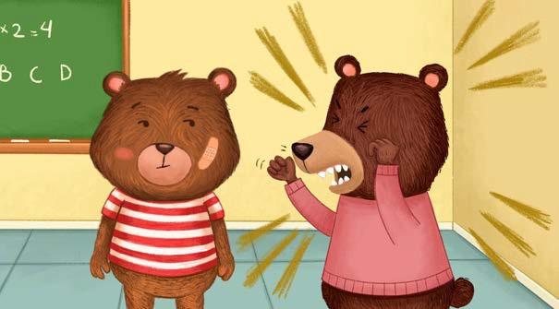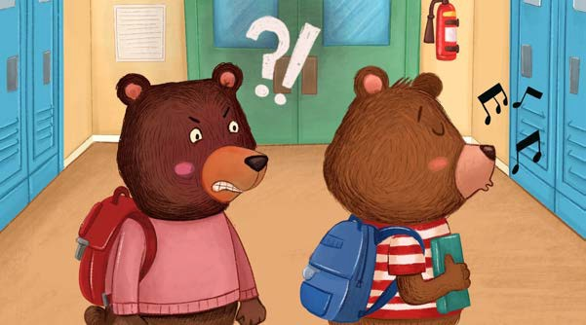Coping With Bullying

|  |
| --- |
| Walk Away |
| Whenever it’s reasonable to do so, just walk away. Pretend you don’t hear your bully or don’t  care about what they say. |

|  |
| --- |
| Stand Tall and Proud |
| Don’t let a bully know their words are hurting your feelings or making you angry. Stand tall and proud, even if you don’t feel that way inside! Most bullies will  get bored and leave you alone. |

|  |
| --- |
| Tell an Adult |
| Adults can handle the bully and help keep you safe. Adults  can even help the bully deal with their own problems so they don’t  hurt anyone else in the future. |