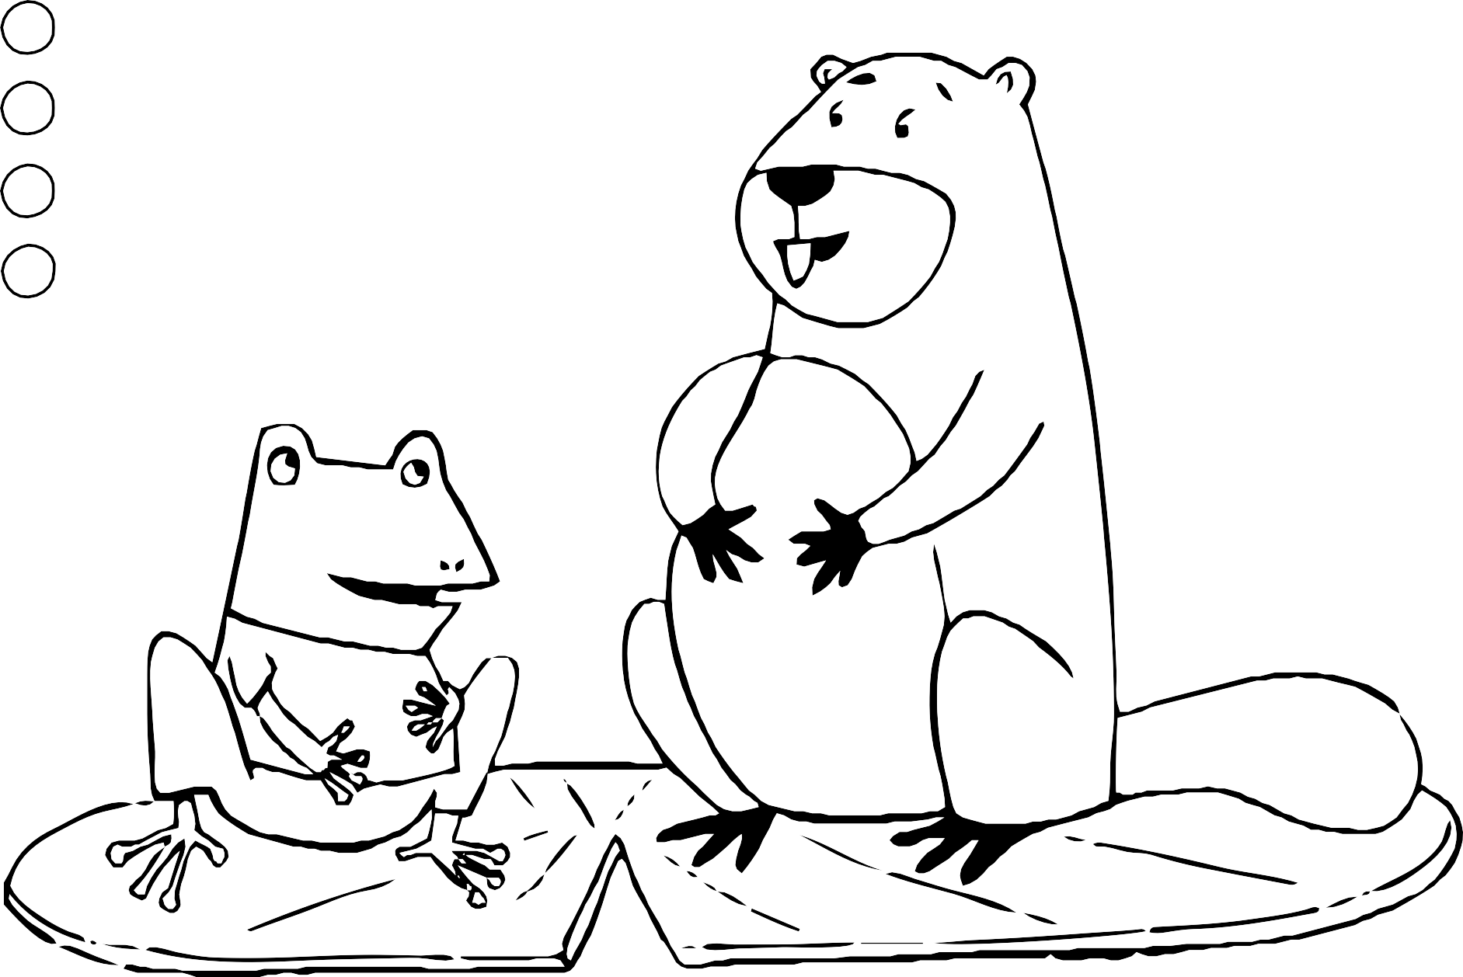Belly Breathing

1. **Breathe In**
2. **Pause**
3. **Breathe Out**
4. **Repeat**