Look at the figure below. Where in your body do you feel anxiety? Next to the figure, write what it feels like to have anxiety.

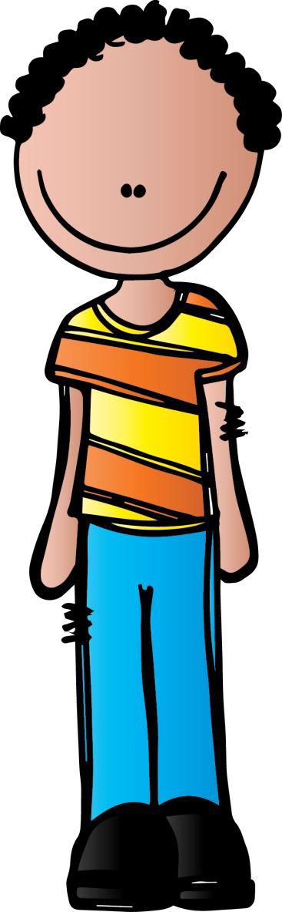

Look at the figure below. Where in your body do you feel anxiety? Next to the figure, write what it feels like to have anxiety.

