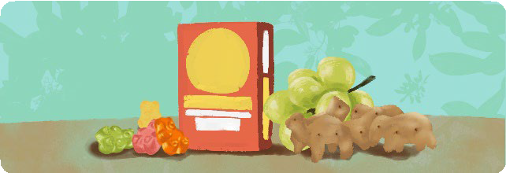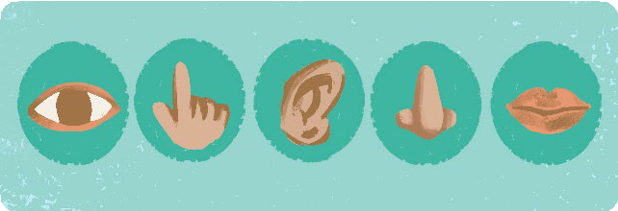*Mindfulness* means paying attention to the present moment, without judging or trying to change it.

**Why is mindfulness important?**

* By focusing on the here-and-now, we take a break from worrying about the past or future.
* Mindfulness can help people manage difficult emotions like anxiety and anger.

**Teaching tips**

* Help kids practice mindfulness by having them slow down and focus on what they're doing. For example, instead of eating ice cream so fast they get a brain freeze, they can learn to eat it slowly and carefully, enjoying every bite.
* Reinforce the benefits of mindfulness by helping kids reflect on the exercises after completing them.
* With consistent practice, kids will learn to use mindfulness when they most need it.

**In this packet**

|  |
| --- |
| **Ocean Breathing:** Teach participants to breathe deeply by creating the relaxing sound of ocean waves. |
| **Raisin Exercise:** Guide participants in slowly exploring and eating a raisin. |
| **Five Senses:** Instruct participants to pay attention to everything they can see, feel, hear, smell, and taste. |

It's easy to get caught up in your thoughts when you're worried about something. Slowing down and paying attention to your breathing is helpful when you find yourself stuck in your head. In this exercise, you will practice deep breathing by making the sound of ocean waves with your breath.

**1**

**2**

**3**



**Prepare**

Have participants sit comfortably or lie down. They can close their eyes if they feel comfortable doing so.

**Practice**

|  |
| --- |
| Breathe deeply in through the nose and then slowly out through the mouth to create the relaxing sound of waves. Demonstrate this a few times, exaggerating the whoosh sound of the exhale. |
| Ask participants to follow along while you continue to demonstrate. Once they’ve gotten the hang of it, set a timer and lead them in practicing for one minute. |
| Talk about how it felt to practice ocean breathing and when they can use it in their lives (e.g. when they feel angry or stressed out). |

We often scarf down our meals so quicky that we barely taste them. We have so many things to do that a meal becomes just another chore. However, eating mindfully slows us down and can even help us enjoy our food more. In this activity, you will find there’s a lot to discover about a food as simple as a raisin.

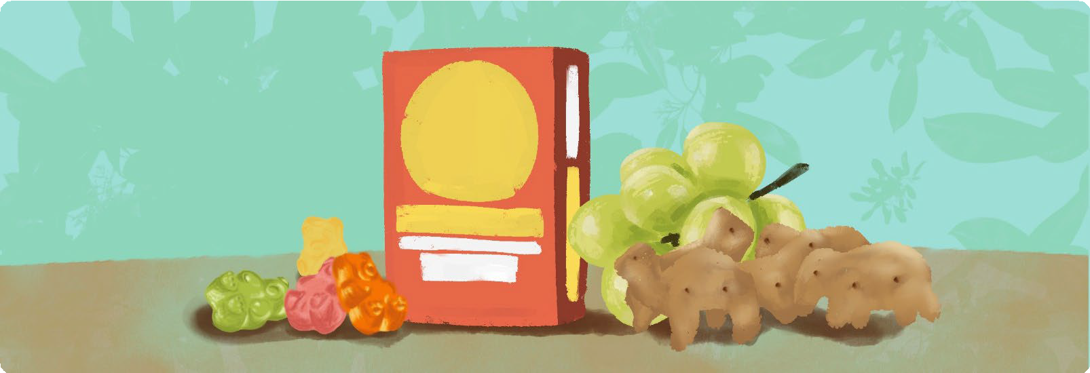

**Prepare**

Give each participant a small box of raisins. When you’re ready to begin, instruct them to remove a single raisin and place it in front of them.

Note: If you don’t have raisins, try gummy bears, grapes, or crackers. Adapt the questions accordingly.

**Practice**

|  |
| --- |
| Guide participants in slowly exploring and eating their food, spending about 30 seconds on each stage. |
| **1** Notice the color, size, and shape of your raisin. |
| **2** Notice how your raisin feels in your hand and when you squeeze it. |
| **3** Bring the raisin close to your nose and notice how it smells. |
| **4** Place the raisin in your mouth and pay attention to what it feels and tastes like. |
| **5** Slowly chew the raisin and notice how the texture changes. |
| **6** Swallow the raisin and notice how that feels. |

Every day, we’re surrounded by countless sights, sounds, and smells. Unfortunately, our brains are often so focused on thoughts or worries that we miss important things right in front of us. Mindfulness helps us slow down and appreciate our surroundings, which keeps us grounded in the here-and-now. In this exercise, the goal is to notice what’s around you.

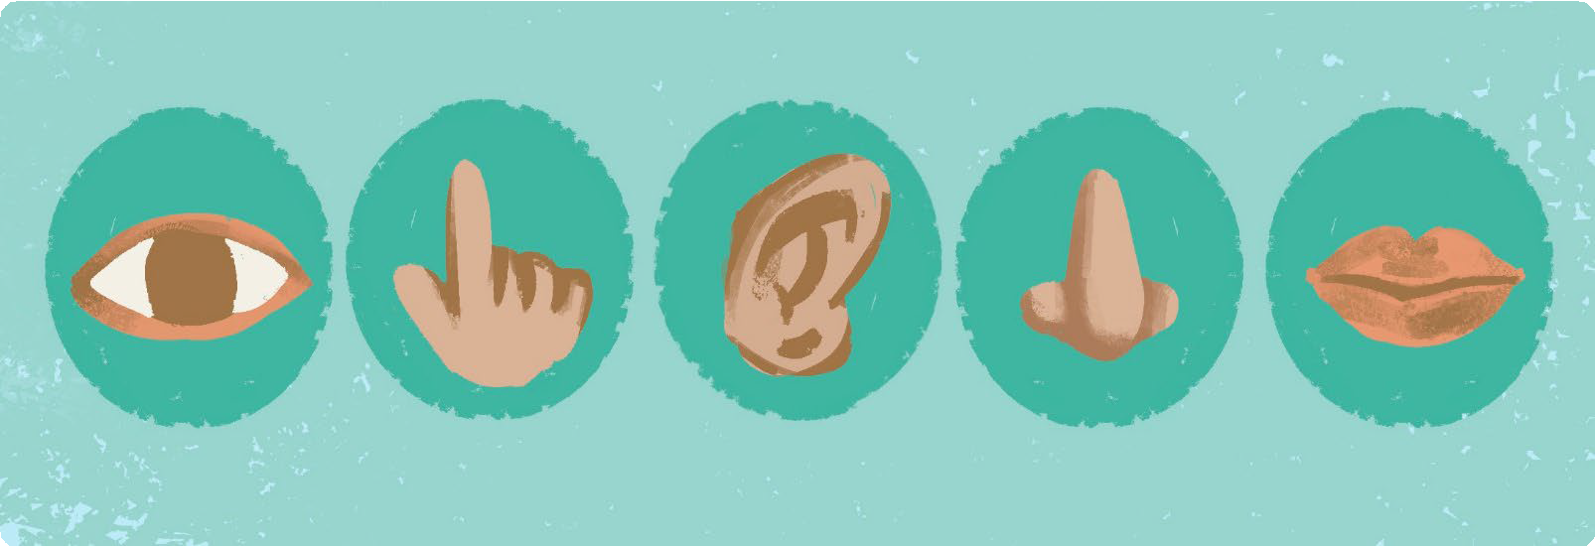

**Prepare**

This activity can be done while seated quietly inside, or outside while walking. Focusing on one sense at a time, you'll instruct participants to pay attention to everything they can see, feel, hear, smell, and taste.

Pause for a minute between each of the senses.

**Script**

*Start by noticing 5 things you can see. Try to find something you’ve never noticed before. It could be an object, the color of something, a pattern, or anything else. It could be on you or your clothes, or it could be off in the distance.*

*Next, notice 4 things you can feel. This could be your clothes on your skin or something your hand can reach out and touch. Maybe something is rough, or maybe something is smooth.*

*Listen for 3 things you can hear. The sound might be very quiet, but if you pay attention, you can hear it. You might hear your own breathing or your stomach rumbling, or you might hear something off in the distance.*

*Now notice 2 things you can smell. It’s okay if it’s not your favorite smell.*

*Finally, notice one thing you can taste. If you’re having trouble tasting anything, try to think about the last thing you ate. Maybe you can almost taste it!*