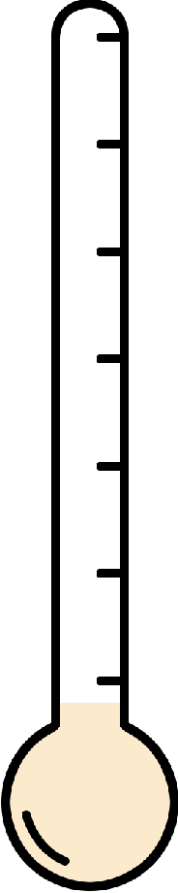Very Happy

Happy

Not Happy

Very Angry

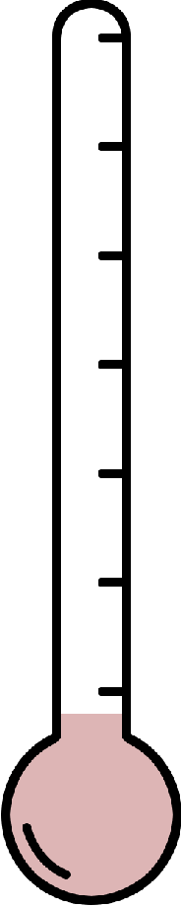Angry

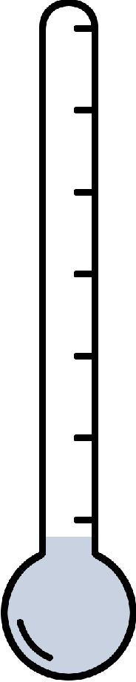

**Very Sad**

**Sad**

**Not Sad**

Not Angry

Very Worried

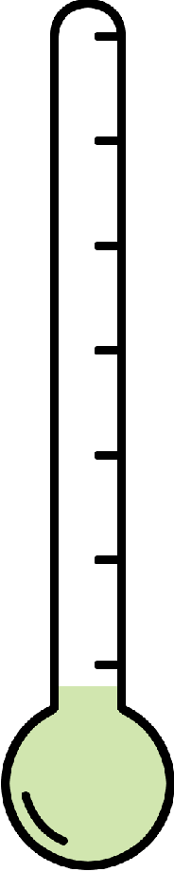Worried

Not Worried

Very Worn-Out

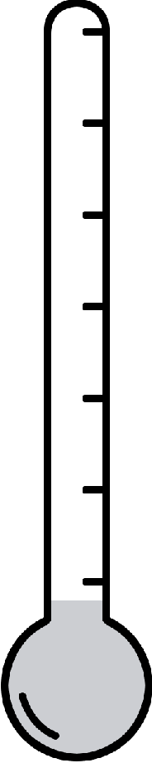Worn-Out

Not

Worn-Out

Very Annoyed

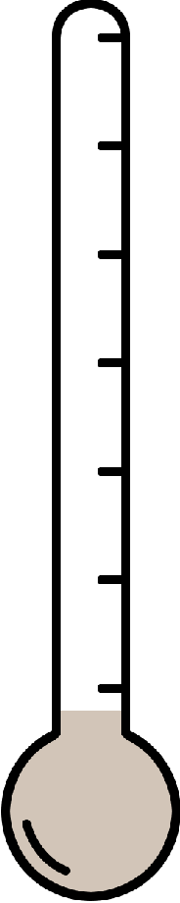Annoyed

Not Annoyed

 