Anger Coping Skills

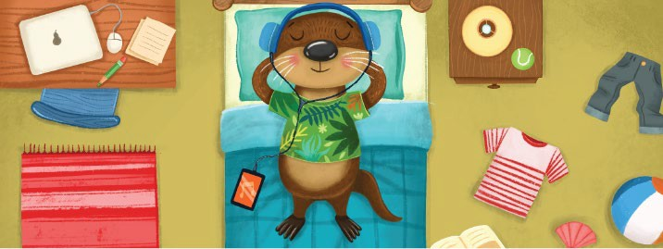

Walk Away

Get away from whatever is making you mad and take time to cool down. If someone is being mean to you,

try to leave the situation.

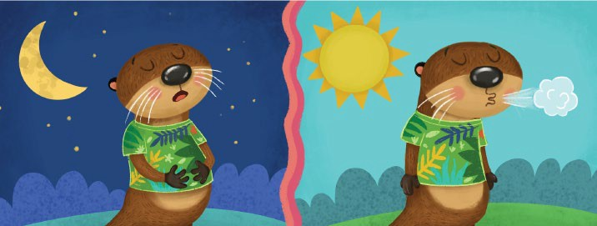

Take a Deep Breath

Take a big, deep breath. Fill your belly with air, then slowly blow it out. Imagine that your anger is leaving you, too.

Do this five times.

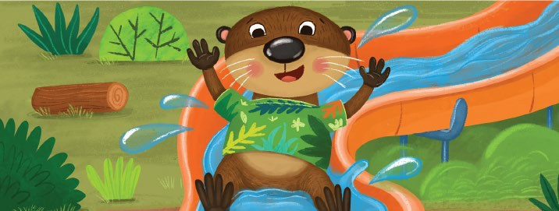

Do Something Fun

Play outside, draw a picture, or do anything else you like. This will take your mind off your anger. In a little while, you’ll feel better.

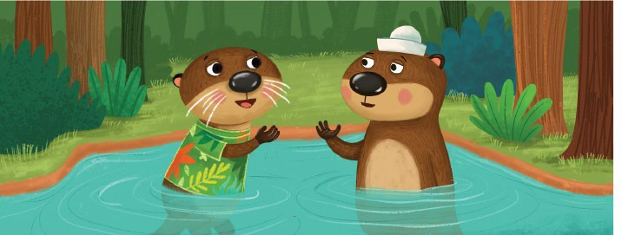

Talk About It

Talk to someone you trust, like a parent, teacher, or friend. When you talk about your problems, they don’t feel so big.