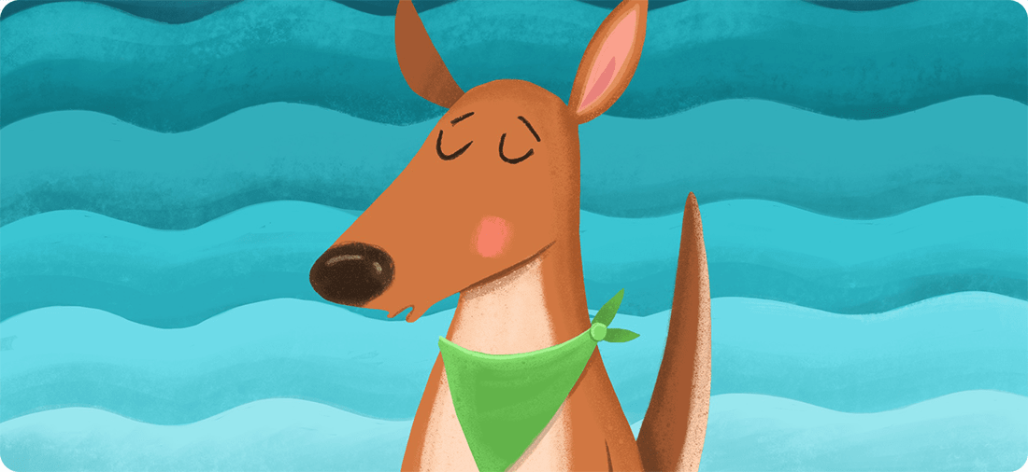

**Ocean breathing** is a skill that will help you calm down when you feel hyper or excited.

Close your eyes and imagine ocean waves. Each wave crashes onto the shore, and then gently rolls back into the ocean.

**1**

Breathe in **slowly** through your nose. Imagine the sound of breathing in as a wave rolling back into the ocean.

**2**

Put your lips together like you are blowing through a straw, and **slowly** breathe out. Imagine the sound of breathing out as an ocean wave crashing onto the shore.

**3**

Keep breathing in through your nose, and out through your lips, imagining ocean waves. Practice for 1 minute.

**4**

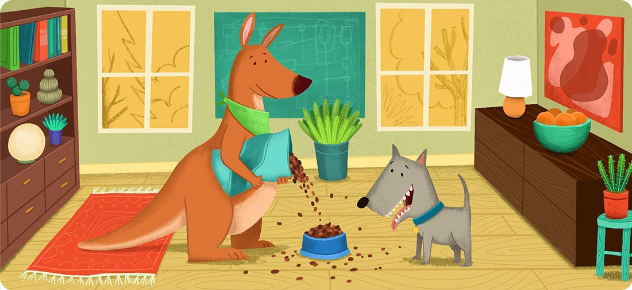

**Creating a routine** will help you remember to do important things like homework and chores. A good routine will also have plenty of time for playing and having fun!

A “routine” means doing the same things every day. For example, brushing your teeth every night right before bed.

With a grown-up, write down your routine and put it somewhere you can see it, like on the fridge, or in your room.

Include time for resting, snacks, and playing. Scatter fun things throughout your routine so you don’t get too bored.

For difficult tasks, plan even the little things. For example, think of a quiet place where you can always do homework, or if mornings are difficult, lay out clothes the night before.

It takes time to learn a new routine. A grown-up can remind you what’s next in your day, and help you stay on track.

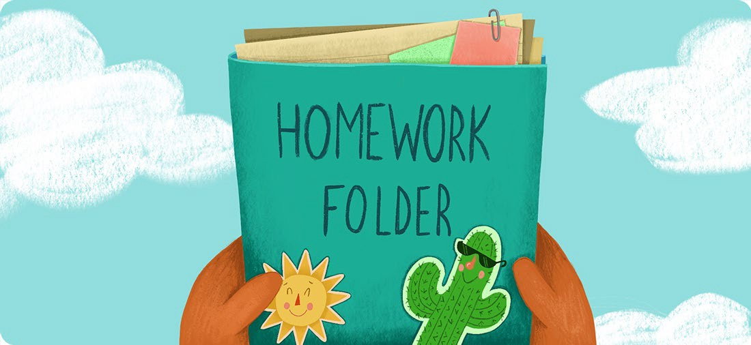

**Problem solving** means coming up with new ways to deal with challenges. Sometimes you have to try a bunch of different solutions before finding what works.

# Clearly explain the problem.

**1**

*I keep losing my homework before turning it in.*

# Think of a few different ways to solve the problem.

**2**

* *Create a special folder for my homework. Homework to do goes in the left pocket, completed homework goes in the right.*
* *Have a grown-up review homework and put it in my backpack.*

# Pick your favorite solution and try it for a few days. If it isn’t working, try making changes.

**3**

*I tried the homework folder first. One day I forgot the folder at home, so I made a rule that it always stays in my backpack.*

**Review if the solution worked. If it did, great! If not, try one of your other solutions.**

**4**