A-level Electronics
Homework Booklet VI
Topic 209 Communication Systems, Topic 210 Wireless Transmission, Topic 211 Digital Communication Systems


Name ………………………………………………………………………………………………

Group ………………………………………………………………………………………………

Teacher ……………………………………………………………………………………………

Exercise 1
1. A 25 mW signal enters a cable system of length 150 km. The cable has an attenuation of 7 dB/km. Amplifiers of gain 36dB are located at 5 km intervals. Calculate:

a. the total power loss of the signal as a result of travelling through the 150 km cable

……………………………………………………………………………………………………..

……………………………………………………………………………………………………..

b. the total signal gain as a result of passing through the 30 amplifiers in the system

……………………………………………………………………………………………………..

……………………………………………………………………………………………………..

c. the signal power emerging from the thirtieth amplifier, at the end of the system.

……………………………………………………………………………………………………..

……………………………………………………………………………………………………..

Exercise 2
- A 100kHz carrier is amplitude modulated by a 10 kHz square wave. The carrier has an amplitude of 20V and the square wave has an amplitude of 5V. Use the axes on the graph paper below to draw:

(i) 10 cycles of the carrier wave


(ii) the 10kHz square wave using the same time scale

(iii) the resulting AM signal, labelling important points on the voltage and time axes.

- The diagram below shows an AM carrier modulated by a pure tone.

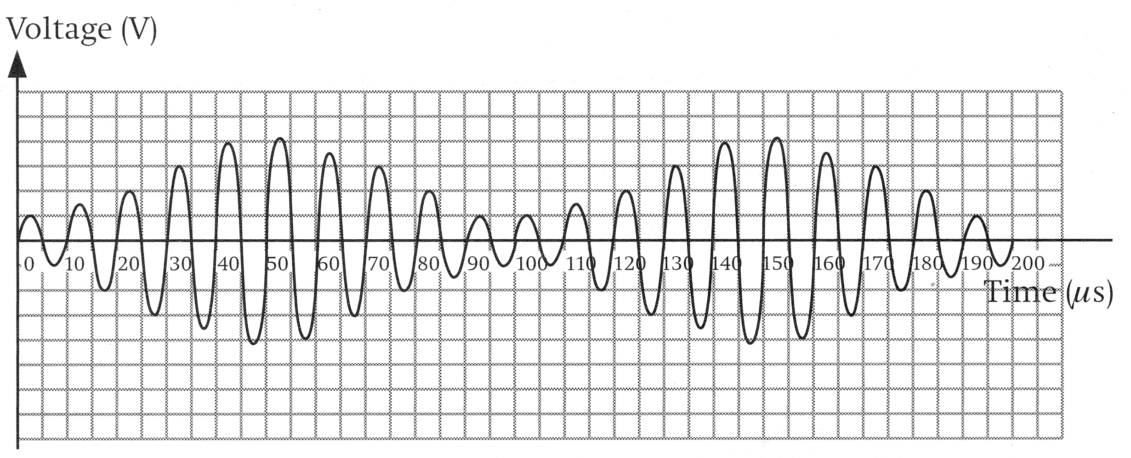
(i) Calculate the carrier frequency and the pure tone frequency.

Carrier Frequency = ………………………

Pure Tone Frequency = ………………….

(ii) Fill in the graph to show the frequency spectrum of the AM signal.

frequency / kHz

Amplitude

- A radio station on the MW network transmits with a carrier frequency of 500 kHz, amplitude modulated by an audio baseband of 100 Hz to 3.5 kHz. Sketch the frequency spectrum of the station and calculate the bandwidth of the AM signal.

frequency / kHz

Amplitude

Bandwidth …………………………………… kHz

Exercise 3
1. A radio station broadcasts for 20 hours per day on a frequency of 100 kHz, using Amplitude Modulation. During the 4 hours when the radio station is ‘off-air’ the station transmits its call-sign, a continuous 10kHz single frequency with a modulation depth of 50%.

a. Use the axes provided below to sketch the amplitude modulated envelope of the carrier wave. [3]

b. Using the axes below sketch the frequency spectrum diagram for the amplitude modulated carrier of the radio station when transmitting its call-sign. Label all frequencies. [3]

frequency / kHz

Amplitude

2. A carrier wave is amplitude modulated by a single frequency test signal and broadcast by a radio station. An engineer received the following signal on the receiving circuit.

25 50 75 100 125 150 175 200

time / us

Voltage

a. Determine the period and frequency of the test signal.

Period : ............................................

Frequency : ...................................................
[2]

b. The single frequency test signal is now replaced by an audio signal. The frequency spectrum of this broadcast is shown below.

frequency (kHz)

amplitude

90

110

i. What is the carrier frequency of the radio station ?

....................................................................................................................................
[1]
ii. What is the broadcast bandwidth of this transmission ?

.....................................................................................................................................
[1]

iii. Use the axes provided to sketch the frequency spectrum for the audio signal being transmitted. Label the frequency axis with the appropriate scale.
[2]

frequency (kHz)

amplitude

Exercise 4
1. A 10 MHz carrier is frequency modulated by a pure signal tone of frequency 8 kHz. The frequency deviation is 32 kHz. Calculate the bandwidth of the resulting FM waveform.

……………………………………………………………………………………………………..

……………………………………………………………………………………………………..

2. An audio signal, with a base band of 200 Hz to 4 kHz, frequency modulates a carrier of frequency 50 MHz. The frequency deviation per volt is 10 kHz/V and the maximum audio voltage it can transmit is 3V. Calculate the frequency deviation and the bandwidth of the FM signal.

……………………………………………………………………………………………………..

……………………………………………………………………………………………………..

3. The diagram below shows an FM carrier modulated by a pure tone (sinusoidal wave). Calculate the carrier frequency and the pure tone frequency.

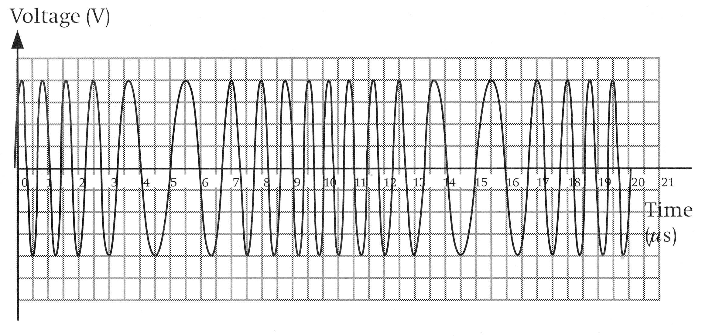

……………………………………………………………………………………………………..

……………………………………………………………………………………………………..

……………………………………………………………………………………………………..

……………………………………………………………………………………………………..

……………………………………………………………………………………………………..

4. A 24 MHz carrier is frequency modulated by a pure signal tone of frequency 12 kHz. The frequency deviation is 56 kHz. Calculate the bandwidth of the resulting FM waveform.

……………………………………………………………………………………………………..

……………………………………………………………………………………………………..

5. An audio signal, with a base band of 200 Hz to 12 kHz, frequency modulates a carrier of frequency 50 MHz. The frequency deviation per volt is 15 kHz/V and the maximum audio voltage it can transmit is 7 V. Calculate the frequency deviation and the bandwidth of the FM signal.

……………………………………………………………………………………………………..

……………………………………………………………………………………………………..

Exercise 5
- A Schmitt trigger circuit is shown in the following circuit diagram.

-

+

30kΩ

15kΩ

V_{IN}

1V

V_{OUT}

X

R₁

R₂

The comparator saturates at ±10V.

i) Calculate the value of VX, when VIN = +4V and VOUT=+10V

……………………………………………………………………………………………………..

……………………………………………………………………………………………………..

ii) Calculate the value of VIN which causes VOUT to change from +10V to –10V

……………………………………………………………………………………………………..

……………………………………………………………………………………………………..

……………………………………………………………………………………………………..

……………………………………………………………………………………………………..

iii) Calculate the value of VIN which causes VOUT to change from -10V to +10V.

……………………………………………………………………………………………………..

……………………………………………………………………………………………………..

……………………………………………………………………………………………………..

……………………………………………………………………………………………………..

iv) Sketch the characteristic for this Schmitt trigger below.

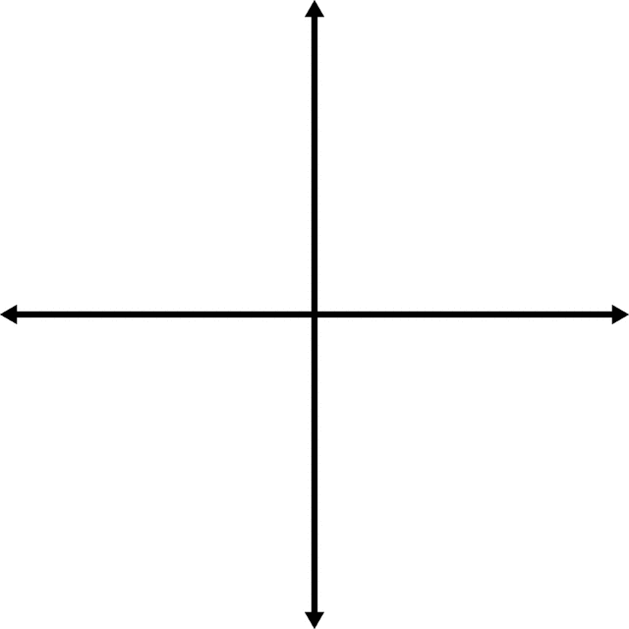

- A non-inverting Schmitt trigger is required to have saturation values of ±9V, and switching thresholds of ±4V.

-

+

30kΩ

15kΩ

V_{IN}

V_{REF}

V_{OUT}

X

R₁

R₂

i) What is the value of VREF ? .......................................................

ii) Determine the value of R1 and R2 to meet the design specification.

……………………………………………………………………………………………………..

……………………………………………………………………………………………………..

……………………………………………………………………………………………………..

……………………………………………………………………………………………………..

……………………………………………………………………………………………………..

R1 ……………………………………………… R2 …………………………………………….

- A non-inverting Schmitt trigger is required to have saturation values of ±15V, and switching thresholds of ±5V.

-

+

30kΩ

15kΩ

V_{REF}

V_{IN}

V_{OUT}

X

R₁

R₂

i) What is the value of VREF ? .......................................................

ii) Determine the value of R1 and R2 to meet the design specification.

……………………………………………………………………………………………………..

……………………………………………………………………………………………………..

……………………………………………………………………………………………………..

……………………………………………………………………………………………………..

……………………………………………………………………………………………………..

R1 ……………………………………………… R2 …………………………………………….

Exercise 6
1. The following circuit diagram shows an op-amp connected as a Schmitt trigger. The op-amp saturates at +10V and 0V.

-

+

20kΩ

10kΩ

V_{IN}

+2V

V_{OUT}

X

R₁

R₂

(b) Calculate the voltage at ‘X’ when VIN = 7V, and VOUT= +10V. [2]

……………………………………………………………………………………………………..

……………………………………………………………………………………………………..

……………………………………………………………………………………………………..

(c) Calculate the upper switching threshold by calculating the value of VIN that produces a voltage of +2V at X when VOUT=0V. [2]

……………………………………………………………………………………………………..

……………………………………………………………………………………………………..

……………………………………………………………………………………………………..

……………………………………………………………………………………………………..

(d) Calculate the lower switching threshold. [2]

……………………………………………………………………………………………………..

……………………………………………………………………………………………………..

……………………………………………………………………………………………………..

(e) Give a use for this circuit in a digital communication system. [1]

……………………………………………………………………………………………………..

2. A digital signal is transmitted down a copper cable communications link.
The signal is attenuated and subjected to noise in the copper cable.

(a) (i) Explain what is meant by the phrase “...the signal is attenuated....” [1]

……………………………………………………………………………………………………..

……………………………………………………………………………………………………..

……………………………………………………………………………………………………..

(ii) Identify one possible source of noise. [1]

……………………………………………………………………………………………………..

……………………………………………………………………………………………………..

……………………………………………………………………………………………………..

(b) The receiver contains a non-inverting Schmitt trigger to regenerate the signal.
The following graph shows the signal picked up by the receiver.

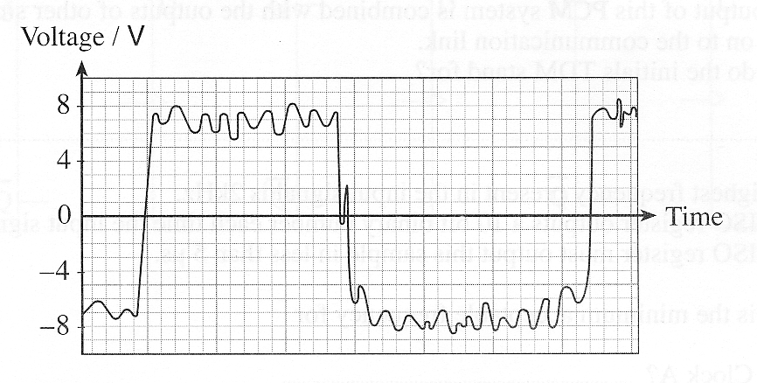
Give suitable threshold values for the non-inverting Schmitt trigger. [2]

Upper switching threshold = ...................................

Lower switching threshold = ...................................

(c) The next diagram shows an inverting Schmitt trigger. The output of the comparator saturates at ±10V.

-

+

220kΩ

330kΩ

V_{IN}

0V

V_{OUT}

R₁

R₂

Calculate the switching thresholds for this circuit. [4]

……………………………………………………………………………………………………..

……………………………………………………………………………………………………..

……………………………………………………………………………………………………..

……………………………………………………………………………………………………..

……………………………………………………………………………………………………..

……………………………………………………………………………………………………..

……………………………………………………………………………………………………..

……………………………………………………………………………………………………..

……………………………………………………………………………………………………..

Upper switching threshold = ...................................

Lower switching threshold = ...................................

3) The following diagram shows the circuit for a Schmitt trigger. The comparator saturates at +10V and 0V.

-

+

400kΩ

200kΩ

V_{IN}

+4V

V_{OUT}

X

R₁

R₂

(a) Calculate the voltage at ‘X’ when VIN = 7V, and VOUT= +10V. [2]

……………………………………………………………………………………………………..

……………………………………………………………………………………………………..

……………………………………………………………………………………………………..

(b) Calculate the value of VIN that causes VOUT to change from 0V to +10V. [2]

……………………………………………………………………………………………………..

……………………………………………………………………………………………………..

……………………………………………………………………………………………………..

(c) Calculate the value of VIN that causes VOUT to change from +10V to 0V. [2]

……………………………………………………………………………………………………..

……………………………………………………………………………………………………..

……………………………………………………………………………………………………..

(d) Sketch the characteristic for this Schmitt trigger. [3]

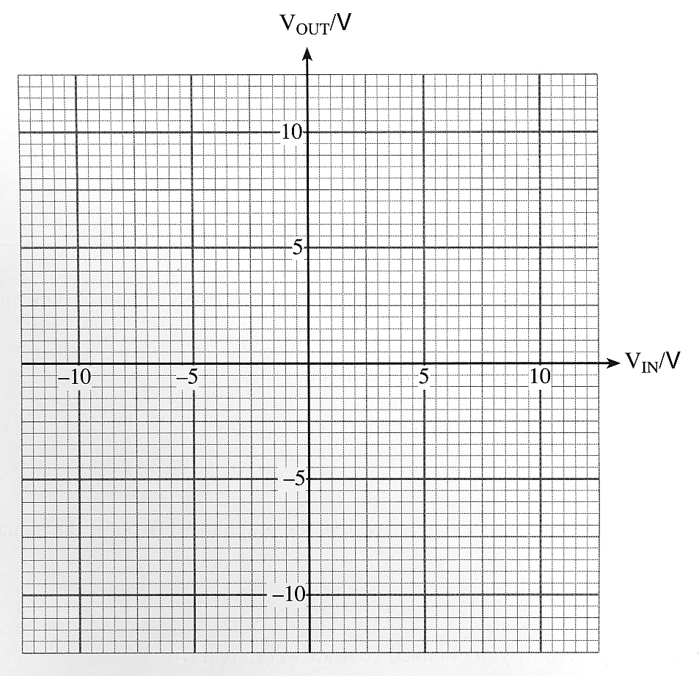

Exercise 7
1. a. How many clock pulses does it take to load a 4-bit number into

i) a 4-bit PISO (parallel-in-serial-out) shift register?

.........................................................
[1]
ii) a 4-bit SIPO (serial-in-parallel-out) shift register?

.........................................................
[1]

b. Complete the following circuit diagram for a SIPO shift register, that uses four D-Type flip-flops. Label the serial input and one of the parallel outputs.

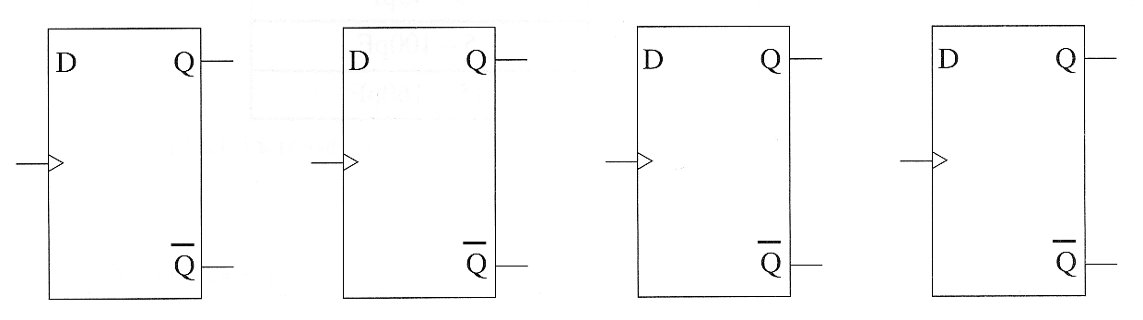
[4]
2. The circuit diagram shows a three bit shift register, made from rising-edge-triggered D-type flip-flops.

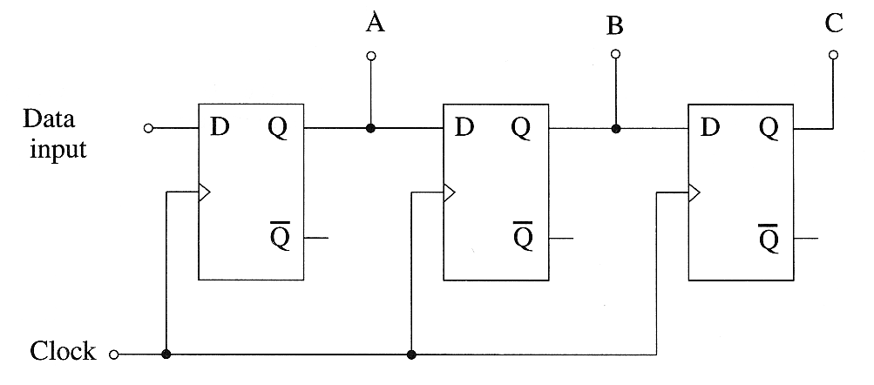

Initially all three flip flops are reset.

The upper two graphs shows the signals applied to the data input and clock input.
Use the axes provided to show the corresponding signals at the outputs A, B and C. [3]

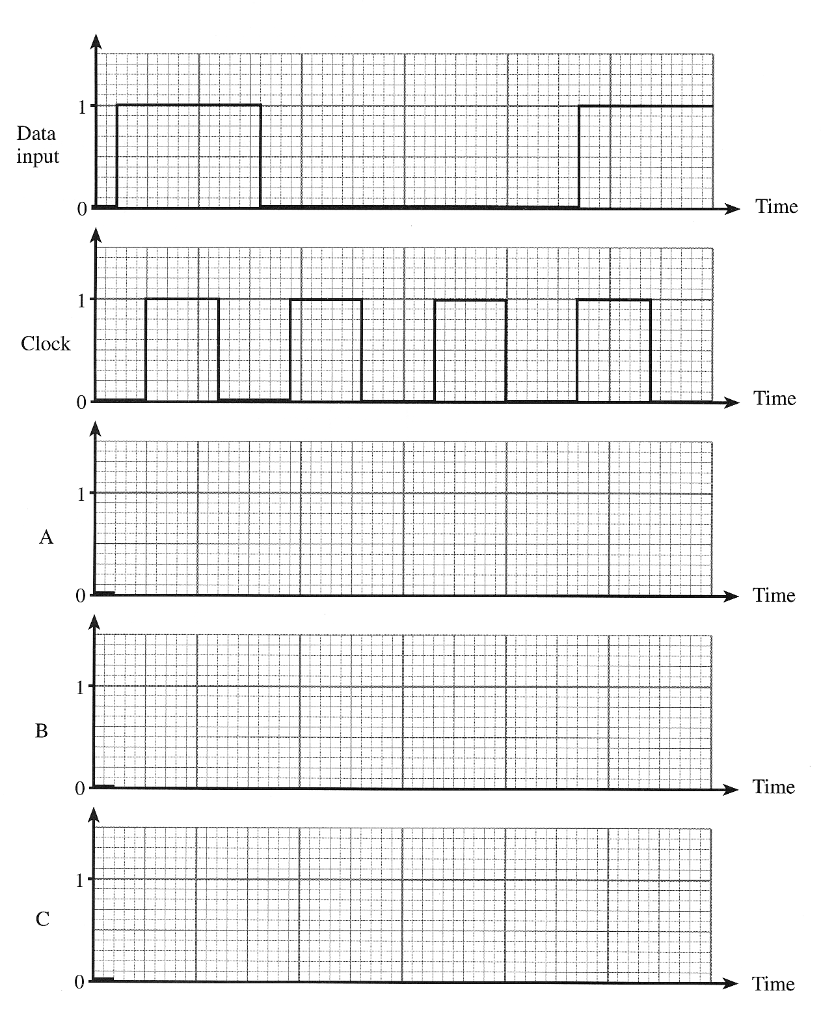

3. The diagram shows 3-D-Type flip-flops that are rising edge triggered.

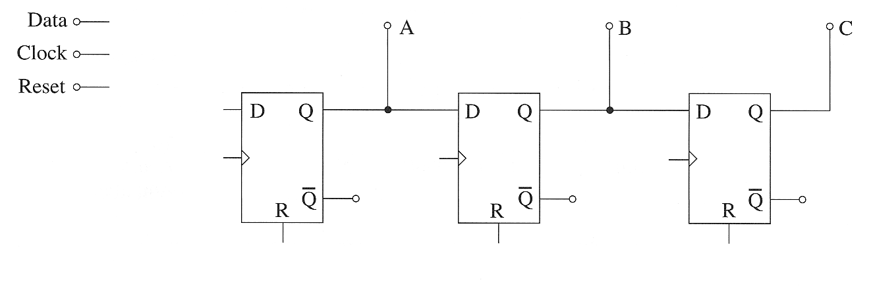

(a) Complete the diagram to show how these are connected to make a 3-bit Serial-In-Parallel-Out (SIPO) shift register, with a reset facility. [4]

(b) Initially all three flip-flops are reset.

The first two graphs show the signal applied to the data input and clock input.

Use the axes provided to show the corresponding signals at the outputs A, B, and C. [3]
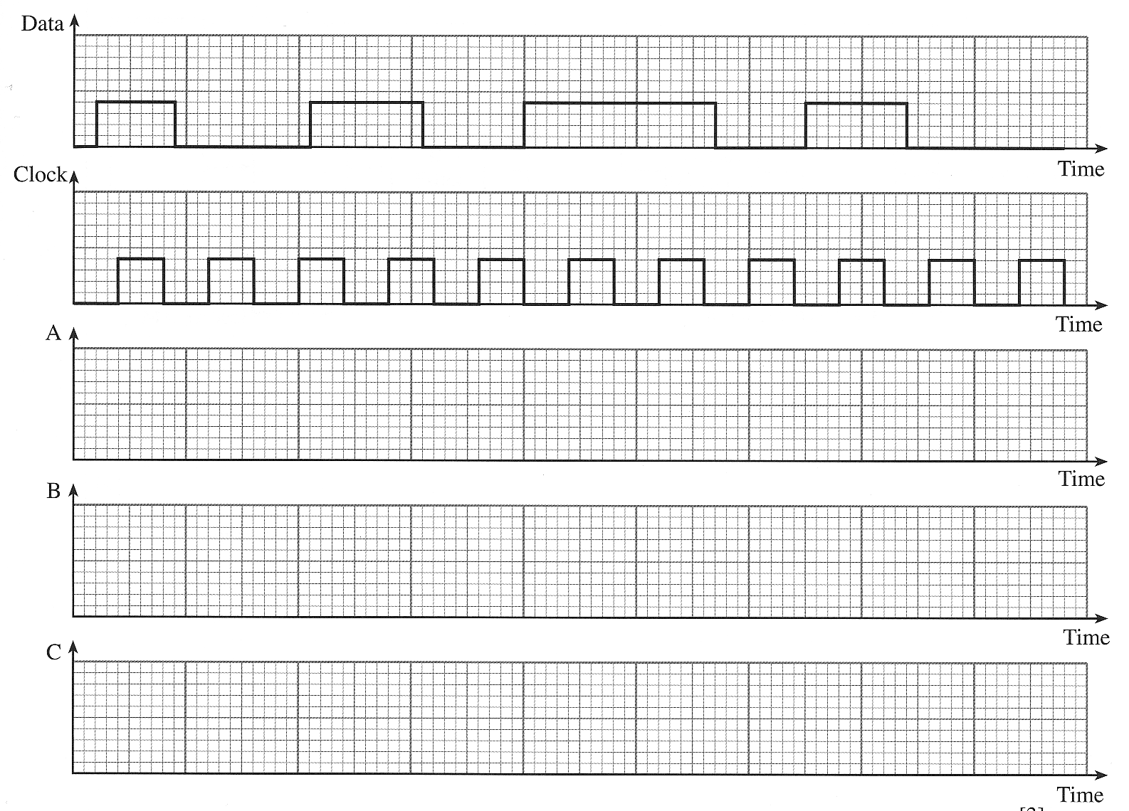

Exercise 8
1. An analogue signal can be modulated onto a stream of pulses using techniques such as pulse width modulation or pulse position modulation. Use the axes provided to show the effect of modulating the carrier pulse train with the analogue signal shown. The original pulse train is shown to assist you. [4]

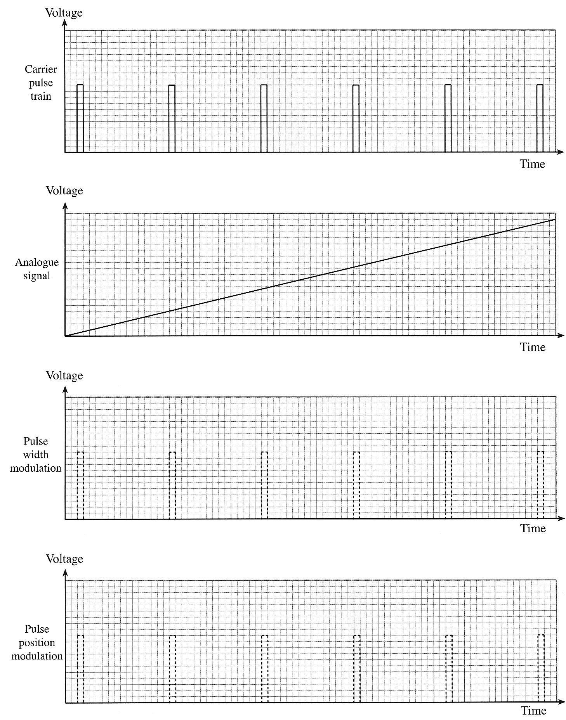
2. Pulse Amplitude Modulation, Pulse Position Modulation and Pulse Width Modulation are three methods of transmitting information.

On each of the following graphs illustrate what would happen to the unmodulated pulse train (shown dotted) if the signal below were transmitted using (i) PAM, (ii) PPM and (iii) PWM. [6]

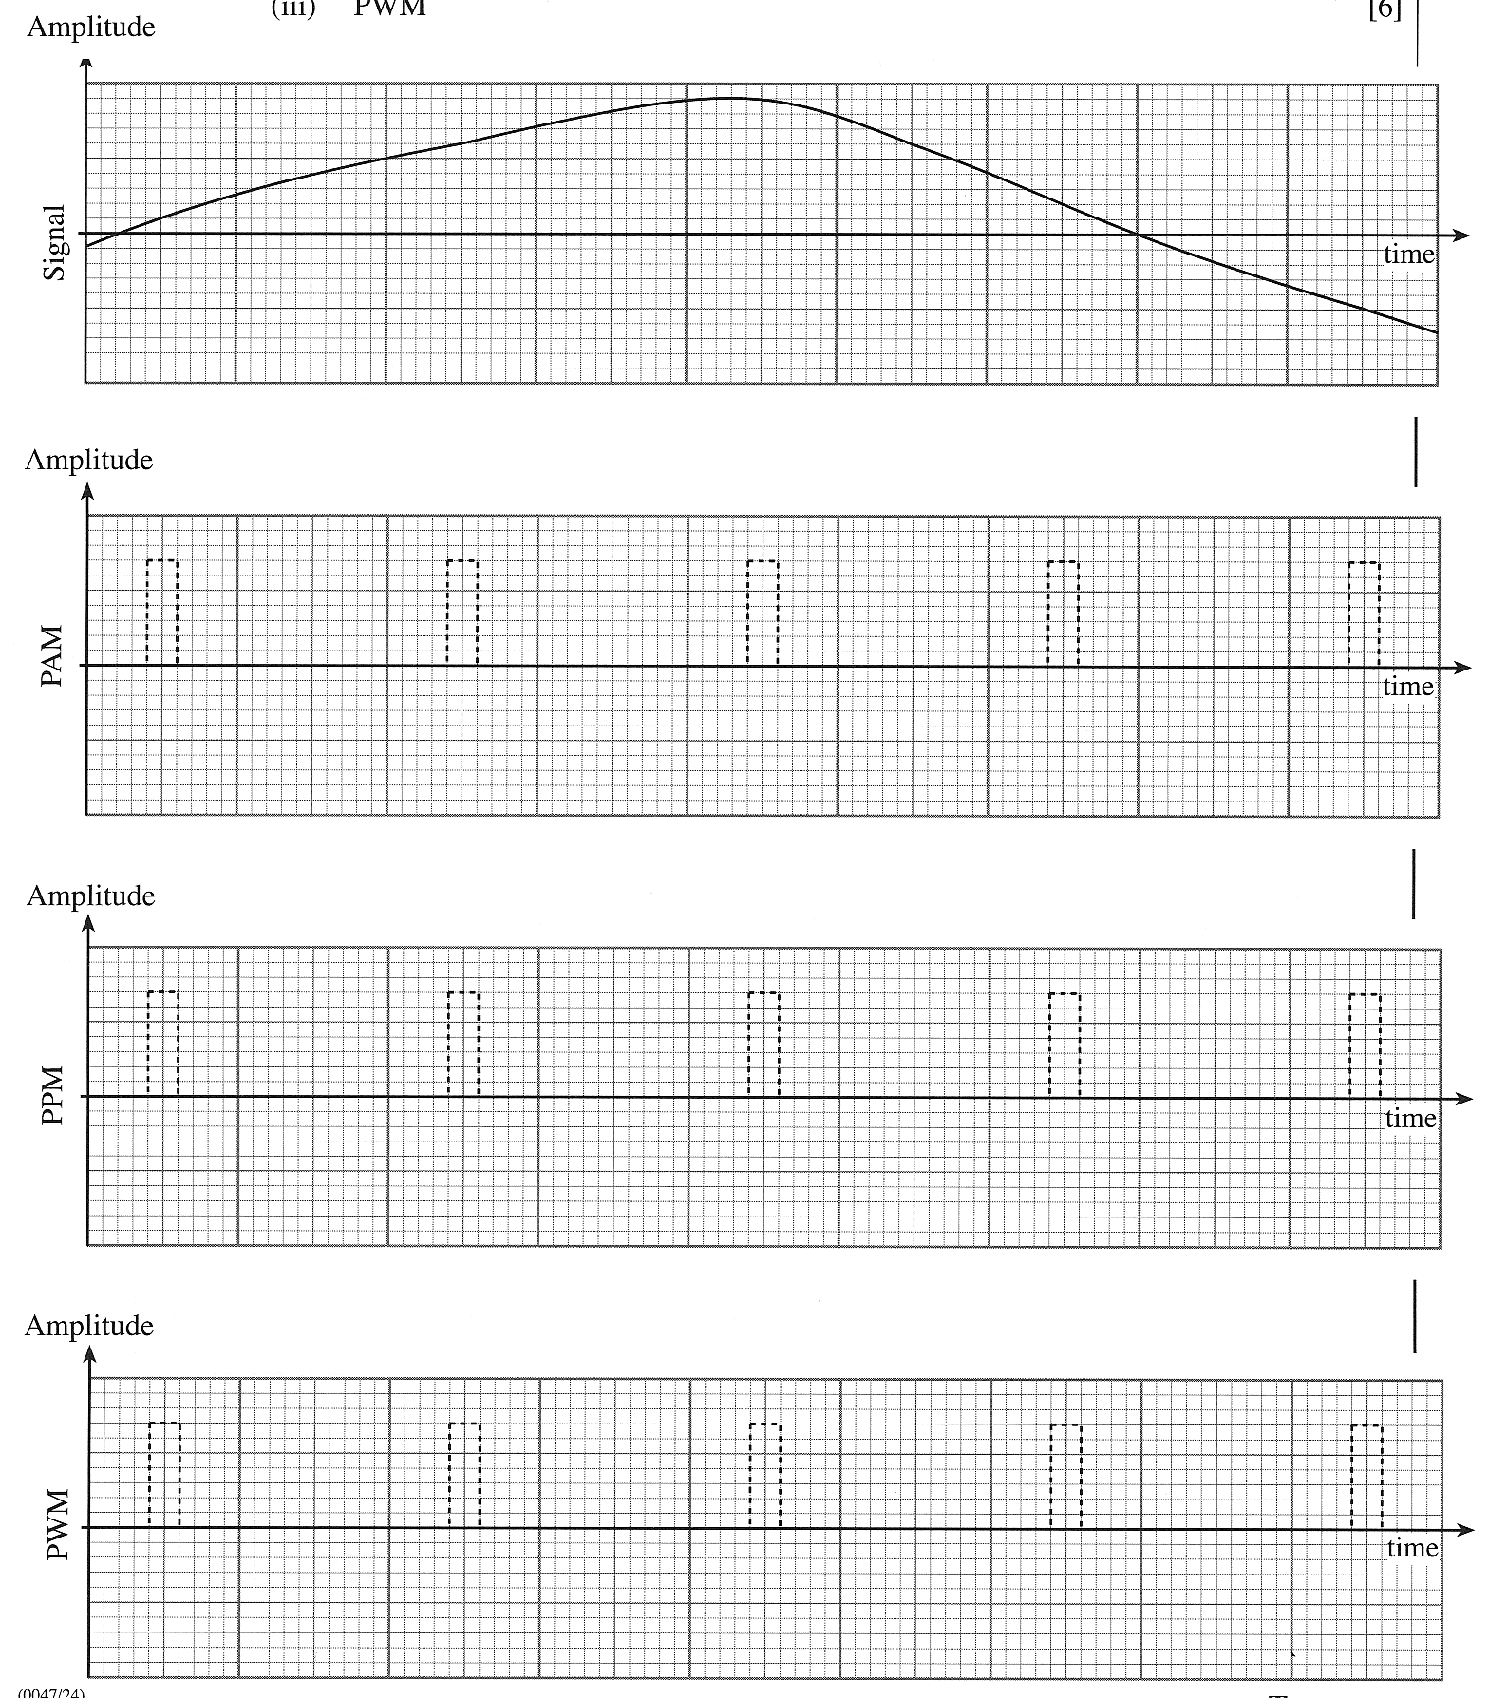

3. (a) The first graph shows a pulse position modulated (PPM) signal. The unmodulated pulse carrier is shown as a dotted trace.

Use the axes provided to sketch the output produced when the PPM signal is demodulated.

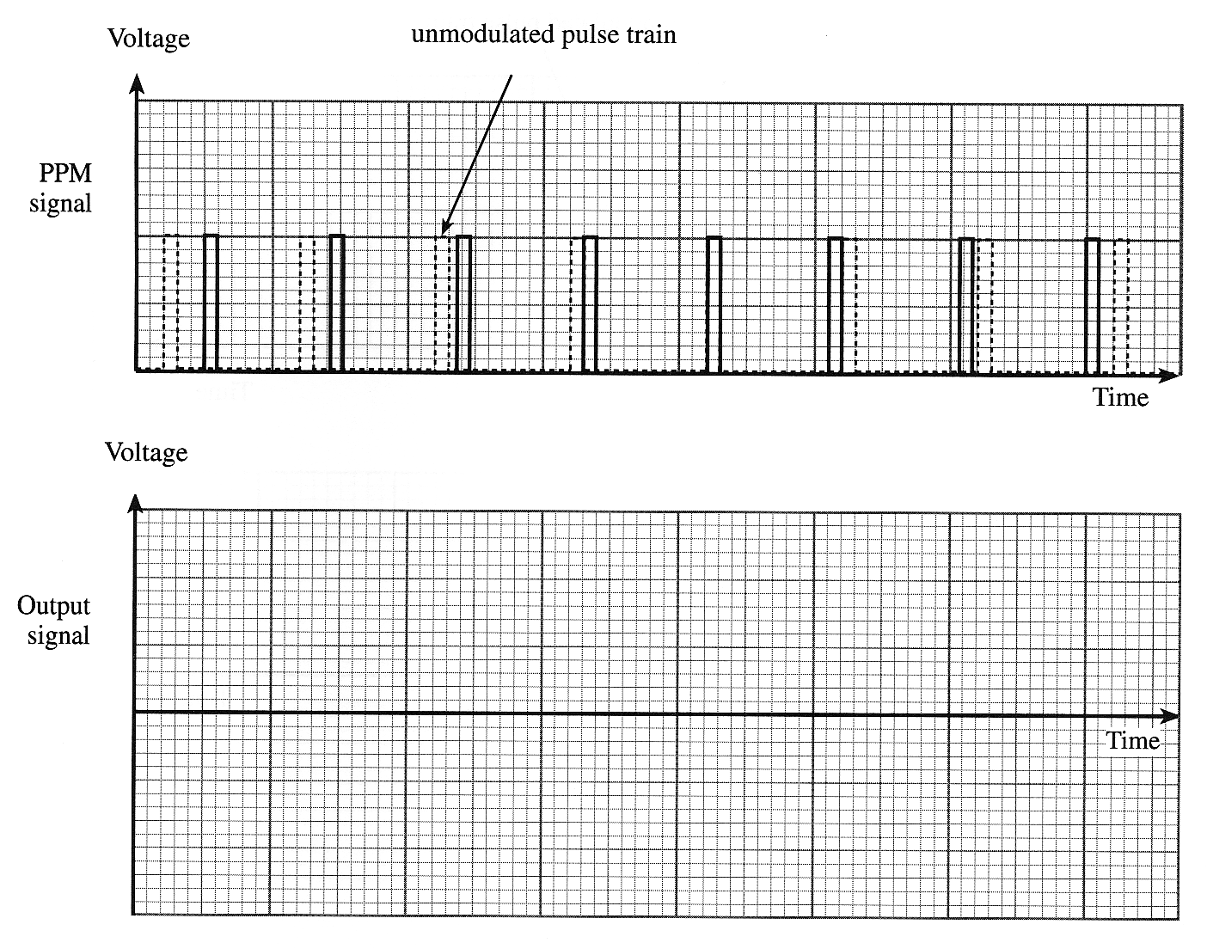

(b) The next graph shows a pulse width modulated (PWM) signal. Again, the unmodulated pulse carrier is shown as a dotted trace.

Use the axes provided to sketch the output produced when the PWM signal is demodulated.

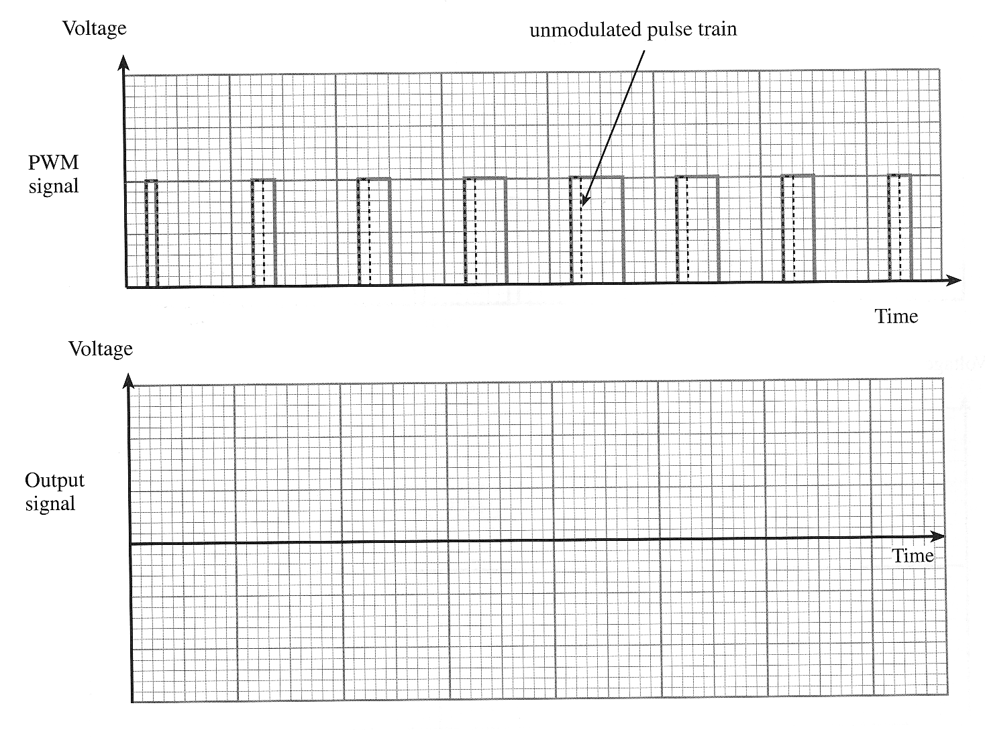

4. Pulse Amplitude Modulation, Pulse Position Modulation and Pulse Width Modulation are three methods of transmitting information.

On each of the following graphs on the next page illustrate what would happen to the un-modulated pulse train (shown dotted) if the signal below were transmitted using
(i) PAM, (ii) PPM and (iii) PWM. [6]

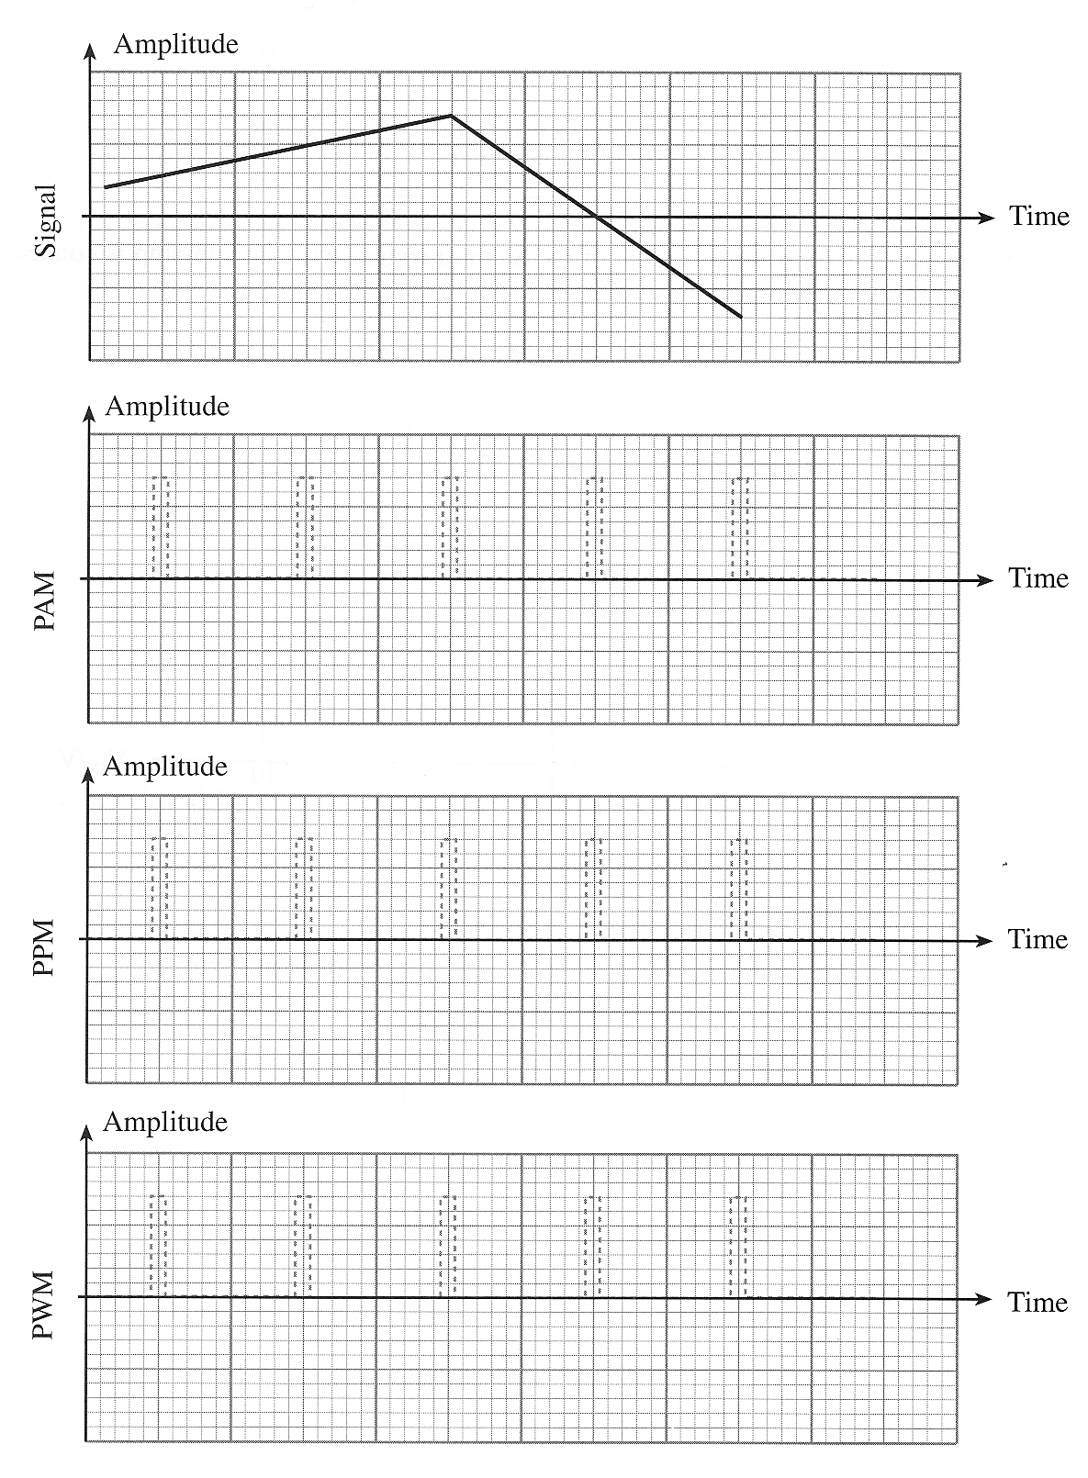

5. Pulse Amplitude Modulation, Pulse Position Modulation and Pulse Width Modulation are three methods of transmitting information.

On each of the following graphs illustrate what would happen to the un-modulated pulse train (shown dotted) if the signal below were transmitted using
(i) PAM, (ii) PPM and (iii) PWM. [6]

