A-level Electronics
Homework Booklet I
Topics 100 Core Concepts, and Topic 101 Logic Systems

Name ………………………………………………………………………………………………

Group ………………………………………………………………………………………………

Teacher ……………………………………………………………………………………………

Exercise 1
1. A 12V power supply is connected to a 3kΩ resistor. What is the current flowing in the circuit?

……………………………………………………………………………………………………………

……………………………………………………………………………………………………………

……………………………………………………………………………………………………………

2. A 9V battery provides a current of 1.5A to a resistor, What is the value of the resistance?

……………………………………………………………………………………………………………

……………………………………………………………………………………………………………

……………………………………………………………………………………………………………

3. A lamp is marked with the following maximum ratings: 6V 0.3A. What is the resistance of the lamp if it is operated at these maximum values ?

……………………………………………………………………………………………………………

……………………………………………………………………………………………………………

……………………………………………………………………………………………………………

4. A current of 4mA is driven through an 8 kΩ resistor. What is the voltage of the power supply producing the current.

……………………………………………………………………………………………………………

……………………………………………………………………………………………………………

……………………………………………………………………………………………………………

5. A resistor of 15 Ω is connected to a battery of unknown voltage. The current in the circuit is measured to be 0.1A. What is the voltage of the battery ?

……………………………………………………………………………………………………………

……………………………………………………………………………………………………………

……………………………………………………………………………………………………………

6. A 4.5V battery is connected to a 36 Ω resistor. How much current flows in the circuit ?

……………………………………………………………………………………………………………

……………………………………………………………………………………………………………

……………………………………………………………………………………………………………

7. A current of 3A leaves a 24V power supply. What is the value of the resistor connected to the power supply?

……………………………………………………………………………………………………………

……………………………………………………………………………………………………………

……………………………………………………………………………………………………………

8. A current of 0.2A flows through a 45 Ω resistor. What is the voltage of the battery producing the current?

……………………………………………………………………………………………………………

……………………………………………………………………………………………………………

……………………………………………………………………………………………………………

9. A resistor of 24 Ω is connected to a power supply. The current in the circuit is measured to be 0.05A. What voltage does the power supply provide ?

……………………………………………………………………………………………………………

……………………………………………………………………………………………………………

……………………………………………………………………………………………………………

10. A 1.5V battery is connected to a 75Ω resistor. How much current flows in the circuit ?

……………………………………………………………………………………………………………

……………………………………………………………………………………………………………

……………………………………………………………………………………………………………

Exercise 2

1. Calculate the equivalent resistance of the arrangement of resistors shown below.
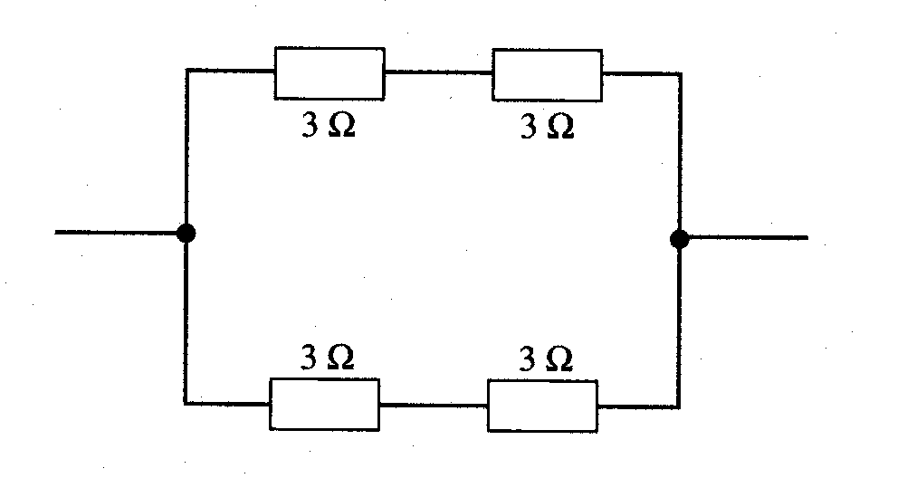
……………………………………………………………………………………………………………

……………………………………………………………………………………………………………

……………………………………………………………………………………………………………

……………………………………………………………………………………………………………

……………………………………………………………………………………………………………

……………………………………………………………………………………………………………

2. Calculate the equivalent resistance of the arrangement of resistors. (Hint: First find the resistance of the parallel combination.)
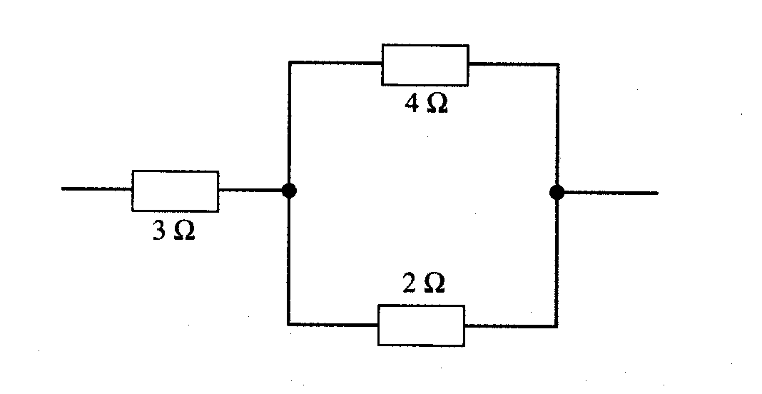
……………………………………………………………………………………………………………

……………………………………………………………………………………………………………

……………………………………………………………………………………………………………

……………………………………………………………………………………………………………

……………………………………………………………………………………………………………

……………………………………………………………………………………………………………

3. Calculate the effective resistance between the points A and B in the network below.
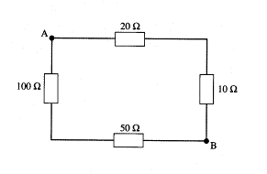
……………………………………………………………………………………………………………

……………………………………………………………………………………………………………

……………………………………………………………………………………………………………

……………………………………………………………………………………………………………

……………………………………………………………………………………………………………

……………………………………………………………………………………………………………

4. You have 3 resistors of 60Ω, 60Ω and 30Ω, Show how some or all of these resistors can be connected to make the following resistor values.
(i) 150Ω (ii) 20Ω (iii) 90 Ω (iv) 15 Ω

Exercise 3

1. Find the total resistance in each of the following combinations of resistors.

10

30

80

(a)

2.0

40

10

(b)

60k

15k

(c)

10k

……………………………………………………………………………………………………………

……………………………………………………………………………………………………………

……………………………………………………………………………………………………………

……………………………………………………………………………………………………………

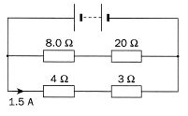
2. Given the information on this circuit diagram

find:
(a) the voltage of the battery.
(b) the current in the 20 Ω resistor.
(c) the current supplied by the battery.

……………………………………………………………………………………………………………

……………………………………………………………………………………………………………

……………………………………………………………………………………………………………

……………………………………………………………………………………………………………

……………………………………………………………………………………………………………

3. Find the value of VOUT in the following circuits.

(a)

V_{IN} = 20 V

4

12

V_{OUT}

……………………………………………………………………………………………………………

……………………………………………………………………………………………………………

……………………………………………………………………………………………………………

……………………………………………………………………………………………………………

(b)

V_{IN} = 12 V

12

4

V_{OUT}

……………………………………………………………………………………………………………

……………………………………………………………………………………………………………

……………………………………………………………………………………………………………

……………………………………………………………………………………………………………

(c)

V_{IN} = 6 V

200

800

V_{OUT}

……………………………………………………………………………………………………………

……………………………………………………………………………………………………………

……………………………………………………………………………………………………………

……………………………………………………………………………………………………………

4. Plot a sketch graph showing how the output voltage varies as the slider is moved from the bottom to the top of the variable resistor.
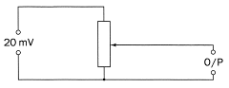

5. Determine the values of R1, V1, I1, I2 and R2 in the following circuit.

15 V

0 V

0.4 mA

I₂

I₁

R₁

R₂

10 k

6 V

V₁

(a) R1

……………………………………………………………………………………………………………

……………………………………………………………………………………………………………

(b) V1

……………………………………………………………………………………………………………

……………………………………………………………………………………………………………

(c) I1

……………………………………………………………………………………………………………

……………………………………………………………………………………………………………

(d) I2

……………………………………………………………………………………………………………

……………………………………………………………………………………………………………

(e) R2

……………………………………………………………………………………………………………

……………………………………………………………………………………………………………

6. Determine the values of V1, I1, R1, I2 and R2 in the following circuit.

3 V

R₁

R₂

1.5 k

I₁

V₁

9 V

0 V

2.5 mA

I₂

(a) V1
……………………………………………………………………………………………………………

……………………………………………………………………………………………………………

(b) I1
……………………………………………………………………………………………………………

……………………………………………………………………………………………………………

(c) R1
……………………………………………………………………………………………………………

……………………………………………………………………………………………………………

(d) I2
……………………………………………………………………………………………………………

……………………………………………………………………………………………………………

(e) R2
……………………………………………………………………………………………………………

……………………………………………………………………………………………………………

(f) What is the effective resistance of R1 and R2 in parallel?

……………………………………………………………………………………………………………

……………………………………………………………………………………………………………

Exercise 4
1. Calculate the power dissipated in a light bulb, carrying a current of 60mA, when connected to a 6V battery.

……………………………………………………………………………………………………………

……………………………………………………………………………………………………………

……………………………………………………………………………………………………………

2. A 220Ω resistor has a power rating of 0.4W. What is the maximum current that can be allowed through the resistor if the power rating is not to be exceeded?

……………………………………………………………………………………………………………

……………………………………………………………………………………………………………

……………………………………………………………………………………………………………

3. The current flowing through a resistor is 0.125A, and the voltage across the resistor is 12V. Calculate

(i) the value of the resistance,

……………………………………………………………………………………………………………

……………………………………………………………………………………………………………

……………………………………………………………………………………………………………

(ii) the power dissipated in the resistor.

……………………………………………………………………………………………………………

……………………………………………………………………………………………………………

……………………………………………………………………………………………………………

Exercise 5

1. Use the information given in the circuit diagram, to determine the values of the quantities listed below.

V₁

R₁

R₂

1.5 k

I₁

3 V

9 V

0 V

0.6 mA

I₂

(a) I1
……………………………………………………………………………………………………………

……………………………………………………………………………………………………………

(b) V1
……………………………………………………………………………………………………………

……………………………………………………………………………………………………………

(c) R1
……………………………………………………………………………………………………………

……………………………………………………………………………………………………………

(d) I2
……………………………………………………………………………………………………………

……………………………………………………………………………………………………………

(e) R2
……………………………………………………………………………………………………………

……………………………………………………………………………………………………………

[6]

2. Determine the values of V1, VS, I1, I2 and R2 in the following circuit.
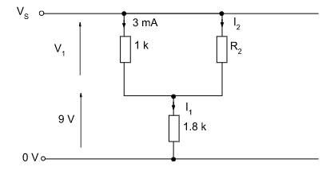
(a) V1
……………………………………………………………………………………………………………

……………………………………………………………………………………………………………

(b) VS
……………………………………………………………………………………………………………

……………………………………………………………………………………………………………

(c) I1
……………………………………………………………………………………………………………

……………………………………………………………………………………………………………

(d) I2
……………………………………………………………………………………………………………

……………………………………………………………………………………………………………

(e) R2
……………………………………………………………………………………………………………

……………………………………………………………………………………………………………

[6]

3. Use the information given in the circuit diagram, to determine the values of the quantities listed below.

V₁

R₁

R₂

1.2 k

I₁

3 V

9 V

0 V

0.5 mA

I₂

(a) I1

……………………………………………………………………………………………………………

……………………………………………………………………………………………………………

(b) V1
……………………………………………………………………………………………………………

……………………………………………………………………………………………………………

(c) R1
……………………………………………………………………………………………………………

……………………………………………………………………………………………………………

(d) I2
……………………………………………………………………………………………………………

……………………………………………………………………………………………………………

(e) R2
……………………………………………………………………………………………………………

……………………………………………………………………………………………………………

[6]

4. Use the information given in the circuit diagram, to determine the values of the quantities listed below.
(a) VS

V_{S}

0 V

3 mA

I₂

I₁

R₂

R₁

1 k

7.5 V

4.5 V

……………………………………………………………………………………………………………

……………………………………………………………………………………………………………

(b) R1
……………………………………………………………………………………………………………

……………………………………………………………………………………………………………

(c) I1
……………………………………………………………………………………………………………

……………………………………………………………………………………………………………

(d) I2
……………………………………………………………………………………………………………

……………………………………………………………………………………………………………

(e) R2
……………………………………………………………………………………………………………

……………………………………………………………………………………………………………

(f) What is the effective resistance of R1 and R2 in parallel.

……………………………………………………………………………………………………………

……………………………………………………………………………………………………………

[7]

5. Determine the values of V1, R1, I2, I3 and R3 in the following circuit. Hence determine the power dissipated in the 15kΩ resistor.

V₁

3 V

R₁

15 k

R₃

0.5 mA

12 V

0 V

I₂

I₃

(a) V1
……………………………………………………………………………………………………………

……………………………………………………………………………………………………………

(b) R1
……………………………………………………………………………………………………………

……………………………………………………………………………………………………………

(c) I2
……………………………………………………………………………………………………………

……………………………………………………………………………………………………………

(d) I3
……………………………………………………………………………………………………………

……………………………………………………………………………………………………………

(e) R3
……………………………………………………………………………………………………………

……………………………………………………………………………………………………………

(f) What is the power dissipated in the 15kΩ resistor.

……………………………………………………………………………………………………………

……………………………………………………………………………………………………………

[7]

6. Determine the values of V1, I1, I2, R1, and R2 in the following circuit.

7.5 V

0 V

0.2 mA

I₂

I₁

R₂

R₁

10 k

V₁

3 V

(a) V1
……………………………………………………………………………………………………………

……………………………………………………………………………………………………………

(b) I1
……………………………………………………………………………………………………………

……………………………………………………………………………………………………………

(c) I2
……………………………………………………………………………………………………………

……………………………………………………………………………………………………………

(d) R1
……………………………………………………………………………………………………………

……………………………………………………………………………………………………………

(e) R2
……………………………………………………………………………………………………………

……………………………………………………………………………………………………………

(f) What is the effective resistance of R1 and R2 in parallel?

……………………………………………………………………………………………………………

……………………………………………………………………………………………………………

[7]

7. Determine the values of R1, V1, I1, I2 and R2 in the following circuit.

16 V

0 V

I₁

I₂

2 mA

R₂

8.2 k

R₁

7.8 V

V₁

(a) R1
……………………………………………………………………………………………………………

……………………………………………………………………………………………………………

(b) V1
……………………………………………………………………………………………………………

……………………………………………………………………………………………………………

(c) I1
……………………………………………………………………………………………………………

……………………………………………………………………………………………………………

(d) I2
……………………………………………………………………………………………………………

……………………………………………………………………………………………………………

(e) R2
……………………………………………………………………………………………………………

……………………………………………………………………………………………………………

(f) What is the effective resistance of R1 and R2 in parallel?

……………………………………………………………………………………………………………

……………………………………………………………………………………………………………

[7]

8. Determine the values of R1, V1, I1, I2 and R2 in the following circuit.

15 V

0 V

I₂

I₁

5 mA

R₂

3 k

R₁

9 V

V₁

(a) R1
……………………………………………………………………………………………………………

……………………………………………………………………………………………………………

(b) V1
……………………………………………………………………………………………………………

……………………………………………………………………………………………………………

(c) I1
……………………………………………………………………………………………………………

……………………………………………………………………………………………………………

(d) I2
……………………………………………………………………………………………………………

……………………………………………………………………………………………………………

(e) R2
……………………………………………………………………………………………………………

……………………………………………………………………………………………………………

(f) What is the power dissipated in R1?

……………………………………………………………………………………………………………

……………………………………………………………………………………………………………

[7]

Exercise 6
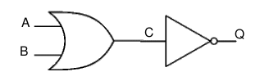
1. The figure below shows a logic circuit and its incomplete truth table. Complete the below truth table.

A | B | C | Q
0 | 0
0 | 1
1 | 0
1 | 1

2. The figure below shows a logic circuit and its incomplete truth table. Complete the below truth table.
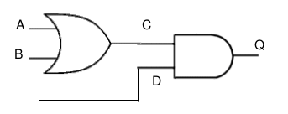
A | B | C | D | Q
0 | 0
0 | 1
1 | 0
1 | 1

3. The figure below shows a logic circuit and its incomplete truth table. Complete the below truth table.
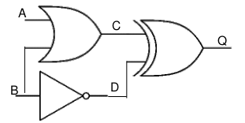
A | B | C | D | Q
0 | 0
0 | 1
1 | 0
1 | 1

4. For the logic circuit below complete the truth table.
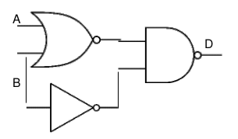
A | B |  |  | Q
0 | 0
0 | 1
1 | 0
1 | 1

Exercise 7
1. The table below shows the truth table for a three-input logic system.
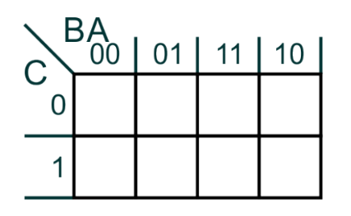
Inputs |  |  | Out
C | B | A | Q
0 | 0 | 0 | 1
0 | 0 | 1 | 1
0 | 1 | 0 | 0
0 | 1 | 1 | 1
1 | 0 | 0 | 0
1 | 0 | 1 | 1
1 | 1 | 0 | 0
1 | 1 | 1 | 0

Complete the following Karnaugh map, using the truth table.

Use your Karnaugh map to create a simplified boolean expression for this logic system.

Draw this logic system in the space below using standard logic gates.

2. The truth table for a four-input logic system is shown below.

Inputs |  |  |  | Out
D | C | B | A | Q
0 | 0 | 0 | 0 | 0
0 | 0 | 0 | 1 | 0
0 | 0 | 1 | 0 | 0
0 | 0 | 1 | 1 | 0
0 | 1 | 0 | 0 | 0
0 | 1 | 0 | 1 | 1
0 | 1 | 1 | 0 | 0
0 | 1 | 1 | 1 | 1
1 | 0 | 0 | 0 | 0
1 | 0 | 0 | 1 | 0
1 | 0 | 1 | 0 | 0
1 | 0 | 1 | 1 | 0
1 | 1 | 0 | 0 | 0
1 | 1 | 0 | 1 | 1
1 | 1 | 1 | 0 | 0
1 | 1 | 1 | 1 | 1

Fill out the Karnaugh map for this truth system, and derive a simplified boolean expression.

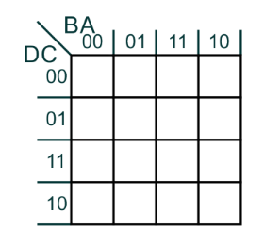

3. The truth table for a four-input logic system is shown below.

Inputs |  |  |  | Out
D | C | B | A | Q
0 | 0 | 0 | 0 | 0
0 | 0 | 0 | 1 | 0
0 | 0 | 1 | 0 | 0
0 | 0 | 1 | 1 | 0
0 | 1 | 0 | 0 | 0
0 | 1 | 0 | 1 | 0
0 | 1 | 1 | 0 | 0
0 | 1 | 1 | 1 | 0
1 | 0 | 0 | 0 | 0
1 | 0 | 0 | 1 | 0
1 | 0 | 1 | 0 | 0
1 | 0 | 1 | 1 | 0
1 | 1 | 0 | 0 | 1
1 | 1 | 0 | 1 | 1
1 | 1 | 1 | 0 | 1
1 | 1 | 1 | 1 | 1

Fill out the Karnaugh map for this truth system, and derive a simplified boolean expression.

Exercise 8
1. Redraw the following logic system using two-input NAND gates only. Identify any redundant gates.

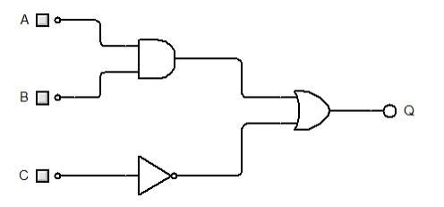

2. Redraw the following logic system using two-input NAND gates only. Identify any redundant gates.

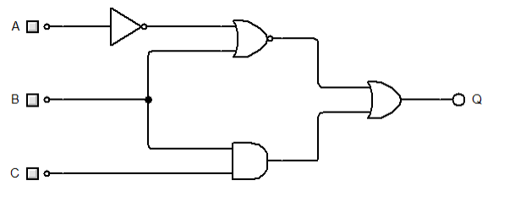

Exercise 9
1. A multiplexer can be used to perform logic functions.

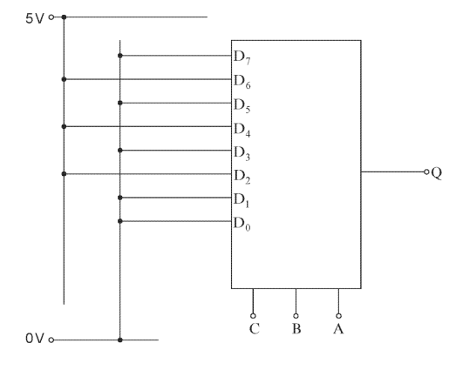
Fill in the truth table for the multiplexer above.

Inputs |  |  | Output
C | B | A | Q
0 | 0 | 0
0 | 0 | 1
0 | 1 | 0
0 | 1 | 1
1 | 0 | 0
1 | 0 | 1
1 | 1 | 0
1 | 1 | 1

Use the table to write the unsimplified boolean expression for Q in terms of C,B and A.

2. The truth table for a logic system is given below.

Inputs |  |  | Out
C | B | A | Q
0 | 0 | 0 | 0
0 | 0 | 1 | 0
0 | 1 | 0 | 1
0 | 1 | 1 | 0
1 | 0 | 0 | 0
1 | 0 | 1 | 1
1 | 1 | 0 | 1
1 | 1 | 1 | 1
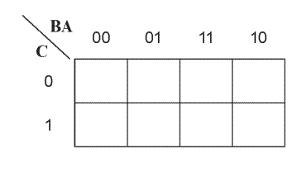
Use the Karnaugh map to determine the simplest boolean expression for output Q.

Show how the output Q could be generated using a multiplexer.

