A-level Electronics
Homework Booklet V
Topic 206 Audio Systems, Topic 207 Instrumentation Systems, Topic 208 High Power Switching Systems


Name ………………………………………………………………………………………………

Group ………………………………………………………………………………………………

Teacher ……………………………………………………………………………………………

Exercise 1
The graph shows the frequency response needed for a filter:

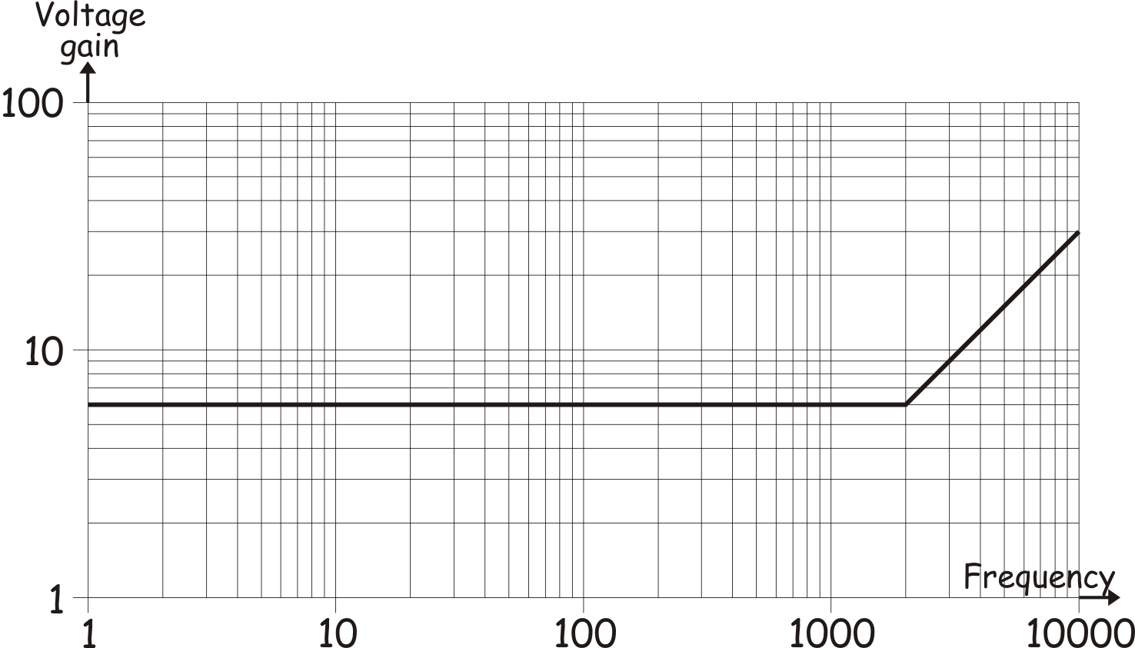

Design a filter circuit which has this frequency response, using an op-amp, two resistors and a 3.3 nF capacitor. Draw the circuit diagram for your filter.

Calculate suitable values for the resistors, showing how you obtain your results.

Exercise 2
(a) In terms of voltage gain, what is the difference between the performance of an active filter and a passive filter? [1]

……………………………………………………………………………………………………..

……………………………………………………………………………………………………..

(b) Identify the following types of active filter. [2]
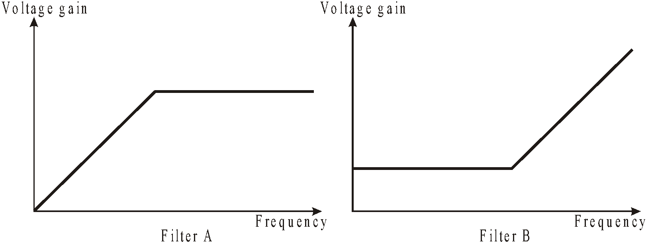

Filter A = ………………………………………………
Filter B = ………………………………………………
(c) An audio communications system uses a low-pass filter with the following frequency response:
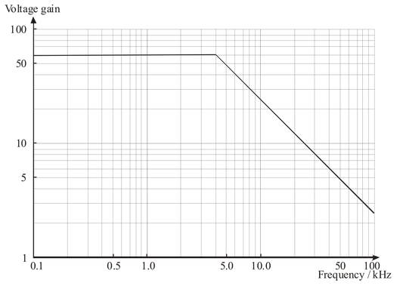
(i) What is the break frequency for this filter? [1]
Break frequency = ………………………………………………
(ii) Draw the circuit diagram for a filter which has a frequency response of this type, based on a single op-amp. [3]

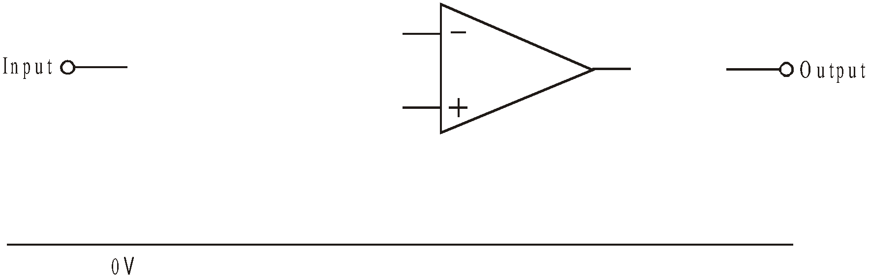
(d) Another low pass active filter has a voltage gain of 40 and a break frequency of 2kHz.
[2]
The following resistors are available.
10Ω 50Ω 400Ω 2kΩ 10kΩ 80kΩ 4MΩ

(i) Select the one pair of resistors that is most suitable to give the specified voltage gain.
[2]
Resistor 1 …………….………….
Resistor 2 …………….………….

(ii) Calculate the value of capacitor required. [2]

……………………………………………………………………………………………………..

……………………………………………………………………………………………………..

……………………………………………………………………………………………………..

……………………………………………………………………………………………………..

Exercise 3
1. Here is the block diagram for a public address system.

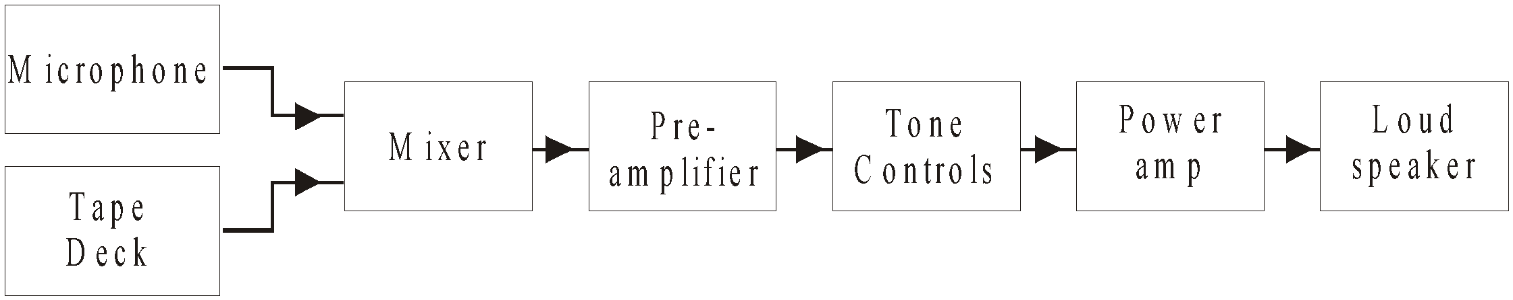

(a) Part of the specification for the mixer is given below.

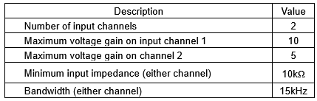

(i) Complete the following circuit diagram for the mixer. [4]

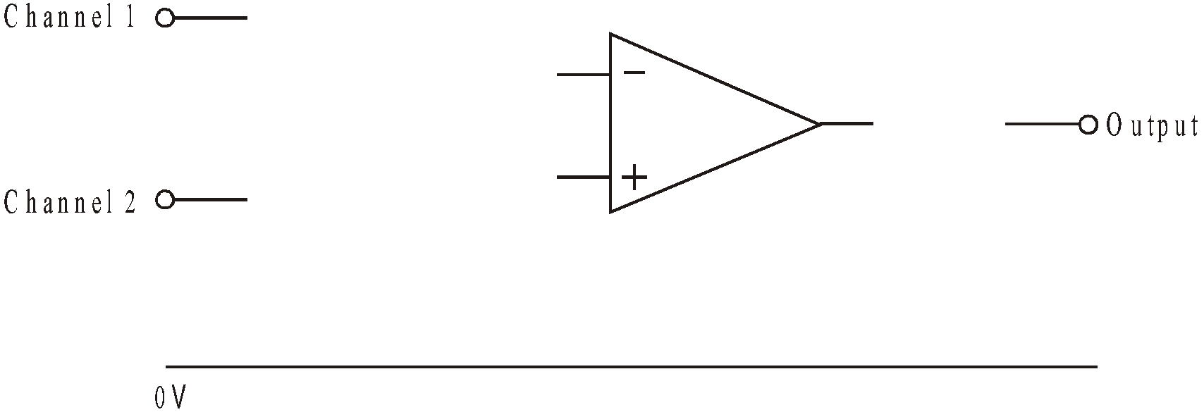

(ii) Calculate suitable values for the fixed resistors used in the circuit. [3]

……………………………………………………………………………………………………..

……………………………………………………………………………………………………..

……………………………………………………………………………………………………..

……………………………………………………………………………………………………..

……………………………………………………………………………………………………..

(b) The pre-amplifier is a 2-stage non-inverting amplifier with a gain of 900.

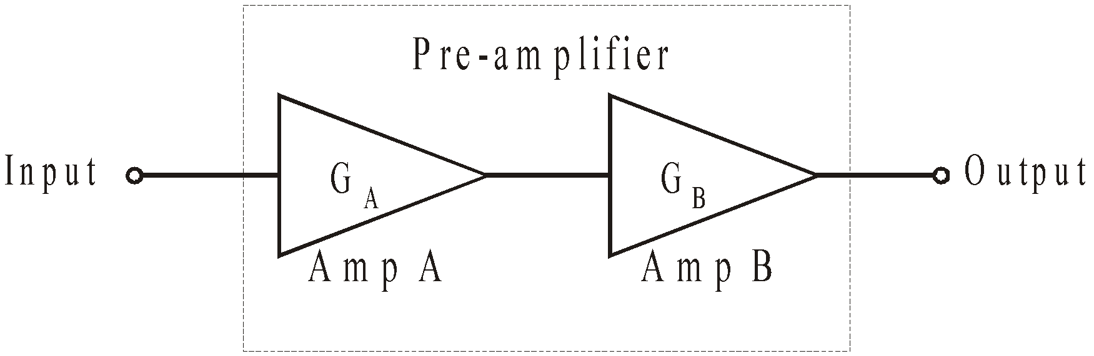

(i) In order to optimise the bandwidth of the pre-amp, what is the gain of

Amplifier A, GA; ………………………………..

Amplifier B, GB; ……………………………….. [2]

(ii) The table gives some data on the op-amps used in the circuits for amplifiers A and B.

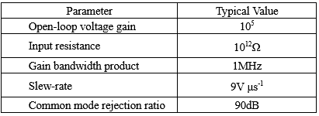
What is the resulting bandwidth of the pre-amplifier? [1]

……………………………………………………………………………………………………..

……………………………………………………………………………………………………..

(c) Part of the tone control circuit is shown below.

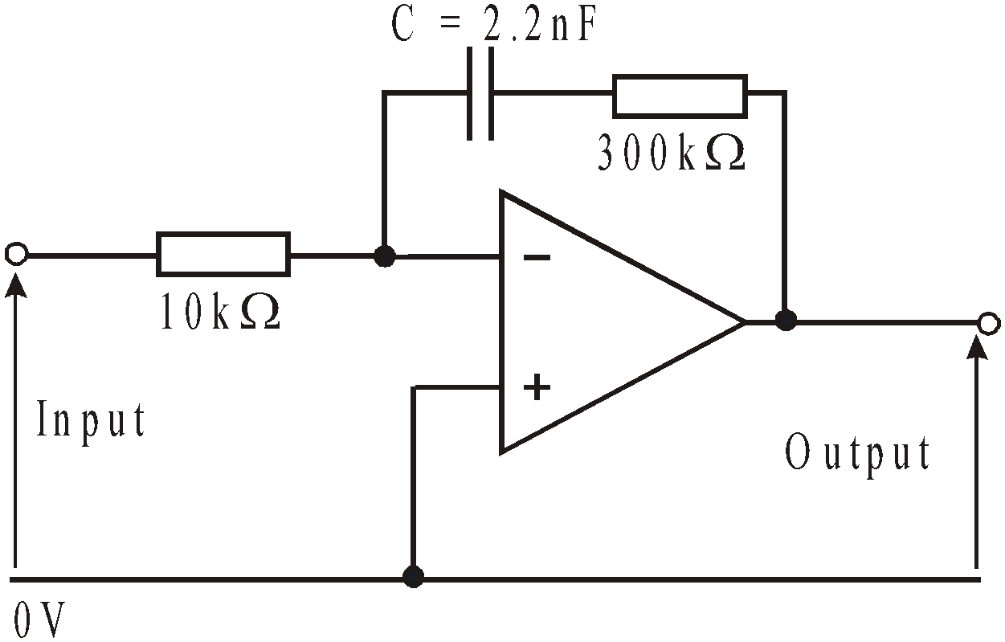

(i) What type of filter is this? [1] ……………………………………………………………………………………………………..

(ii) Calculate the break frequency of this filter [3]

……………………………………………………………………………………………………..

……………………………………………………………………………………………………..

……………………………………………………………………………………………………..

(iii) Calculate the voltage gain of the filter at frequencies well above the break frequency. [1]

……………………………………………………………………………………………………..

……………………………………………………………………………………………………..

(iv) Use the axes provided to sketch the frequency response of this filter. [3]

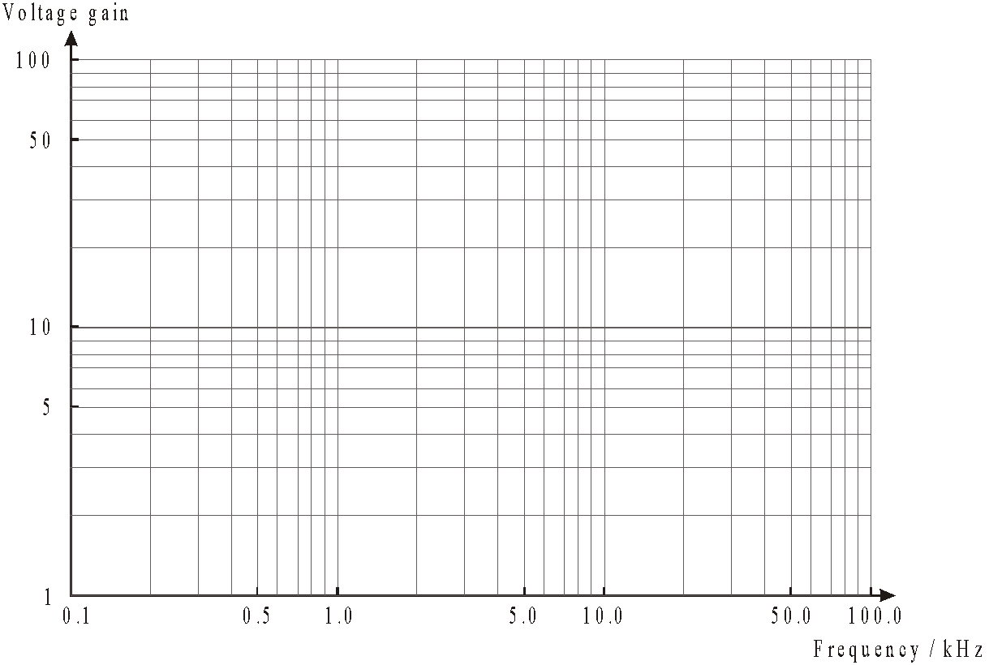

2. An audio system requires a treble-cut filter, having a low frequency voltage gain of 20 and a break frequency of 800Hz.

(a) Sketch the frequency response of the filter using the axes provided. [3]
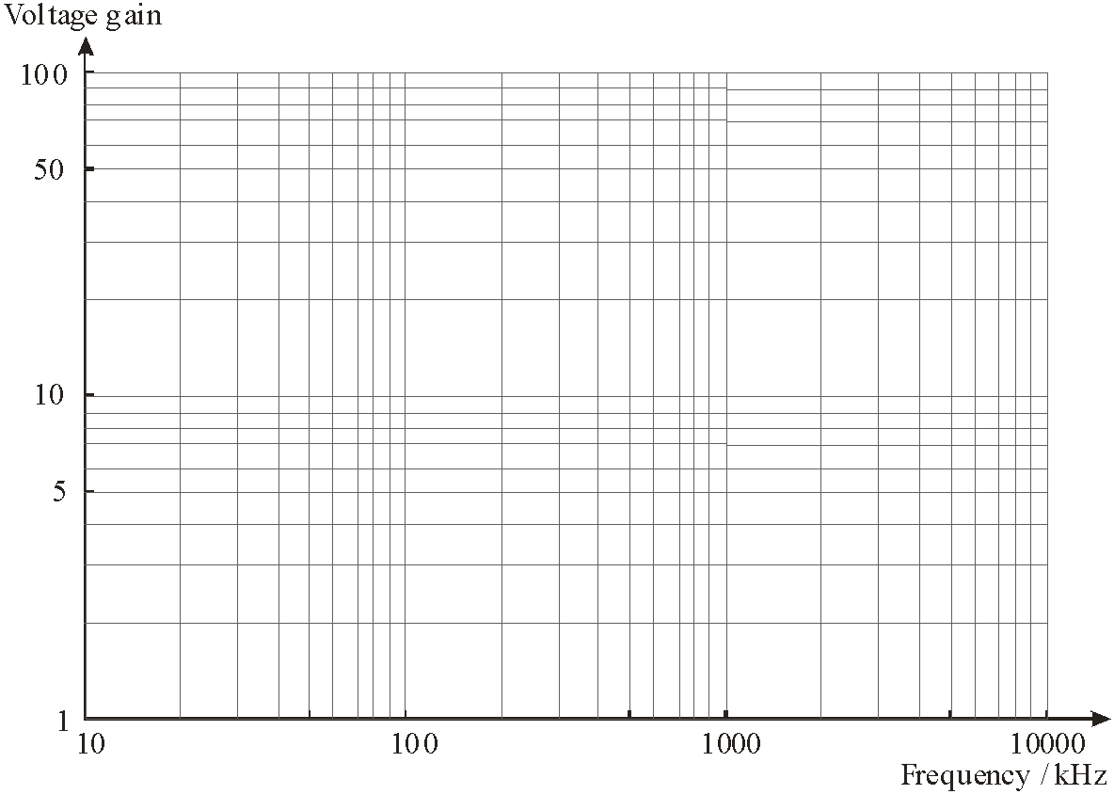
(b) A passive filter circuit would be unsuitable for this application. Why? [1]

……………………………………………………………………………………………………………..

(c) Draw the circuit diagram for an active treble-cut filter, based on an op-amp. [3]

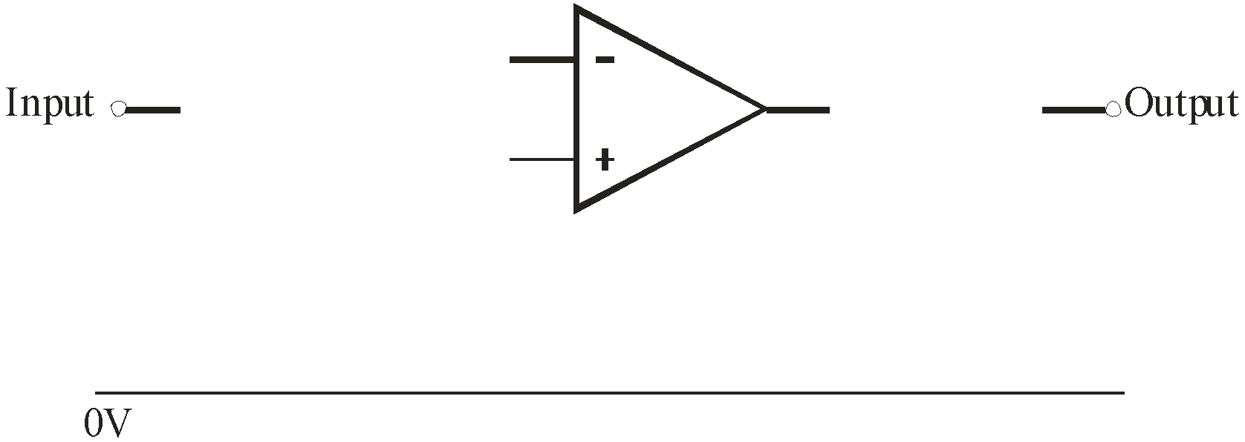

(d) The circuit includes a 10 nF capacitor. Calculate the ideal values for any resistors used in the circuit. [2]

……………………………………………………………………………………………………..

……………………………………………………………………………………………………..

Exercise 4
The block diagram for a simple public address system is shown below.



Extracts from the data sheets for the microphone and loudspeaker given in the table.
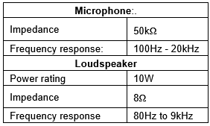
(a) (i) What is the ideal value of the input impedance of the preamplifier required to maximise transfer of the voltage signal from the microphone? [1]

……………………………………………………………………………………………………..

……………………………………………………………………………………………………..

(ii) What is the ideal value of the output impedance of the power amplifier required to maximise power transfer of the signal from the output of the power amplifier to the loudspeaker?
[1]
……………………………………………………………………………………………………..

……………………………………………………………………………………………………..

(b) The power amplifier uses the emitter follower circuit shown below.

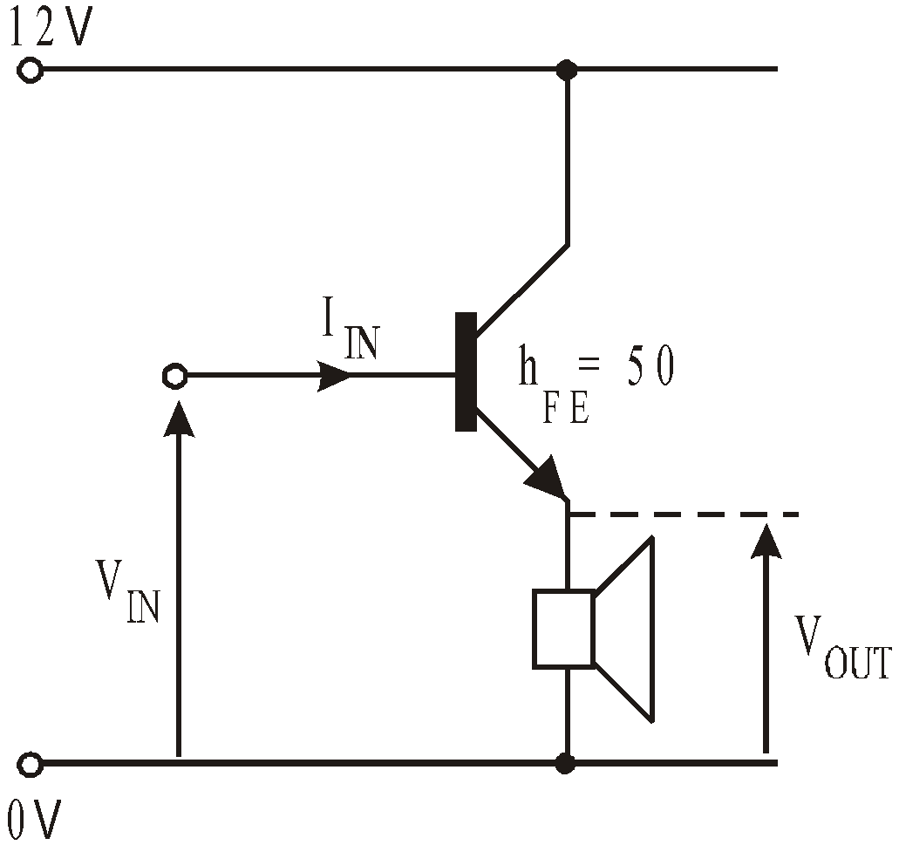
A student tests this by applying a DC input voltage, VIN , of +3.0V.

(i) Calculate the expected value of VOUT? [1]

……………………………………………………………………………………………………..

……………………………………………………………………………………………………..

(ii) What is the voltage drop across the transistor? [1]

……………………………………………………………………………………………………..

……………………………………………………………………………………………………..

The student measures a DC current of 0.4A flows through the loudspeaker.

(iii) What is the power dissipated in the transistor when VIN = +3.0V? ………………… [1]

(iv) Estimate the corresponding current IIN, and show how you obtain your value. [2]

……………………………………………………………………………………………………..

……………………………………………………………………………………………………..

……………………………………………………………………………………………………..

(c) (i) An improved power amplifier uses a push-pull follower circuit. Complete the circuit diagram for the push-pull follower. [3]

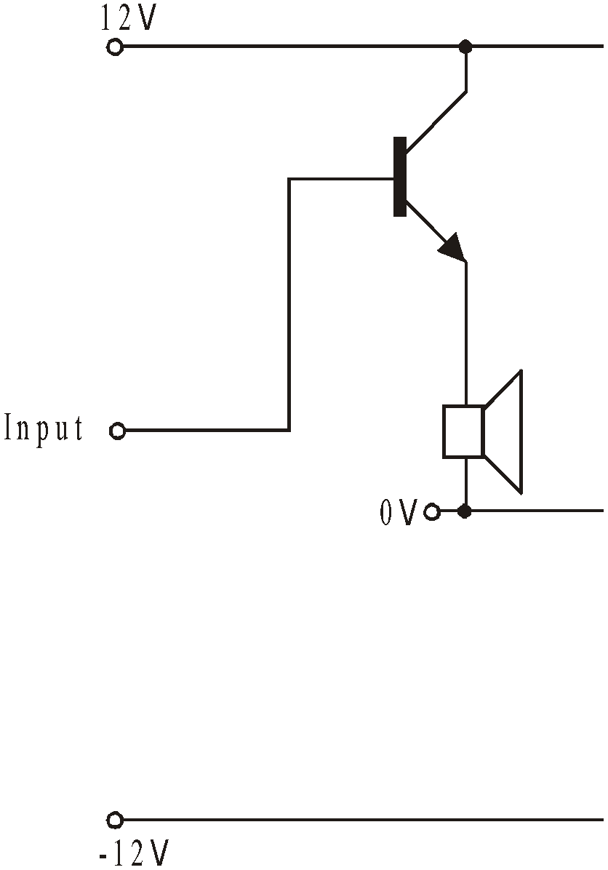

(ii) Give one advantage of the circuit over the emitter follower power amplifier. [1]

……………………………………………………………………………………………………..

……………………………………………………………………………………………………..

(d) (i) Push-pull followers can cause crossover distortion. Illustrate the meaning of cross-over distortion by drawing an output signal which exhibits it. An undistorted output signal is shown to assist you. [1]

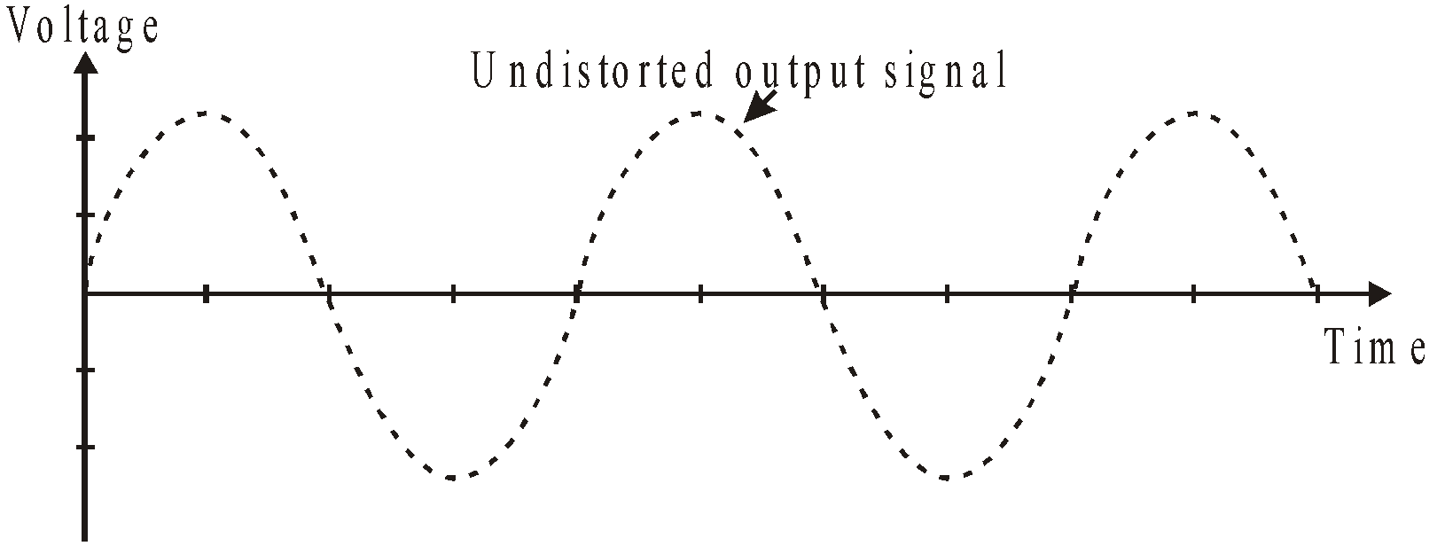

(ii) Explain what causes crossover distortion in a push-pull amplifier. [1]

……………………………………………………………………………………………………..

……………………………………………………………………………………………………..

……………………………………………………………………………………………………..

Exercise 5
(a) The circuit diagram shows a summing amplifier with two inputs, A, and B.

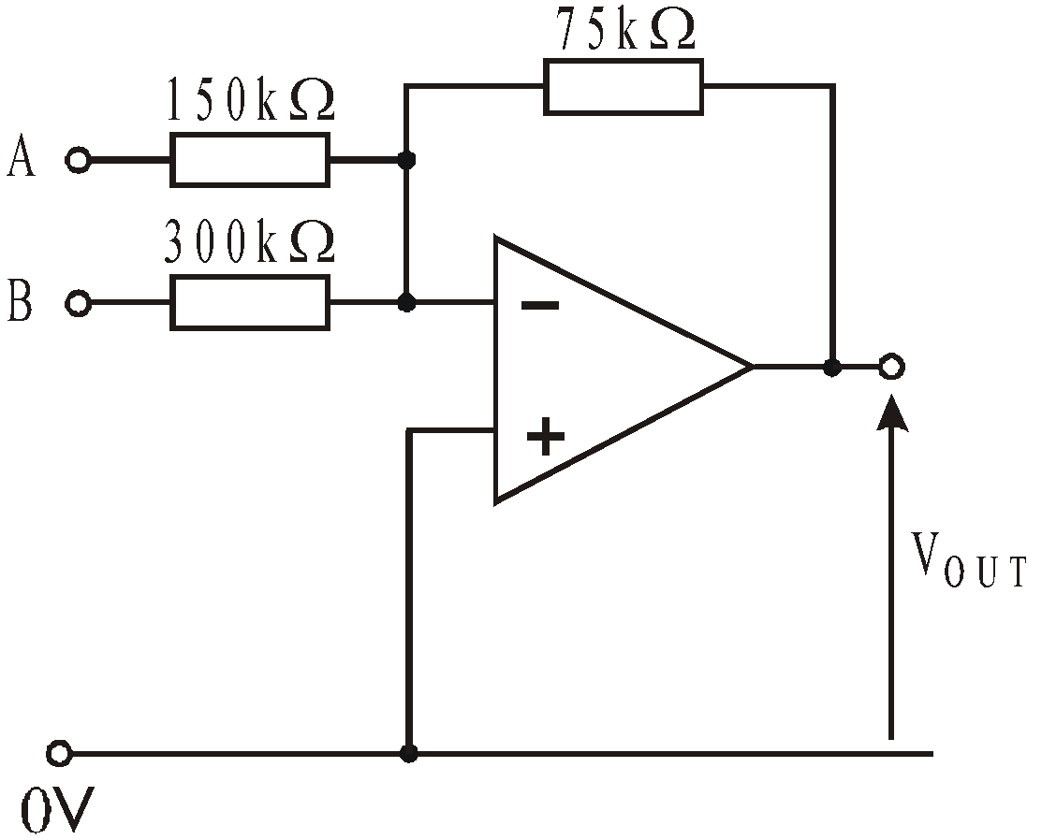
(i) The following input voltages are applied:
VA = 1.8V VB = 2.0V
Calculate the output voltage VOUT. [2]

……………………………………………………………………………………………………..

……………………………………………………………………………………………………..

(ii) The summing amplifier is now provided with new input signals. A sinusoidal input voltage is applied to input A and a steady negative voltage applied to input B. These signals are shown in the following graphs.
Use the axes provided to sketch the resulting output signal VOUT. [3]

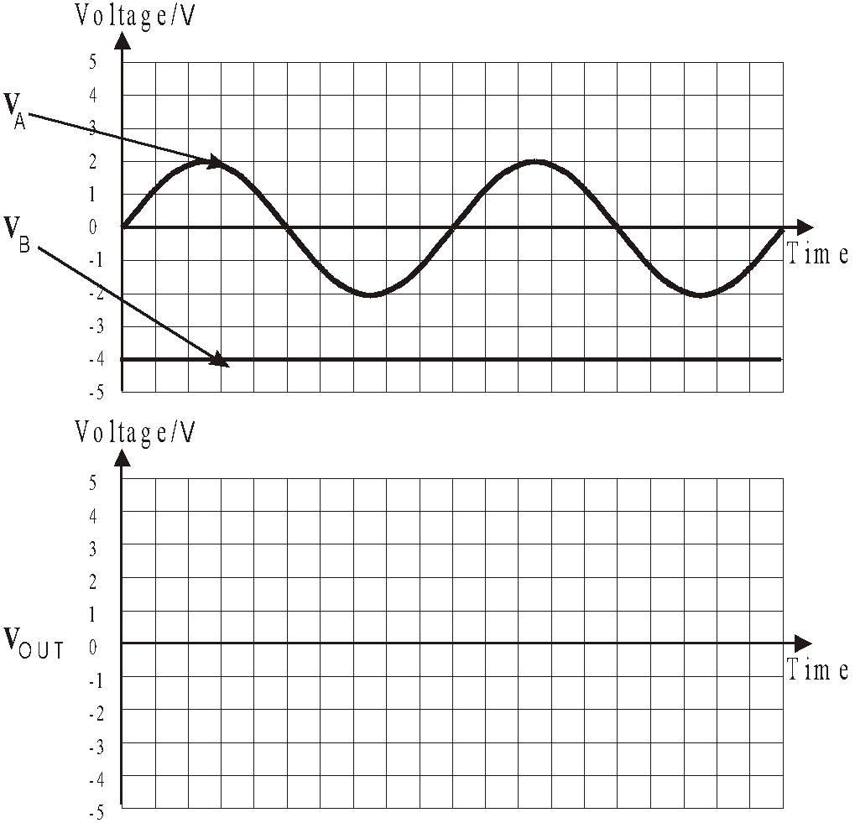

(b) The summing amplifier is modified to make a mixer for an audio system.

The 75kΩ feedback resistor is retained.

The specification for the system states that both inputs must have a voltage gain that is variable from a minimum of 0.1 to a maximum of 1.0.

Complete the circuit diagram for the mixer, and calculate suitable ideal values for all components. [4]

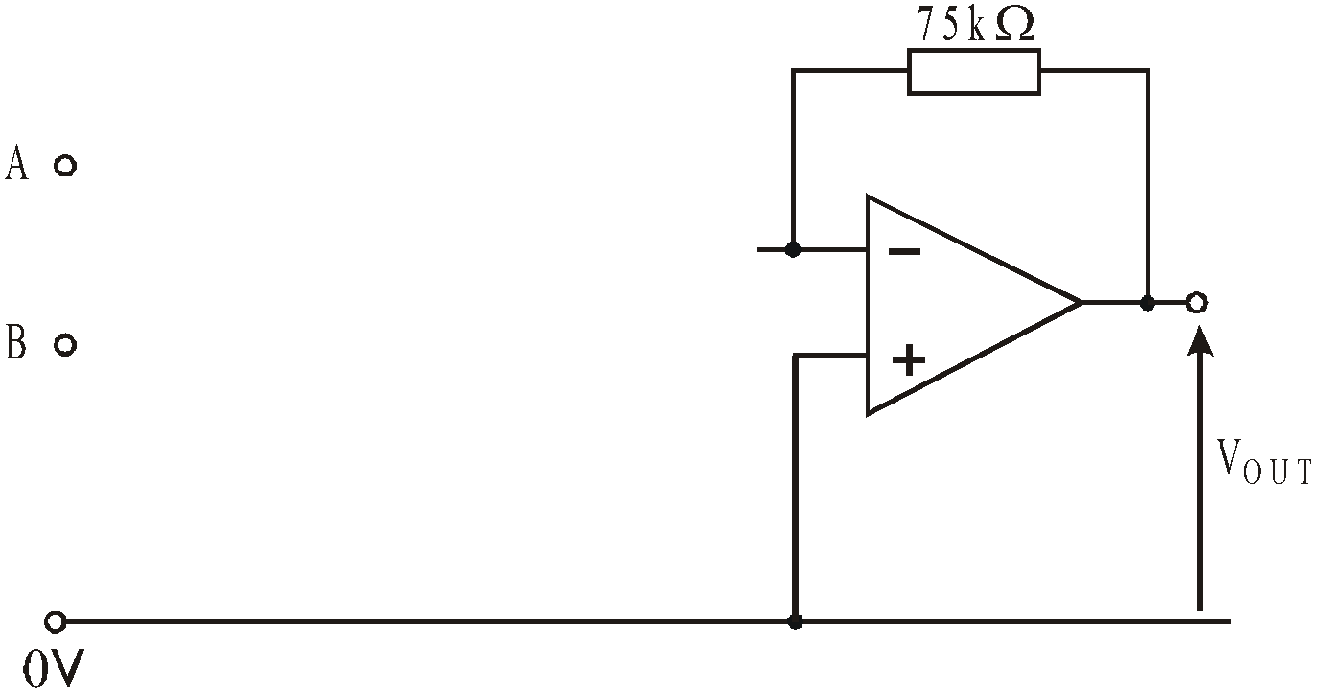

……………………………………………………………………………………………………..

……………………………………………………………………………………………………..

……………………………………………………………………………………………………..

……………………………………………………………………………………………………..

……………………………………………………………………………………………………..

……………………………………………………………………………………………………..

Exercise 6
1. (a) A difference amplifier is used to control a fan to keep the temperature constant throughout a pottery kiln. Two temperature sensors provide information about the temperature at the top and the bottom of the kiln.

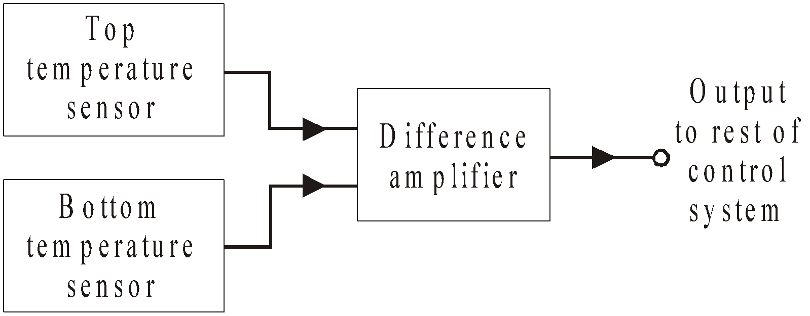
(i) Each temperature sensor consists of a voltage divider, using a ntc thermistor and variable resistor.

Draw the circuit diagram for a temperature sensor, designed to give an output voltage that increases as the temperature increases. [1]

(ii) The circuit diagram for the difference amplifier is given below.
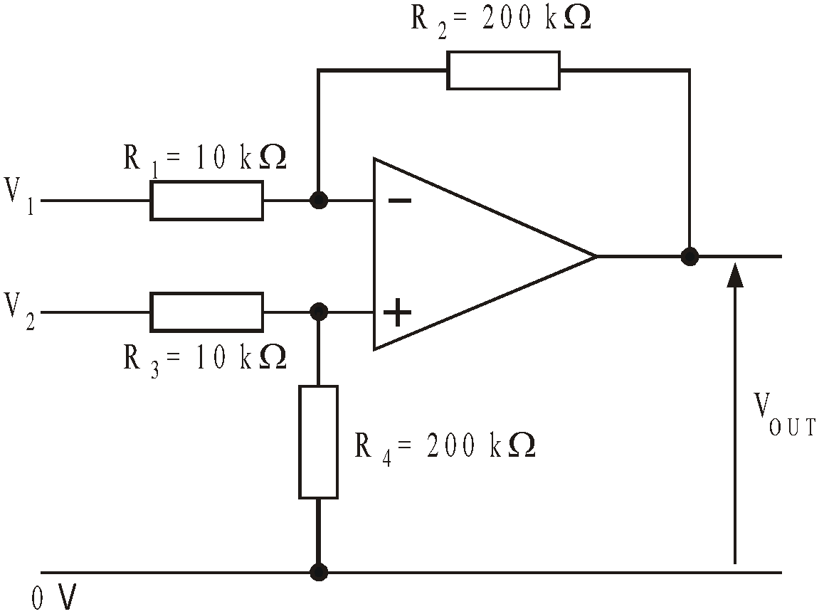
The Top temperature sensor output voltage, V1 = 2.4V.
The Bottom temperature sensor output voltage, V1 = 2.1V.
Calculate the output voltage VOUT of the difference amplifier. [1]

……………………………………………………………………………………………………..

……………………………………………………………………………………………………..
(b) The difference amplifier is used to amplify the output of a bridge circuit containing a strain gauge S, two equal resistors, R, and a variable resistor VR.

(i) Complete the following circuit diagram, to show how this is done. [3]

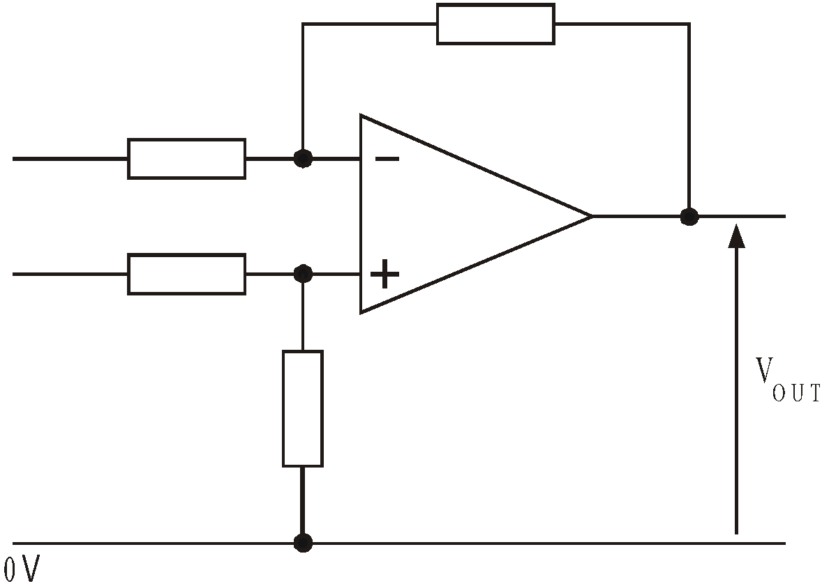

(ii) What is the advantage of this arrangement over a simple voltage divider and amplifier. [2]

……………………………………………………………………………………………………..

……………………………………………………………………………………………………..

(iii) It is important that the op-amp in this circuit has a very high input impedance and common mode rejection ratio.

Explain why a high value is important for these two quantities. [2]

……………………………………………………………………………………………………..

……………………………………………………………………………………………………..

…………………………………………………………………………………………………..

……………………………………………………………………………………………………..

……………………………………………………………………………………………………..

……………………………………………………………………………………………………..

2. The circuit diagram shows two identical strain gauges connected to precision 100Ω resistors in a bridge circuit.

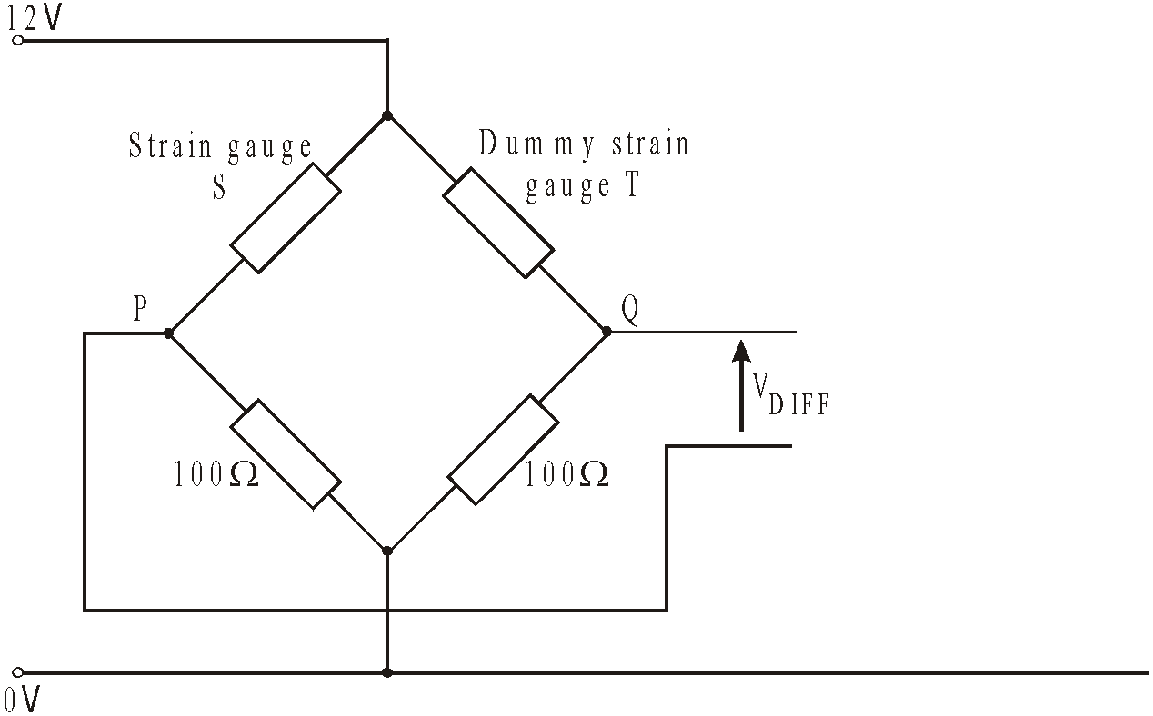
Under test conditions, the strain gauge, S, is found to have a resistance of exactly 100.5Ω, while the dummy strain gauge, T, has a resistance of exactly 100Ω.
(a) Calculate the voltages at points P and Q, and hence work out the voltage VDIFF. [2]
……………………………………………………………………………………………………..

……………………………………………………………………………………………………..

……………………………………………………………………………………………………..

(b) Modify the circuit diagram by adding a difference amplifier based on an op-amp, arranged to amplify the voltage VDIFF. [3]
(c) Choose suitable values of resistors to give a voltage gain of 100. Label the resistors with these values. [3]
……………………………………………………………………………………………………..

……………………………………………………………………………………………………..

……………………………………………………………………………………………………..

(d) Calculate the output voltage of the system under these test conditions. [1]
……………………………………………………………………………………………………..

……………………………………………………………………………………………………..
(e) What is the purpose of the dummy strain gauge, in this circuit? [1]
……………………………………………………………………………………………………..

……………………………………………………………………………………………………..

Exercise 7
- Here is a DC lamp switching circuit that uses capacitor commutation:

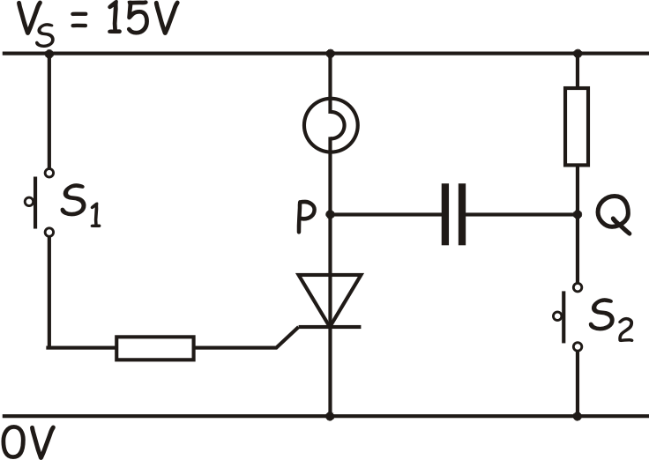
Complete the table to show the effect of the changes made to switches S1 and S2.

Action |  | State of  thyristor | Voltage at:
Switch S₁ | Switch S₂ | State of  thyristor | P | Q
Open | Open | Off | 15V | 15V
Closed | Open
Open | Open
Open | Closed
Open | Open

- The following circuit shows part of a car security alarm. S1 and S2 are microswitches attached to the front doors of the car. When either door is opened, the attached switch closes. The siren switches on, and stays on, if either switch closes.

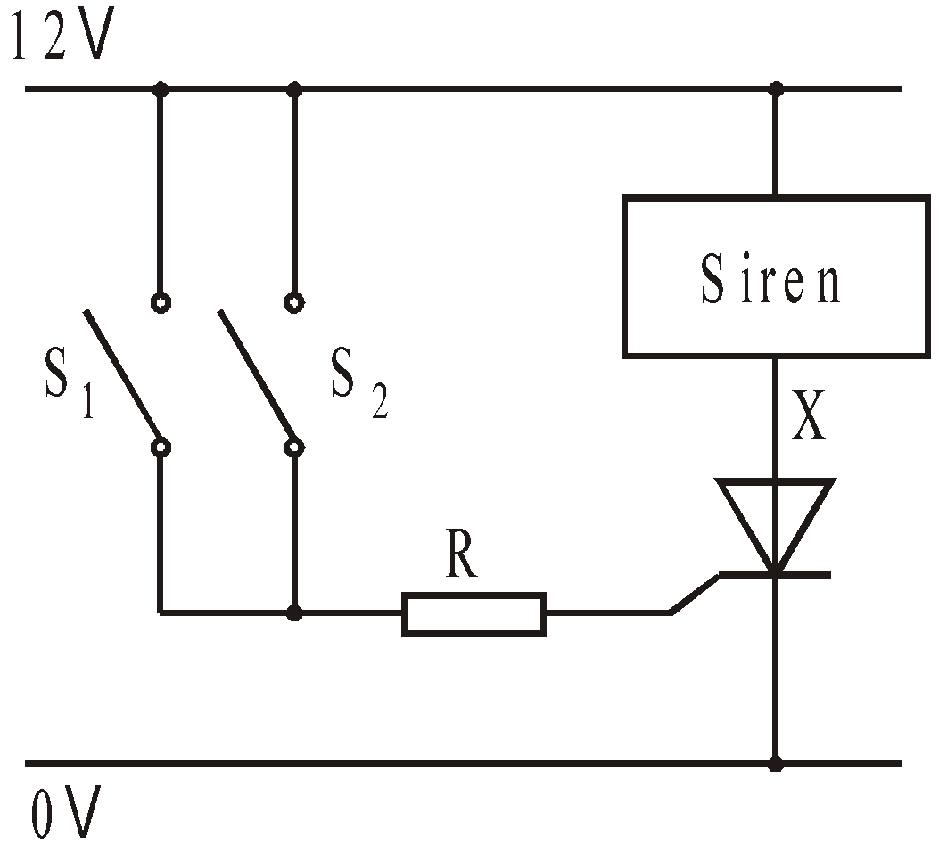

(a) The siren is switched off initially. What is the voltage at point X:

(i) before either switch is pressed; [1]

……………………………………………………………………………………………………..

(ii) after either switch is pressed? [1]

……………………………………………………………………………………………………..

(b) The table gives data for the thyristor used in this system.

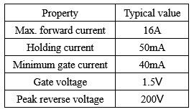

Using relevant data, calculate the maximum value which resistor R can have in this circuit. [2]

……………………………………………………………………………………………………..

……………………………………………………………………………………………………..

……………………………………………………………………………………………………..

……………………………………………………………………………………………………..

……………………………………………………………………………………………………..

……………………………………………………………………………………………………..

Exercise 8
- (a) In industrial control systems, high power electrical equipment, such as heaters and motors, used to be operated by relays, but are now usually controlled by a thyristor circuit.

Give one advantage of using a thyristor instead of a relay in these applications. [1]

……………………………………………………………………………………………………..

……………………………………………………………………………………………………..

(b) The following circuit is used to control the output of a heater.

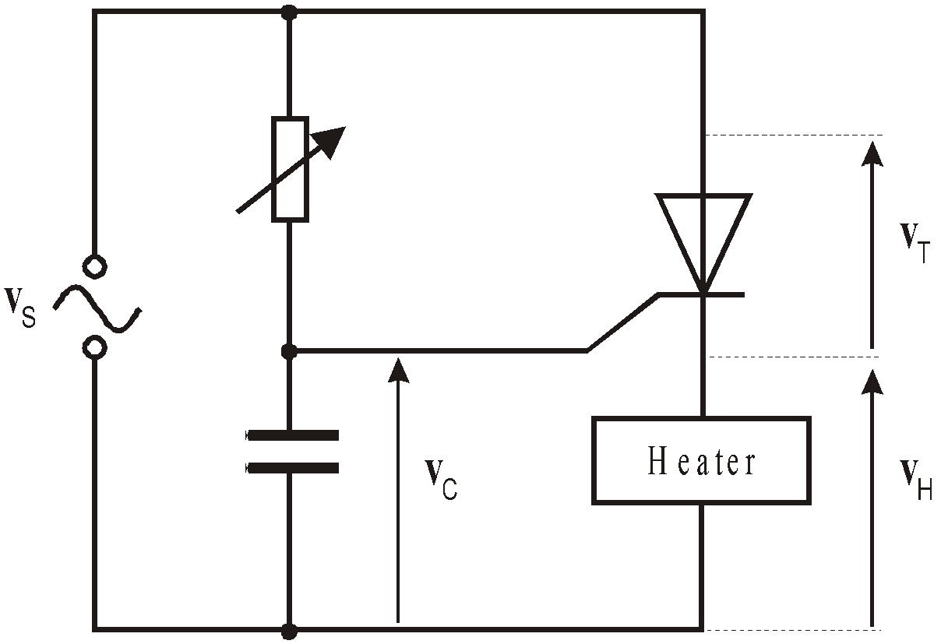
The thyristor fires when VC , the voltage across the capacitor, reaches the firing voltage shown on the graph.

Use the axes on the next page to draw graphs to illustrate the phase relationship between the supply voltage VS, VC , the voltage VT across the thyristor and the voltage VH across the heater.

An outline of the supply voltage waveform is provided to assist you. [5]

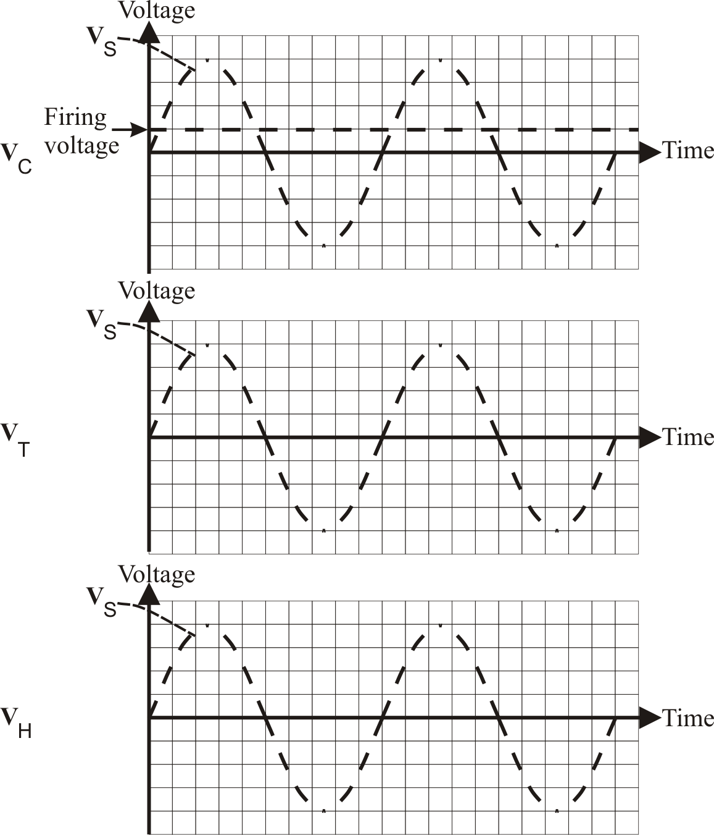

2) (a) State two conditions necessary to make a thyristor conduct. [2]

First condition ………………………………………………………………………………..

Second condition ……………………………………………………………………………..

(b) (i) The behaviour of a thyristor depends on the signal applied to the gate terminal and the voltage bias applied between its anode and cathode. The table lists various combinations of these conditions.

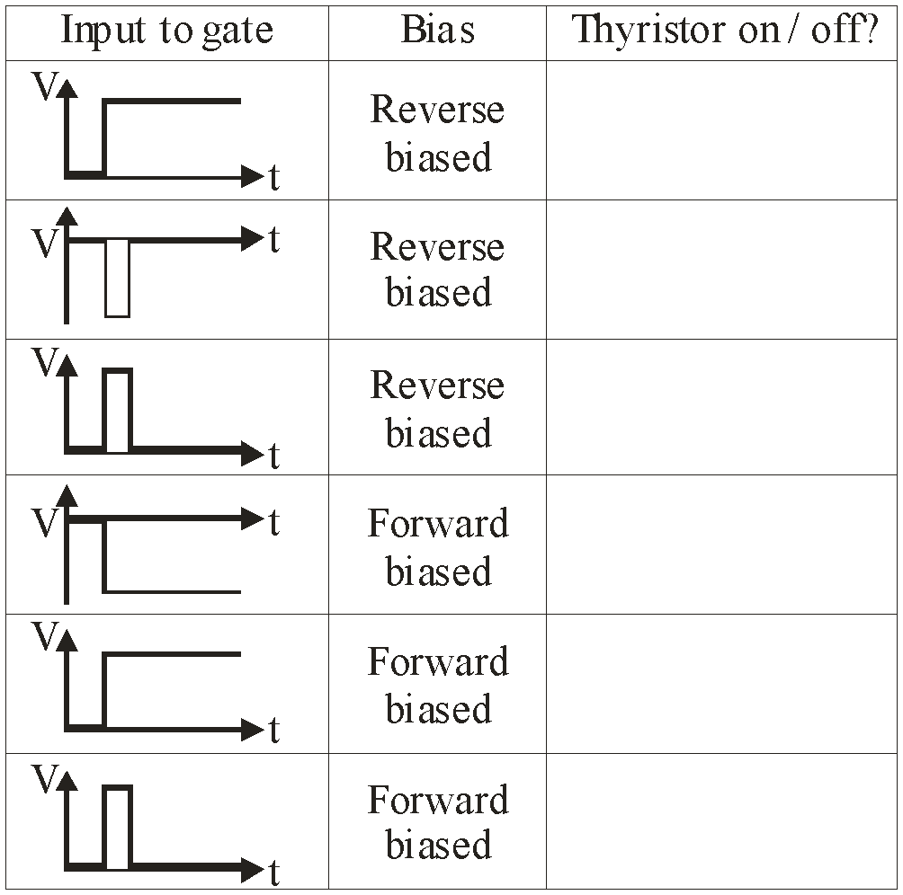

Complete the third column of the table to show whether the thyristor will be switched on or off
under each of the conditions shown. [3]

(ii) The diagram shows part of a circuit in which a thyristor is used to control a heater.

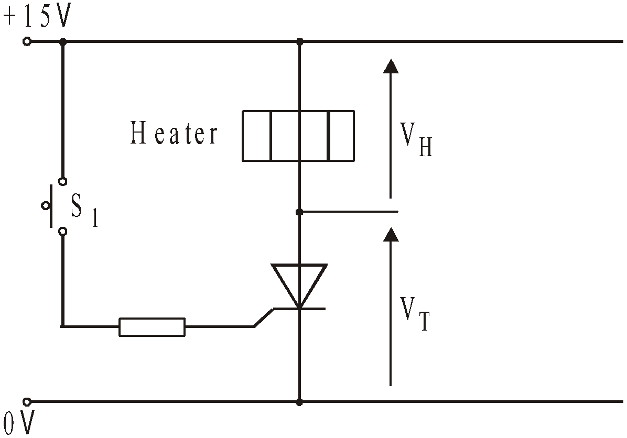
(i) Complete the table by adding the values of VH and VT when switch S1 is closed and
then re-opened. The thyristor is initially switched off. [3]
Switch S₁ | Voltage V_{T}  across thyristor | Voltage V_{H}  across heater
Initially off
Momentarily on
Switched off
(ii) Complete the circuit diagram by adding a switch S2 and other components
needed to turn off the thyristor using capacitor commutation. [3]

3) A thyristor is used to control the heat output of a heating element.
Part of the AC control circuit is shown in the next diagram.
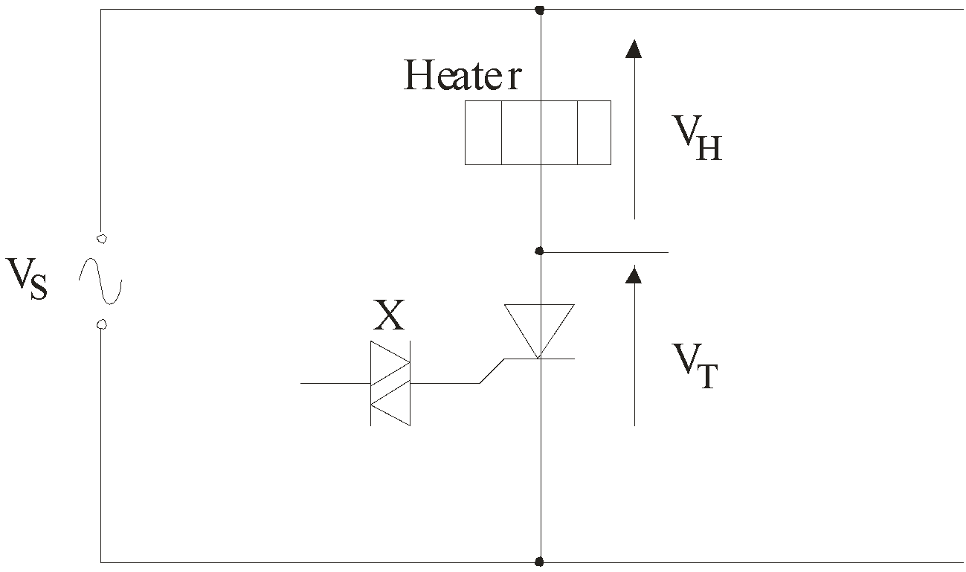
(i) What is the name of component X? ……………………………………………[1]
(ii) What is the function of component X in this circuit? [1]

……………………………………………………………………………………………………..

……………………………………………………………………………………………………..
(iii) Complete the circuit diagram by adding components to allow phase control of the thyristor. [2]
(iv) The upper graph shows the AC waveform VT across the thyristor when this phase control is in place. Use the axes provided to sketch the corresponding AC waveform VH across the heater. The supply voltage VS is shown as a dotted line. [2]
