A-level Electronics
Homework Booklet III
Topic 104 Operational Amplifiers, Topic 105 Semiconductor Devices, Topic 107 Mains Power Supplies

Name ………………………………………………………………………………………………

Group ………………………………………………………………………………………………

Teacher ……………………………………………………………………………………………

Exercise 1
1. The TL081 Op-amp has a GBP (gain-bandwidth product) of 4MHz, calculate the missing values in the table below for the TL081 amplifier.

Gain | Bandwidth
1
 | 40kHz
 | 400kHz
500
25

2. Here is some data about two op-amps, X and Y.

Property | X | Y
Input Impedance / Ω | 5 x 10⁹ | 4 x 10⁶
Open loop gain | 6 x 10⁵ | 1 x 10⁵
Max. output current /mA | 5 | 20
Gain bandwidth product / MHz | 3 | 0.6
Slew rate / Vs⁻¹ | 2.0 | 1.0
Max. output voltage / V | 16 | 5

Which amplifier would have a bandwidth of 6kHz when configured to have a gain of +500?

.........................................................................................................................................................

(ii) Give a reason for your answer:

.........................................................................................................................................................

Exercise 2
- The following circuit shows an inverting amplifier connected to a ±12V power supply.

390kΩ

13kΩ

+

-

V_{out}

V_{in}

0V

- What is the voltage gain of this amplifier?

.........................................................................................................................................................

.........................................................................................................................................................

.........................................................................................................................................................

- If Vin = 300mV, determine the value of Vout

.........................................................................................................................................................

.........................................................................................................................................................

.........................................................................................................................................................

- What is the input impedance of this amplifier?

.........................................................................................................................................................

.........................................................................................................................................................

.........................................................................................................................................................

.........................................................................................................................................................

.........................................................................................................................................................
- The graph below shows an alternating signal applied to Vin. On the axes below, sketch the graph of Vout. Label the graph with suitable values.

V_{in}/mV

300

225

150

75

0

-75

-150

-225

-300

V_{out}/V

0

2) An inverting amplifier is required to act as a preamplifier for an electric guitar pickup. The amplifier requires a gain of -400 and should have an input impedance of 2kΩ.

- Draw the circuit diagram for an inverting amplifier.

- Determine suitable resistors for Rin and Rf

.........................................................................................................................................................

.........................................................................................................................................................

.........................................................................................................................................................

.........................................................................................................................................................

.........................................................................................................................................................

Exercise 3
- The following circuit shows a non-inverting amplifier connected to a ±10V power supply. The input impedance of the amplifier is 20MΩ.

R_{f} = 68kΩ

R₁= 2kΩ

+

-

V_{out}

V_{in}

0V

+V

-V

- What is the voltage gain of this amplifier?

.........................................................................................................................................................

.........................................................................................................................................................

.........................................................................................................................................................

- If Vin = 75mV, determine the value of Vout.

.........................................................................................................................................................

.........................................................................................................................................................

.........................................................................................................................................................

- What is the input impedance of this amplifier?

.........................................................................................................................................................

.........................................................................................................................................................

.........................................................................................................................................................

- The graph below shows an alternating signal applied to Vin. On the axes below, sketch the graph of Vout. Add suitable labels to the axis.

V_{in}/mV

100

75

50

25

0

-25

-50

-75

-100

V_{out}/mV

0

2) A non-inverting amplifier is required to act as a preamplifier for a microphone in a public address system. The amplifier requires a gain of +40.

- Draw the circuit diagram for a non-inverting amplifier.

- Determine suitable resistors for R1 and Rf.

.........................................................................................................................................................

.........................................................................................................................................................

.........................................................................................................................................................

.........................................................................................................................................................

.........................................................................................................................................................

.........................................................................................................................................................

Exercise 4
- A green l.e.d. is to be used as an indicator on a 555 astable. If the output voltage from the 555 timer is 5V, and the forward voltage drop of the l.e.d. is 2.2V, calculate the series resistance required from the E24 series to limit the current to a maximum of 15mA.

.........................................................................................................................................................

.........................................................................................................................................................

.........................................................................................................................................................

.........................................................................................................................................................

.........................................................................................................................................................

.........................................................................................................................................................

- The following table gives an extract from the data sheet for an l.e.d.

IF(MAX) | 20mA
VF(MAX) | 2.5V
VR(MAX) | 5V

Use the information in the table to calculate the minimum value of the series resistor which will protect the LED when used as an indicator on a 9V DC power supply.

.........................................................................................................................................................

.........................................................................................................................................................

.........................................................................................................................................................

.........................................................................................................................................................

.........................................................................................................................................................

.........................................................................................................................................................

- The following diagram shows an astable built with a 555 timer used to clock a l.e.d

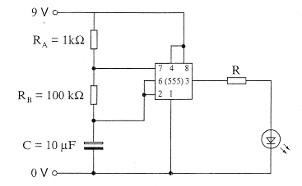
A data sheet for the 555 astable gives the following information

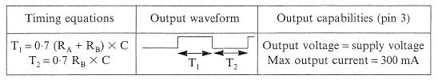
Determine the value of the series resistor R required to limit the current through the l.e.d. To 20mA. Assume the forward voltage drop across the LED is 2V.

.........................................................................................................................................................

.........................................................................................................................................................

.........................................................................................................................................................

.........................................................................................................................................................

.........................................................................................................................................................

.........................................................................................................................................................

Exercise 5
- The transistor shown in the following switching circuit has a current gain, hFE = 120.

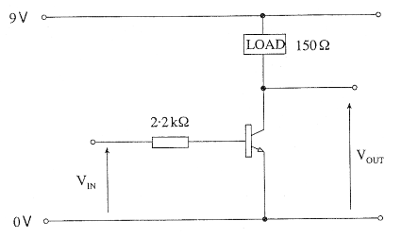
(a) The value of VIN is sufficient just to saturate the transistor. Calculate:

(i) The collector current.

.........................................................................................................................................................

.........................................................................................................................................................

(ii) The base current.

.........................................................................................................................................................

.........................................................................................................................................................

(iii) The value of VIN.

.........................................................................................................................................................

.........................................................................................................................................................

(b) The switching circuit is used to operate a fan when the temperature in a room increases above a pre-determined value.

Add the required input sensing sub-system to the circuit diagram.

2. The following circuit is set up to investigate a transistor switching circuit.

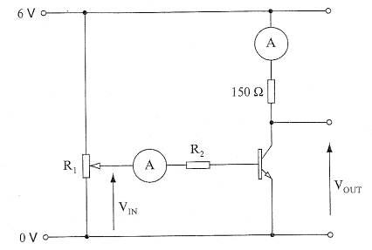
(a) As the base current is increased from 0 to 0.2mA the collector current increases from 0 to 16mA.

(i) Complete the graph below to show how the ammeter readings change as IB is increased from 0 to 0.2mA. You may assume that the transistor does not saturate.
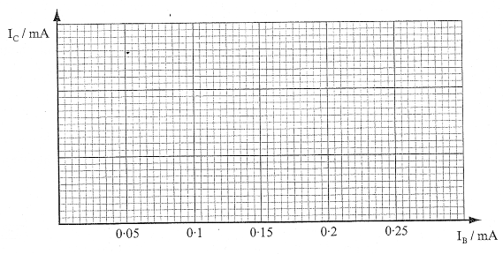
(ii) Calculate the current gain (hFE) of the transistor.

.........................................................................................................................................................

.........................................................................................................................................................

(b) The following graph shows how VOUT changes as VIN is increased from 0 to 2V.

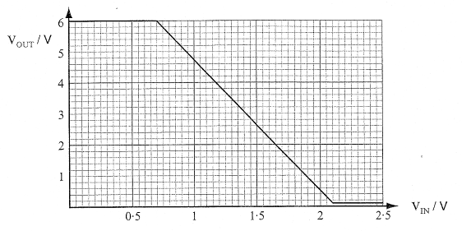

With VIN set at 1.5V,

(i) determine the value of VOUT,

.........................................................................................................................................................

.........................................................................................................................................................

(ii) calculate the collector current,

.........................................................................................................................................................

.........................................................................................................................................................

(iii) calculate the power dissipated in the transistor.

.........................................................................................................................................................

.........................................................................................................................................................

3. The following graph shows the characteristic of a certain thermistor.

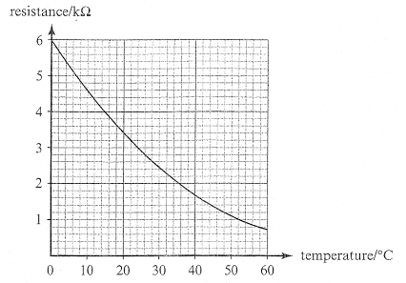

(a) What is the resistance of the thermistor at 20°C?

........................................................

(b) The thermistor is used in the following temperature alarm circuit.

12kΩ

V_{IN}

2.2kΩ

R=200Ω

10V

0V

(i) determine the minimum value of VIN required to saturate the transistor, if the transistor has a current gain (hFE) of 125.

(ii) Show by calculation whether the transistor is saturated at a temperature of 20°C.

.........................................................................................................................................................

.........................................................................................................................................................

(c) The temperature alarm was found to be too insensitive. Complete the diagram for a circuit which will have greater sensitivity.

10V

0V

12kΩ

4. The following diagram shows a temperature sensing circuit which operates a warning lamp when the ambient temperature rises above a pre-determined value.

2.2kΩ

V_{IN}

R=56Ω

12V

0V

(a) The thermistor has a resistance of 11kΩ at 20°C. Calculate the value of VIN at this temperature.
Assume that the base current is small enough to be ignored in this calculation.

........................................................................................................................................

........................................................................................................................................

(b) The relationship between VIN and VOUT as the ambient temperature changes is shown below.

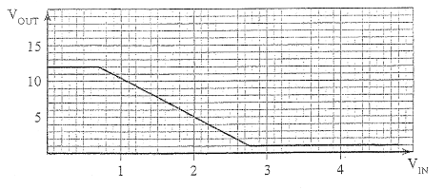

(i) use the graph to estimate the value of VOUT at 20°C.

.....................................................................................................................

(ii) calculate the power dissipated in the transistor at a temperature of 20°C

........................................................................................................................................

........................................................................................................................................
5. The circuit below shows a MOSFET being used to interface a CMOS logic system to a lamp rated at 24V, 12A.

24V
12A

0V

24V

Output from CMOS logic system

An extract from the datasheet for the MOSFET is shown below:

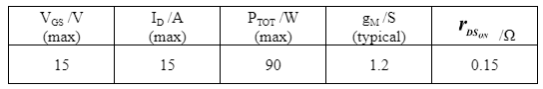
(a) Calculate the minimum value of VGS required to enable the lamp to operate at its rated current.
………………………………………………………………………………………………

………………………………………………………………………………………………
[2]
(b) Calculate the power dissipated in the MOSFET when the lamp is operating at its rated current.

………………………………………………………………………………………………

………………………………………………………………………………………………
[2]
(c) The maximum output current available from the logic system is 30mA. Explain why an NPN transistor would be unsuitable for this application.

………………………………………………………………………………………………

………………………………………………………………………………………………
[2]

Exercise 6
1. A 10V rms a.c. source from a transformer is half-wave rectified, and connected to a 2.2kΩ resistor.

i) Draw a circuit diagram of this arrangement.

ii) Calculate the peak value of the output voltage.

.............................................................................................................................

.............................................................................................................................

.............................................................................................................................

.............................................................................................................................

iii) Draw a sketch graph of the input voltage and output voltage on the grid below, label all important values:

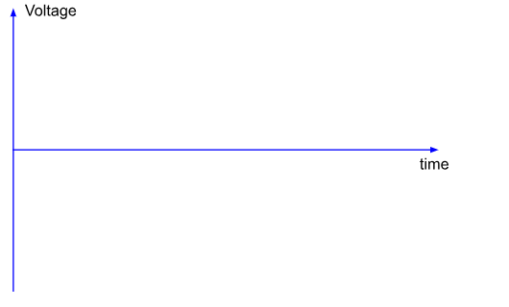
2. A 12.75V rms a.c. source from a transformer is full-wave rectified, and connected to a 3.9kΩ load resistor.

i) Draw a circuit diagram of this arrangement.

ii) Calculate the peak value of the output voltage.

.............................................................................................................................

.............................................................................................................................

.............................................................................................................................

.............................................................................................................................

iii) Draw a sketch graph of the input voltage and output voltage on the grid below, label all important values:

Exercise 7
1. The following diagram shows a smoothed half-wave rectified power supply connected to a load.

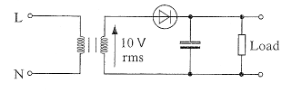

(a) The rms value of the secondary voltage is 10V. Calculate the peak value of

(i) the secondary voltage,

......................................................................................................................................
......................................................................................................................................
[1]
(ii) the voltage across the load.
......................................................................................................................................
[1]
(b) The following graph shows the voltage across the secondary windings.
On the same graph show the voltage across the load.

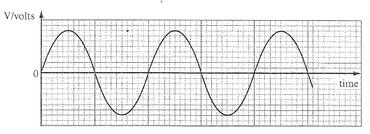
(c) Describe one advantage full-wave rectification has over half-wave rectification.

..................................................................................................................................................

..................................................................................................................................................

..................................................................................................................................................
[1]

2. The following diagram shows a smoothed half-wave rectified power supply.

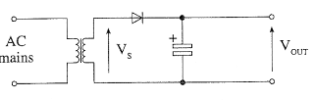
(a) The rms value of the secondary voltage VS is 12V. Calculate the peak value of

(i) the secondary voltage VS,

..................................................................................................................................................

..................................................................................................................................................
[1]
(ii) the voltage VOUT.

..................................................................................................................................................
[1]
(b) On the axes provided below, sketch a graph to show the output voltage VOUT when
(i) there is no load connected,
(ii) a load that draws a significant current is connected to the output.

Label the axes with any relevant voltages.
The Voltage VS is shown as a dotted waveform.

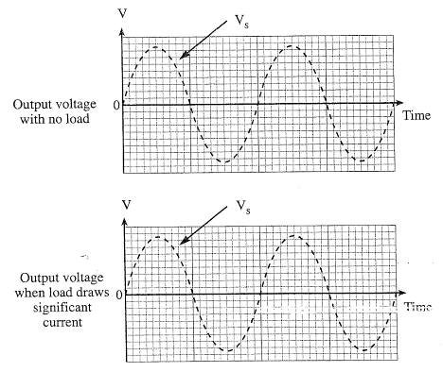
(c) (i) Explain by making reference to the graphs, what is meant by ripple voltage?

.................................................................................................................................................

.................................................................................................................................................

.................................................................................................................................................
[1]

(ii) Give two factors that contribute to the size of the ripple voltage.

First Factor ..................................................................................................................

Second Factor .............................................................................................................
[2]

3. The following diagram shows part of a half-wave rectified power supply.

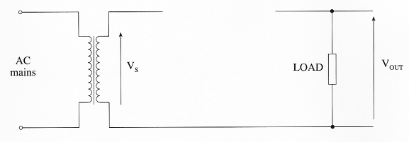
(a) Complete the circuit by adding:

(i) a diode to produce the half-wave rectification,

(ii) a capacitor to smooth the output.
[2]

(b) The rms value of the secondary voltage VS is 20V. Calculate the peak value of

(i) the secondary voltage,

......................................................................................................................................

......................................................................................................................................

(ii) the voltage VOUT.

......................................................................................................................................
[2]

(c) On the axes provided below, sketch the graph to show the voltage VOUT when

(i) the load draws a small current,

(ii) the load draws a large current.

Label the axes with any relevant voltages.

The voltage across the secondary windings of the transformer is shown as a dotted waveform.

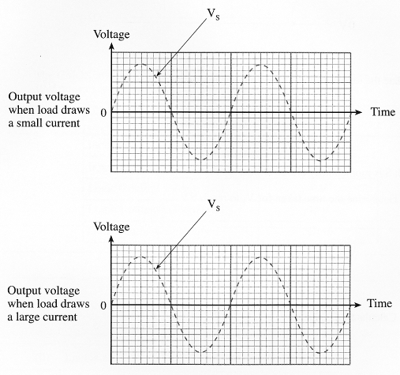
[2]

Exercise 8
- A stabilised power supply is shown in the diagram below. The zener diode requires a current of 10mA to maintain the zener voltage.

9V

R

5.1V

0V

Load

The system must be able to supply a load current of 240 mA.

(a) (i) Calculate the value of the resistor R.
.............................................................................................................................
.............................................................................................................................
.............................................................................................................................
.............................................................................................................................
.............................................................................................................................

(ii) Select from the E24 series the preferred value of resistor that you would use. Give a reason for your choice.
.............................................................................................................................

(b) Calculate the power dissipated in the zener diode if the load is suddenly disconnected from the power supply.

.............................................................................................................................
.............................................................................................................................
.............................................................................................................................
2. The following diagram shows a stabilised power supply with a load connected. The zener diode requires a minimum current of 10 mA to maintain the zener voltage.

9V

R

6.2V

0V

Load

(a) The system must be able to supply a load current of 100 mA.

(i) Calculate the power dissipated in the zener diode if the load is suddenly disconnected from the power supply.
.............................................................................................................................
.............................................................................................................................

.............................................................................................................................

(ii) Calculate the ideal value of resistor R.

.............................................................................................................................
.............................................................................................................................
.............................................................................................................................
.............................................................................................................................

(iii) Select from the E24 series the preferred value of resistor that you would use. Give a reason for your choice.
.............................................................................................................................
.............................................................................................................................

(b) Sketch a graph to show the effect on the voltage across the load, when the load current is gradually increased to 120 mA.



V

8

6

4

2

0 50 100 150 mA
Current through the load

Voltage
across
load

