A-level Electronics
Homework Booklet IV
Topic 201 Further Sequential Logic Systems, Topic 202 Further Power Supplies, Topic 204 AC Circuits and Passive Filters, Topic 205 Signal Conversion
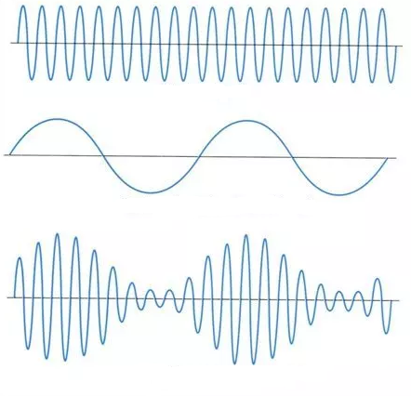
Name ………………………………………………………………………………………………

Group ………………………………………………………………………………………………

Teacher ……………………………………………………………………………………………

Exercise 1
- A sequence generator is governed by the following Boolean equations:

DA = A

DB = B ⊕ A

DC = B ⊕ A

- Complete the circuit diagram for this sequence generator by adding:
i) correct clock connections for the three D-type flip-flops,
ii) logic gates to provide the required input signals for the D-type flip-flops.
[4]

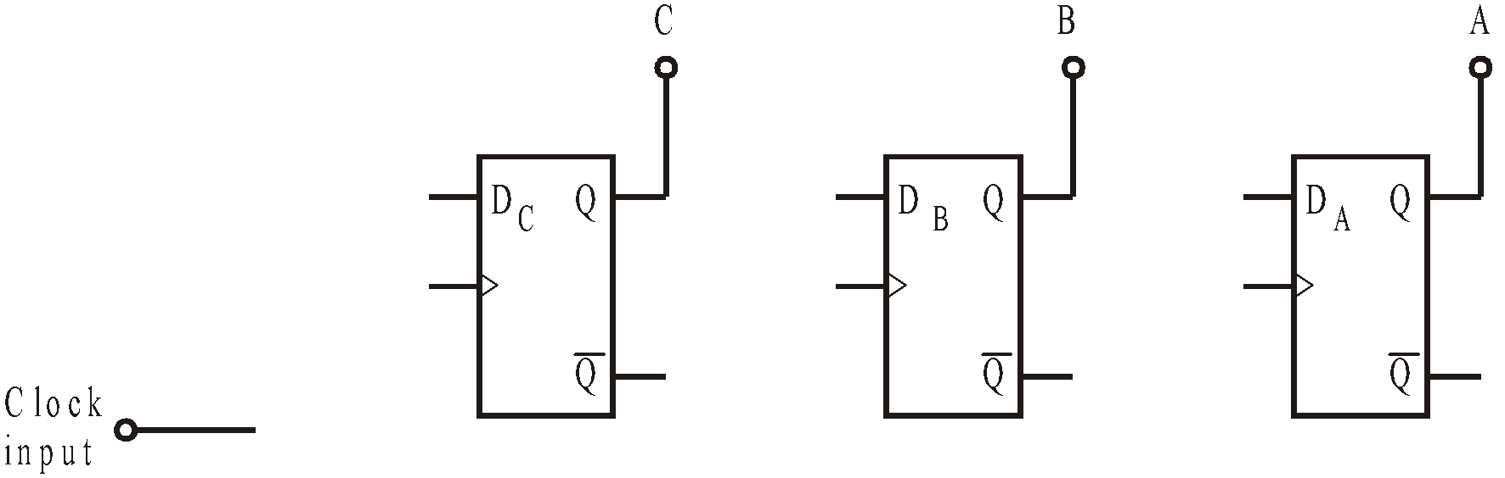

- Complete the following truth table to show the sequence of states produced by this system.

You should find that the sequence contains only four states.
[3]

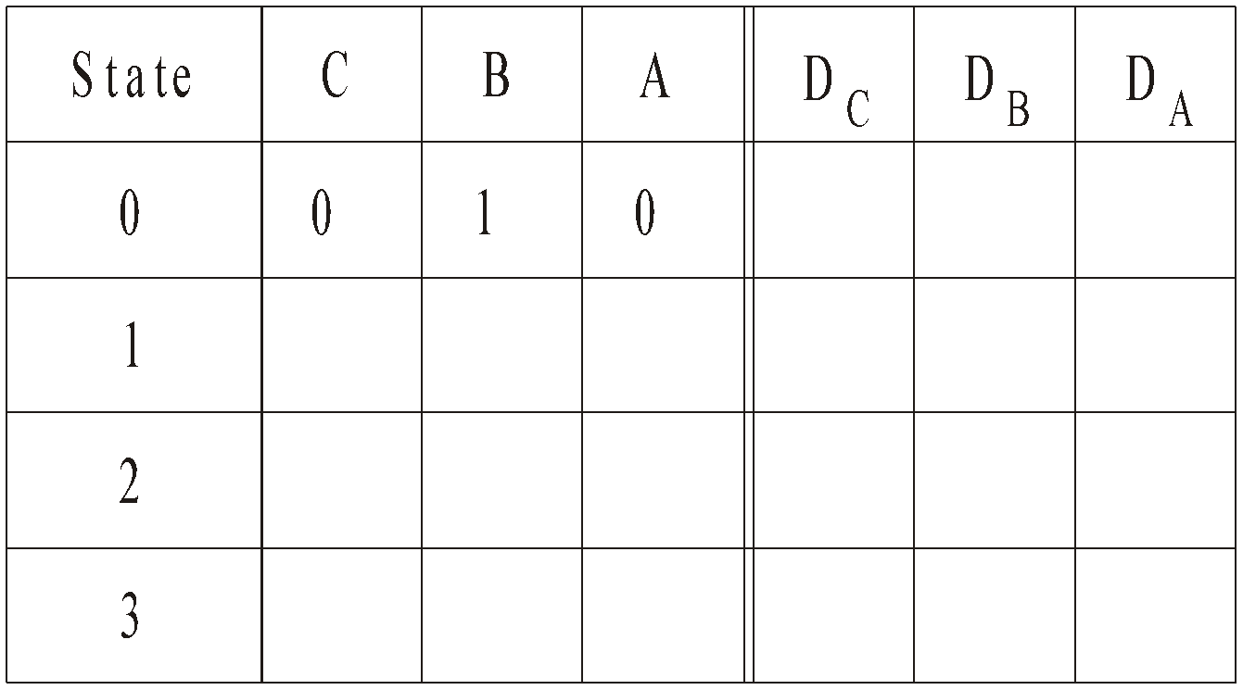

(c) Identify the four unused states and for each one, show into which state the unused state will lead.
[4]

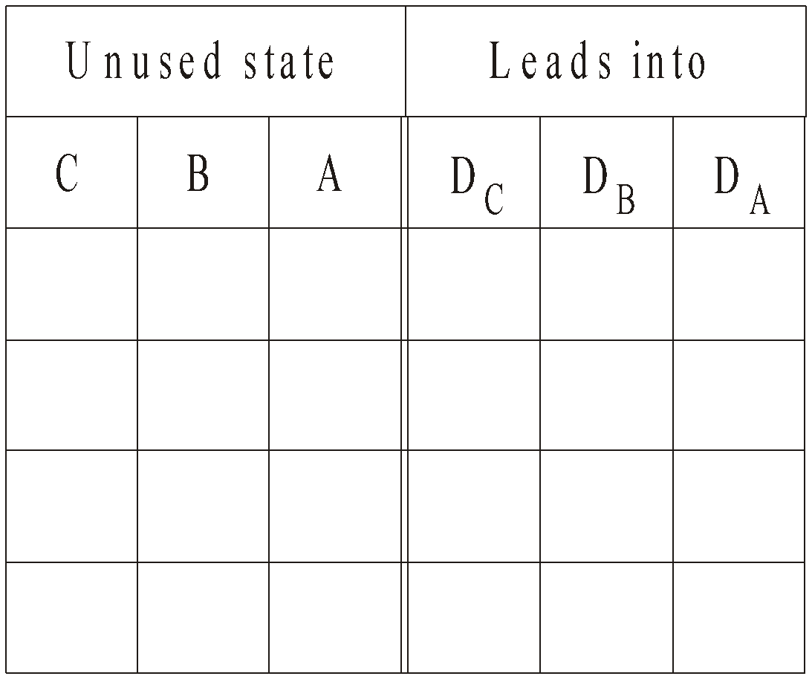

(d) Hence draw the state diagram for this sequence generator.
[2]



2. A student designs a light-chaser effect, based on a synchronous counter, for a model car. Part of the circuit diagram is shown below.

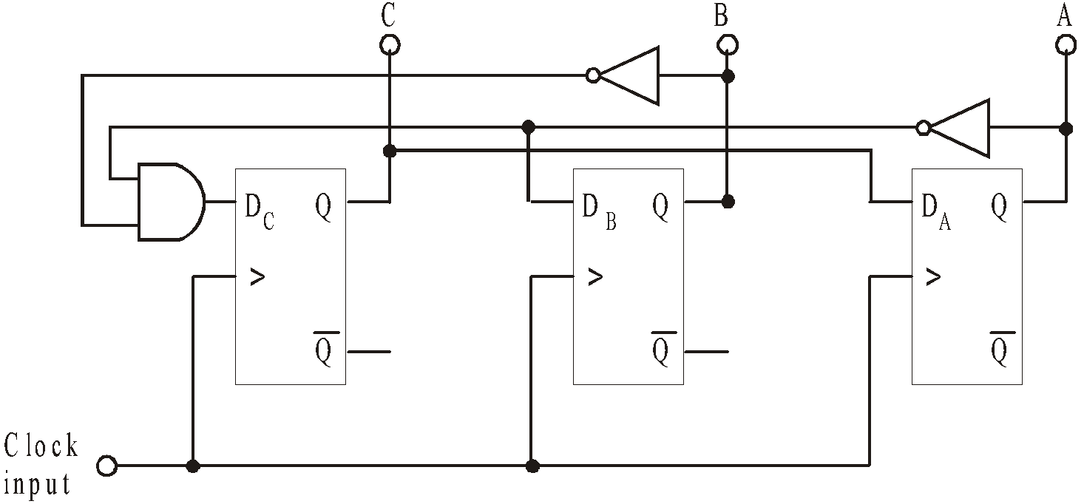

(a) The circuit can be simplified without changing its performance.
Explain how to modify the circuit so that the NOT gates are not needed. [1]

……………………………………………………………………………………………………..

……………………………………………………………………………………………………..

……………………………………………………………………………………………………..

(b) Write down Boolean expressions for the inputs DA, DB and DC in terms of the outputs A, B and C.
[3]

DA = ……………………………………………………………

DB = ……………………………………………………………

DC = ……………………………………………………………

(c) Use these Boolean expressions to complete the table, showing the sequence of output states that this system will generate. You should find there are only three states in the sequence.

State | A | B | C | D_{A} | D_{B} | D_{C}
0 | 0 | 0 | 0
1
2 |  |  |  | 0 | 0 | 0
[2]

(d) Complete the next table by listing the unused states, and by working out the state that each one progresses into.

[5]

 | Current Outputs |  |  | Next Outputs
State | A | B | C | A | B | C
3
4
5
6
7

(e) Hence draw the state diagram for this system
[2]



(f) There is a serious defect with the design of this sequence generator. Explain what this defect is, and why it might cause a problem.
[2]

……………………………………………………………………………………………………..

……………………………………………………………………………………………………..

……………………………………………………………………………………………………..

Exercise 2
- A high quality power supply offers good line and load regulation.

Explain what is meant by, and distinguish between the terms line regulation and load regulation.
[2]

Line regulation……………………………………………………………………………….......

………………………………………………………………………………………….………….

………………………………………………………………………………………….………….

Load regulation ……………………………………………………………………………….....

………………………………………………………………………………………….………….

………………………………………………………………………………………….………….

(b) Here is part of the circuit diagram for a regulated power supply.

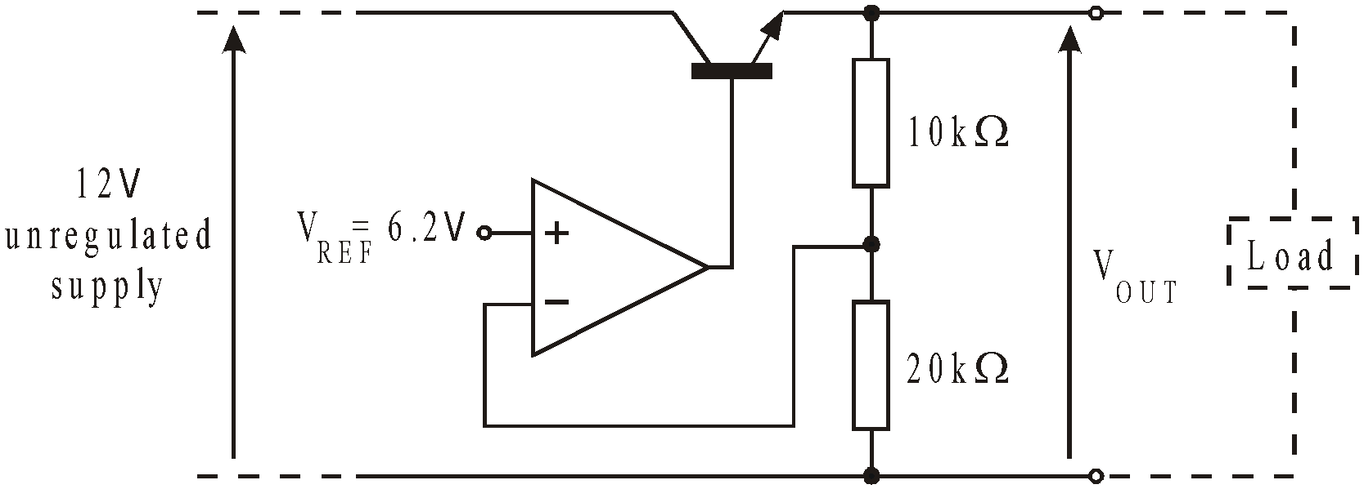

(i) Calculate the output voltage V_{OUT}.
[2]

………………………………………………………………………………..................................

………………………………………………………………………………………….………….

………………………………………………………………………………………….………….

(ii) What modification to the circuit is needed in order to make it possible to vary the output voltage produced by a fixed reference voltage V_{REF} of 6.2V?
[1]

………………………………………………………………………………..................................
………………………………………………………………………………………….………….

………………………………………………………………………………………….………….
2. An emitter follower is used as part of the voltage regulator in a power supply.
Here is the circuit diagram for the power supply, containing a series regulator.
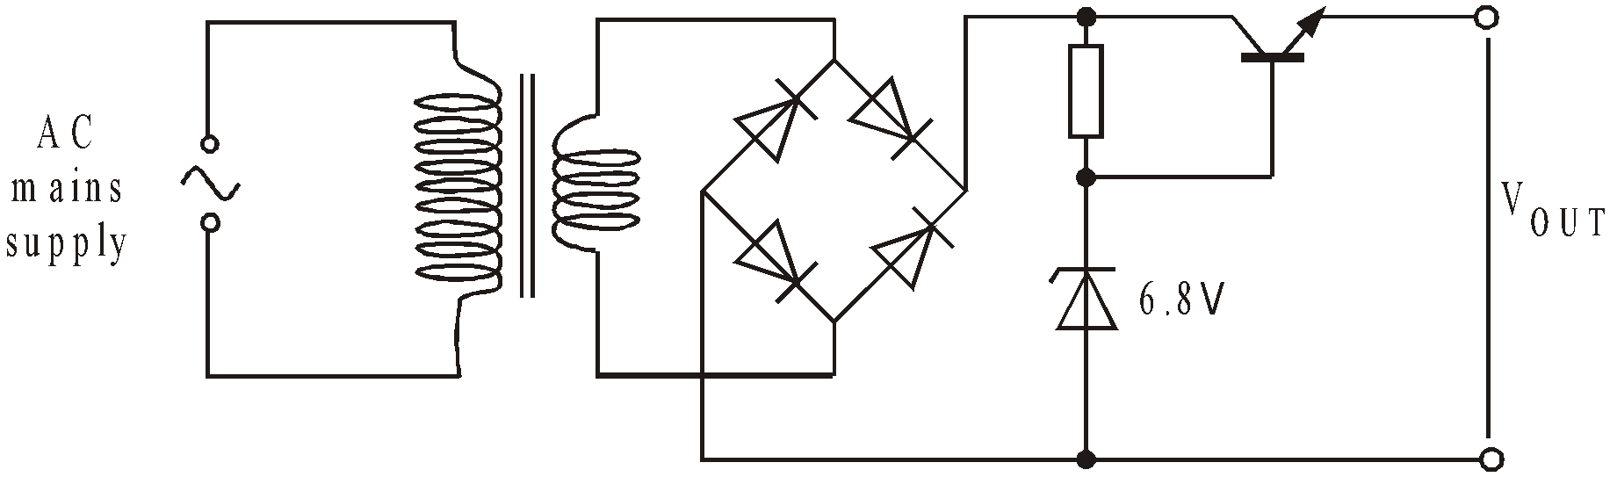
(a) Calculate the output voltage, V_{OUT}, of the power supply.
[1]

………………………………………………………………………………..................................

………………………………………………………………………………………….………….

(b) Give one benefit of using an emitter follower in this circuit?
[1]

………………………………………………………………………………..................................

………………………………………………………………………………………….………….

3. The following subsystem is part of a power supply unit.

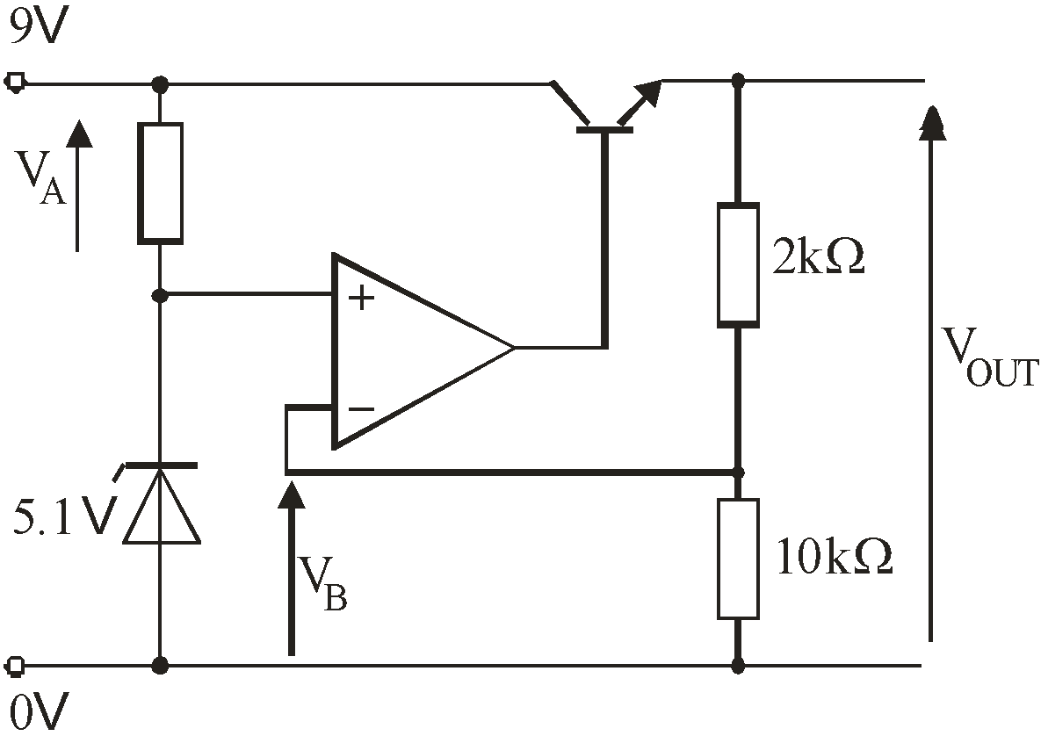

Calculate:

(a) the voltage V_{A};
[1]

……………………………………………………………………………………………………………..

(b) the output voltage V_{OUT;}
[1]

……………………………………………………………………………………………………………..

(c) the voltage V_{B} at the inverting input of the op-amp.
[1]

……………………………………………………………………………………………………………..

4. The power supply circuit shown below uses a zener diode to provide good line regulation.

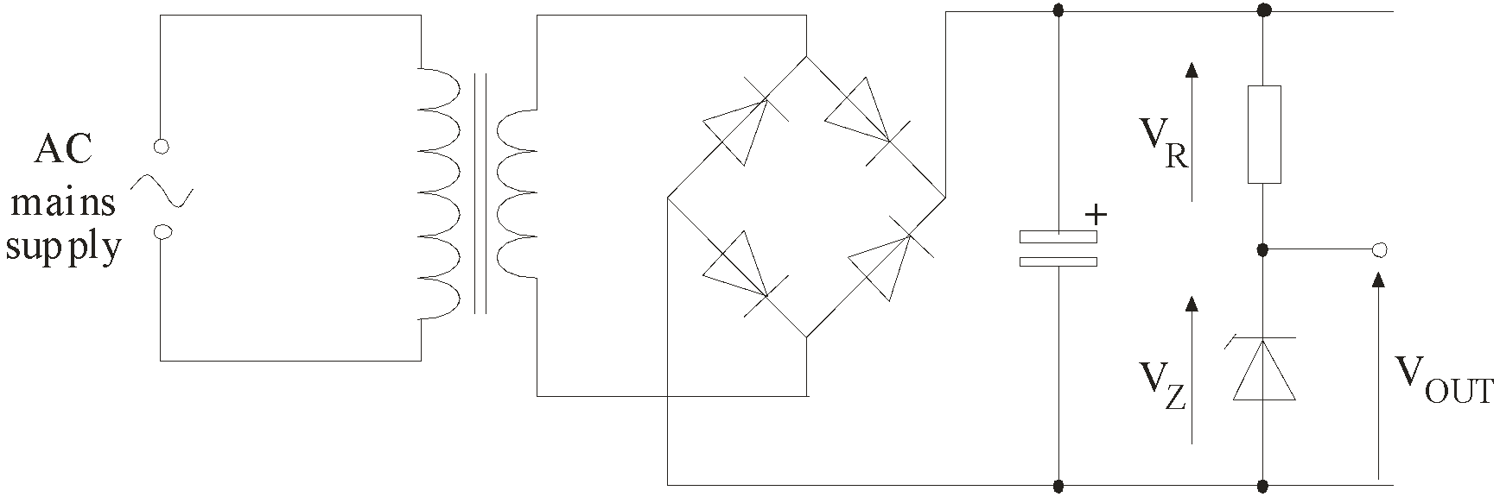

(a) Explain how the circuit provides line regulation. Your explanation should describe what happens to voltages V_{R} and V_{Z} when the AC mains supply voltage increases.
[1]

………………………………………………………………………………..................................

………………………………………………………………………………………….………….

(b) A stabilised power supply circuit is shown below.

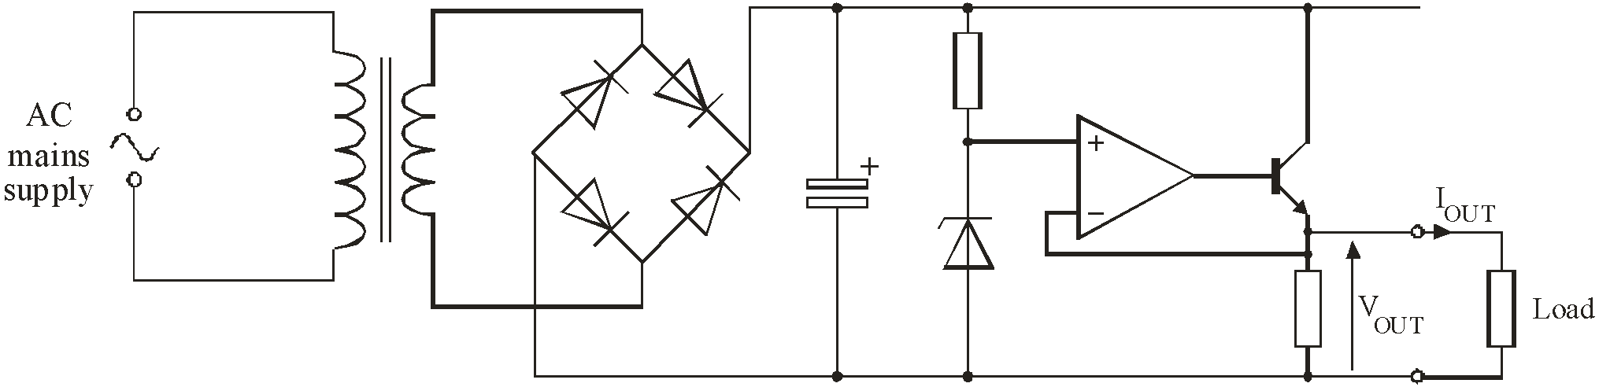

Explain how this circuit keeps V_{OUT} constant as the load current I_{OUT} increases.
[2]

………………………………………………………………………………..................................

………………………………………………………………………………………….………….

………………………………………………………………………………………….………….

………………………………………………………………………………..................................

………………………………………………………………………………………….………….

………………………………………………………………………………………….………….

Exercise 3

- The figure shows a low pass filter.
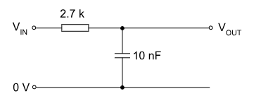

i) calculate the reactance of the capacitor at 10Hz, 100Hz, 1kHz, 10kHz and 100kHz.

ii) calculate the output voltage at each of these frequencies given 12V input voltage.

iii) calculate the break frequency of this circuit.

iv) calculate VOUT at the break frequency.

iv) plot a graph of output voltage against frequency on log graph paper.

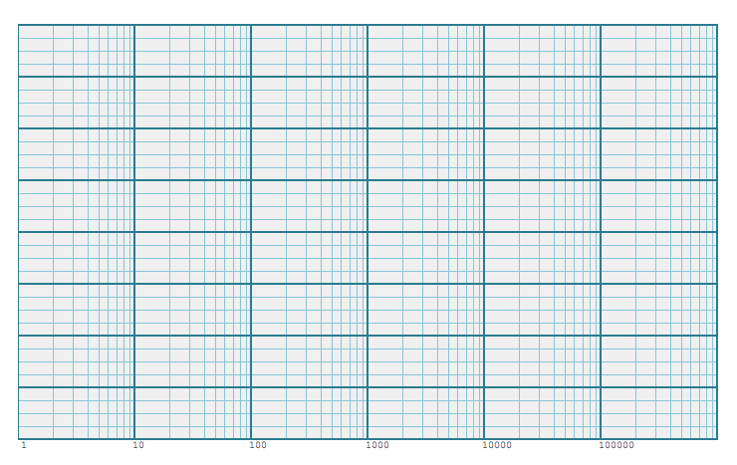

- The figure shows a high-pass filter.

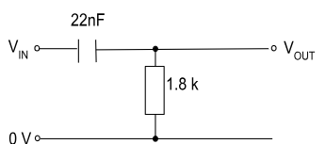

i) calculate the reactance of the capacitor at 10Hz, 100Hz, 1kHz, 10kHz and 100kHz.

ii) calculate the output voltage at each of these frequencies given a 12V input voltage.

iii) calculate the break frequency of this circuit.

iv) calculate VOUT at the break frequency.

iv) plot a graph of output voltage against frequency on log graph paper.

Exercise 4
- The following circuit is to be used as a filter.

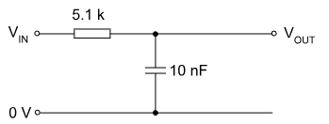

- What is the name of this type of filter ? ………………………………………………
[1]

- Calculate the reactance of the capacitor at 100 Hz.

………………………………………………………………………………………………………

………………………………………………………………………………………………………

………………………………………………………………………………………………………
[2]
c. Estimate the reactance of the capacitor at 10 kHz.

………………………………………………………………………………………………………
[1]
d. Calculate the break frequency for this filter.

………………………………………………………………………………………………………

………………………………………………………………………………………………………

………………………………………………………………………………………………………
[2]
e. Sketch the characteristic of this filter labelling all critical values.
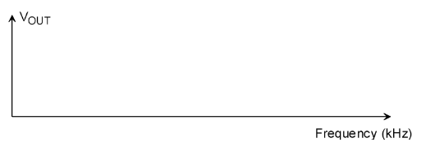
[2]
2. The following circuit is to be used as a filter.

47nF

1.5 k

V_{IN}

0 V

V_{OUT}

- What is the name of this type of filter ? ………………………………………………
[1]

- Calculate the reactance of the capacitor at 1000 Hz.

………………………………………………………………………………………………………

………………………………………………………………………………………………………

………………………………………………………………………………………………………
[2]
- What is the impedance of the circuit at 1000 Hz.

………………………………………………………………………………………………………

………………………………………………………………………………………………………

………………………………………………………………………………………………………
[2]
- Calculate the output voltage if VIN = 10V at 1000 Hz.

………………………………………………………………………………………………………

………………………………………………………………………………………………………

………………………………………………………………………………………………………
[1]
e. Calculate the break frequency for this filter.

………………………………………………………………………………………………………

………………………………………………………………………………………………………

………………………………………………………………………………………………………
[2]

f. Sketch the characteristic of this filter labelling all critical values.

[2]

3. The ideal frequency response for a filter is shown below.

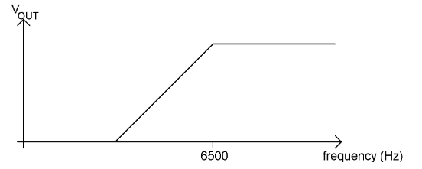

- This filter is built using a simple RC circuit. Sketch the response you are likely to obtain from the simple RC filter circuit clearly showing how it would differ from the ideal response which is shown as a dotted line.

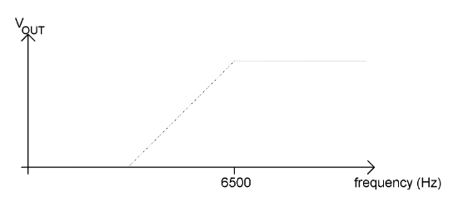

b. You have available the following capacitors, 1µF, 47nF, and 6.8pF and the E24 series of resistors to choose from. Calculate the most suitable resistor for this filter.
…….………………………………………………………………………………………………

…….………………………………………………………………………………………………

…….………………………………………………………………………………………………

…….………………………………………………………………………………………………

…….………………………………………………………………………………………………

…….………………………………………………………………………………………………

…….………………………………………………………………………………………………
[3]

c. Draw the circuit diagram of the completed filter, label all component values and input and output terminals.

[2]
d. Give reasons why you have chosen the components you have for your filter.

.........................................................................................................................................................

.........................................................................................................................................................

.........................................................................................................................................................

.........................................................................................................................................................
[2]

4. A low pass filter is required to correspond to the following characteristic. You can assume you have access to any standard value capacitors and resistors.

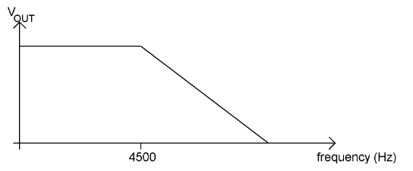

- What is the break frequency of this filter ? ………………………………
[1]
- Draw the circuit diagram of a low pass filter.

[2]
c. Determine the value of the components required to realise the function of the low pass filter identified in the characteristic.

………………………………………………………………………………………………………..

………………………………………………………………………………………………………..

………………………………………………………………………………………………………..

………………………………………………………………………………………………………..

………………………………………………………………………………………………………..

………………………………………………………………………………………………………..

………………………………………………………………………………………………………..

………………………………………………………………………………………………………..

………………………………………………………………………………………………………. [4]

Exercise 5
1. The following circuit shows a band pass filter connected to a signal generator with VIN set to 8V. The inductor has a resistance rL of 3Ω. VIN is kept at 8V and the frequency increased to give the maximum value of VOUT.
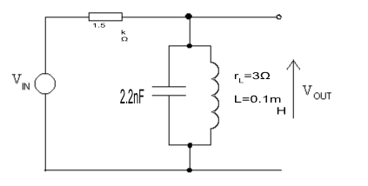

(a) Calculate the frequency at which VOUT is a maximum.

………………………………………………………………………………………………………………

………………………………………………………………………………………………………………

………………………………………………………………………………………………………………

(b) By calculating the Dynamic Resistance RD of the filter, determine the maximum value of the voltage VOUT with VIN set to 8V.

………………………………………………………………………………………………………………

………………………………………………………………………………………………………………

………………………………………………………………………………………………………………

………………………………………………………………………………………………………………

………………………………………………………………………………………………………………

(c) Determine the bandwidth of this filter.

………………………………………………………………………………………………………………

………………………………………………………………………………………………………………

………………………………………………………………………………………………………………

………………………………………………………………………………………………………………
(d) Sketch the frequency response of the filter using the axes below. Label all important values.

………………………………………………………………………………………………………………

………………………………………………………………………………………………………………
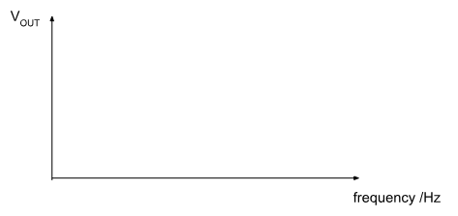

2. The following graph was plotted by a student investigating the behaviour of a band pass filter.

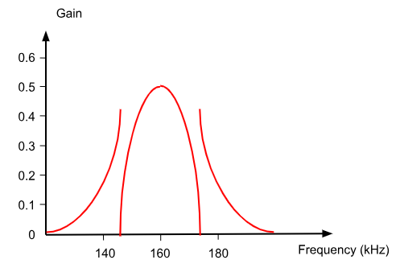

(a) Determine the resonant frequency of the filter which has the response shown above.
……………………………………………………………

(b) Determine the maximum gain that can be obtained from this filter.

……………………………………………………………

(c) Determine the bandwidth of the filter shown above.

………………………………………………………………………………………………………………

………………………………………………………………………………………………………………

(d) Hence calculate the Q-Factor for the filter.

………………………………………………………………………………………………………………

………………………………………………………………………………………………………………

3. The following circuit shows a band pass filter connected to a signal generator with VIN set to 6V. VIN is kept at 6V and the frequency increased to give the maximum value of VOUT.

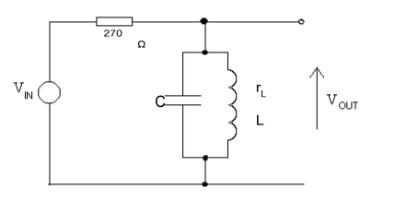
The filter is required to have a Q-Factor of 10, and a bandwidth of 10kHz.

(a) Calculate the resonant frequency of the filter.

………………………………………………………………………………………………………………

………………………………………………………………………………………………………………

………………………………………………………………………………………………………………

………………………………………………………………………………………………………………

(b) Three inductors A, B and C with the following properties are available.
Inductor A L=50mH, rL = 2.45Ω.
Inductor B L=50µH, rL = 3.15Ω.
Inductor C L=50µH, rL = 2.45Ω.
Show by calculation which is the correct inductor to use for this circuit.

………………………………………………………………………………………………………………

………………………………………………………………………………………………………………

………………………………………………………………………………………………………………

………………………………………………………………………………………………………………

………………………………………………………………………………………………………………

………………………………………………………………………………………………………………

………………………………………………………………………………………………………………

Correct Inductor to use is ………

(c) Using your answer to (b) calculate the value of the capacitor ‘C’ to meet the specification.

………………………………………………………………………………………………………………

……………………………………………………………………………………………………………

………………………………………………………………………………………………………………

………………………………………………………………………………………………………………

(d) Hence calculate the value of RD at resonance.

………………………………………………………………………………………………………………

………………………………………………………………………………………………………………

………………………………………………………………………………………………………………

………………………………………………………………………………………………………………

(e) Hence calculate the output voltage at resonance.

………………………………………………………………………………………………………………

………………………………………………………………………………………………………………

………………………………………………………………………………………………………………

………………………………………………………………………………………………………………

4. The following circuit shows a band pass filter connected to a signal generator with VIN set to 12V. VIN is kept at 12V and the frequency increased to give the maximum value of VOUT.
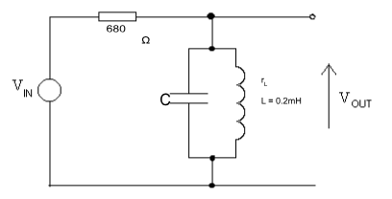

The filter is required to have a Q-Factor of 85, and a bandwidth of 2.4kHz.

(a) Calculate the resonant frequency of the filter.

………………………………………………………………………………………………………………

………………………………………………………………………………………………………………

………………………………………………………………………………………………………………

………………………………………………………………………………………………………………

(b) Use your answer to (a) to calculate the value of the capacitor required to achieve this resonant frequency.

………………………………………………………………………………………………………………

………………………………………………………………………………………………………………

………………………………………………………………………………………………………………

………………………………………………………………………………………………………………

(c) Using your answer to (a), (b) and the Q-factor to calculate the value of rL, the resistance of the inductor.

………………………………………………………………………………………………………………

………………………………………………………………………………………………………………

………………………………………………………………………………………………………………

(d) Hence calculate the value of RD at resonance.

………………………………………………………………………………………………………………

………………………………………………………………………………………………………………

………………………………………………………………………………………………………………

………………………………………………………………………………………………………………

(e) Hence calculate the output voltage at resonance.

………………………………………………………………………………………………………………

………………………………………………………………………………………………………………

………………………………………………………………………………………………………………

………………………………………………………………………………………………………………

Exercise 6

- A microprocessor systems can contain both an analogue-to-digital converter (ADC) and a digital-to-analogue converter (DAC)

Here is the circuit diagram for a digital-to-analogue converter (DAC).

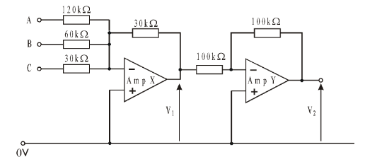
The most significant bit of the binary number is applied to input C, and the least significant bit to input A. The outputs of the op-amps saturate at +12V and -12V.

(i) What is the gain of amplifier Y? [1]
…………………………………………………………………………………………….……….

(ii) The following voltages are applied to inputs A, B and C.
VA = +5V
VB = 0V
VC = 0V
Calculate:
V1 [1]

…………………………………………………………………………………………….……….
…………………………………………………………………………………………….……….

V2 [1]
…………………………………………………………………………………………….……….
…………………………………………………………………………………………….……….

(iii) The system uses +5V to represent logic 1 and 0V to represent logic 0.

Use the axes provided to draw a graph showing the relationship between V2 and the digital input signal, for the four values of input given. Indicate the scale you are using for the vertical axis. [2]

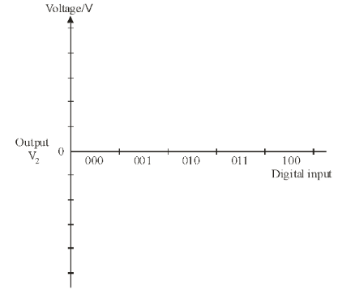

(iv) What is the maximum value of output voltage V2 that this 3- bit DAC will produce? [1]
…………………………………………………………………………………………….……….

2.(a) The diagram shows the circuit for a 3-bit linear digital-to-analogue converter (DAC), based on a summing amplifier.

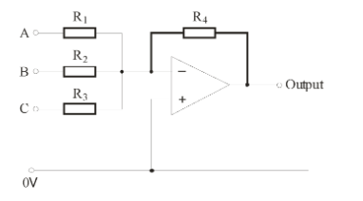

(i) Calculate suitable values for the resistors used in the circuit, so that the DAC has the following characteristics:
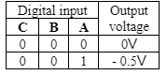

In this system, logic 1 is 12V and logic 0 is 0V. [3]

……………………………………………………………………………………………………………..

……………………………………………………………………………………………………………..

……………………………………………………………………………………………………………..

……………………………………………………………………………………………………………..

R1 = …………………………………

R2 = …………………………………

R3 = …………………………………

R4 = …………………………………

(ii) The DAC is connected to a counter, as shown in the following diagram.

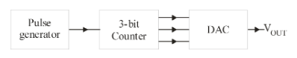

Initially, the counter is reset. Then ten pulses are sent into the counter.

Use the axes provided to sketch the resulting output signal VOUT as this happens. [3]

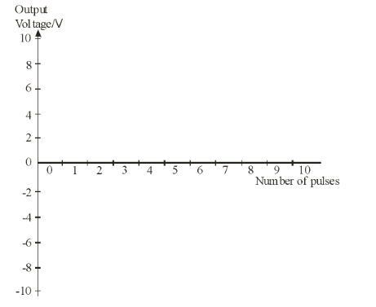

Exercise 7
- A microprocessor systems can contain both an analogue-to-digital converter (ADC) and a digital-to-analogue converter (DAC)

(a)The diagram shows part of the circuit for a 2-bit flash ADC.
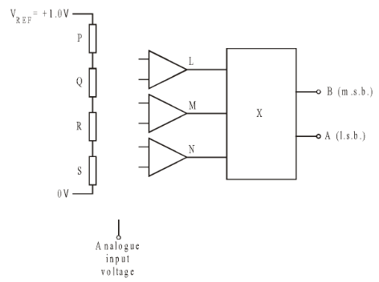
The system meets the following specification:
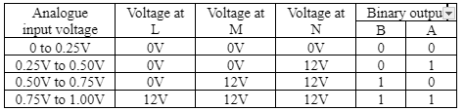

(i) Complete the circuit diagram by:
- adding a fourth comparator so that its output indicates an overflow condition, when the analogue input voltage exceeds 1.0V;
- adding all connections needed;
- labelling the inverting inputs of the op-amps with a ‘-‘ and the non-inverting inputs with a ‘+’.
[4]
(ii) Calculate suitable values for resistors P, Q, R and S. [2]
…………………………………………………………………………………………….……….
…………………………………………………………………………………………….……….

Resistor P = ............... Resistor Q = ............... Resistor R = ............... Resistor S = ...............

(iii) What is the name of the sub-system X, used to convert the output signals from the op-amps into a binary sequence. [1]
…………………………………………………………………………………………….……….

- Here is the circuit diagram for an Analogue-to-Digital converter (ADC.)
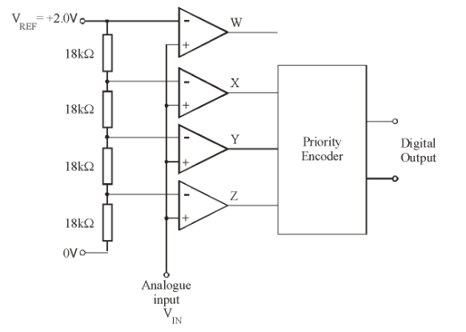

- What is the name of this type of ADC? [1]

……………………………………………………………………………………………………..
- What is the function of the following components in this system: [2]
(i) Priority Encoder

……………………………………………………………………………………………………..

(ii) the comparator whose output is labelled W

……………………………………………………………………………………………………..

(c) Calculate the resolution of this ADC. [1]

……………………………………………………………………………………………………..

(d) What is the analogue input voltage range for this ADC [1]

……………………………………………………………………………………………………..
(e) VREF is reduced to +1.0V. What is the effect of this change on:

(i) resolution; [1]

……………………………………………………………………………………………………..
(ii) analogue input voltage range? [1]

……………………………………………………………………………………………………..

(f) The comparators have saturation voltages of +8V and +1V and VREF is set at +1.0V.

The top graph shows how the input voltage VIN changes over a period of time.

Use the axes provided to draw the signals at X, Y and Z over this time. [4]
