A-level Electronics
Homework Booklet II
Topic 102 Timing Systems and Topic 103 Sequential Logic Systems

Name ………………………………………………………………………………………………

Group ………………………………………………………………………………………………

Teacher ……………………………………………………………………………………………

Exercise 1
- Calculate the time constant for the following combinations of resistor and capacitor.

i) R = 4.7kΩ, C = 1000μF.

........................................................................................................................................

........................................................................................................................................

ii) R = 82kΩ, C = 15μF.

........................................................................................................................................

........................................................................................................................................

iii) R = 56kΩ, C = 33nF.

........................................................................................................................................

........................................................................................................................................

iv) R = 470kΩ, C = 8.2nF.

........................................................................................................................................

........................................................................................................................................

v) R = 2.2MΩ, C = 33μF.

........................................................................................................................................

........................................................................................................................................

vi) R = 91kΩ, C = 0.22μF.

........................................................................................................................................

........................................................................................................................................

vii) R = 1.8MΩ, C = 470pF.

........................................................................................................................................

Exercise 2
- Find the voltage across the capacitor, after 0.5s and then after 8s, assume that before the switch is closed there is no charge on the capacitor.

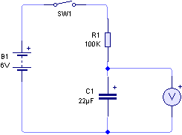

........................................................................................................................................

........................................................................................................................................

........................................................................................................................................

........................................................................................................................................

........................................................................................................................................

........................................................................................................................................

........................................................................................................................................

........................................................................................................................................

........................................................................................................................................

........................................................................................................................................

........................................................................................................................................

........................................................................................................................................

........................................................................................................................................

........................................................................................................................................

- Calculate the voltage across the capacitor in the following circuit, 15s and 40s after the switch is opened.

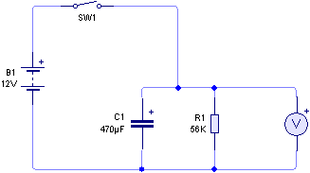

........................................................................................................................................

........................................................................................................................................

........................................................................................................................................

........................................................................................................................................

........................................................................................................................................

........................................................................................................................................

........................................................................................................................................

........................................................................................................................................

........................................................................................................................................

........................................................................................................................................

........................................................................................................................................

........................................................................................................................................

........................................................................................................................................

........................................................................................................................................

- In the following circuit, the capacitor is initially uncharged and the switch is closed at time t = 0. How long will it take for the voltage across the capacitor to rise to 9V?
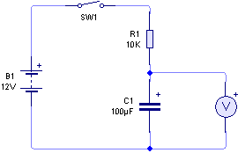

........................................................................................................................................

........................................................................................................................................

........................................................................................................................................

........................................................................................................................................

........................................................................................................................................

........................................................................................................................................

........................................................................................................................................

........................................................................................................................................

........................................................................................................................................

........................................................................................................................................

........................................................................................................................................

........................................................................................................................................

........................................................................................................................................

........................................................................................................................................

- In the following circuit, the switch is closed to charge the capacitor instantly. Calculate how long after the switch is released for the output voltage to fall from 6V to 2V.
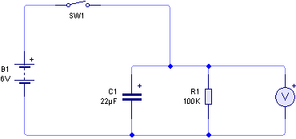

........................................................................................................................................

........................................................................................................................................

........................................................................................................................................

........................................................................................................................................

........................................................................................................................................

........................................................................................................................................

........................................................................................................................................

........................................................................................................................................

........................................................................................................................................

........................................................................................................................................

........................................................................................................................................

........................................................................................................................................

........................................................................................................................................

........................................................................................................................................

Exercise 3

1. The following circuit is used to provide a time delay.

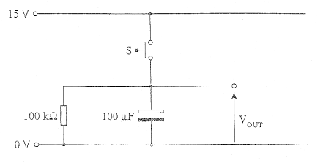

(a) Calculate the time constant of the circuit.

............................................................................................................................

............................................................................................................................
[1]
(b) When the switch S is momentarily closed the capacitor charges up to 15V. Calculate the output voltage 5 seconds after the switch is released.

............................................................................................................................

............................................................................................................................

............................................................................................................................
[2]
(c) Calculate the time taken after the switch is released for the output voltage to fall from 15V to 3V.

............................................................................................................................

............................................................................................................................

............................................................................................................................

............................................................................................................................
[2]

2. (a) The capacitor shown in the circuit below is initially discharged. Switch S1 is closed at time t = 0.

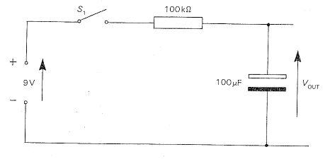

(i) Calculate the time constant of the circuit.

............................................................................................................................

............................................................................................................................
[1]

(ii) Calculate the output voltage after 2s.

............................................................................................................................

............................................................................................................................

............................................................................................................................
[2]
(iii) Calculate the time taken for VOUT to reach 5V.

............................................................................................................................

............................................................................................................................

............................................................................................................................

............................................................................................................................
[2]

(b) The capacitor shown in the circuit below charges up to 12V when switch S2 is closed.

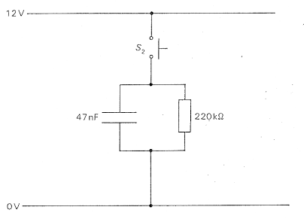

Calculate the time taken, after the switch is released, for the voltage across the capacitor to fall from 12V to 3V

............................................................................................................................

............................................................................................................................

............................................................................................................................

............................................................................................................................

............................................................................................................................

............................................................................................................................
[3]

3. The capacitor shown in the following circuit is initially discharged. The switch S is opened at time t = 0.

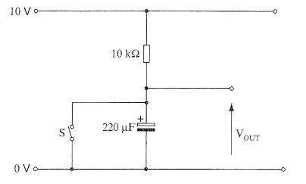

(a) Calculate the time constant of the circuit.

............................................................................................................................

............................................................................................................................
[1]
(b) Determine the time taken for VOUT to reach 5V.

............................................................................................................................

............................................................................................................................

............................................................................................................................
[2]
(c) Calculate the output voltage 20 seconds after the switch is opened.

............................................................................................................................

............................................................................................................................

............................................................................................................................

............................................................................................................................

............................................................................................................................
[2]

4. The capacitor shown in the following circuit is initially discharged. Switch S is closed at time t = 0.

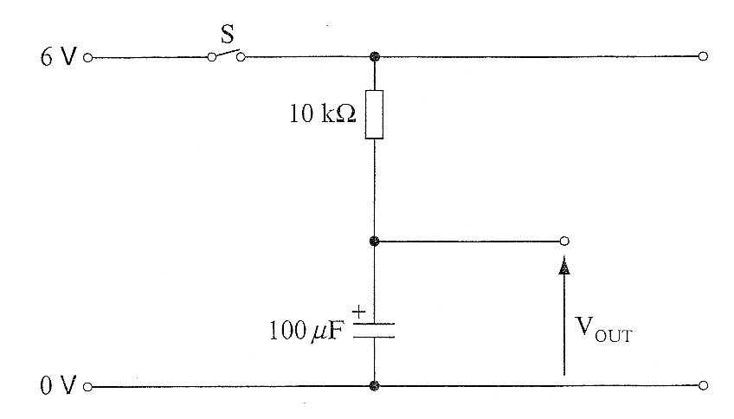

(a) Calculate the time constant of the circuit.

............................................................................................................................

............................................................................................................................
[1]
(b) Determine the time taken for VOUT to reach 3V.

............................................................................................................................

............................................................................................................................

............................................................................................................................
[2]
(c) Calculate the output voltage after 5s.

............................................................................................................................

............................................................................................................................

............................................................................................................................

............................................................................................................................
[2]

5. The capacitor shown in the circuit below is initially uncharged. S1 is closed at time t = 0.

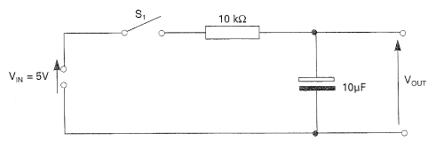

Calculate:

(i) the time constant of the circuit.

............................................................................................................................

............................................................................................................................
[1]
(ii) the time taken for VOUT to reach 2V.

............................................................................................................................

............................................................................................................................

............................................................................................................................
[2]
(iii) the output voltage after 0.5s.

............................................................................................................................

............................................................................................................................

............................................................................................................................

[2]

6. The following circuit is used to provide a time delay. The capacitor charges up to 12V when switch S is momentarily closed.

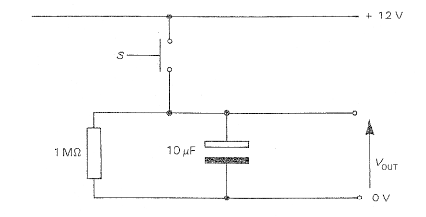

(i) Calculate the time constant of the circuit.

............................................................................................................................

............................................................................................................................
[1]
(ii) Calculate the output voltage 3 seconds after the switch is released.

............................................................................................................................

............................................................................................................................

............................................................................................................................
[2]
(iii) Calculate the time taken after the switch is released for the output voltage to fall from 12V to 4V.

............................................................................................................................

............................................................................................................................

............................................................................................................................

............................................................................................................................
[2]

7. The capacitor shown in the following circuit is initially discharged.

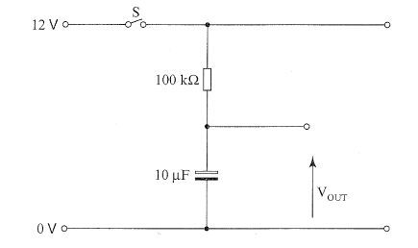

(a) Calculate the time constant of the circuit.

............................................................................................................................

............................................................................................................................
[1]
(b) Switch S is closed at time t = 0.

(i) Determine the time taken for VOUT to reach half the supply voltage.

............................................................................................................................

............................................................................................................................

............................................................................................................................
[2]
(ii) Calculate the output voltage 2s after the switch is closed.

............................................................................................................................

............................................................................................................................

............................................................................................................................
[2]

Exercise 4
- For the circuit shown below; determine the time taken for the output to change after the switch is closed. The output of the NOT gate changes when the input voltage reaches 7V.
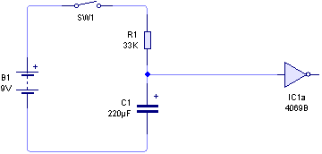

............................................................................................................................

............................................................................................................................

............................................................................................................................

............................................................................................................................

- For the circuit shown below, determine the time taken for the output to change after the switch is momentarily closed and then opened. The output of the NOT gate changes when the input voltage reaches 3V.
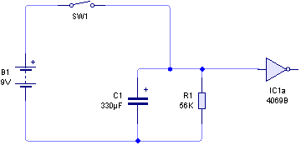

............................................................................................................................

............................................................................................................................

............................................................................................................................

............................................................................................................................

Exercise 5
- The following circuit shows a 555 timer configured as a monostable timer.

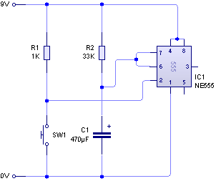

Calculate the duration of the output pulse when the switch SW1 is pressed momentarily.

............................................................................................................................

............................................................................................................................

............................................................................................................................

............................................................................................................................

............................................................................................................................

............................................................................................................................

............................................................................................................................

............................................................................................................................

............................................................................................................................

............................................................................................................................

............................................................................................................................

............................................................................................................................

- The following diagram shows an incomplete circuit for a 555 monostable.

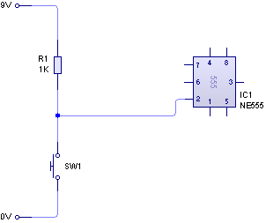

(i) Complete the circuit diagram for a 555 monostable.

(ii) Determine the value of components required to provide an output time delay of approximately 2 minutes.

............................................................................................................................

............................................................................................................................

............................................................................................................................

............................................................................................................................

............................................................................................................................

............................................................................................................................

............................................................................................................................

............................................................................................................................

............................................................................................................................

............................................................................................................................

............................................................................................................................

............................................................................................................................

Exercise 6
1. The following diagram shows an incomplete circuit for a 555 monostable timer.

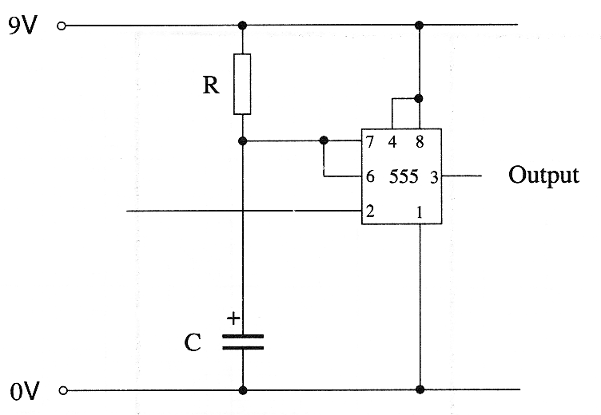

(a) Add a switch and any other necessary component to the diagram above to complete the trigger section of this monostable.
[2]

(b) Complete the graph below to show the output signal from the 555 i.c. in response to the trigger signal below.

Trigger

Output

[2]

2. (a) The following diagram shows a timing circuit.

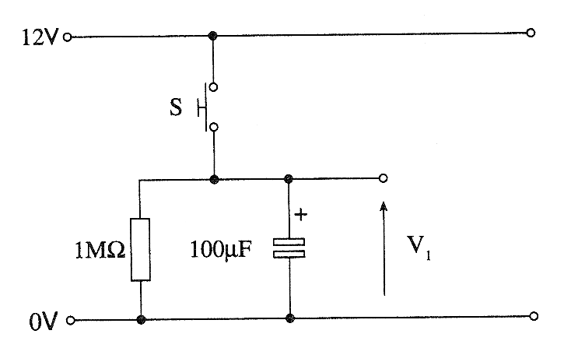

The capacitor is initially uncharged.
Switch S is closed and then opened at time t = 0.

(i) Calculate the time constant of the circuit.

..................................................................................................................................................

..................................................................................................................................................
[2]

(ii) Determine the time taken for V1 to fall to 6V.

..................................................................................................................................................

..................................................................................................................................................
[2]

(iii) Calculate the value of V1 at time t = 20s.

..................................................................................................................................................

..................................................................................................................................................
[2]

(b) The timing circuit is connected to a CMOS inverting buffer (NOT gate) and a buzzer as shown below.

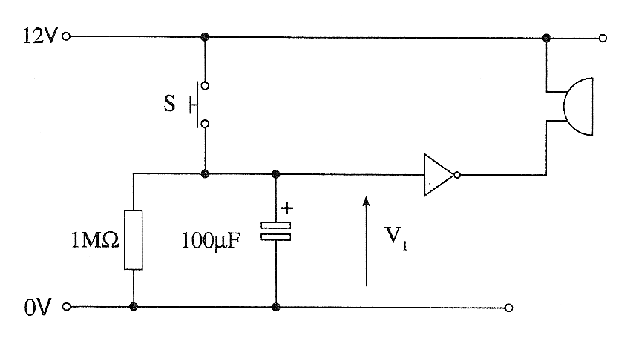

The capacitor is initially uncharged.
The buffer has the following parameters:

Parameter | Value
Input switching threshold | Half supply voltage
Input Impedance | infinite
Output current capability | 40mA

(i) Switch S is momentarily closed. Describe what you would observe.

..................................................................................................................................................
.
.................................................................................................................................................
[1]
(ii) Explain in terms of V1 and the data provided in the table what happens during the next few minutes after S is released.

..................................................................................................................................................

..................................................................................................................................................

..................................................................................................................................................
[3]

- A 555 monostable is used in an alarm system. When a push switch is momentarily closed a buzzer sounds for 1 minute.
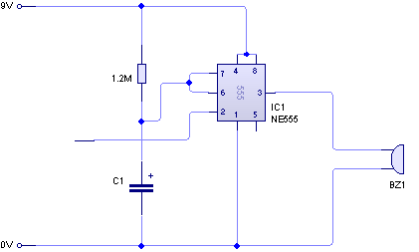

(a) Add a switch and any other necessary component to the diagram below to complete the trigger section of the monostable.
[2]

(b) Draw a sketch to illustrate the shape of the waveform produced at the output of the monostable when the pressure switch is momentarily pressed. Label the time axis to indicate when the switch was pressed and provide a suitable scale.

Voltage

Monostable
Output

Time

[2]

(c) Calculate a suitable value for capacitor C to allow the buzzer to come on for one minute when the pressure switch is momentarily pressed.

.........................................................................................................................................................

.........................................................................................................................................................

.........................................................................................................................................................
[2]

Exercise 7
- The following circuit diagram shows a 555 timer configured as an astable timer.

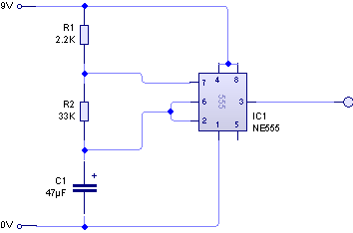

(i) Calculate the duration of the ‘on’ pulse for the above circuit.

......................................................................................................................................

......................................................................................................................................

......................................................................................................................................

(ii) Calculate the duration of the ‘off’ pulse for the above circuit.

......................................................................................................................................

......................................................................................................................................

......................................................................................................................................

(iii) Hence, or otherwise calculate the frequency of the output.

......................................................................................................................................

......................................................................................................................................

......................................................................................................................................

......................................................................................................................................

2. (a) Use the grid below to draw an astable waveform with a mark-space ratio of 2:1.

time

(b) Use the grid below to draw an astable waveform with a mark-space ratio of 2:3.

time

3. Complete the diagram below to show how an astable timer can be made from a Schmitt NOT gate, and choose component values to give a frequency of 2Hz.

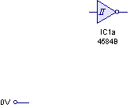

Exercise 8
1. The following diagram shows an astable built with a 555 timer used to clock an l.e.d.

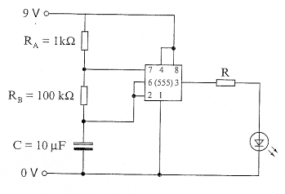
A data sheet for the 555 astable gives the following information
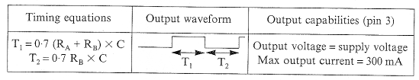
(a) Calculate the values of T1 and T2 for the astable.

.........................................................................................................................................................

.........................................................................................................................................................

.........................................................................................................................................................

.........................................................................................................................................................

.........................................................................................................................................................
[2]
(b) Explain how the circuit could be modified to provide a variable mark-space ratio.

.........................................................................................................................................................

.........................................................................................................................................................

.........................................................................................................................................................
[2]

- A Schmitt inverter can be used as an astable circuit.

(a) Complete the circuit diagram for the astable circuit.

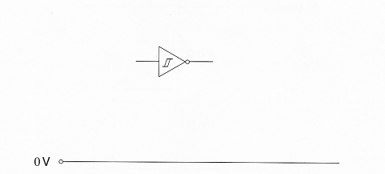
[2]
(b) Draw a sketch to illustrate the output waveform produced by the astable. Your sketch should show clearly how an astable waveform differs from a monostable waveform.

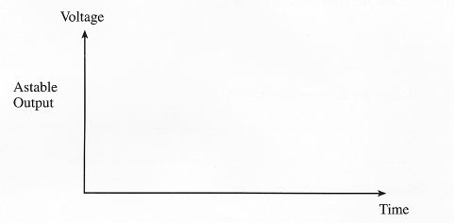
[2]

- The following diagram shows a 555 timer being used as an astable.
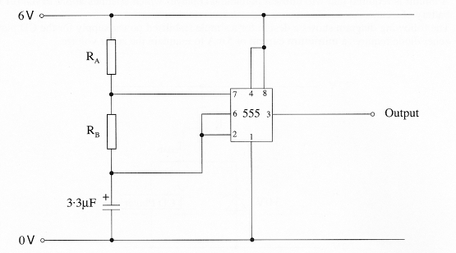
(a) The output signal has a mark:space ratio of 4:1. Sketch two cycles of the output signal. Label the mark T1 and the space T2.
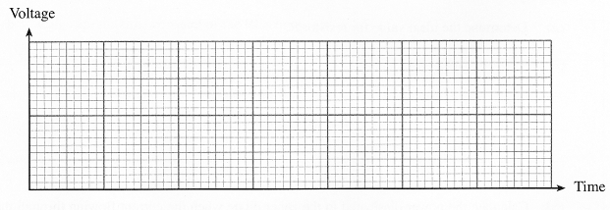
[3]
(b) The space T2 has a duration of 30 ms. Calculate the value of resistor RB that will produce this space when C = 3.3μF.

.........................................................................................................................................................

.........................................................................................................................................................

.........................................................................................................................................................
[2]
(c) Determine the value of resistor RA.
.........................................................................................................................................................

.........................................................................................................................................................
[1]

Exercise 9
- The D-type flip-flop in the diagram is rising-edge triggered.

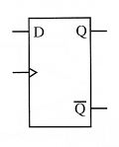

The signals applied to the clock and data inputs are shown below.
Complete the timing diagrams for the Q and 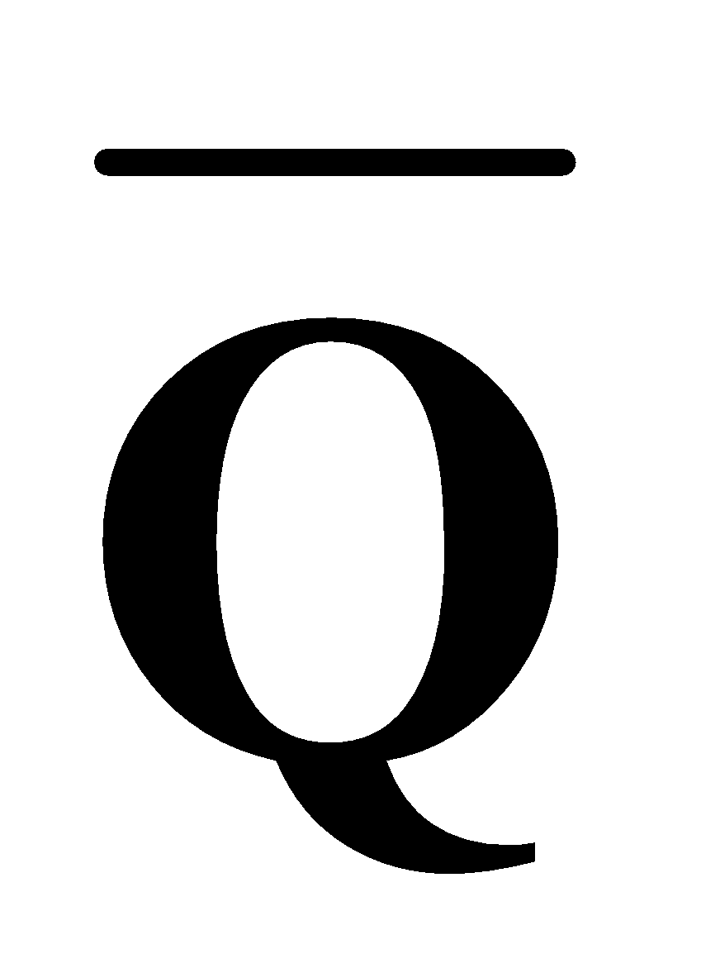 outputs.

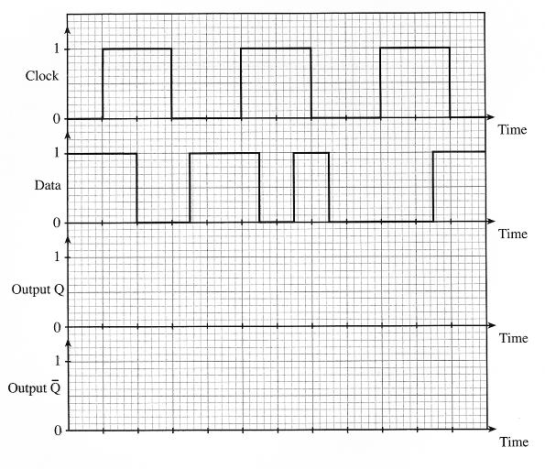
[4]
- The D-type flip-flop in the diagram is rising-edge triggered.

The signals applied to the clock and data inputs are shown below.
Complete the timing diagrams for the Q and outputs.
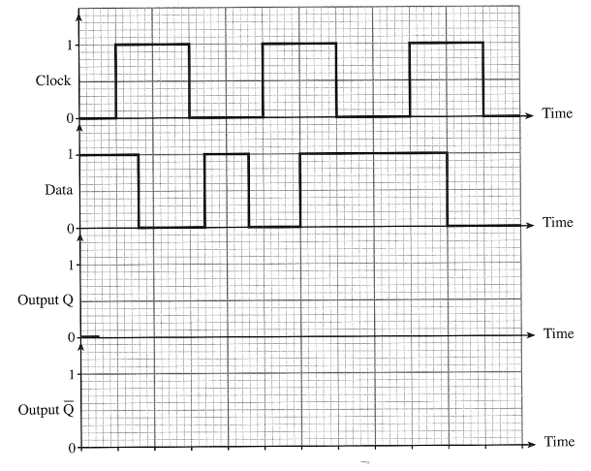
[4]

- (a) The following transition gate is used within a D type flip-flop to provide edge triggering.
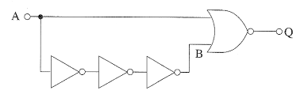
Each gate has a propagation delay of 10ns.
Complete the following diagram to show how the output Q changes when the pulse shown is applied to input A. Initially, output Q is at logic 0.
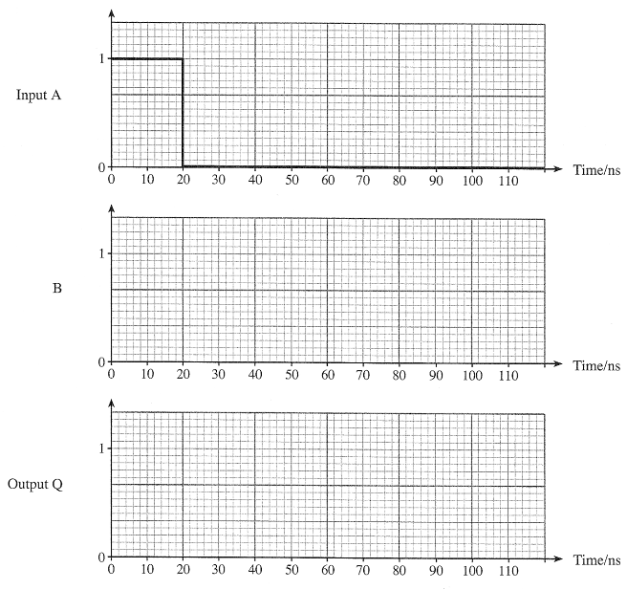
[4]
(b) The D-type flip-flop in the following diagram is rising-edge triggered. The Set and Reset inputs are active high.
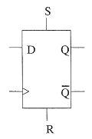
The signals shown in the timing diagram on the opposite page are applied to the D-type. Complete the timing diagram for the Q output.
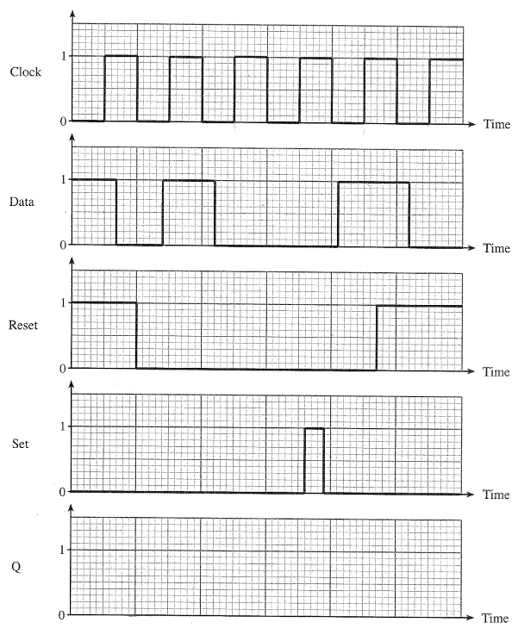
(c) The D-type flip-flop is modified as shown below. The Set and Reset inputs are disabled by connecting them to 0V.
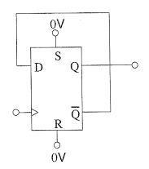

Complete the timing diagrams for the Q and outputs for the new arrangement.
The Q output is initially at logic 0.

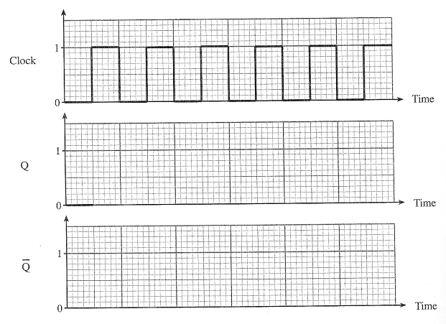
[2]

