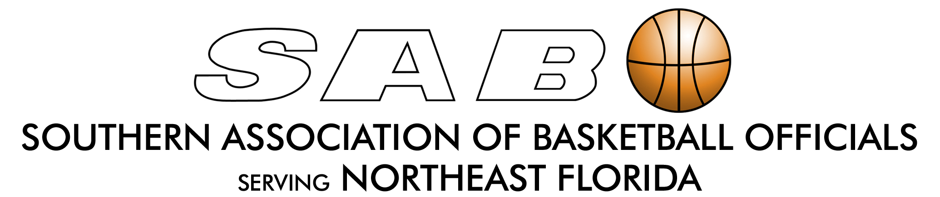

Independent Contractor Officiating Contract

I, _____________________________________, (herein referred to as Official), have been approved as an independent contractor with The Southern Association of Basketball Officials (herein referred to as SABO) to serve as a basketball official for the 2024-2025 basketball season.

By signing this Contractor Agreement, official acknowledges and agrees as follows:

(1) Official must provide SABO with a signed contract before accepting any
game assignments from SABO.

(2) Official’s acceptance of this contract is limited to assignments for the
2024-2025 basketball season (July 1, 2024 through June 30, 2025).

(3) Official is to serve as an independent contractor and NOT as an employee of
SABO. Therefore, official is NOT entitled to any employee benefits including
workers’ compensation other than payment for the worked game assignments.

(4) Official is solely responsible, at his or her own discretion, for obtaining health,
medical, liability, disability of life insurance benefits to cover any claims by,
or on behalf of, the official in the event of an injury, illness or death while
performing officiating duties before, during or after any game assignment.

(5) Official will NOT hold SABO, nor any of its Executive Board Members,
liable for any reason in the event of an injury, damage or loss of any kind
incurred as a result of the acceptance of a game assignment or while
performing officiating duties before, during or after any game assignment.

_________________________ ______________________________ ________
PRINT NAME SIGNATURE DATE

