How to collect the data?
Steps to follow:
- Selection of Study Area: Choose an area that has few trees, gardens, sunny patches, some ground cover. Such area could be around your home/school/office. Once you select the study area, keep collecting data from this area only. However ensure the area is safe, accessible and not remote or deserted.
- Duration: The schools can choose any of 2-3 months to collect authentic data.
- Selecting the day: Choose one day in the week and continue observing on that day every week e.g. if you choose Thursday then ensure you observe every Thursday.
- Selecting the time: Choose one morning hour on the chosen day. Ensure to observe between 8.00 a.m. to 11.00 a.m. for better results. So choose one hour from this time slot. Thereafter follow the same time throughout the study period.
Observation: Take one hour stroll in your study area and start your observation. For example if you are observing trees, first you will need to identify using the mobile app. Ignore those trees which are not in your mobile and concentrate only on those which you could identify. Carry a copy of the datasheet and fill in the required information except the weather data which could be collected from The Weather Channel website . In case of trees it may happen you will collect repeated data for same tree and it is correct to do so. This may not be applicable for birds and butterflies as they are mobile. You may take pictures of your study object which you could upload on the website while reporting the data.

Reporting of the Data:
Once you complete your field work and filled in your datahsheet, you may need to report the data through iNaturalist online platform- a Citizen Science Project and Online Social Network of naturalists, citizen scientists..
Website: https://www.inaturalist.org/projects/urban-inaturewatch-challenge-2-0 as well as send the filled datasheets on info@inaturewatch.org as well
Follow the below mentioned steps in pictures:

- Schools have to create a profile on the website www.inaturalist.org.

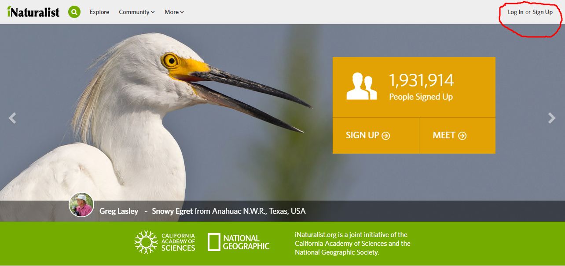

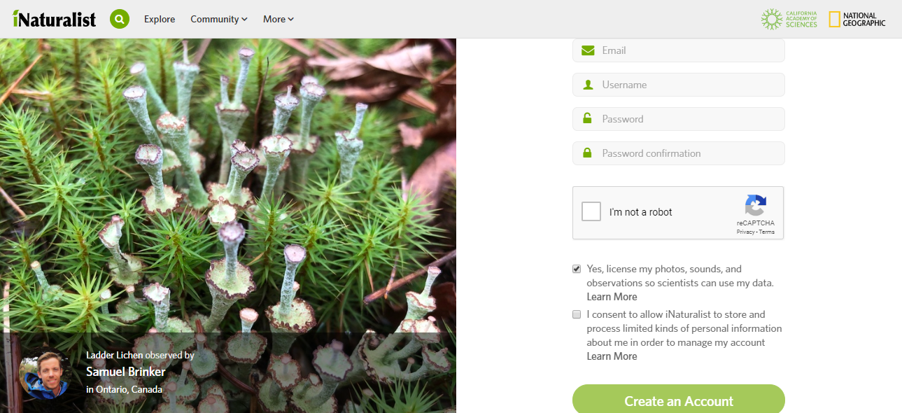

- Log in to your account

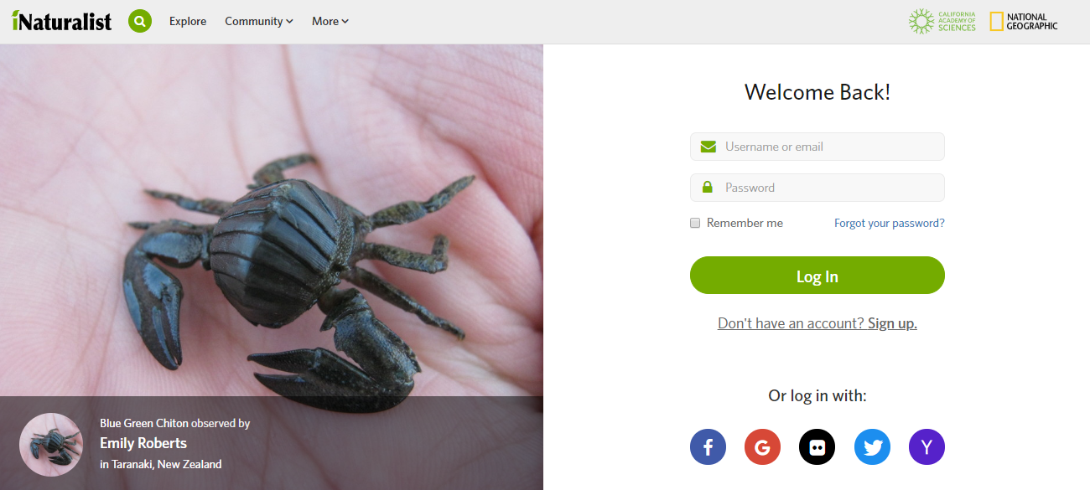

- Click the upload button to upload your data.

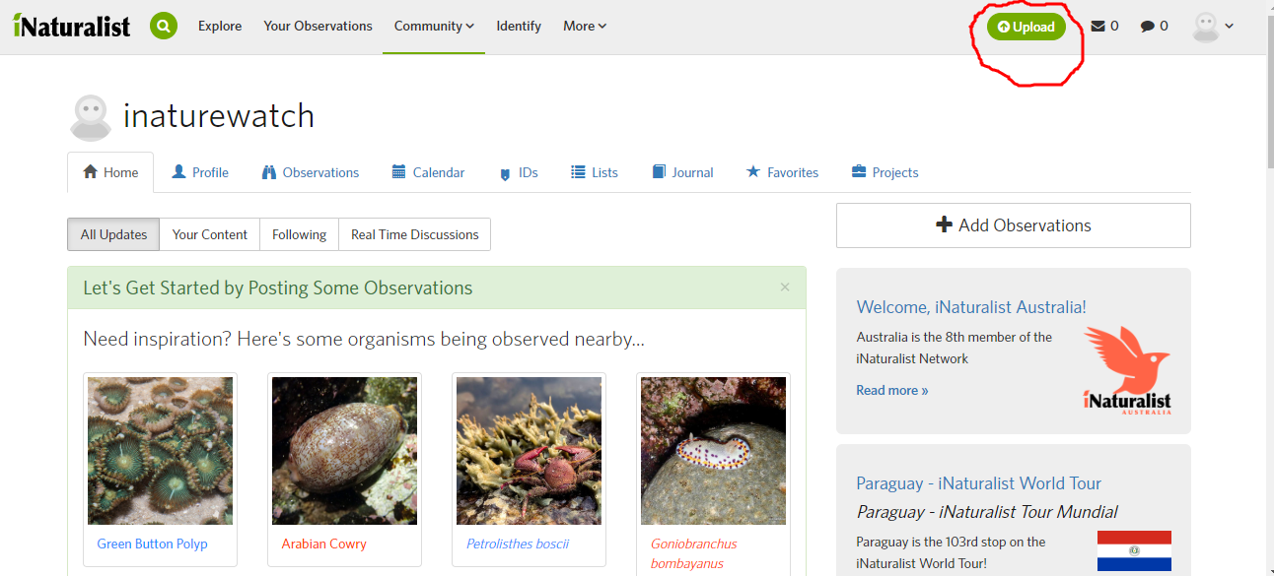

- Choose the file and upload the picture.

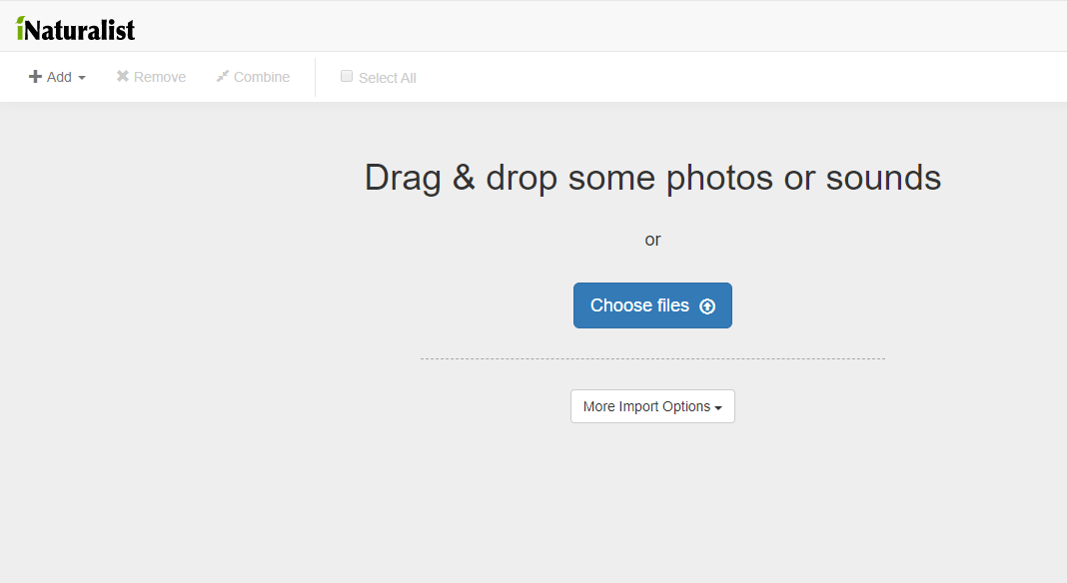

- Upload the observation with a picture of any species, schools have to fill other details with respect to the observation such as species name, date, location, description, choose field activity of the species, add project name- Urban iNaturewatch 2.0 and submit your observation

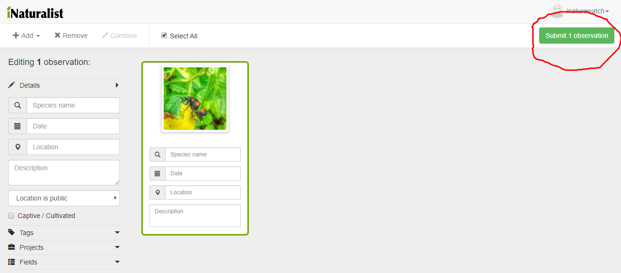

What will happen to your data?
Once your data is received at our end, we will scrutinize for correctness and then pool it with our master data. At end of the project, all data will be collated and the data will be analyzed to answer some of the basic questions such as:

- Is there any variation in the flowering/fruiting/seed dispersal/leaves shedding/new leaves among the trees found in four metros? If yes why? Whether it has to do anything with the changing weather? If yes, then how variable the weather has been?
- Is there any variation in the sighting/egg laying of butterflies among the four metros? If yes why? Whether it has to do anything with the changing weather? If yes, then how variable the weather has been?
- Is there any variation in the sighting/nesting of birds among the four metros? If yes why? Whether it has to do anything with the changing weather? If yes, then how variable the weather has been?
- Does the biodiversity vary in terms of different urban habitats? If yes, which were the most preferred habitats that supported maximum diversity of tree/bird/butterfly diversity?
- Among the following metros which city supports highest biodiversity and why?
We will share our research finding at end of the project and acknowledge all contributors

In case you have queries please contact:
Ms Shriya Randive
Environmental Officer
iNaturewatch Foundation
Cabin No 2, Shop No 4,
Shree Ambika Heritage,
Sector 1,
Kharghar NaviMumbai
Phone: 9987013144 Email: info@inaturewatch.org.

