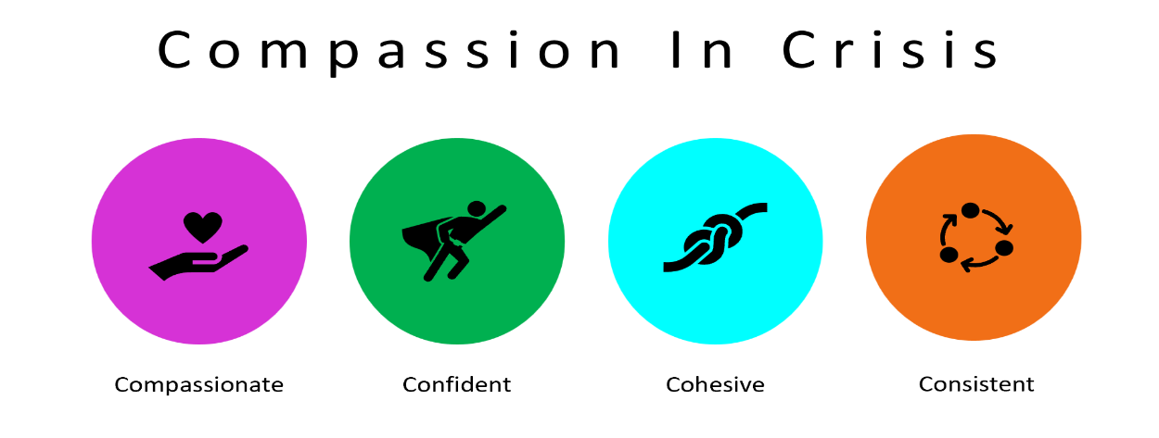
In collaboration with Surrey Heartlands, Surrey County Council, Surrey Coalition of Disabled People

Information Sheet

First of all, thank you for showing interest in this project.
What is this all about?

We are researchers who have personal experiences of using mental health services and are working with local health and care providers in Surrey to do research with local autistic people and people with learning disabilities.

Why do we want to do the project?

Autistic people and people with learning disabilities are more likely to experience mental health distress and crisis than people who are not autistic or have a learning disability. We want to do this project to ensure that the system response, inclusive of everyone around the person experiencing the crisis, is confident and capable and ensures that the crisis is resolved as swiftly and with as much compassion as is possible.

Crisis also often results in an admission to a mental health hospital or a specialist learning disability assessment and treatment unit (‘specialist unit’), often a long way from home. We also hope that by supporting a crisis confidently and compassionately, will help avoid unnecessary admissions.

To do this, we need to find out from both autistic people and people with learning disabilities what happened to them, when they were unwell and were admitted to a mental health hospital or specialist unit. We want them to tell us their stories so that we can help professionals to make changes, so that other autistic people and people with learning disabilities have better experiences in the future.

The research team members are:
- Dawn Benson
- Alex Hird
- Kirsty Smith
- Sarah Bredin-Kemp
- Alison Cockayne
- Claire Beezer
- Laurie Henderson (Artist in Residence)

What will happen to the finished research?

We will write what we find into a report, make a short film and podcasts about it. We hope that the research will be shared across Surrey, so lots of people can learn about what autistic people and people with learning disabilities want to happen.

How can you help and what is involved?

If you are an autistic person and/or a person with learning disabilities and you would like to tell us your story, we will arrange to meet with you in a place which is convenient for you. We suggest you have a friend or family member with you at the time. There will be 2 of us from the research team and we will tell you our names when we make the arrangements to meet. At the meeting we will ask you to tell us your story about being in crisis which may or may not have led to an unplanned admission to a mental health hospital or specialist unit.

You may prefer to record yourself telling the story and send it to us, or you may prefer to write your story down. We can also help you to create a storyboard or comic strip using art and photographs.

If you prefer, we can meet online using Zoom/Microsoft Teams or we can talk on the telephone or by e-mail. If we meet to talk, it should take about an hour, and we will reimburse you for any expenses you incur for transport or support.

With your permission, our conversation will be recorded for transcription purposes. We will not include your name so that no one can identify you. Afterwards, the recordings will be destroyed but the written record and the consent forms will be held securely, and not retained for longer than necessary.
If you decide to take part, you will be given this information sheet to keep. We will not share your identity with anyone, unless you want us to.

What if I change my mind?

If you change your mind, then you can withdraw from the study at any point and you do not need to tell us why and your data will be destroyed.

If I say ‘no’, what will happen?

If you choose to not take part, then nothing will happen. You may have been given this information sheet by someone else. We will only know about you if you contact us or if we have met you. Taking part, or not taking part will have no impact on your personal use of any services.

What are the possible disadvantages and risks of taking part?

There are no foreseeable risks associated with this study and it is hoped that you enjoy taking part. It is possible that you may find discussing your experiences upsetting. Should this be the case, we can stop the conversation and you will be referred to an appropriate source of support.

In the unlikely event that you have cause for complaint, please contact Dr Dawn Benson on dawn.benson@systemssafety.co.uk or call 07850 425 070.
If you remain dissatisfied with the response, you may wish to contact the Information Commissioner’s Office (ICO). Contact details, and details of data subject rights, are available on the ICO website at: https://ico.org.uk/for-organisations/data-protection-reform/overview-of-the-gdpr/individuals-rights

Confidentiality

Only the research team will know who said what, as all of the transcripts from our discussions will be anonymous and confidential. You will not be identified in any reports or publications from the research. You can withdraw from the research at any stage, without question and with no effect on your entitlement to future support.

Data Protection

All personal information about you (e.g. name, contact details) will be kept confidential. Information held electronically will be and held securely in Systems Safety Ltd IT system and paper documents, such as your consent form, will be stored securely in a lockable cabinet.

The data for this project will be in the form of anonymised quotes from interviews and focus groups. Participants who are quoted will be given a pseudonym, and any personal information about them will be anonymised so that they cannot be identified from the quote. Only the researchers led by Dr Dawn Benson, will have access to your personal details and data.
In accordance with the terms and conditions of funded research, it is possible that the research data (not personal contact details data) collected within this project may be required to be deposited in an approved data repository for archiving and sharing. All data will be fully anonymised before it is deposited, and no individual will be identified in the archived data.
Please note that in exceptional circumstances confidentiality may have to be breached in cases where a person is considered to be at risk or if required by law.

What happens immediately after data collection?

You will be debriefed and will have the opportunity to ask further questions regarding the study should you wish to do so.

Does the project conform to GDPR guidelines?

This research is being conducted in accordance with the General Data Protection Regulation (GDPR) guidelines.

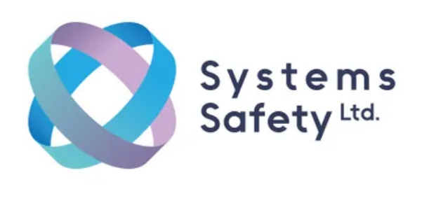 | info@systemssafety.co.uk  www.systemssafety.co.uk
Systems Safety is an inclusive and compassion driven, independent service improvement consultancy. We specialise in research, investigation and training to improve safety in health, social care, education and rescue services.

