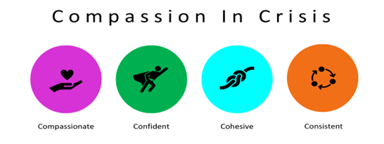
In collaboration with Surrey Heartlands, Surrey County Council, Surrey Coalition of Disabled People and Systems Safety.
Participant Consent Form
Before you decide to take part, you must read the accompanying Information Sheet.
This form is to confirm that you understand what the purposes of the research project are, what will be involved and that you agree to take part. If you are happy to participate, please tick each box to indicate your agreement, sign and date the form, and return to the researcher.
Please do not hesitate to ask questions if anything is unclear or if you would like more information about any aspect of this research. It is important that you feel able to take the necessary time to decide whether you wish to take part.
I understand that the information I provide will remain the subject of confidentiality and anonymity, that is, names, places and dates will not be included in any research outputs. The information that I give will be used only for the purpose of this research project and is subject to data protection.
I understand any data which is produced from the information that I share will be stored securely and will be destroyed at the end of the project.
I have been told that I can withdraw from the project at any stage, without giving a reason, and that my involvement in this project will not influence the services I receive.
I understand that the research conversation and/or focus group will be recorded for the purposes of transcription.
I have read the information sheet about the research project and agree to take part in:
a research conversation
a focus group discussion
Participant’s Name | Date | Signature
Researcher’s Name | Date | Signature

