4th Session of 14th SPA of DPRK Held
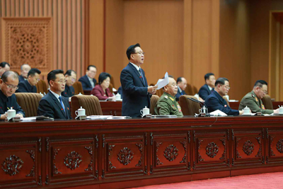

Pyongyang, January 18 (KCNA) -- The 4th Session of the 14th Supreme People's Assembly (SPA) of the Democratic People's Republic of Korea (DPRK) took place at the Mansudae Assembly Hall on Jan. 17.

Present there were the deputies to the SPA.

Attending it as observers were officials of the Central Committee of the Workers' Party of Korea (WPK), the SPA Presidium, the Cabinet, the armed forces organs, ministries and national institutions, and chief secretaries of the city and county committees of the WPK, chairpersons of the people's committees, chairpersons of the cooperative farm management committees and officials of major industrial establishments.

The platform was taken by Choe Ryong Hae, member of the Presidium of the Political Bureau of the WPK Central Committee, first vice-chairman of the State Affairs Commission (SAC) of the DPRK and president of the Presidium of the SPA, Ri Pyong Chol, member of the Presidium of the Political Bureau of the Central Committee of the WPK, vice-chairman of the Central Military Commission of the WPK and secretary of the WPK Central Committee, and Kim Tok Hun, member of the Presidium of the Political Bureau of the Central Committee of the WPK and premier of the DPRK Cabinet.

Among those on the platform were Pak Thae Song, Ri Il Hwan, Kim Tu Il, Choe Sang Gon, Kim Yong Chol, O Su Yong, Kwon Yong Jin, Kim Jong Gwan, Jong Kyong Thaek, Ri Yong Gil, Pak Thae Dok, Ho Chol Man, Kim Hyong Sik, Pak Myong Sun, Ri Chol Man, Thae Hyong Chol, Kim Yong Hwan, Pak Jong Gun, Yang Sung Ho, Jon Hyon Chol and Ri Son Gwon, and members of the SAC of the DPRK, vice-presidents, secretary general and members of the SPA Presidium and vice-chairpersons of the SPA.

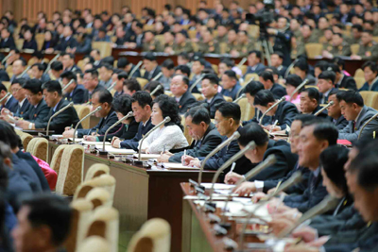

Choe Ryong Hae, president of the SPA Presidium, made an opening address.

The session decided on its agenda items; an organizational matter, on thorough implementation of the five-year plan for national economic development set forth at the 8th WPK Congress and on review of fulfillment of the state budget for Juche 109 (2020) and the state budget for Juche 110 (2021) of the DPRK.

The session discussed the first agenda item.

Cabinet members suggested by Deputy Kim Tok Hun, premier of the Cabinet, upon authorization by the WPK Central Committee, were appointed with the unanimous approval.

The director of the Central Public Prosecutors Office was dismissed and appointed.

Deputy Kim Tok Hun, premier of the Cabinet, took an oath on behalf of the members of the Cabinet.

Deputy Kim Tok Hun made a report on the second agenda item and Deputy Ko Jong Bom, minister of Finance, on the third agenda item.

Speeches were made on the basis of a study of the reports.

The speakers said that the execution of the state budget for last year was correctly reviewed and the state budget for this year was properly drawn up, they voiced full support and approval.

They seriously analyzed and reviewed shortcomings, causes and experience in the efforts for making remarkable progress in the development of the country's economy and improvement of the people's standard of living in the past. They also suggested realistic and dynamic measures for implementing the new 5-year plan.

Adopted at the session with the unanimous approval were the ordinance of the SPA of the DPRK "On thoroughly implementing the five-year plan for national economic development set forth at the Eighth Congress of the WPK", the decision of the SPA of the DPRK "On approving the execution of the state budget of the DPRK for Juche 109 (2020) " and the ordinance of the SPA of the DPRK "On state budget of the DPRK for Juche 110 (2021)".

President of the SPA Presidium Choe Ryong Hae made a closing address.

