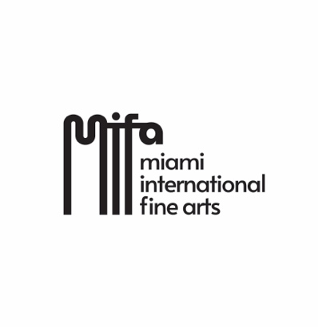

ROSARIO RIVERA-BOND SHOWS “EMOTIONALLY CHARGED” AT MIFA
The exhibition "Emotionally Charged" by Dominican-American artist Rosario Rivera-Bond, will open on February 3, 2024, at 5:00 p.m. at Miami International Fine Arts, MIFA Gallery, curated by Katherine Chacón.
This exhibition gathers 25 artworks that “cover a decisive period in Rivera-Bond's trajectory, marked by the softening of elements in her language. Gradually, her paintings abandon thick layers of vibrant color to make room for neutral spaces that act as a background, without forsaking emotional and intuitive power”, according to the curator.
Chacón points out that “Since the mid-1970s Rivera-Bond undertook a commitment to the expression of her inner self, creating an extensive body of work that, while falling within contemporary expressionist currents, is difficult to classify. Her practice, although predominantly pictorial, is openly experimental and includes collage, installation, assemblage, agglomeration, and participatory events.”
“Addressing the challenges of contemporary creation with fierce automatism, Rosario Rivera-Bond's practice rests in the unstable field of free associations and in the liminal tension between abstraction and representation, terms that become insufficient to describe a work that pertains to the emotion, the memory, and even deeper and more indecipherable drives” Chacón explained.

Rosario Rivera-Bond is a Dominican-American artist based in Miami, Florida. She studied Interior Architectural Design in Santo Domingo and Visual Arts at the Académie de la Grande Chaumière, Paris, and the Camden Art Centre, London. She has held two solo exhibitions at the Museum of Modern Art in Santo Domingo and many others in galleries and cultural institutions in Paris, London, and Miami. She has participated in more than 60 group exhibitions in USA, Latin America, Europe, and Asia. In 2017 and 2018 she was awarded the Juror’s Choice Award at the ArtBrazil Contemporary Art Fair in Fort Lauderdale.

The exhibition "Emotionally Charged" by Rosario Rivera-Bond will remain open until February 28, 2024, in Miami International Fine Arts, MIFA, 5900 NW 74th Ave, Miami, FL 3316.

