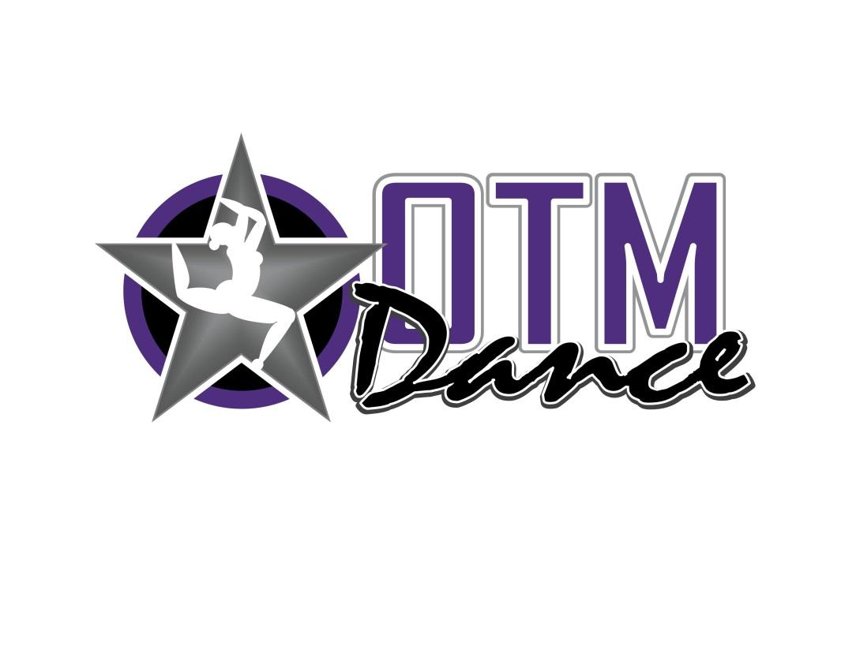

**HD VIDEO ($25)**

**2025 On the Move Dance Recital**

All three recitals can be viewed by streaming or download via a private online link sent to your email address. Order options:

1. Direct link: <https://square.link/u/iok6Zivs>
2. QR code below

Please allow several weeks for email to arrive from [robprice6@gmail.com](mailto:robprice6@gmail.com) that will provide the shared google folder link. If you have any technical problems or permission issues, contact RP Media at the same email address.

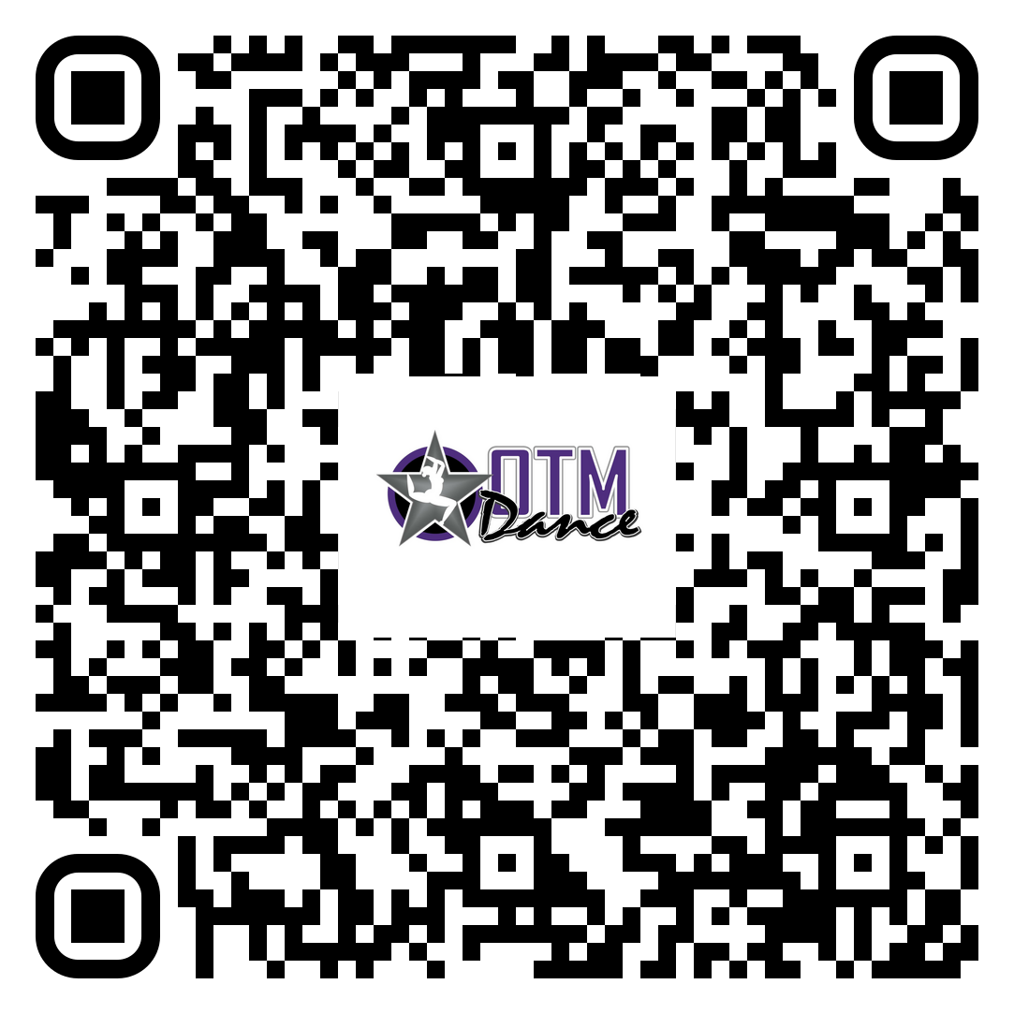

**Produced by since OTM Dance opened in 2009!**