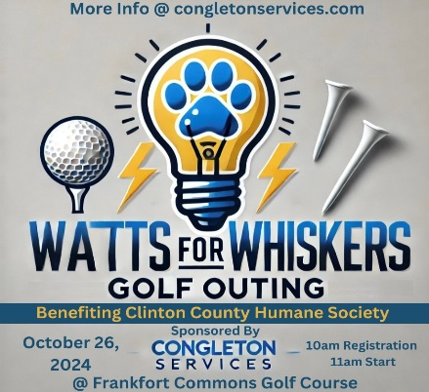**Sponsor Form**

**Watts Fore Whiskers**  
Golf Outing Fundraiser  
Hosted by Congleton Services, LLC  
Benefiting the Clinton County Humane Society  
**October 26, 2024** at the Frankfort Commons Golf Course

**Sponsor Information**

Please complete the following information to confirm your sponsorship:

* **Company Name:** ______________________________________
* **Contact Person:** ______________________________________
* **Title/Position:** ______________________________________
* **Phone Number:** ______________________________________
* **Email Address:** ______________________________________
* **Mailing Address:** ______________________________________

**Sponsorship Amount: ($100 minimum hole sponsor)**

___________________

**Payment Options**

Please indicate how you would like to provide payment:

* Check
  + Please make checks payable to **Aaron Congleton Services**)
* Cash

**Return Completed Form**

Please return this form by **October 21, 2024** to:

Congleton Services, LLC  
**55 E Morrison St, Frankfort**

[congletonservices@gmail.com](mailto:congletonservices@gmail.com)

765-650-6926