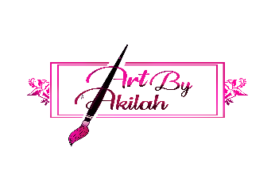
( Registration Form)

Name of Student _________________________________________________________

Date of Birth______/_____/______

Gender_______________ Age of child_____________

Monthly ( ) Daily ( )

Amount Paid__________________

Parent(s) or legal guardian

Name:__________________________________________________________________

Address:________________________________________________________________

Home Phone#:(______)________-_____________

Work Phone#:(______)________-_____________

Email:__________________________________________________________

Emergency Contact:_______________________________________________________

Emergency Contact Phone Number: (_____)_________-_________

Does your child have any allergies? Yes ( ) No ( )

If Yes what are they? ________________________________________________________________________

________________________________________________________________________

Individuals authorized to pick up my child :

________________________________________________________________________

Cancellation of Classes

If a class is cancelled due to inclement weather or any other circumstances they will be rescheduled. No refunds will be granted when students leave class early.

Medical

I give permission to Art by Akilah to take whatever emergency measures are judged necessary for the care and protection of my child(ren) while under their supervision. In case of a medical emergency, I understand that my child will be transported to an appropriate medical facility by the local emergency unit for treatment if the local emergency team deems it necessary. It is understood that in some medical situations Art by Akilah’s staff will need to contact the local emergency resources before the parents/guardians, the child’s physician, and/or other adults acting on the parents/guardian behalf are notified. I understand that any expenses incurred will be borne by the child’s family.

Parent/Guardian Signature: __________________________________________________

Picture Policy

I give permission to Art by Akilah to publish pictures of my child and their artwork while conducting

these classes for promotional use.

Parent/Guardian Signature: __________________

