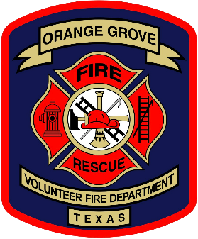

Orange Grove Volunteer Fire Department
PO Box 1228, Phone: (361) 384 - 2681
Orange Grove, TX 78372 Email: Info@ogvfd.org

March 1st, 2026

Dear Valued Supporter of the Orange Grove Volunteer Fire Department,

A year have come and gone since our 16th Annual Cook-Off in 2025. Last year was a great success! The event would not have been success if it wasn’t for the support from you. We hope you will consider purchasing a sponsorship for this year’s 17th annual OGVFD Cook-Off!
The Orange Grove Volunteer Fire covers the City of Orange Grove and approximately 227 square miles surrounding our city. We are a 100% volunteer department operating a fleet of 2-Class A Pumpers, 1-2500 Gallon Tanker, 4-Wildland Firefighting Trucks, 1-Quick Response Mini-Pumper, 1-Rescue Pumper equipped with the “Jaws of Life” and many other rescue tools, 2-mobile command vehicles to transport firefighter, and a Rescue Boat for water rescue and recovery. The age of most of our equipment exceed 20+ years, but with a great maintenance program we have been able to keep it in service. But good preventative maintenance is costly.
Our firefighters train hard throughout the year and strive to meet the criteria set forth for volunteer firefighters to become certified through the State Fireman and Fire Marshall’s Office. Along with training, the equipment and personal protective equipment needed for each firefighter continues to grow in price. The cost of training and equipping a firefighter rapidly increases each year resulting in higher operating expenses.
Every year the cost of operating our department becomes greater as the cost of training, equipment, fuel, tires and repairs increase and the only way we can offset the costs are through fundraisers and donations that enhance our small city budget. We hope that you choose to support us in our endeavors as a sponsor. We are offering four levels of sponsorships: Platinum, Gold, Silver, and Bronze, all which are tax deductible. See Below:

Platinum | Gold | Silver | Bronze
$1,000 | $500 | $300 | $100
Logo or Name on  Individual Sponsor Banner | Logo or Name on  Gold Sponsor Banner | Name on  Silver Sponsor Banner | Name on Bronze Sponsor Banner

We certainly hope that you choose to support us in our endeavor as a sponsor. Along with your sponsorship, you will get your name on the banner of your sponsorship displayed at different locations throughout the event, your sponsorship name announced throughout the day on the PA system and a mention of your sponsorship on our Facebook page. We would also like to invite you to the event being held in conjunction with the Orange Grove Area Museum’s Pioneer Days, April 18th, 2026. This is a community festival with vendors, food, music, and other activities.
Thank you for your kind consideration and we hope to hear from you soon! Please feel free to contact us by our e-mail: Info@ogvfd.org or by contacting David Gebert: 361-701-3035 or Jeff McFatter: 361-701-3857.

Thank you,
Orange Grove Volunteer Fire Department &
Chairmen of the OGVFD Cook-Off

