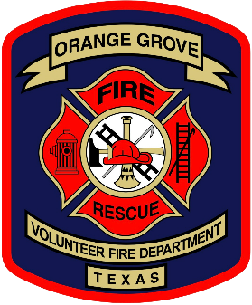
Orange Grove Vol Fire Dept.
17th Annual IBCA BBQ Cook-Off
Sponsorship Form
April 17th and 18th, 2026

SPONSOR INFORMATION

COMPANY NAME: _________________________________________________________

CONTACT NAME: __________________________________________________________

ADDRESS: _________________________________________________________________

CITY: _____________________________________ STATE: _____ ZIP: ______________

PHONE NO: ________________________________________________________________

EMAIL: ____________________________________________________________________

SPONSORSHIP

- Platinum $ 1,000.00 Logo or Name on Individual Sponsor Banner
- Gold $ 500.00 Logo or Large Name on Gold Sponsor Banner
- Silver $ 300.00 Medium Name on Silver Sponsor Banner
- Bronze $ 100.00 Name on Bronze Sponsor Banner

Total Due $_____________

Name to be printed on banner for all levels: __________________________________________________

Select if wish to utilize logo for Platinum or Gold Level. You will be contacted by the information you list above for arrangements.

PAYMENT METHOD

Please specify type of payment to be used for Entry Fees and include when returning entry form

- Cash
- Check Check No: ________________________

Make all checks payable to Orange Grove VFD and return to PO Box 1228, Orange Grove, TX 78372 by April 3rd, 2026.
If wishing to pay by Credit Card, please contact David Gebert at 361-701-3035

