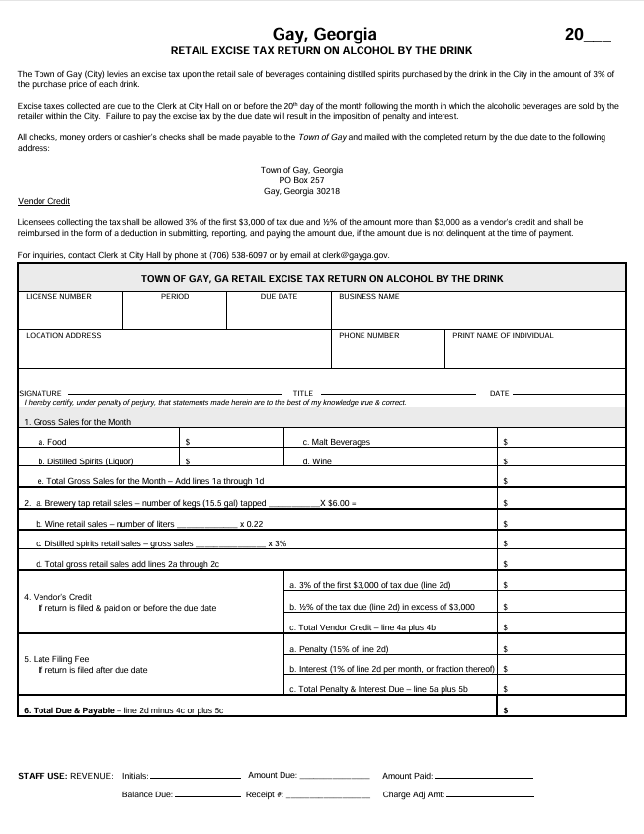
gaycityhall@bellsouth.net

