Town of Gay, Georgia
ALCOHOLIC BEVERAGE APPLICATION

Application Requirements:
- Business Location and Business Type Must Meet Ordinance Requirements
- All Applicants Must Be A US Citizen or Legal Permanent Resident
- Anyone That Owns 20% or More of the Business Must Be Identified and Complete Licensee Forms
- If a Manager is Appointed, They Must Also Complete All Licensee Forms

Additional Items to be Submitted with Application
⃝ Copy of Lease or Property Closing Documents
⃝ Application Forms for All Owners & Manager (pgs. 7-13)
⃝ Copy of Driver’s License for All Applicants
⃝ Recent Photo of Each Applicant

Application Process
- Complete Alcohol Beverage Application Packet and Submit to City Hall
- Each Owner/Licensee and Manager Must Register for Fingerprints
- Inform the City Clerk the Applicants Have Gone to Sheriff’s Dept for Fingerprinting
- Application will be Processed & Reviewed by Town Staff
- If Approved, All License Fees Must be Paid & Town License Will Be Issued
- Business Must Apply and Receive a State Alcohol License

Application Fee:

$ 100.00 NON-REFUNDABLE Application Fee

Submit Applications To
Town Clerk’s Office
19125 Hwy 85
Gay, Ga 30218

State of Georgia Alcohol License Must Be Acquired Online at: https://gtc.dor.ga.gov/
(229) 420-1221or (229) 420-1220
https://dor.georgia.gov/alcohol-tobacco/alcohol-licenses-permits

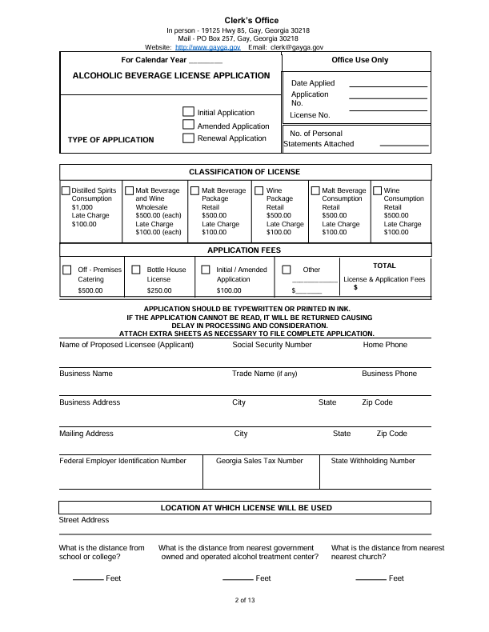
gaycityhall@bellsouth.net

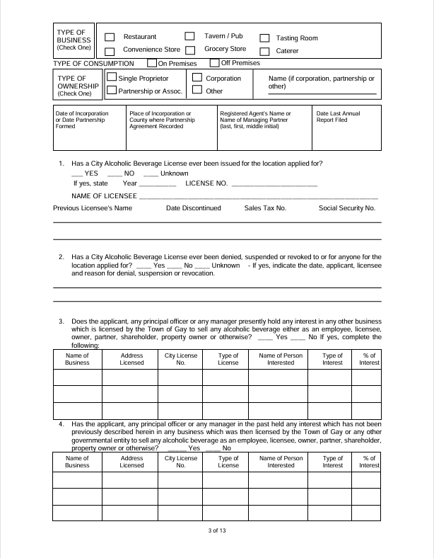

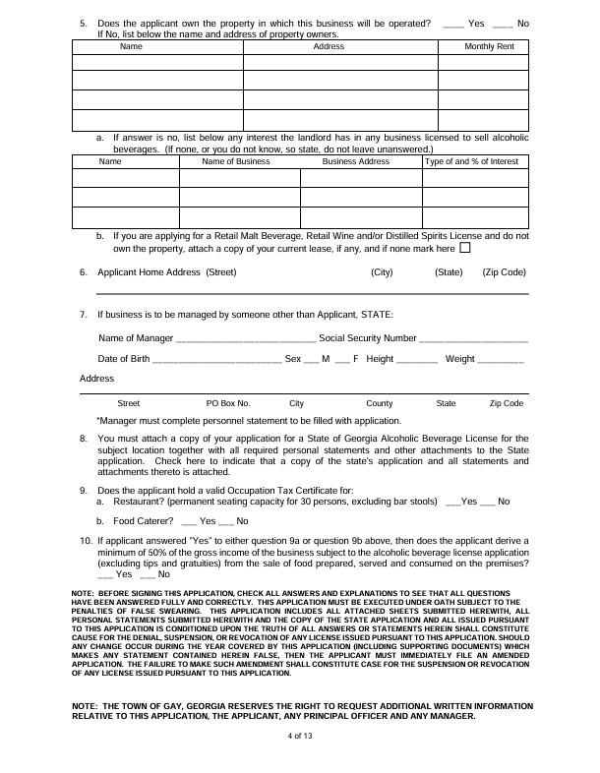

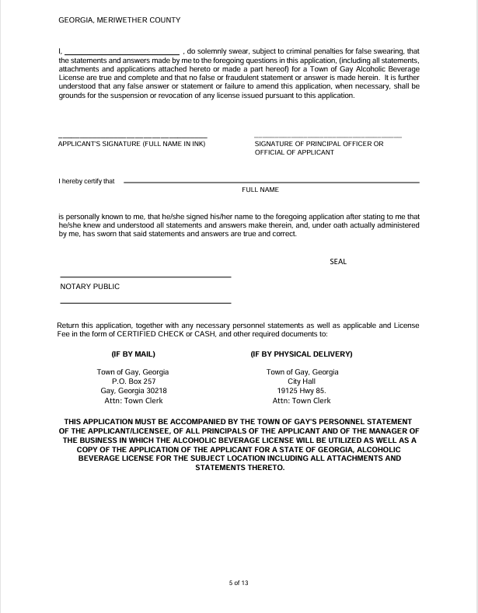

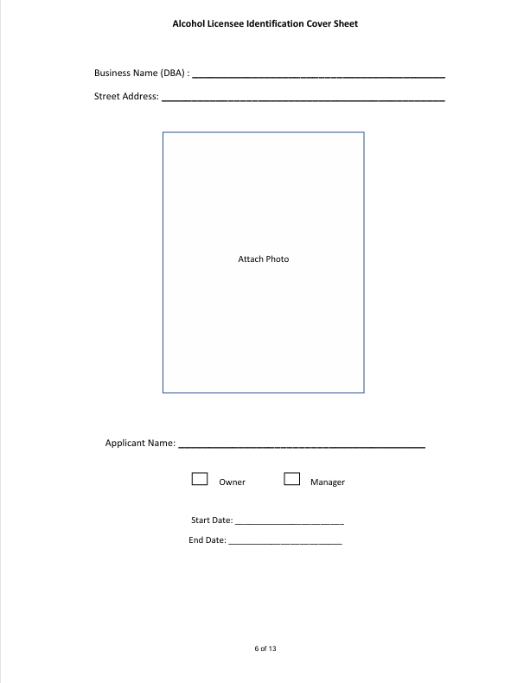

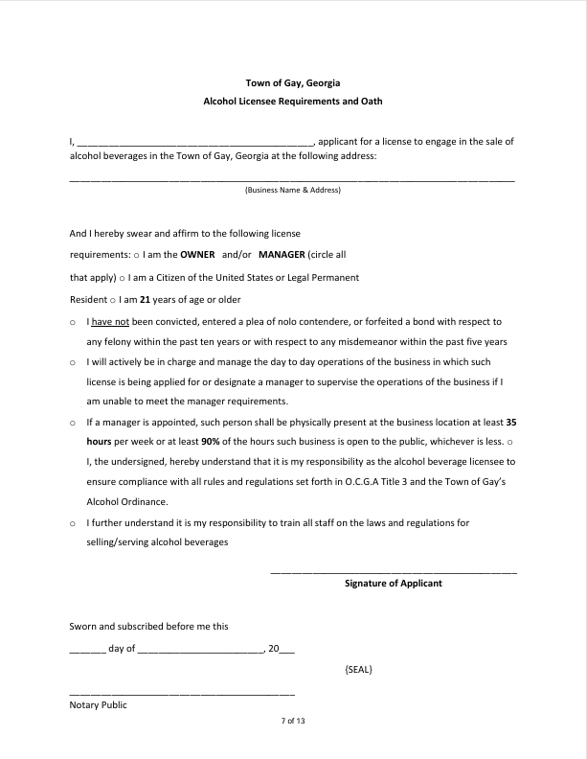

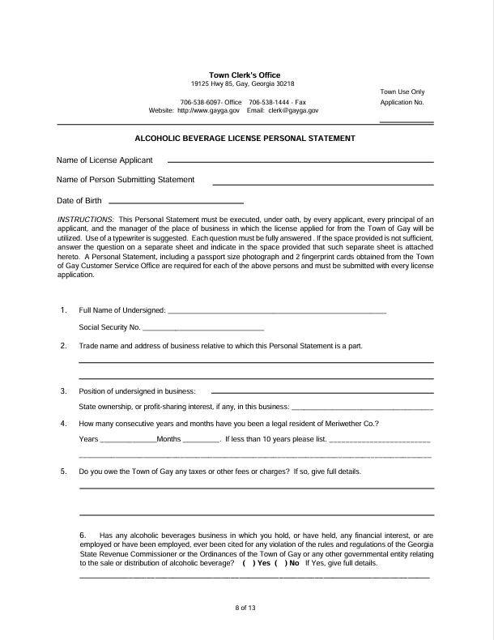

gaycityhall@bellsouth.net

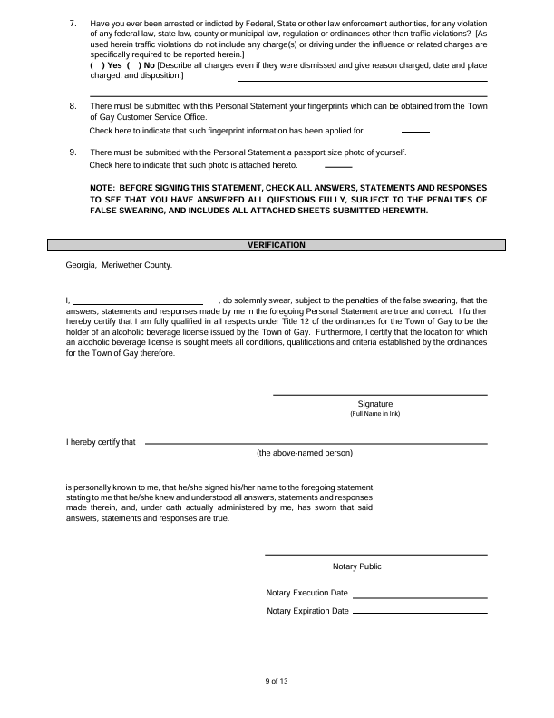

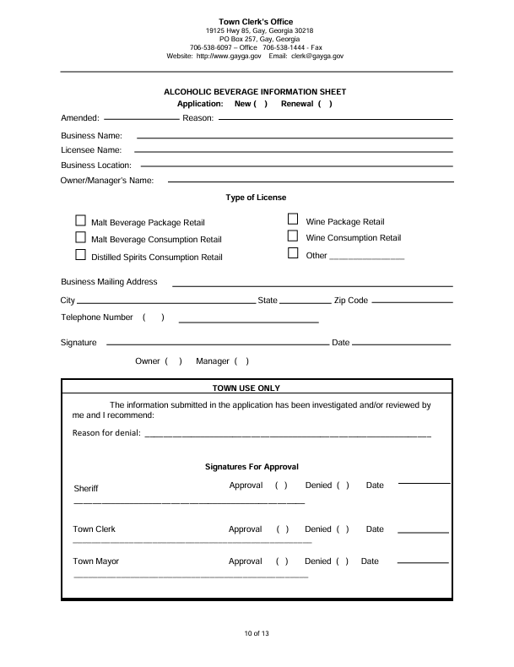

gaycityhall@bellsouth.net

