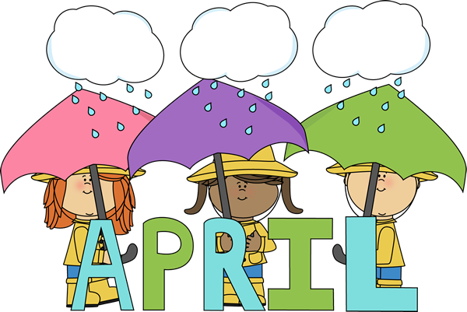

SpecialVisitors

* Frank Sarris Librarian Visit 4/4/18, 4/18/18

@ 10:15 am

Special Days

Easter – April 1st

April Fool’s Day – April 1st

Earth Day – April 22nd

Arbor Day – April 27th



Samantha – April 1st

Nathan – 2nd

Kyleigh – April 6th

Madelynn – April 11th

Ellie – April 11th

Vincent – April 17th

Ms. Rachel – April 19th

Willow – April 20th

Ava – April 21st

Tyler – April 26th

Laila – April 28th

We have successfully “marched” through March and “sprang” into April! One minor April Fool’s joke with snow but hopefully we are in the clear! Thank you, thank you, THANK YOU! To all the families who participated in our Sarris Easter candy fundraisers. It was a huge success. A very special thank you to Ben Frank & Family, they were the top sellers and will receive a gift card! 😊

We had a great visit with the Easter Bunny, lots of brave kiddos this year! We will get a copy of their photo out to you. The preschoolers and older toddlers had a quick Easter egg hunt in the rain but still had fun! Treats were left for everyone big and small. 😊 We hope all had a great Easter!

If you have not received them yet, the photos from picture day are in! All the children did a great job with the photographer, a few shy ones but we got mostly all smiles. We are very happy with the photos and hope you are too!

As always-Please let us know when your child is feeling under the weather & especially if they have something ’to share` so we can post a notice for all to be aware & cautious. We post these notices on our entrance/exit doors. If you plan to take your child in for a well visit-PLEASE take a Health Assessment form. We need to keep all files current & up to date as possible.

As always, if you have any comments or suggestions we would love to hear from you! We are working on a few parent involvement activities to share with you, also some new fundraising ideas as well as field trips and special events. Stay tuned!

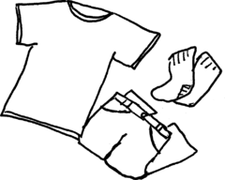

Spring is finally here! Please send in an appropriate change of clothes to swap out the winter layers!

If you have any extra “bottoms” to be used here for anyone that would be greatly appreciated! Even school age sizes!

**Themes**

Spring/Growing Things/ Flowers

Farm Animals

Solar System

Earth Day/Recycling & Arbor Day