
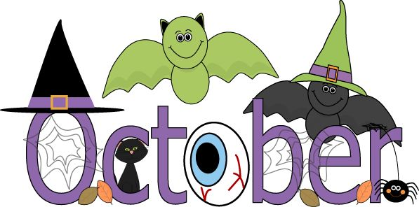



Themes
Community Helpers
Fire Safety/Prevention
Halloween Safety
Halloween
Halloween Party & Parade
Friday
10-30-26 @ 10 am

Nico – October 1st
Ms Kelsey-2nd
Brooks – October 13th
Ricky – 21st
Henry – October 31st
Ms. Taylor – October 31st
Important Dates
School Dates:
Canon Mac: No school – Act 80 Day - Monday, October 12th
Ringgold: No school – Teacher Inservice – Wednesday, October 14th
Peters: No school – Parent Conference- Thursday, October 29th & No school – Inservice Day – Friday, October 30th

Shout out to Parker Roche who became a Big Brother on Sept 18th when his brother Griffin was born! And to Aurora Sed who also became a Big Sister on Sept 27th when her brother Ronan was born! Congratulations!
BOO! October is here! Hopefully, we will be treated to a sweet and sunny Halloween party and Parade. We are shooting for Friday, October 30th approx. 10am, depending on the weather. Please have your child here by 9:30 am. You may send them in their PJ’s with their costumes, labeled, in a NON-plastic bag, we will dress them up for the parade at 10am! As always, if this is not your child’s schedule day, you may add it or come in with your child for the parade. You are always welcome. But we must warn you, you will be turned into vendors & will be forced to pass out the treats as the children parade down the street (I really mean the parking lot ) We have a total of 45 possible parading pumpkins… 18 preschoolers, 7 older toddlers, 11 young toddlers, 9 infants. There may be 21 more witches and warlocks that come after school, they get all the tricks!
October is also Fire Prevention Month. Please check the batteries in your smoke detectors & have an escape plan. We will have a Firemen visit from the North Strabane Fire Department & maybe Finleyville, dates to be determined. 😊
With the fall and winter months upon us, please be considerate during 2hr delays/cancellations/early dismissals. These days can sneak up on us or happen without notice, so we understand the confusion. Please let us know as in advance as you can so we can ensure we have enough staff to watch over the children. You can call/text or email to ensure your child has a spot. We are sorry if this causes any issues, but we need to maintain the appropriate child to staff ratios. Thank you in advance!
If you have any changes... phone number, job, insurance, address, please bring in that info ASAP. Well visit? Please take a Health Assessment form. We need to keep all files current & as up-to-date as possible. Feeling under the weather? Let us know if it is something to share; we will post a notice for all to be aware. 😊

Have A Spooky Fun October!!
Please send in an appropriate change of clothes for the Fall!

