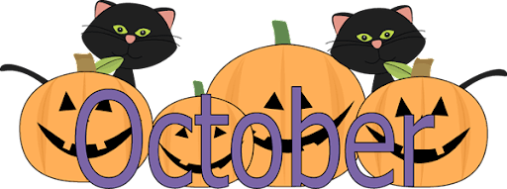
Monday | Tuesday | Wednesday | Thursday | Friday | Saturday | Sunday
Happy belated birthday!!!  ****Ms Jaidyn’s 9/1  ****Ms Ibby’s 9/15 |  |  | 1  Happy Birthday Nico! | 2  Happy Birthday Ms Kelsey! | 3 | 4
5 | 6 | 7 | 8    Happy Birthday  Emma! | 9 | 10 | 11
  13  CanMac No School    Columbus Day | 13  Happy Birthday Brooks! | 14  Ringgold No School | 15  Vision Screenings | 16  Boss’s Day | 17 | 18
19 | 20 | 21 Unity Day! National “Bullying” Day-wear ORANGE  Happy Birthday Ricky! | 22 | 23 | 24 | 25
26 | 27 | 28 | 29  Peters No School | 30  Peters No School  Halloween Party & Parade @ 10 am | 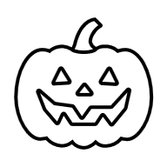  31  Happy Birthday  Henry & Ms. Taylor! | 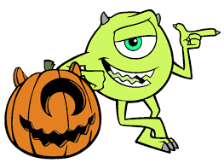  Themes: Community Helpers, Fire Safety & Prevention, Halloween Safety & Halloween   Pumpkin Wishes and Candy Corn Kisses! Happy Halloween!

