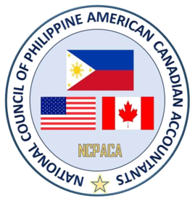
NCPACA 32nd Annual Professional Development Convention
“Harnessing the Power of Information and
Creating Diversified and Global Innovation”

Anaheim Marriott Hotel - Anaheim, California
August 31 to September 02, 2018

SCHEDULE OF ACTIVITIES

Friday, August 31, 2018
Officers of the Day – Gina Mellendrez Lilly Chilton
Vladi Rivera & Gino Miguel..

Time | Activity | Location
9:00am - 5:00pm | Registration | Grand G Alcove
9:00am - 5:00pm | Exhibits (Daily) | Grand Ballroom  G - K
9:00am - 11:30pm | NCPACA/PASCPA Office (Daily) | Gold Key III
12:00noon - 1::00pm | NCPACA Past Presidents’ Meeting | Grand Ballroom C
1:00pm - 2:00pm | NCPACA Auxiliary Meeting | Grand Ballroom B
1:00pm - 2:00pm | NCPACA Board Meeting | Grand Ballroom C
2:00pm - 3:00pm | NCPACA Board of Councilors’ Meeting | Grand Ballroom Salon E
 | PRACTICE – CHAPTER’S TALENT NIGHT PRESENTATION
2:00pm - 4:00pm | PASCPA – Los Angeles | Suite 304
3:00pm – 4:00pm | AFCA Toronto | Suite 312
3:00pm - 4:00pm | FAATx Houston | Los Angeles/La Jolla
3:00pm - 4:00pm | AFAA New York | Newport Beach/  Rancho Las Palmas
4:00pm - 5:00pm | AFAA New Jersey | Suite 304
4:00pm -5:00pm | FAACPA Seattle | Suite 312
4:00pm - 5:00pm | PCPA of Greater Chicago | Los Angeles/La Jolla
4:00pm – 5:00pm  5:00pm - 6:30pm | PICPA San Francisco  Photo Session | Newport Beach/  Rancho Las Palmas  Grand F Foyer
6:30pm – 11:30pm | Talents Night | Grand Ballroom Saloon F

