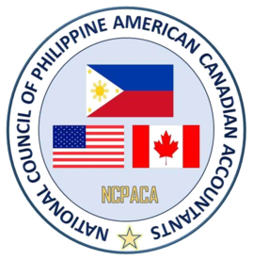
NCPACA 32nd Annual Professional Development Convention
“Harnessing the Power of Information and
Creating Diversified and Global Innovation”

Anaheim Marriott Hotel - Anaheim, California
August 31 to September 02, 2018

SCHEDULE OF ACTIVITIES

Sunday, September 2, 2018
Officers of the Day – Gina Mellendrez Lilly Chilton
Vladi Rivera & Gino Miguel..

Time | Activity | Location
7:00am - 8:00am | Breakfast | GB Salon F
8:00am - 8:25am | Philippines Tax Journey by TRAIN  Ms. Rhodora Icaranom, CPA | GB Salon E
8:25am - 9:40am | Non-Profit GAAP Update - Karen D. Miessner, CFE, CPA, Partner Assurance & Advisory, SingerLewak | GB Salon E
9:40am - 9:50am | Break
9:50am - 11:05am | Artificial Intelligence and Data Analytics, Technology Update – Jared M. Savin, FIMC, CMC, EMERITUS, CPA, Pres/CEO, Cambridge Technology Consulting Group | GB Salon E
11:05am - 11:55am | Fraud – Kathy Johnson, CPA, CFF, CGMA, MBA, CPA Forensics | GB Salon E
11:55am - 12:05pm | Break
12:05pm - 1:05pm | Lunch  Presentation of New Councilors | GB Salon F
1:05pm - 1:15pm | Break
1:15pm - 2:05pm | Revenue Recognition – Mark Dauberman, CPA, CALCPA Education Foundation CPE Instructor | GB Salon E
2:05pm - 3:20pm | Update 2018 TCJA – Arthur Dillenger, CPA, Author | GB Salon E
3:20pm - 3:25pm | Closing Remarks – Marlo Mallari, EVP / President Elect – NCPACA | GB Salon E
3:25pm - 3:35pm | Break
3:35pm - 4:20pm | General Membership Meeting – NCPACA | GB C - D
4:30pm – 5:30pm | Mass – Most Reverend Bishop Oscar Solis  Bishop of the Diocese of Salt Lake City, Utah | GB Salon F
5:30pm - 6:30pm | Photo Session | GB Salon F Foyer
7:00pm - 1:00am | President`s Gala Night | GB Salon E

