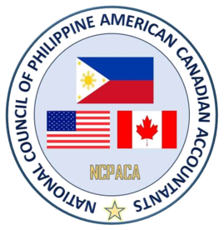
NCPACA 32nd Annual Professional Development Convention
“Harnessing the Power of Information and
Creating Diversified and Global Innovation”

Anaheim Marriott Hotel - Anaheim, California
August 31 to September 02, 2018

TALENTS NIGHT SHOW
Theme “Disney Fantasy Night”
Friday, August 31, 2018

 | PROGRAMME
 | NATIONAL ANTHEM | The Star-Spangled Banner  Ms. Michelle L. Anaya
- | WELCOME ADDRESS | Lupang Hinirang  Ms. Annie Nepomuceno, Educator, Producer and Performer  Managing Director of Music Arts Event  O Canada  AFCA Toronto Chapter  Marissa Bueno, CPA  PASCPA President
 | INVOCATION | Vladimir Rivera
 | DINNER & ENTERTAINMENT  INTRODUCTION OF TALENTS NIGHT SHOW | PASCPA Auxiliary President  Gino Miguel  PASCPA Auxiliary VP
 | ANNOUNCEMENT OF RULES & INTRODUCTION OF JUDGES  CHAPTER PRESENTATIONS | Minda Longkines  NCPACA Auxiliary President  Monette Rivera  NCPACA Convention Co-Chair
 | ENTERTAINMENT  ANNOUNCEMENT & AWARDING OF WINNERS  CLOSING REMARKS  DANCE DANCE DANCE  MINDA LONGKINES & MONETTE RIVERA  Masters of Ceremonies | PASCPA-LA Youth Presentation  Paolo Alcedo, Choreographer  Vee Cristobal, CPA, CGMA  NCPACA Convention Co-Chair

