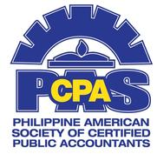
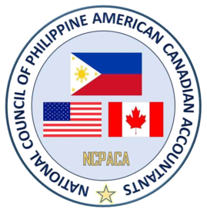
NCPACA 32nd Annual Professional Development Convention
“Harnessing the Power of Information and
Creating Diversified and Global Innovation”

Anaheim Marriott Hotel - Anaheim, California
August 31 to September 02, 2018

YOUTH PROGRAM
“Career Paths and Opportunities in the Accounting Profession” Saturday, September 01, 2018

 | PROGRAMME
8:00am - 8:55am | REGISTRATION
8:55am – 9:00am  9:00am - 9:05am  9:05 am - 9:10am  9:10am - 9:40am OPENING REMARKS April Misa, CPA PASCPA Past VP Membership Youth | INVOCATION  WELCOME ADDRESS  OPENING REMARKS  BUSINESS APTITUDE AND PERSONALITY TEST |  |  | Fernando Austria, CPA  PASCPA Past VP Membership  Marie Domingo, CPA  PASCPA Youth Advisor and  PASCPA Past President  April Misa, CPA  PASCPA Past VP Membership Youth  Rusten O’Neil, CPA  PASCPA Past VP Membership  Various Speakers
9:40am – 11:25am | OPPORTUNITIES IN ACCOUNTING  Public Accounting – Audit/Assurance  Public Accounting – Tax  Academia  Finance and Strategy Consulting  Financial System Architect & Development (IT) |  |  | Various Speakers
11:25am - 11:55am  11:55am - 1:25pm  1:25pm – 1:55pm | FINANCIAL LITERACY  How to Manage Your Money  Lunch with the Delegates (Grand Ballroom F)  AICPA PROGRAMS AND INITIATIVES |  |  | AXA Advisors  Kim Drumgo  Director of Diversity & Inclusion, AICPA
1:55pm – 3:10pm  3:10pm – 3:55pm  3:55pm – 4:00pm | PROFESSIONAL IMAGE BUILDING  Professional Resume Updates  Linkedin Profile Building & Professional Photo Op  CPA EXAMINATION & CA LICENSING REQUIREMENTS BY ROGER CPA REVIEW  CLOSING REMARKS |  |  | Accounting Principals  Robert Half Professionals  Andrea Johnson  Ed Ortiz, CPA, CGMA  NCPACA Scholarship Committee Chairperson
 | MODERATORS:
APRIL MISA, RUSTEN O’NEIL, MARIE DOMINGO & KATHLEEN REYES

ADVISER:
SAM MISA

