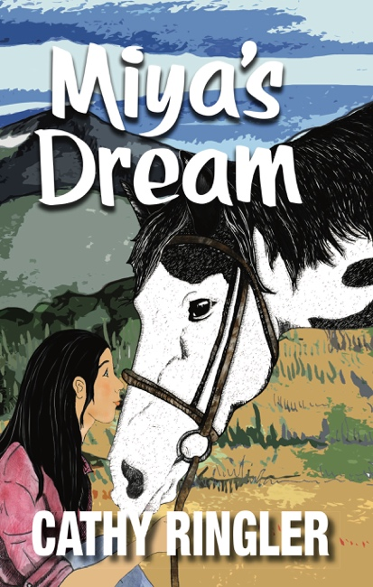
FOR IMMEDIATE RELEASE
Contact: Patricia Landy
506 Tyler Street,
Fort Collins, CO 80521-3121
307-630-5752
www.crystalpublishingllc.com
Email: plandy@me.com

Growing up is hard when
You’re fat,
Your horse is fat,
And your life is one fat mess.

Fourteen-year-old Miya Skippingbird, aka Mega Miya, knows all about middle school struggles. She wants the perfect horse that will win every time so the rodeo kids will notice her in a good way and maybe even like her. However, Miya’s hope is shattered when her “Dream” turns out to be a stubborn paint mare who has no interest in running, much less winning a barrel race.

“She’s the fattest horse I’ve ever seen. Yeah, she’s stubborn. She wouldn’t move. First, she was so barn-sour she acted like she couldn’t gather up enough strength to leave that end of the arena. Then, no matter how hard I kicked her, she barely trotted. To top it off, when I asked her to lope, she tried to kill me. So, there you have it. She’s not a dream. She’s my worst nightmare.”

Can Miya overcome the viral videos and humiliation?
Can she face her nightmares and stand up?
Can she move forward? Take a chance?

Sometimes you might win something unexpected. . . .

Author: Cathy Ringler’s first book, Miya’s Dream, began as a story she told her daughters as they rode their horses home in the evenings. Throughout her teaching career, she continued to write and tell stories to inspire, motivate, and educate. In the summertime, Cathy can be found riding her horse along wilderness trails, camping in the mountains, and jotting down stories in the tent by lantern light. Miya’s Dream is her first book.

Website: cathyringler.com
Email: cathyringler@yahoo.com
Facebook: cathyringler

MIYA’S; Author: Cathy Ringler; Publisher: Crystal Publishing LLC; Category: MG, Western/Adventure; Soft Cover: 978-1-942624-54-7, $12.95; Availability Amazon, LULU, Ingram Sparks, Kindle, Smashwords, KOBO.

