

**GRADE 12 LIFE SCIENCES**

**Assignment Term 3 task: Evolution TOTAL: 50**

**TIME: 60 minutes**

**INSTRUCTIONS AND INFORMATION**

**Read the following instructions carefully before answering the questions.**

1. This is a formal SBA task and needs to be done under supervised conditions in the classroom.
2. Each learner completes this task on his/her own (under test conditions).
3. Present your answers per the instructions of each question.
4. Draw all diagrams in pencil and labels in blue ink.
5. The diagrams in this task may NOT be drawn to scale.

**BACKGROUND INFORMATION**

The Theory of Evolution is regarded as a scientific theory since various hypotheses relating to evolution have been tested and verified over time.

**QUESTION 1**

|  |  |  |  |  |
| --- | --- | --- | --- | --- |
| The fat content of cow's milk may vary between 2,6% and 5%. A farmer has found that there is a high demand for low-fat milk (milk with a fat content of 3% or less). He determined the fat content in the milk produced by the cows on his farm. The results of his survey are given in the table below. | |  | |  |
|  | |  | |  |
| 1.1 | Draw a histogram to represent the results of the survey. | | (6) | |
|  |  | |  | |
| 1.2 | Calculate the percentage of the farmer's cows that produce low-fat milk. Show ALL your working. | | (3) | |
| 1.3 | State the type of variation that occurs in the cows, based on the evidence in the table. | | (1) | |
| 1.4 | Give an explanation for your answer to QUESTION 1.3. | | (1) | |
|  |  | | **(11)** | |

**QUESTION 2**

|  |  |  |
| --- | --- | --- |
| Study the diagram of the rhinoceros group shown below. | |  |
| State whether the following statements regarding the diagram depicted above are **TRUE** or **FALSE**. | |  |
| 2.1 | The diagram above is called a phylogenetic tree. | (1) |
| 2.2 | All species have a horn. | (1) |
| 2.3 | **B** became extinct before **A**. | (1) |
| 2.4 | **E** is not extinct. | (1) |
| 2.5 | **F** and **G** share a more recent common ancestor than **E** and **F**. | (1) |
| 2.6 | **D** was present and living on earth for more than 10 million years. | (1)  **(6)** |

**QUESTION 3**

|  |
| --- |
| Identify the **mechanisms of reproductive isolation** illustrated in each of the following diagrams. Write only the answer next to the question number (3.1 to 3.4) in your ANSWER BOOK. |

|  |  |
| --- | --- |
| **3.1** | **3.3** |
| **3.2** | **3.4** |

**(4)**

**QUESTION 4**

Read the extract below and use the information and your own knowledge to answer the questions that follow:

|  |
| --- |
| **Picky female frogs drive evolution of new species in less than 8 000 years**  "Female frogs in a tiny rainforest of Australia have driven the evolution of a new species", according to scientists from the University of Queensland, the University of California, Berkeley, and the Queensland Parks and Wildlife Service.  Between 1 and 2 million years ago the original population of tree frogs had become geographically separated into the northern and southern populations of tree frogs when the rainforest become smaller (see images below). A new species arose after the original two populations (the northern and southern populations) of the green-eyed tree frog re-established contact sometime during the last 8 000 years, resulting in three species of tree frog living in this rainforest today.  This speciation happened in the following manner. Although the mating calls of the northern and southern male frogs had become different from each other - which are what females pay attention to in the mating game - the two groups could still interbreed. However, their offspring were less viable. In particular, the northern and southern groups had apparently changed enough during their million-year separation that offspring of southern females and northern males fail to develop beyond the tadpole/embryo stage. |

The southern females, however, were pickier about their mates than the northern females. And in one area of contact that had become isolated from the southern range, the southern females were extremely picky, to the extent that they almost never mated with northern males.

Southern females that mated with southern males had healthy offspring and over several thousand years, this behaviour created a new reproductively isolated population – essentially a new species – that is unable to mate with either of the original northern and southern frog populations. The male frog mating call in the *new isolated south population* has changed significantly from both the northern and southern groups' calls. The calls of these male frogs had a higher pitch, were of shorter length and had a faster rate. (See graphs below)

**Location and mating calls of the Green-Eyed Tree frog populations in the rainforest of Australia.**

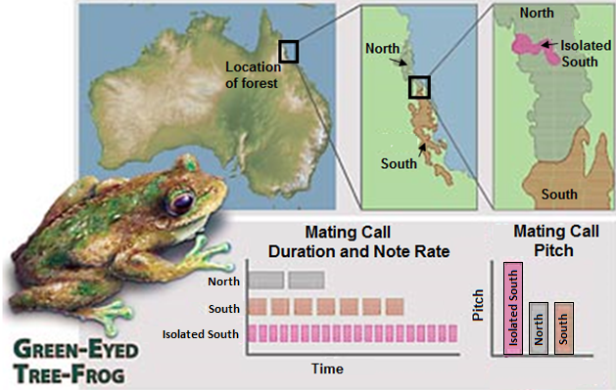

Adapted from: <https://www.berkeley.edu>

|  |  |  |
| --- | --- | --- |
| 4.1 | State TWO ways in which the mating call of the new isolated southern frog population differs from the north population of frogs. | (2) |
| 4.2 | Suggest why the new isolated southern population of frogs could be considered a separate new species. | (2) |
|  |  |  |
| 4.3 | Describe how it can be proven that the new isolated southern population of frogs is a different species. | (2) |
|  |  |  |
| 4.4 | Use the theory of natural selection to explain the changes seen in the mating calls of the new isolated southern male frogs. | (6) |
| 4.5 | Can the information in this article be considered reliable? Provide a well explained reason for your answer. | (2) |
|  |  | **(14)** |

**QUESTION 5**

|  |  |  |
| --- | --- | --- |
| An owl perched on a branch  Description automatically generatedThere is variation in tawny owls. Some are white and others are brown in colour.    Scientists studied these owls over a period of 30 years, from 1980 to 2010, to determine the effect of climate change on the survival of the owls. During this time, climate change caused increasing global temperatures with less snow falling each year.  The scientists:  • Conducted the investigation over the same four months of winter each year  • Observed the same population of tawny owls each year  • Determined the number of tawny owls of each colour that survived every year  The results are shown in the graph below: |  |  |

|  |  |  |  |
| --- | --- | --- | --- |
| 5.1 | Identify the dependent variable in this investigation. |  | (1) |
| 5.2 | What conclusion can be made about the suitability of each colour owl to survive in more snow? |  | (2) |
|  |  |  |  |
| 5.3 | (a) How many brown owls were there in 1990?  (b) In which year was the number of brown and white owls the  same?  (c) What was the percentage increase in the number of brown  owls from 1995 to 2005? Show all workings. |  | (1)  (1)  (3) |
|  |  |  |  |
| 5.4 | Explain the results obtained from 2000 to 2010 for the white owls. |  | (3) |
|  |  |  |  |
| 5.5 | Describe how the scientists determined the number of owls that survived each year. |  | (3) |
| 5.6 | Name ONE variable that was kept the same. |  | (1)  **(15)**  **[50]** |