LIFE SCIENCES Grade 12

Total
50
Assignment Term 3 2023

Marking Guideline

QUESTION 1

1.1 | Archaeopteryx shows characteristics of Velociraptor/ dinosaurs and Yanornis /birds | (2)
1.2 | (a) Teeth/long bony tail/ wing claws  (b) Feathers/wishbone or furcula/ wings | (1)  (1)
 |  | (4)

QUESTION 2

2.1 | - Certain types of plastics  - Crop fertilizers  - Synthetic and natural oestrogen  Mark first TWO only Any | (2)
2.2 | At night | (1)
2.3 | To attract females for mating | (1)
2.4 | - The higher the concentration of oestrogen the shorter the call duration of the frogs  OR  - The lower the concentration of oestrogen the longer the call duration of the frogs  Mark the first ONE only Any | (2)
2.5 | - They would be less likely to attract females  - and reproduction rate would decrease | (2)
 |  | (8)

QUESTION 3

3.1 | Organisms that are able to interbreed and produce fertile offspring. | (1)
3.2 | - The population of the ancestral species of anoles became separated by the sea */onto different islands.  - and split into different populations.  - There was no gene flow between the different populations.  - Since each population was exposed to different environmental conditions /the selective pressure was different  - natural selection occurred independently in each of the populations  - such that the individuals of the different populations became very  different from each other  - genotypically and phenotypically.  - Even if the populations were to mix again  - they would not be able to interbreed  - The six populations are now different species.  1* Compulsory mark + Any 5 | (6)
3.3 | - All the male anoles had small dewlaps originally.  - The male anoles frequently displayed their dewlaps,  - to attract females to reproduce /establish their territory.  - According to Lamarck’s law of use and disuse  - The dewlaps became larger  - The larger dewlaps were passed on to the next generation  - according to his law of inheritance of acquired characteristics  - This is why all the male anoles had a large dewlap. Any | (4)
3.4 | - Breeding at different times of the year  - Species-specific courtship behaviour  - Infertile offspring  - Prevention of fertilisation  Mark the first TWO only | (2)
 |  | (13)

QUESTION 4

 | - There is variation in genes for heamoglobin formation in the population  - Some have the allele for sickle cell trait  - and some have the allele for normal haemoglobin  - Individuals with sickle cell trait are resistant to malaria  - They are more likely to survive and reproduce  - They pass the allele for sickle cell trait/ recessive allele onto their offspring  - Over time sickle cell trait is more prevalent in the population  Any | (5)

QUESTION 5

5.1 | The selective breeding of organisms to achieve a desirable phenotype /characteristic/trait | (1)
5.2 | (a)  - Hard-working  - Highly alert  - Intelligent  - Hardy  - Agile /able to move quickly and easily  Mark first ONE only Any | (1)
 | (b)  - Small-to-mid-sized  - Loyal  - Loving  Mark first ONE only Any | (1)
5.3 | - Harmful traits can become more common in future generations of the Icelandic Sheepdog breed  - as the gene pool becomes limited | (2)
5.4 | - Characteristics that are desirable/beneficial to humans are being selected  - The characteristics are chosen by humans / it is an artificial process  - It is not necessarily beneficial for the organism  Mark first TWO only Any | (2)
 |  | (7)

QUESTION 6
6.1 | (a) Year  (b) Antibiotic resistance (%) in three types of bacteria | (1)  (1)
6.2 | The study was conducted over a 20 year period | (1)
6.3 | (a) VRE  (b) FQRP | (1)  (1)
6.4 | 60 x 100  105  = 57,1 % | (2)
6.5 | 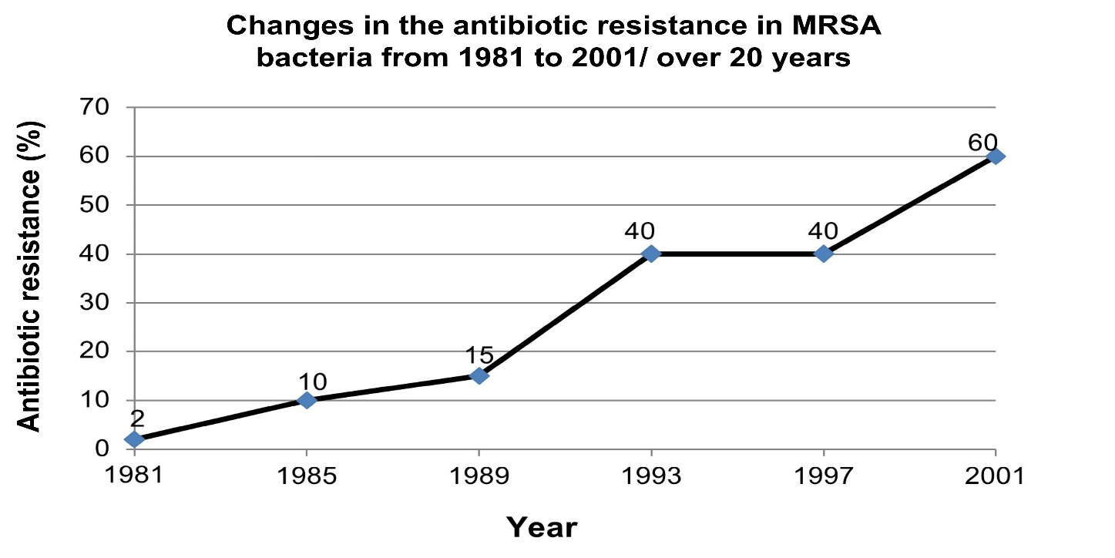
 | Criteria Mark allocation  Correct type of graph (line graph) (T) 1  Title of graph including both variables (C) 1  Correct scale of the X and Y-axis (S) 1  Correct label of the X and Y-axis including units (L) 1  Plotting of points (P) 1: 1 to 5 points correctly plotted 2: all 6 points correctly plotted | (6)  (13)
 |  | [50]

Assignment Term 3
Weighting: Practical Skills
Practical Skills
Follow instructions | Handle equipment | Make observations | Draw a diagram | Calculation | Interpret | Design/Plan

Weighting: Cognitive Levels & Levels of Difficulty
Question | Cognitive Levels |  |  |  | Levels of Difficulty
 | Level A  Knowledge | Level B  Understanding | Level C  Application | Level D  Evaluate, analyse & synthesize | Easy | Medium | Difficult | Very difficult
1.1 |  | 2 |  |  |  | 2
1.2 (a) |  | 1 |  |  | 1
1.2 (b) |  | 1 |  |  | 1
2.1 |  | 2 |  |  |  | 2
2.2 |  | 1 |  |  | 1
2.3 |  |  | 1 |  |  | 1
2.4 |  |  |  | 2 |  |  | 2
2.5 |  |  |  | 2 |  |  |  | 2
3.1 | 1 |  |  |  | 1
3.2 | 4 |  | 2 |  |  | 6
3.3 |  |  | 4 |  |  | 4
3.4 | 2 |  |  |  |  | 2
4 |  |  | 5 |  |  |  | 5
5.1 | 1 |  |  |  | 1
5.2 (a) |  | 1 |  |  | 1
5.2 (b) |  | 1 |  |  | 1
5.3 |  |  | 2 |  |  |  | 2
5.4 |  |  | 2 |  | 2
6.1 (a) |  |  |  | 1 |  |  |  | 1
6.1 (b) |  |  |  | 1 |  |  |  | 1
6.2 |  |  | 1 |  |  |  | 1
6.3 (a) |  | 1 |  |  | 1
6.3 (b) |  | 1 |  |  | 1
6.4 |  | 2 |  |  |  | 2
6.5 | 1 | 3 | 2 |  |  | 6
Total | 9 | 16 | 19 | 6 | 11 | 25 | 10 | 4
Percentage | 18 | 32 | 38 | 12 | 22 | 50 | 20 | 8

