GRADE 12 ASSIGNMENT TERM 3
MARKING GUIDELINES

QUESTION 1

1.1  1.2  1.3  1.4 | 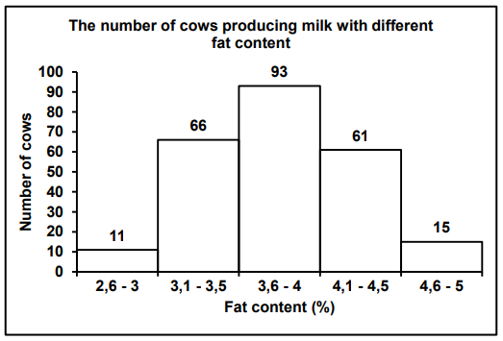  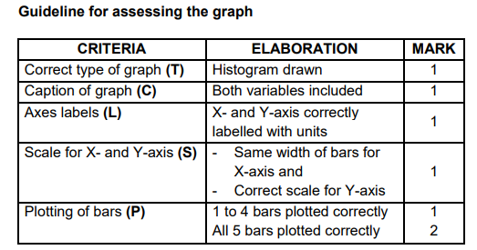  11 x 100  246  = 4,47%  Continuous variation  There is a continuous range of phenotypes /the fat content % is a range |  | (6)  (3)  (1)  (1)  (11)

QUESTION 2

2.1 | True | (1)
2.2 | False | (1)
2.3 | False | (1)
2.4 | True | (1)
2.5 | True | (1)
2.6 | False | (1)  (6)

QUESTION 3

3.1  3.2  3.3  3.4 | Breeding at different times of the year  Prevention of fertilization due to the lack of fit between sexual organs  Infertile offspring  Species specific courtship hehaviour |  | (4)

QUESTION 4

4.1 | The calls of these male frogs had a higher pitch , were of shorter length and had a faster rate. Any  Mark first two only | (2)
4.2 | - Reproductively isolated/unable to breed with original northern  and southern frogs  - because the mating call differs  - Offspring between northern and southern frogs not viable Any | (2)
4.3 | - Conduct DNA analysis and  - check for differences | (2)
4.4 | - There is a great deal of variation in male calls/males  - calls most closely resembling southern calls/calls with faster  note rate and longer duration  - were selected by southern females more often  - than calls most closely resembling northern calls  - there was competition between the males  - males with southern call more likely to reproduce with  southern females  - offspring with southern call had a bigger chance of survival  - gene for call passed to offspring  - over time southern mating call most numerous in species. | (6)
4.5 | Reliable:  - research conducted by experts/scientists in field  - from a university  - many scientists agree  OR  Not reliable:  - no peer review  - no publication of findings mentioned | (2)
 |  | (14)

QUESTION 5

5.1 | Survival of the owls |  | (1)
5.2 | The brown owls are less suited to survive than the white owls  OR  The white owls are more suited to survive than the brown owls |  | (2)
5.3 | (a) 50  (b) 2000  (c) 70 – 60 x 100  60  = 16,67% OR 16,7% |  | (1)  (1)  (3)
5.4 | - There is a decrease in the number of white owls because  - there is less snow and  - white owls will not be camouflaged /will be more visible to  predators |  | (3)
5.5 | - They counted/sampled the number of owls at the beginning  of the 4-month period  - and again, at the end  - Then they calculated the difference between the two numbers |  | (3)
5.6 | Same:  - Time period/4 months  - Population  - Season  - Method of calculation Any |  | (1)  (15)  [50]

Assignment Term 3
Weighting: Practical Skills
Practical Skills
Follow instructions | Handle equipment | Make observations | Draw a diagram | Calculation | Interpret | Design/Plan
Weighting: Cognitive Levels
Question | Cognitive Levels |  |  |  | Levels of difficulty
 | Level A  Knowledge | Level B  Understanding | Level C  Application | Level D  Evaluate, analyse & synthesize | Easy | Moderate | Difficult | Very difficult | Source of difficulty
1.1 | 1 | 2 | 3 |  | 6
1.2 |  | 3 |  |  | 3
1.3 |  |  | 1 |  |  | 1
1.4 |  | 1 |  |  | 1
2.1 | 1 |  |  |  | 1
2.2 |  |  |  | 1 | 1
2.3 – 2.6 |  |  |  | 4 | 4
3.1 – 3.4 |  |  | 4 |  |  | 4
4.1 |  | 2 |  |  |  | 2
4.2 |  | 2 |  |  |  | 2
4.3 |  | 2 |  |  |  | 2
4.4 |  |  | 6 |  |  |  | 6 |  | Source/Task
4.5 |  |  |  | 2 |  | 2
5.1 |  |  |  | 1 |  |  | 1 |  | Source
5.2 |  |  |  | 2 |  | 2
5.3 a |  | 1 |  |  | 1
5.3 b |  | 1 |  |  | 1
5.3 c |  | 3 |  |  | 3
5.4 |  |  |  | 3 | 3
5.5 |  |  |  | 3 | 3
5.6 |  |  |  | 1 | 1
Total | 2 | 17 | 14 | 17 | 28 | 15 | 7
Percentage | 4 | 34 | 28 | 34 | 56 | 30 | 14

