**LIFE SCIENCES Grade 11**

|  |  |
| --- | --- |
| **Total** |  |
|  | **30** |

**Practical Task Term 3 2024**

**Marking Guideline**

**QUESTION 1**

1.1 To maintain validity / make sure the experiment is valid/ same conditions

for the enzyme action. ✓ (1)

1.2 It acts as a control ✓ /to compare the results/ to prove that the results obtained are due to the addition of enzymes. (1)

1.3 Lipase ✓/Protease (1)

1.4

* + Digestion of fat produces fatty acids✓
  + fatty acids change the mixture from alkaline to acidic✓ (2)

1.5

* Bile salts emulsify fats changing them into small droplets ✓
* this increases surface area of fat✓
* enzyme action is increased/faster✓, therefore
* indicator changes colour faster✓ (4) **(9)**

**QUESTION 2**

2.1

|  |  |
| --- | --- |
| **Criteria** | **Mark allocated** |
| Correct type of graph **T** | 1 |
| Caption correct and contains both variables **C** | 1 |
| Y axis: Scale, label, and unit correct **S** | 1 |
| X axis: Correct scale, the bars are the same width, equal spaces in between, correct label and unit **L** | 1 |
| Plotting **P**  1-3 bars correctly plotted  All 4 bars correctly plotted | 1  2 |
| **Total** | **6** |

2.2 a) Temperature activity✓ of the enzyme

b) Digestion of egg white✓ (2)

2.3 The hydrochloric acid provides:

* + an acidic environment✓which is a
  + medium for optimum enzyme activity✓ (2)

2.4 12-5✓

=7 ✓minutes ✓ (3)

.

**(13)**

**QUESTION 3**

|  |  |  |
| --- | --- | --- |
| 3.1. | - The heater warms the air and removes the moisture from the air ✓/ |  |
|  | humidity in the room |  |
|  | - The person sleeping in the room will continuously inhale dry air ✓ |  |
|  | - causing the lungs (the moist lining of alveoli) to become dry ✓ and |  |
|  | - this prevents diffusion of gases between the atmospheric air and |  |
|  | the blood in the alveolar capillaries ✓ |  |
|  | - the low concentration of oxygen / high concentration of carbon |  |
|  | dioxide in the blood stops metabolic processes in the cell ✓/tissues |  |
|  | causing possible death ✓  **Any** | (3) |

3.2

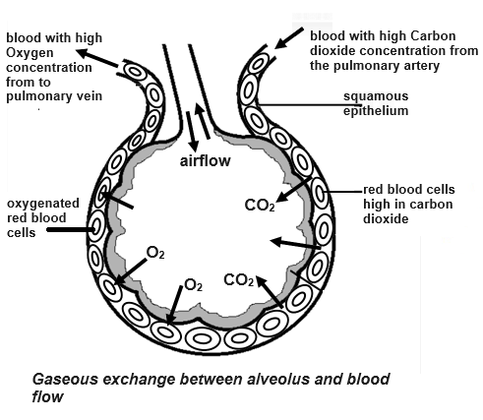

|  |  |
| --- | --- |
| **Criteria** | **Mark allocation** |
| Caption of graph  Both variables included **C** | 1 |
| Correct labels on Alveolus **L**  **Any 1-2**  **All 4** | 1  2 |
| Correct indication of direction of arrows showing movement of gases **G** | 1 |
| Correct indication of direction of arrows showing movement of blood flow **B** | 1 |

(5)

**(8)**

**TOTAL: 30**

**Practical Task Term 3**

**Weighting: Practical Skills**

|  |  |  |  |  |  |  |
| --- | --- | --- | --- | --- | --- | --- |
| **Practical Skills** | | | | | | |
| **Follow instructions** | **Handle equipment** | **Make observations** | **Draw a diagram** | **Calculation** | **Interpret** | **Design/Plan** |
| ✓ |  | ✓ | ✓ | ✓ | ✓ |  |

**Weighting: Cognitive Levels & Levels of Difficulty**

|  |  |  |  |  |  |  |  |  |
| --- | --- | --- | --- | --- | --- | --- | --- | --- |
| **Question** | **Cognitive Levels** | | | | **Levels of Difficulty** | | | |
| **Level A**  **Knowledge** | **Level B**  **Understanding** | **Level C**  **Application** | **Level D**  **Evaluate, analyse & synthesize** | **Easy** | **Medium** | **Difficult** | **Very difficult** |
| 1.1 |  |  |  | 1 |  | 1 |  |  |
| 1.2 |  |  |  | 1 |  | 1 |  |  |
| 1.3 | 1 |  |  |  | 1 |  |  |  |
| 1.4 |  | 2 |  |  |  |  | 2 |  |
| 1.5 |  | 4 |  |  |  |  | 4 |  |
| 2.1 |  |  |  | 2 |  |  | 2 |  |
| 2.2 |  | 2 |  |  |  | 2 |  |  |
| 2.3 |  | 3 |  |  | 3 |  |  |  |
| 2.4 | 1 | 2 | 3 |  | 6 |  |  |  |
| 3.1.1 |  | 3 |  |  |  |  |  | 3 |
| 3.1.2 |  |  | 5 |  |  | 5 |  |  |
| **Total** | **2** | **16** | **8** | **4** | **10** | **19** | **8** | **3** |
| **Percentage** | **6** | **53** | **27** | **13** | **23** | **50** | **26** | **3** |