LIFE SCIENCES
GRADE 10

Practical Task Term 3 2024: Mitosis and Plant Tissues

Marking Guidelines
Question 1: Mitosis
1.1 B C A | (2)
1.2 B- Chromosomes are visible | (1)
C - Chromosomes are aligned at the equator. | (1)
A – Chromosomes are being pulled apart | (1)
1. 3
Telophase
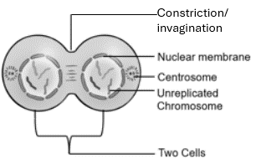

Description | Code | Marks
Correct name of Phase | P | 1
Each cell has 4 chromosomes | C | 1
Correct diagram showing TWO cells  Nuclear membrane  Centrosome | D | 1
Must show constriction/ invagination | F | 1
Any ONE correct label. | L | 1
TOTAL |  | 5

 | (10)
QUESTION 2: Plant Tissues

2.1 | A Collenchyma  C Sclerenchyma | (1)  (1)
2.2 | Cells A / Collenchyma Cells C / Sclerenchyma  Walls are unevenly thickened Walls are evenly thickened  Cells have nuclei Cells have no nuclei  Table | (3)
2.3 | Acts as packing tissue
 | Stores water, sugar, and starch
 | Intercellular air spaces allow for gaseous exchange and water to pass through the tissue.  Any | (2)
 |  | (7)
 | Question 3 : Cancer
3.1 | Cells dividing uncontrollably by mitosis to form a mass / tumour | (2)
3.2 | Surgery, Radiotherapy, Chemotherapy Any | (2)
 |  | (3)
3.3 | A -Age group of Men
 | B – Number of Men
3.4 | 60-69 age group
3.5 | 1000 - 100 = 900 | (3)
3.6 | The number of men that die from lung cancer increases as the age increases after 69 years, the number of deaths decreases | (3)
 |  | (13)
 | TOTAL | [30]

