**MOCK EXAMINATION**

**GRADE 12**

LIFE SCIENCES P1

**OCT/NOV 2022**

**MARKS: 150 TIME: 2½ HOURS**

# This question paper consists of 20 pages.

**INSTRUCTIONS AND INFORMATION**

Read the following instructions carefully before answering the questions.

|  |  |
| --- | --- |
| 1.  2.  3.  4.  5.  6.  7.  8.  9.  10.  11. | Answer ALL the questions.  Write ALL the answers in the ANSWER BOOK.  Start the answers to EACH question at the top of a NEW page.  Number the answers correctly according to the numbering system used in this question paper.  Present your answers according to the instructions of each question. Make ALL drawings in pencil and label them in blue or black ink.  Draw diagrams, tables or flow charts only when asked to do so.  The diagrams in this question paper are NOT necessarily drawn to scale. Do NOT use graph paper.  You must use a non-programmable calculator, protractor and a compass, where necessary.  Write neatly and legibly. |

# SECTION A QUESTION 1

|  |  |
| --- | --- |
| 1.1 | Various options are given as possible answers to the following questions. Choose the answer and write only the letter (A to D) next to the question  numbers (1.1.1 to 1.1.10) in the ANSWER BOOK, for example 1.1.11 D. |

|  |  |  |
| --- | --- | --- |
| 1.1.1 | Which part of the brain controls the heart rate? | |
|  | A B C D | Hypothalamus Cerebrum Cerebellum Medulla oblongata |
| 1.1.2 | Which ONE of the following hormones prepares the body for an emergency? | |
|  | A B C D | ADH  Testosterone Adrenalin TSH |
| 1.1.3 | Which ONE of the following refers to the process whereby sperm and ova are produced in the testes and ovaries? | |
|  | A B C D | Gametogenesis Oogenesis Spermatogenesis Ovulation |

|  |  |  |
| --- | --- | --- |
| 1.1.4 | The central nervous system is made up of the … | |
|  | A B C D | cranial and spinal nerves.  autonomic and peripheral nervous systems. cranial nerves and the brain.  brain and the spinal cord. |

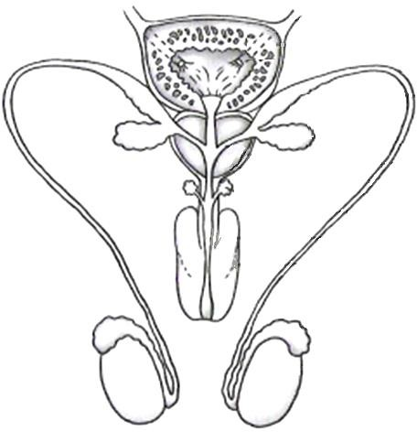

|  |
| --- |
| **QUESTIONS 1.1.5 AND 1.1.6 ARE BASED ON THE DIAGRAM OF THE HUMAN MALE REPRODUCTIVE SYSTEM** |
| **1**  **2**  **3**  **4** |

|  |  |  |
| --- | --- | --- |
| 1.1.5 | Which numbered part is responsible to keep the temperature a few degrees lower than body temperature? | |
|  | A B C D | 1  2  3  4 |

|  |  |  |
| --- | --- | --- |
| 1.1.6 | Which numbered part(s) contribute(s) to the development of mature and motile sperm? | |
|  | A B C D | 1  1, 2 and 3  4  1, 2, 3 and 4 |

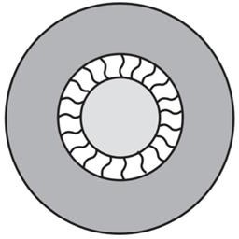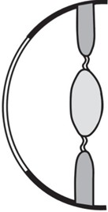

|  |  |  |
| --- | --- | --- |
| 1.1.7 | During an investigation a man was placed in an airtight room. Sensors were used to monitor his breathing and heart rate. The investigators were able to change the environmental conditions in the room. After 30 minutes the man's breathing and heart rate increased.  The investigators changed the environmental conditions in the room by … | |
|  | A B C D | decreasing the humidity. decreasing the light intensity.  increasing the amount of carbon dioxide in the air. increasing the amount of oxygen in the air. |
| 1.1.8 | The diagram represents the parts of the eye responsible for accommodation.  **Front view Side view**  lens | |
|  | The following statements are used to describe accommodation in the eye: | |
|  | 1. Ciliary muscles contract 2. Suspensory ligaments become taut 3. Tension on the lens increases 4. Lens becomes more convex 5. Refractive power of the lens increases   Which of the statements relate to this diagram? | |

|  |  |
| --- | --- |
| A B C  D | (i), (ii), (iv) and (v) only   1. , (ii), (iii), (iv) and (v) (i), (iv) and (v) only 2. and (iii) only |

* + 1. Which ONE of the following hormones controls metabolic rate?

1. Testosterone
2. Glucagon
3. Thyroxin
4. Oestrogen
   * 1. When there is a decrease in the human body temperature, which ONE of the following shows the correct response by blood capillaries in the skin?

|  |  |  |  |  |
| --- | --- | --- | --- | --- |
| Decrease in body temperature | | | | |
| Dilation of blood capillaries |  | Constriction of blood capillaries |  |  |
| Increased Decreased Increased Decreased blood flow blood flow blood flow blood flow to skin to skin to skin to skin  **I II III IV** | | | | |

* + - 1. I
      2. II
      3. III
      4. IV

(10 x 2) **(20)**

|  |  |
| --- | --- |
| 1.2 | Give the correct **biological term** for each of the following descriptions. Write  only the term next to the question numbers (1.2.1 to 1.2.9) in the ANSWER BOOK. |

|  |  |  |
| --- | --- | --- |
| 1.2.1  1.2.2  1.2.3  1.2.4  1.2.5  1.2.6  1.2.7  1.2.8  1.2.9 | The strategy by the parents where food and protection are provided to increase survival of the offspring  The secretions that are produced in small quantities by the endocrine glands  The fluid surrounding the developing foetus in the uterus The plant hormone responsible for the germination of seeds A structure in the head of a sperm containing enzymes  The functional gap at which a nerve impulse passes from one neuron to another  The liquid secreted by the testes and associated glands The shedding of the endometrium and an unfertilised ovum  The protective membrane covering the cornea of the eye  (9 x 1) | **(9)** |

|  |  |
| --- | --- |
| 1.3 | Indicate whether each of the descriptions in COLUMN I applies to **A ONLY**, **B ONLY**, **BOTH A AND B** or **NONE** of the items in COLUMN II. Write **A only**, **B only**, **both A and B** or **none** next to the question numbers (1.3.1 to 1.3.3)  in the ANSWER BOOK. |

|  |  |  |  |  |
| --- | --- | --- | --- | --- |
| **COLUMN I** | | **COLUMN II** | |  |
| 1.3.1 | Secretions are released into a | A: | Endocrine gland |
|  | cavity/duct of the body | B: | Exocrine gland |
| 1.3.2 | The young develop and is nourished in an amniotic egg that is retained in the mother's | A:  B: | Vivipary Ovipary |
|  | body |  |  |
| 1.3.3 | Increases the permeability of | A: | Less ADH |
|  | the renal tubes for | B: | More ADH |
|  | osmoregulation |  |  |
|  |  |  | (3 x 2) | **(6)** |

|  |  |
| --- | --- |
| 1.4 | The diagram below shows the female reproductive system. |

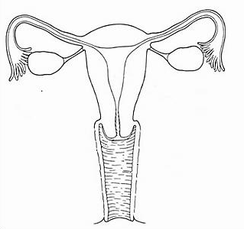

**A**

**E**

**B**

**C**

**D**

|  |  |  |
| --- | --- | --- |
| 1.4.1 | Identify part:   1. **A** 2. **C** |  |
|  | (1)  (1) |
| 1.4.2 | Give the LETTER only of the part, where each of the |  |
|  | following takes place: |  |
|  | (a) Meiosis | (1) |
|  | (b) Fertilisation | (1) |
| 1.4.3 | State TWO functions of part **E**. | (2) |
| 1.4.4 | Name the glands which secrete nutrient rich fluid for the |  |
|  | sperm, to reach part **A**. | (1) |
|  |  | **(7)** |

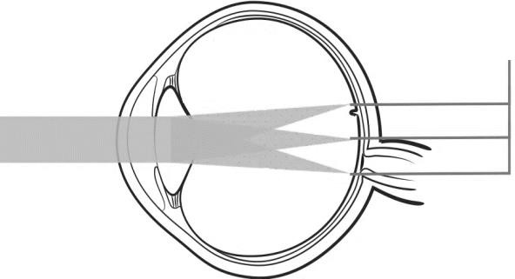

|  |  |
| --- | --- |
| 1.5 | The diagrams below represent different disorders or defects in the human  body. |

|  |  |
| --- | --- |
| **Diagram A**  SOLVED] What kind of lens is used to rectify myopia Biconvex le - Self  Study 365 | **Diagram B**  Normal thyroid Enlarged thyroid |
| **Diagram C**    Cochlear implant | **Diagram D**  More than one focus point |

|  |  |  |  |
| --- | --- | --- | --- |
| 1.5.1 | Identify the following represented in Diagram **B**: | |  |
|  | (a)  (b) | The disorder  Possible dietary cause of the disorder | (1)  (1) |
| 1.5.2 | Name the visual defect represented in diagram: | |  |
|  | 1. **A** 2. **D** | | (1)  (1) |
| 1.5.3 | Give a possible cause of the image falling on more than one focus point in Diagram **D**. | |  |
|  | (1) |

|  |  |  |
| --- | --- | --- |
| 1.5.4 | Name the defect that is treated with a cochlear implant as shown in Diagram **C**. | (1) |
| 1.5.5 | Name the defect:   1. Where the lens becomes cloudy (opaque) and prevents light from reaching the retina. 2. Treated with the insertion of a grommet in the tympanic membrane. |  |
|  | (1)  (1) |
|  |  | **(8)** |

|  |  |
| --- | --- |
| **TOTAL SECTION A:** | **50** |

# SECTION B QUESTION 2

D

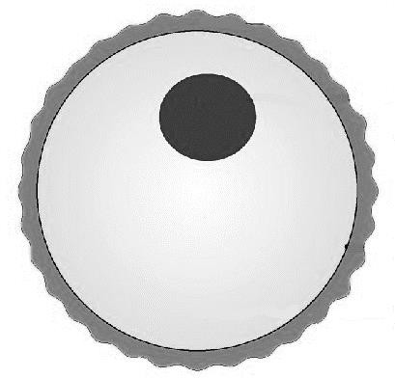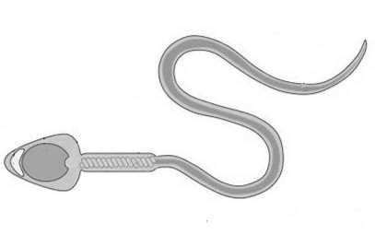

|  |  |
| --- | --- |
| 2.1 | The diagram below represents two human gametes.  **Gamete I Gamete II**  **C**  **B**  **A** |

|  |  |  |
| --- | --- | --- |
| 2.1.1 | What is the function of layer **C**? | (1) |
| 2.1.2  2.1.3 | Explain the role that part **B** plays in increasing the chances of fertilisation.  Describe the significance of the chromosome number of part **A**. | (2)  (2) |
| 2.1.4 | Use a flow diagram to give the correct sequence of the developmental stages of a fertilised ovum until a foetus is formed. |  |
|  | (2) |
|  |  | **(7)** |

|  |  |
| --- | --- |
| 2.2 | The female foam-nest tree frog releases a batch of eggs which are then fertilised by sperm from her mating partner as well as other nearby males. As the eggs are laid male frogs will cover it with foam.  These foam nests are found in water puddles, tree branches, or buried underground. The nests prevent dehydration (drying out), predation and infection from bacteria and fungi. It also provides a healthy environment for the developing embryos.  Sunlight will harden the nest's outer surface. After a few days the developing tadpoles break out and fall into the water where they will complete their development.  *[Adapted from:* [*https://www.sciencedirect.com/science/article]*](https://www.sciencedirect.com/science/article/) |

|  |  |  |
| --- | --- | --- |
| 2.2.1 | State the type of fertilisation used by the foam-nest tree frogs. |  |
|  | (1) |
| 2.2.2 | State TWO ways in which the chances of fertilisation in these frogs are increased. |  |
|  | (2) |
| 2.2.3 | Give TWO functions of the foam nests. | (2) |
|  |  | **(5)** |

|  |  |
| --- | --- |
| 2.3 | The diagram below represents a reflex arc. |

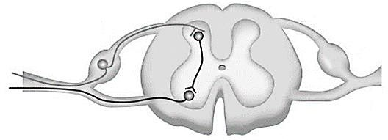

**Neuron B**

**Neuron A**

**Neuron C**

* + 1. What is a *reflex arc*? (2)
    2. Explain the effect on the reflex action when neuron **C** is damaged. (2)
    3. Name the disorder that is the result in the break down of

the myelin sheath of neurons. (1)

# (5)

* 1. The autonomic nervous system controls all involuntary actions in the human body and conducts impulses from the central nervous system.
     1. Name TWO locations that impulses from the autonomic nervous system are conducted to. (2)
     2. Describe the functioning of the autonomic nervous system. (5)

# (7)

progesterone from structure **B**

progesterone from structure **A**

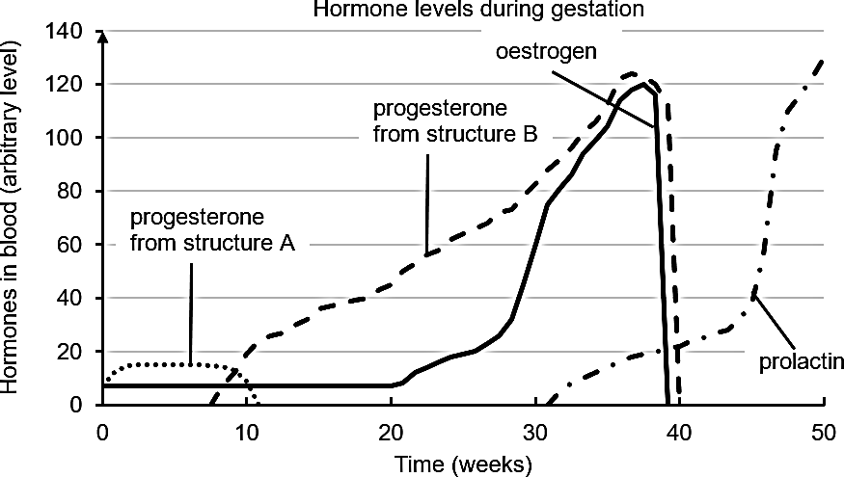

**Hormone levels during pregnancy**

oestrogen

prolactin

**Time (weeks)**

progesterone from structure **A**

progesterone from structure **B**

**Hormone levels in blood (arbitrary units)**

|  |  |
| --- | --- |
| 2.5 | The graph below shows the hormonal changes in a female's body during  pregnancy. |

|  |  |  |
| --- | --- | --- |
| 2.5.1 | Identify the following structures:   1. **A** 2. **B** | (1)  (1) |

|  |  |  |
| --- | --- | --- |
| 2.5.2 | Name the gland where prolactin is produced. | (1) |
| 2.5.3 | Explain the high secretion of prolactin after week 40. | (2) |

|  |  |  |
| --- | --- | --- |
| 2.5.4 | Explain the significance of the levels of oestrogen and  progesterone dropping towards the end of pregnancy. | (2) |

|  |  |  |
| --- | --- | --- |
| 2.5.5 | Describe the effect that the drop in progesterone level has on the ovarian cycle. | (5)  **(12)** |

|  |  |
| --- | --- |
| 2.6 | The diagram below represents part of the inner ear. |

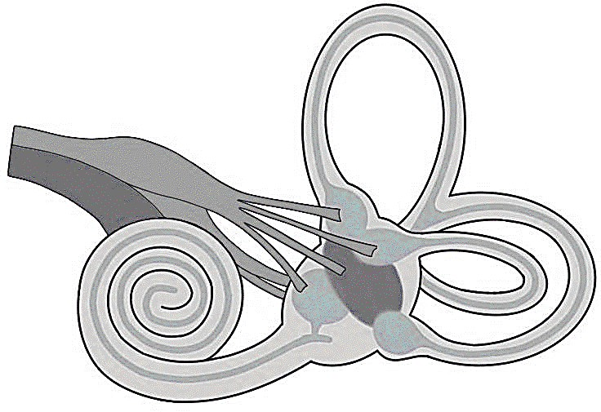

**B**

**A**

**C**

|  |  |  |
| --- | --- | --- |
| 2.6.1 | Identify part: |  |
|  | 1. **B** 2. **C** | (1)  (1) |
| 2.6.2 | Describe the role of the structures of the ear from the time that a sound wave reaches the ear until pressure waves are set up in the inner ear. |  |
|  | (7) |
| 2.6.3 | Name part **A** and explain the consequences if it gets damaged. |  |
|  | (5) |
|  |  | **(14)** |

**[50]**

# QUESTION 3

C

3.1 The diagram below represents the homeostasis of blood glucose in the human body.

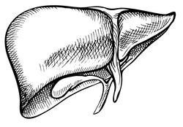

**Hormone X**

Liver

Low blood sugar

Alpha cells

**Responses**

Endocrine tissue in organ **Z**

High blood sugar

Beta cells

Blood vessel

**Hormone Y**

|  |  |  |
| --- | --- | --- |
| 3.1.1 | Identify hormone **Y**. | (1) |
| 3.1.2 | Name:   1. Organ **Z** 2. The endocrine tissue in organ **Z**. |  |
|  | (1)  (1) |
| 3.1.3 | Describe the response that is carried out when a person has not eaten any sugar-containing food for six hours. |  |
|  | (6) |
|  |  | **(9)** |

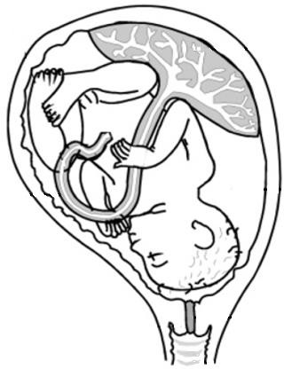

|  |  |  |  |
| --- | --- | --- | --- |
| 3.2 | The following diagram represents a human foetus at 36 weeks of gestation.  **X** | | |
|  | 3.2.1 | Identify part **X**. | (1) |
|  | 3.2.2 | Name and describe the functions of the different blood vessels found in part **X**. |  |
|  |  | (4) |
|  |  |  | **(5)** |

* 1. An experiment was set up to investigate the diameter of the pupil under different light conditions. A person sat in a dark room and an electric light bulb was switched on at different distances from the person. The diameter of the pupil was measured 1 minute after each time the light bulb was switched on. The results are illustrated in the graph below.

**Diameter of the pupil in relation to the position of a light source**

9

8

7

6

5

4

3

2

1

0

1

2

3

4

5

6

**Position of the light source**

3.3.1

**Diameter of the pupil (mm)**

3.3.2

3.3.3

Name the following for this investigation:

1. Independent variable
2. Dependent variable

State TWO reasons why the results of this investigation are not reliable.

Calculate the percentage decrease in the pupil diameter, when the light bulb was moved from position **3** to position **4**. Show all your calculations.

(1)

(1)

(2)

(3)

* + 1. Which coloured structure in the eye is responsible for

changing the diameter of the pupil? (1)

* + 1. Name the mechanism that caused the change in the

diameter of the pupil from position **2** to position **3**. (1)

* + 1. Describe the mechanism mentioned in QUESTION 3.3.5. (3)
    2. Give the:
       1. Diameter of the pupil at position **4** of the light source.
       2. Position where the light source was the furthest form the person

(1)

(1)

# (14)

* 1. The diagram below represents the human endocrine system.

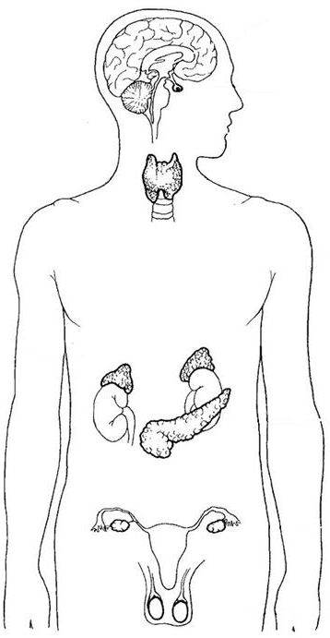

**A**

**B**

**C**

**D E**

|  |  |  |
| --- | --- | --- |
| 3.4.1  3.4.2  3.4.3  3.4.4 | Write down the LETTER and the NAME of the gland that produces a hormone that controls the growth of long bones.  Gland **E** is only found in males.  Explain the consequence if gland **E** cannot secrete its hormone.  Describe the homeostatic control if the salt levels in the blood are low.  Name TWO other substances or factors, except salt, that should be kept constant in the internal environment of the tissue fluids. | (2)  (2)  (4)  (2)  **(10)** |

Please turn over

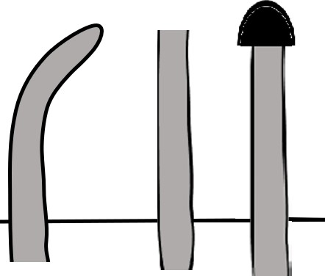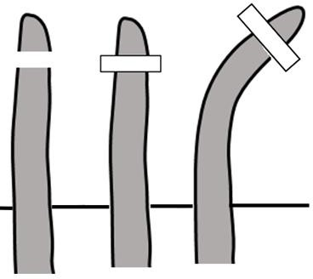

|  |  |  |  |
| --- | --- | --- | --- |
| 3.5 | Phototropism was investigated in young stems.  A group of stem tips were exposed to a unilateral light. The stem tips were treated differently.  Stem **A**'s tip was intact, stem **B**'s tip was removed, and stem **C**'s tip was covered with a black cap. In diagram **D** the tip was removed, and agar (jelly-like substance) was placed between the tip and the stem.  The diagrams below show the different treatments and results. The arrows indicate the position of a unilateral light source.  **A B C D**  agar  Stem Tip Tip covered Tip removed and  intact removed with black a piece of agar is placed  cap on top. The tip of the stem is placed back on top of the agar | | |
|  | 3.5.1 | Name the plant hormone that causes the growth |  |
|  | movements illustrated in the diagrams? | (1) |
| 3.5.2 | Define *phototropism*. | (2) |
| 3.5.3 | Explain why stem **D** grows towards the light source. | (6) |
| 3.5.4 | Explain the result of the experiment with stem **C**. | (3) |
|  |  | **(12)** |
|  |  |  | **[50]** |
|  |  | **TOTAL SECTION B:** | **100** |
|  |  | **GRAND TOTAL:** | **150** |