**MOCK EXAMINATION**

**GRADE 12**

LIFE SCIENCES P2

**OCT/NOV 2022**

**MARKS: 150 TIME: 2½ HOURS**

# This question paper consists of 16 pages.

**INSTRUCTIONS AND INFORMATION**

Read the following instructions carefully before answering the questions.

|  |  |
| --- | --- |
| 1.  2.  3.  4. | Answer ALL the questions.  Write ALL the answers in the ANSWER BOOK.  Start the answer to EACH question at the top of a NEW page.  Number the answers correctly according to the numbering system used in this question paper. |

|  |  |
| --- | --- |
| 5.  6.  7.  8. | Present your answers according to the instructions of each question. Do ALL drawings in pencil and label them in blue or black ink.  Draw diagrams, tables or flow charts only when asked to do so.  The diagrams in this question paper are NOT necessarily drawn to scale. |

|  |  |
| --- | --- |
| 9.  10.  11. | Do NOT use graph paper.  You must use a non-programmable calculator, protractor and a compass, where necessary.  Write neatly and legibly. |

# SECTION A QUESTION 1

|  |  |
| --- | --- |
| 1.1 | Various options are given as possible answers to the following questions. Choose the answer and write only the letter (A to D) next to  the question numbers (1.1.1 to 1.1.10) in the ANSWER BOOK, for example, 1.1.11 D. |

|  |  |
| --- | --- |
| 1.1.1 | Which ONE of the following represents a single RNA  nucleotide? |

|  |  |
| --- | --- |
| A B  C D | Deoxyribose-adenine-thymine Adenine-ribose-phosphate  Deoxyribose-thymine-phosphate Uracil-deoxyribose-phosphate |

|  |  |
| --- | --- |
| 1.1.2 | What percentage of adenine bases is present in a DNA molecule  with 2000 bases if 400 bases are cytosine? |

|  |  |
| --- | --- |
| A B C  D | 20  40  30  60 |

|  |  |
| --- | --- |
| 1.1.3 | Which organelle is responsible for producing spindle fibres?   1. Nucleus 2. Centromere C Centriole   D Chromosome |

|  |  |
| --- | --- |
| 1.1.4 | Which ONE of the following represents the correct order for the possible evolution of modern humans? |
|  | A Ardipithecus  Australopithecus  Homo B Australopithecus  Ardipithecus  Homo C Homo  Australopithecus  Ardipithecus  D Ardipithecus  Homo  Australopithecus |

|  |  |
| --- | --- |
| 1.1.5 | Which ONE of the following represents a trend in human  evolution? |

|  |  |
| --- | --- |
| A B C  D | More developed brow ridges Increased size of canines More developed cranial ridges  More forward position of the foramen magnum |

|  |  |  |
| --- | --- | --- |
| 1.1.6 | Which ONE of the following distinguishes prophase I of meiosis from prophase of mitosis?  A Homologous chromosomes pair up B Spindle forms  C Nuclear membrane breaks down D Chromosomes become visible | |
| 1.1.7 | When a cell divides by meiosis, it results in … | |
|  | A B C D | four haploid gametes. two diploid gametes.  four haploid somatic cells. two haploid somatic cells. |
| 1.1.8 | Comparison of the amino acid sequences in a protein have been made between humans and several other organisms. The number of differences is shown in the table below. | |
| **ORGANISM SHARK KANGAROO FISH COW LIZARD**  Number of differences in amino  acids 79 27 68 17 62  sequences  in a protein compared to humans  The type of evidence for evolution in the table above is … | | |
|  | A B C D | fossil evidence. modification by descent. cultural evidence. genetic evidence. |
| 1.1.9 | Down syndrome occurs when … | |
|  | A B C D | a male sex cell undergoes mitosis.  every cell of an organism has an extra pair of chromosomes. all somatic cells of an organism have an extra chromosome. a female sex cell undergoes mitosis. |

|  |  |  |  |
| --- | --- | --- | --- |
| 1.1.10 | The graph below shows the pace at which evolution occurs in a species of butterfly. | |  |
|  | Which type of evolution is represented by the graph? | |  |
|  | A B C D | Speciation  Inheritance of acquired characteristics Punctuated equilibrium  Artificial selection |  |
|  |  | (10 x 2) | **(20)** |

|  |  |
| --- | --- |
| 1.2 | Give the correct **biological term** for each of the following descriptions. Write only the term next to the question numbers (1.2.1 to 1.2.10) in the ANSWER  BOOK. |

|  |  |  |
| --- | --- | --- |
| 1.2.1  1.2.2  1.2.3  1.2.4  1.2.5  1.2.6  1.2.7  1.2.8  1.2.9  1.2.10 | A section of DNA that carries the code for a particular trait The production of gametes during meiosis  A diagram showing possible evolutionary relationships  The allele that is expressed in the phenotype in the heterozygous condition  The study of animal and plant distribution as a form of evidence for evolution  A group of organisms that share the same gene pool and that can interbreed to produce fertile offspring  A characteristic of primates that enables them to have precision in grip  A set of well-tested ideas that explains a phenomenon in science and is supported by sufficient experimental evidence  The mistake that occurs when two homologous chromosomes do not separate from each other during meiosis  The type of dominance where a long-tailed dog and a short- tailed dog produces a puppy with a medium length tail | **(10)** |

|  |  |
| --- | --- |
| 1.3 | Indicate whether each of the statements in COLUMN I applies to **A ONLY**, **B ONLY**, **BOTH A AND B** or **NONE** of the items in COLUMN  II. Write **A only**, **B only**, **both A and B** or **none** next to the question numbers (1.3.1 to 1.3.3) in the ANSWER BOOK. |

|  |  |  |  |
| --- | --- | --- | --- |
|  | **COLUMN I** | **COLUMN II** |  |
| 1.3.1 | A place in the plant cell where DNA is found | A: Nucleus  B: Mitochondrion |
| 1.3.2 | The evidence used to support the 'Out of Africa' hypothesis by tracing the maternal lineage | A: Mitochondrial DNA B: Y- chromosome DNA |
| 1.3.3 | Phase during which cytokinesis takes place | A: Telophase I  B: Telophase II |
|  |  | (3 x 2) | **(6)** |

|  |  |
| --- | --- |
| 1.4 | In watermelons, there are two alleles for taste, bitter fruit and sweet fruit. The allele for bitter fruit **(B)** is dominant over the allele for sweet fruit **(b)**. There are two alleles for skin appearance, yellow spots and no spots. The allele for yellow spots **(N)** is dominant over the allele for no spots **(n)**.  Plant **A**, which is heterozygous for bitter fruit and for yellow spots, was crossed with plant **B**, which has sweet fruit and no spots. |

|  |  |  |
| --- | --- | --- |
| 1.4.1  1.4.2  1.4.3 | Give the term that describes a genetic cross involving two characteristics.  Give:   1. The genotype of plant **B** 2. The dominant phenotype for taste in watermelons 3. All possible genotypes of the gametes of plant **A**   List TWO ways in which the phenotype of a watermelon with genotype bbNn differs from the phenotype of a watermelon with genotype Bbnn. | (1)  (2)  (1)  (2)  (2)  **(8)** |

|  |  |
| --- | --- |
| 1.5 | The diagram below show two molecules that are required during proteins  synthesis. |

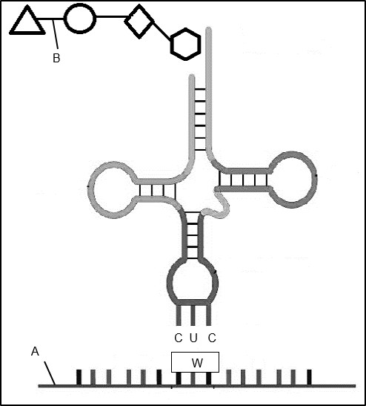

**B**

**A**

**C U C**

**W**

|  |  |  |
| --- | --- | --- |
| 1.5.1 | Identify:   1. Molecule **A** 2. The bond at **B** 3. The base triplet sequences for **W** |  |
|  | (1)  (1)  (2) |
| 1.5.2 | Name the organelle at which this phase of protein synthesis takes place. |  |
|  | (1) |
| 1.5.3 | Name the nitrogenous base represented by **U** in the diagram. | (1) |
|  |  | **(6)** |

|  |  |
| --- | --- |
| **TOTAL SECTION A:** | **50** |

**SECTION B QUESTION 2**

|  |  |
| --- | --- |
| 2.1 | The table below shows the anticodons of tRNA, that carry specific amino acids  during protein synthesis. |

|  |  |  |
| --- | --- | --- |
| **Number** | **Amino Acid** | **tRNA** |
| 1 | Alanine | CGA |
| 2 | Valine | GUA |
| 3 | Aspartic acid | CUA |
| 4 | Valine | CAC |
| 5 | Glutamine | CUC |
| 6 | Arginine | GCC |
| 7 | Cysteine | UGC |
| 8 | Threonine | UCC |
| 9 | Histidine | CAG |
| 10 | Tryptophan | ACC |
| 11 | Tyrosine | AUA |

* + 1. Write down the DNA base triplet that codes for the amino acid Valine

at **number 2**. (2)

* + 1. From the table, write down the names of two amino acids which are

coded for by thymine (T) as the first base in the DNA triplets. (2)

* + 1. Name AND describe the process that occurred in the cytoplasm,

which led to amino acid **number 11** becoming part of a protein. (5)

# (9)

2.2 Tabulate any TWO structural differences between DNA and RNA. **(5)**

|  |  |
| --- | --- |
| 2.3 | The diagrams below show how a sheep was cloned. |

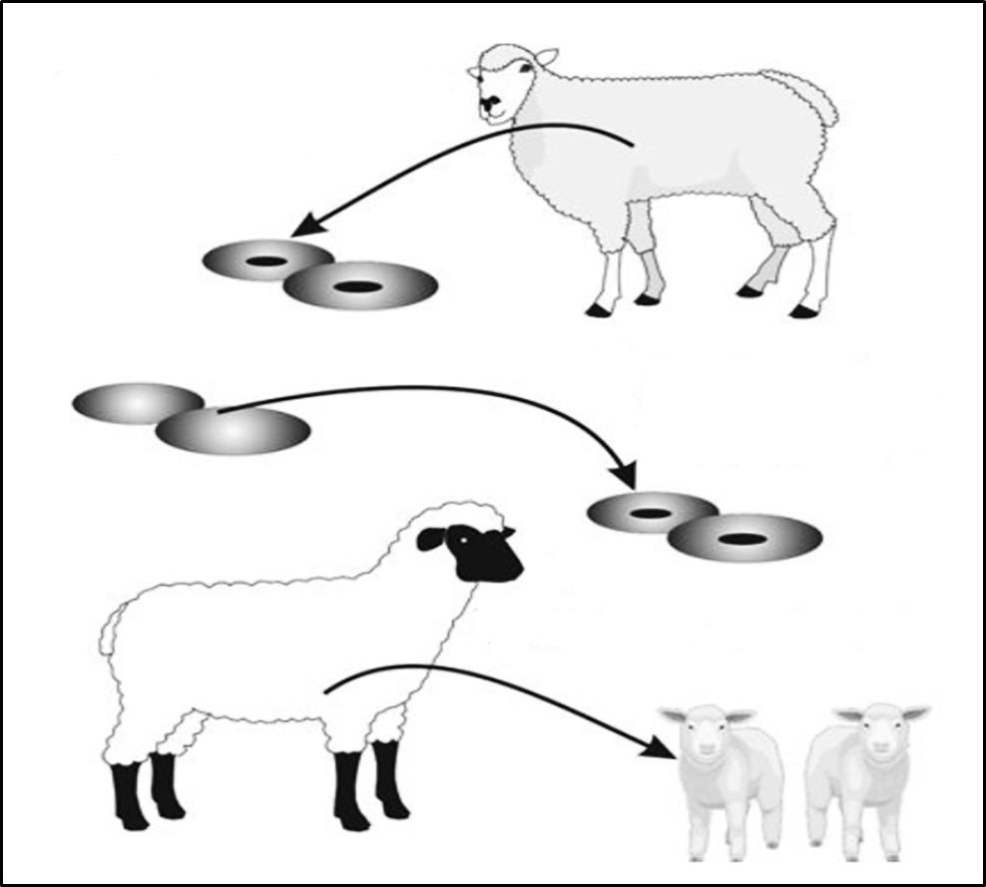

**V**

**W**

**OFFSPRING**

3. The embryos are implanted into the uterus of the **sheep W** and allowed to develop for the full gestation.

'Empty' ova of sheep **W**

2. The nucleus are removed from the somatic cells and placed into the 'empty' ova removed from **sheep W**. These cells are allowed to develop into embryos.

1. A somatic cell are removed from **sheep V**

|  |  |  |
| --- | --- | --- |
| 2.3.1 | What is a somatic cell? | (2) |
| 2.3.2 | Why is the nucleus from the ovum of sheep **W** removed? | (1) |
| 2.3.3 | Explain why the lambs produced by the technique are identical to each other. |  |
|  | (4) |
| 2.3.4 | Give ONE reason why the lambs are not genetically identical to sheep **W**, which produced the ova. |  |
|  | (1) |
| 2.3.5 | State TWO reasons why cloning livestock be can beneficial to humans. |  |
|  | (2) |
| 2.3.6 | Give ONE reason why some people may be against cloning. | (1) |
|  |  | **(11)** |

|  |  |
| --- | --- |
| 2.4 | Mr and Mrs Wilson are concerned because their baby boy does not appear to resemble either of them. They suspected that the baby they were given at the hospital is not theirs. Mr Wilson has blood type **AB**, Mrs Wilson has blood type **B.** Their daughter has blood type **A**. The baby boy they were given, has blood type **O**. They learn that blood groups are determined by multiple alleles – and that there are four phenotypes for blood groups. |

* + 1. Describe how multiple alleles determine blood groups. (2)
    2. Give the genotype of the daughter. (2)
    3. Explain why the baby boy with blood type **O,** cannot be Mr and

Mrs Wilson's biological son. (3)

* + 1. Blood types are not conclusive in paternity testing.

Explain how DNA profiling could be used to determine that Mr Wilson is the father of the daughter. (4)

# (11)

2.5 Using your knowledge of gonosomes, explain why the sex of a child is determined by the male gamete. **(4)**

|  |  |
| --- | --- |
| 2.6 | A population of squirrels lived in the mountains. A landslide caused the river to change direction, thereby separating the populations into two groups on either side of the river. Over a long period of time, the two populations  became different species. |

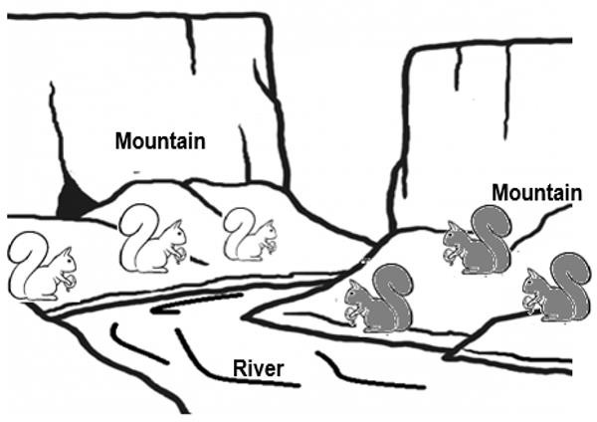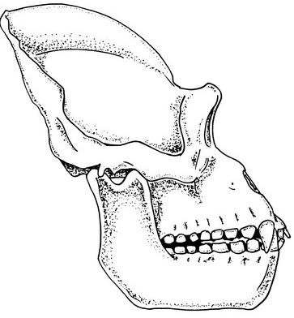

|  |  |  |
| --- | --- | --- |
| 2.6.1 | Describe the process of speciation in the squirrels. | (7) |
| 2.6.2 | Give THREE reproductive isolation mechanisms that help to keep |  |
|  | species separate. | (3) |
|  | **(10)** |
|  | **[50]** |

# QUESTION 3

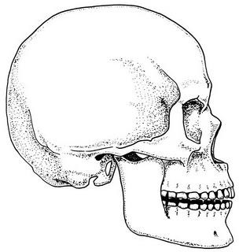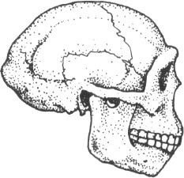

|  |  |  |
| --- | --- | --- |
| 3.1 | The diagrams below show the skulls of three primate genera. The diagrams are NOT drawn to scale. | |
|  | **A B**  **C** | |
|  | 3.1.1 | Give the LETTER only of a skull that: |

|  |  |  |
| --- | --- | --- |
| (a)  (b)  (c)  (d) | Most likely belongs to a bipedal organism Is attached to a C-shaped vertebral column Is most prognathous  Has the largest brain size | (1)  (1)  (1)  (1) |

|  |  |  |
| --- | --- | --- |
| 3.1.2 | State TWO advantages of having a large brain. | (2) |
| 3.1.3 | State any THREE features of skull **B** shown in the diagram above that allows scientists to determine that this was a much earlier species of genus *Homo* than modern humans. (*H. sapiens sapiens*.) |  |
|  | (3) |
| 3.1.4 | Name TWO lines of evidence that support the idea that humans originated on the African continent. |  |
|  | (2) |
|  |  | **(11)** |

|  |  |
| --- | --- |
| 3.2 | *Brassica* plants have hair on their leaves to reduce transpiration. The number of hairs on the leaves varies from plant to plant.  An investigation was conducted to determine whether artificial selection could increase the number of plants with more hair on their leaves.  The students carried out the following procedure:   * 180 *Brassica* plants were selected randomly. * The number of hairs present on the edge of each mature leaf was counted per plant, and an average was calculated. * The number of plants, with different averages, was counted and recorded. * The plants with more than 25 hairs per leaf were separated from the rest of the group and allowed to cross-pollinate. * The seeds produced by these plants were germinated and allowed to grow into mature plants. 180 of these plants were selected randomly. * The number of hairs present on the edge of mature leaves was counted per plant and the average number of hairs was calculated again.   The number of plants with different averages was counted and recorded. The results of the investigation are shown in the table below. |

|  |  |  |  |  |
| --- | --- | --- | --- | --- |
| **WITHOUT ARTIFICIAL SELECTION** | |  | **WITH ARTIFICIAL SELECTION** | |
| Average number of hairs | Number of plants | Average number of hairs | Number of plants |
| 0–5 | 50 | 0–5 | 8 |
| 6–10 | 35 | 6–10 | 5 |
| 11–15 | 24 | 11–15 | 18 |
| 16–20 | 20 | 16–20 | 25 |
| 21–25 | 25 | 21–25 | 35 |
| 26–30 | 12 | 26–30 | 45 |
| 31–35 | 8 | 31–35 | 30 |
| 36–40 | 6 | 36–40 | 14 |

[Adapted from: [*www.media.collegeboard.com*](http://www.media.collegeboard.com/)]

|  |  |  |
| --- | --- | --- |
| 3.2.1  3.2.2  3.2.3  3.2.4 | Identify the:   1. Independent variable 2. Dependent variable   State ONE way the students could have made their results more reliable.  Give a conclusion for this investigation.  Draw a histogram showing the results with artificial selection. | (1)  (1)  (1)  (2)  (6)  **(11)** |

|  |  |
| --- | --- |
| 3.3. | The diagram below shows the somatic cells of an organism in one of the  phases of meiosis. |

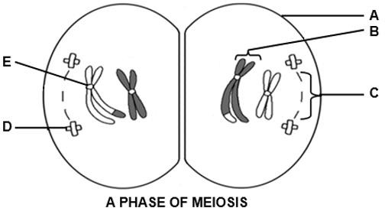

|  |  |  |
| --- | --- | --- |
| 3.3.1  3.3.2 | Which phase of meiosis is represented in the diagram? Give the LETTER and NAME of the part that:   1. Carries the genetic information 2. Holds the chromatids together | (1)  (2)  (2) |

|  |  |  |
| --- | --- | --- |
| 3.3.3 | State the number of chromosomes present in each of the cells of this organism.   1. At the beginning of meiosis 2. In a gamete of this organism | (1)  (1)  **(7)** |

|  |  |
| --- | --- |
| 3.4 | The pedigree diagram below shows the inheritance of colour blindness in a family. The normal allele is represented by **XD** and the allele causing colour  blindness is represented by **Xd**. |



**A**

**B**

**C**

**D**

**E**

Key:

Unaffected male

Unaffected female

Colour blind male

Colour blind female

|  |  |  |
| --- | --- | --- |
| 3.4.1  3.4.2  3.4.3  3.4.4 | Determine the:   1. Phenotype of individual **D** 2. Genotype of individual **A**   State ONE reason why colour blindness is regarded as a sex- linked disorder.  Explain why females have a lesser chance of suffering from colour blindness than males.  Represent a genetic cross to show the percentage chance of individuals **B** and **C** having another colour-blind son. | (1)  (1)  (1)  (4)  (6)  **(13)** |

Please turn over

|  |  |
| --- | --- |
| 3.5 | The photographs of two butterflies are provided below. Both butterflies live in the same habitat and are preyed on by predators. Although these butterflies are very similar in appearance, they are two separate biological species.  *Amauris ochlea* has an unpleasant taste, while *Hypolimnas deceptor* does not have an unpleasant taste. |

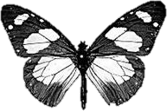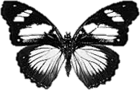

*Amauris ochlea*

*Hypolimnas deceptor*

**TWO SPECIES OF BUTTERFLY**

|  |  |  |
| --- | --- | --- |
| 3.5.1 | Explain why most predators are less likely to feed on *Hypolimnas* |  |
|  | *deceptor.* | (2) |
| 3.5.2 | Use Darwin's theory of evolution through natural selection to |  |
|  | explain the evolution of the appearance of the *Hypolimnas* |  |
|  | *deceptor* butterfly. | (6) |
|  |  | **(8)** |
|  |  | **[50]** |
|  | **TOTAL SECTION B:** | **100** |
| **GRAND TOTAL:** | **150** |