**LIFE SCIENCES Grade 12 2022**

|  |  |
| --- | --- |
| **Total** |  |
|  | **30** |

**Practical Task Term 2: Genetics and Heredity**

**Date:** ____________________________________

**Name: ___________________________________**

**Duration:** 45 minutes

**INSTRUCTIONS TO LEARNERS – THIS IS AN INDIVIDUAL TASK.**

**THE TASK MUST BE DONE IN CLASS UNDER**

**CONTROLLED CONDITIONS.**

**QUESTION 1 - Variations on the face of *Papyrus domesticus***

**Background information**

The Paper Pet (species *Papyrus domesticus*) has four distinct traits as shown below:

|  |  |
| --- | --- |
| **Eyes:**    RR or Rr = square  rr = round | **Nose:**    NN or Nn = triangular  nn = oval |
| **Hair:**    HH or Hh = 3 hairs  hh = 2 hairs | **Teeth:**    TT or Tt = pointed  tt = rectangular |

**Materials**: 2 coins

**Method:**

(1) Use two coins to determine the genotype of a new *Papyrus domesticus* to be born.

Mark one coin with an “F” and the other with an “M” to represent each of the parents. The

parents are heterozygous for all the traits.

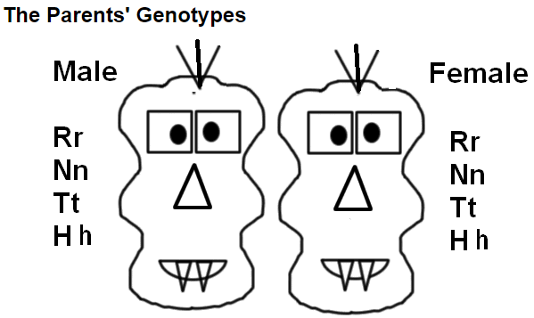

(2) Flip the coins for each parent for each trait. If the coin lands with heads up, it represents a

dominant allele. A coin that lands tails up indicates a recessive allele.

(3)Record the result for each parent by circling the correct letter. Use the results to determine the

genotype and phenotype for each trait of the new baby to be born. (Indicate the phenotype by

circling the trait).

|  |  |  |  |  |  |  |
| --- | --- | --- | --- | --- | --- | --- |
| **Trait** | **Parents** | | | | **Baby** | |
| **Male** | | **Female** | | **Genotype** | **Phenotype** |
| Eyes | R | r | R | r |  |  |
| Nose | N | n | N | n |  |  |
| Hair | H | h | H | h |  |  |
| Teeth | T | t | T | t |  |  |

(8)

|  |
| --- |
| Draw a **detailed picture of** the possible baby with the appropriate traits based on his or her genotype. Clearly label all 4 traits of the baby.  A picture containing hanger, lawn mower, ski tow, cookie cutter  Description automatically generated  (4)  **(12)** |

**QUESTION 2**

|  |
| --- |
| Huntington’s chorea is a disease caused by a gene mutation that results in the degeneration of brain tissue. It is caused by a dominant allele (H) carried on an autosome. The pedigree diagram below shows the inheritance of this disorder in a family. |

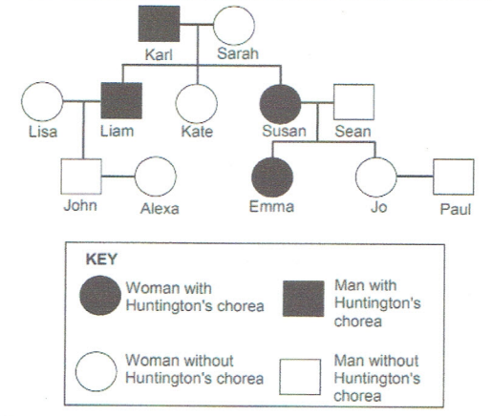

2.1 Define a *gene mutation*. (2)

2.2 What is:

1. Susan’s phenotype (1)
2. Sarah’s genotype (1)

2.3 **Susan** and **Sean** are expecting their third child. Use a genetic cross to show

the percentage chance of them having a child with Huntington’s chorea. (6)

**(10)**

# 

**QUESTION 3**

Chickens come in different colours. A learner bought a black cock (RR) and a white hen (TT) for her coup. The offspring that were born were all black and white speckled.

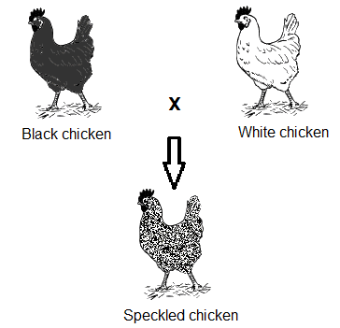

Later, the learner decided to have a second chicken coup and breed two black

and white speckled chickens with each other over a period of a month. There were

20 offspring in total and they had three different colours: black, white, and black and

white speckled.

3.1 Name the type of inheritance shown in the above example. (1)  
3.2 Explain the answer given in QUESTION 3.1. (2)

3.3 Draw a table showing the number of offspring of the different genotypes

from the learner’s second breeding. (5)

**(8)**

**[30]**