**LIFE SCIENCES Grade 12 2023**

|  |  |
| --- | --- |
| **Total** |  |
|  | **30** |

**Practical Task Term 2: Genetics and Heredity**

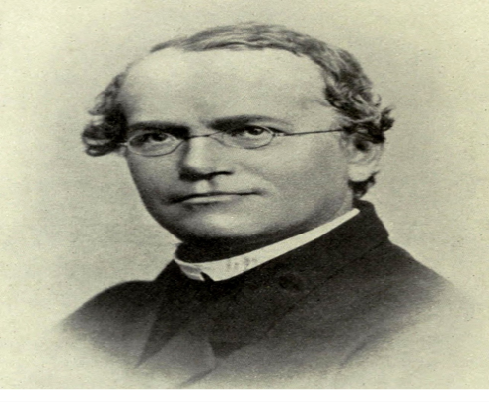

**Duration:** 60 minutes

**INSTRUCTIONS TO LEARNERS**

**Read the following instructions carefully before answering the questions.**

1. This is a formal SBA task and needs to be done under supervised conditions in the classroom.
2. Each learner completes this task on his/her own (under test conditions).
3. Present your answers per the instructions of each question.
4. Draw all diagrams in pencil and labels in blue ink.
5. The diagrams in this task may NOT be drawn to scale.

**QUESTION 1 -Surveying Human Characteristics**

**Background information**

[Genetics](https://www.nigms.nih.gov/education/fact-sheets/Pages/genetics.aspx#130) is the scientific study of [genes](https://www.nigms.nih.gov/education/fact-sheets/Pages/genetics.aspx#127) and heredity, of how certain qualities or traits are passed from parents to offspring. A gene is a segment of DNA that contains instructions for building one or more [molecules](https://www.nigms.nih.gov/education/fact-sheets/Pages/genetics.aspx#196) that help the body work. DNA is shaped like a corkscrew-twisted ladder, called a double helix. Researchers estimate that humans have about 20,000 genes. Humans typically have 23 pairs of chromosomes in their cells. The two chromosomes in each pair contain the same genes, but they may have different versions of those genes because we inherit one chromosome in each pair from our mother and the other from our father.

*Adapted from National Institute of General Medical Sciences*

Many characteristics in humans are controlled by one gene with two alleles, one dominant and one recessive. Three examples are shown below.

|  |  |  |  |  |  |
| --- | --- | --- | --- | --- | --- |
|  |  |  |  |  |  |
| **Unattached**  **Earlobe** | **Attached**  **Earlobe** | **Tongue-roller** | **Non-roller** | **Straight thumb** | **Bent (hitchhiker’s)**  **thumb** |
| Dominant | Recessive | Dominant | Recessive | Dominant | Recessive |

**Activity**

|  |  |
| --- | --- |
| 1. | Select 10 learners that will form part of your sample. |
| 2. | For every learner selected, record the phenotype for each characteristic. |
| 3. | Record the information for each learner in a table. At the end of the table, include  the percentage of learners displaying each phenotype for each of the three characteristics. |
| 4. | Answer the questions set. |

**Questions**

|  |  |  |
| --- | --- | --- |
| 1.1 | In terms of the investigation about the type of earlobe (free or attached),  name the following:  1.1.1 The dependent variable  1.1.2 The independent variable | (1)  (1) |
| 1.2 | Formulate a hypothesis for the frequency of tongue-rollers as compared to  non-rollers in your school. | (2) |
| 1.3 | Draw a table to show the results obtained in this investigation. | (4) |
| 1.4 | According to the results obtained, would you accept or reject the hypothesis formulated in QUESTION 1.2? | (1) |
| 1.5 | Using the same set of axes, draw a bar graph to represent the percentage  of learners displaying each phenotype for each of the three characteristics. | (6)  **(15)** |

**QUESTION 2**

The diagram below shows the inheritance of flower colour in snapdragon plants. The two alleles controlling flower colour are red (**R**) and white (**W**).

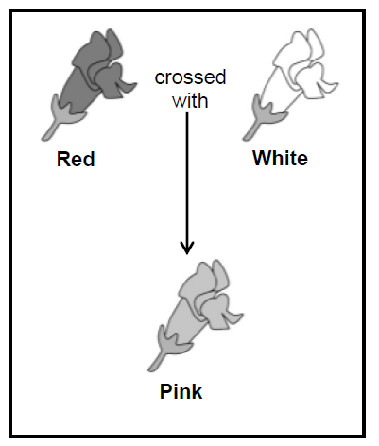

|  |  |  |
| --- | --- | --- |
| 2.1 | State the type of dominance shown by the snapdragon plants. | (1) |
| 2.2 | Give a reason for your answer to QUESTION 2.1. | (2) |
| 2.3 | A gardener crossed two pink-flowered snapdragon plants. Use a genetic cross to show the ratio of the expected phenotypes in the offspring. | (6)  **(9)** |

**QUESTION 3**

Goltz syndrome is a sex-linked genetic disorder. It is caused by a dominant allele

**XG**. The diagram below shows the inheritance of Goltz syndrome in a family**.**

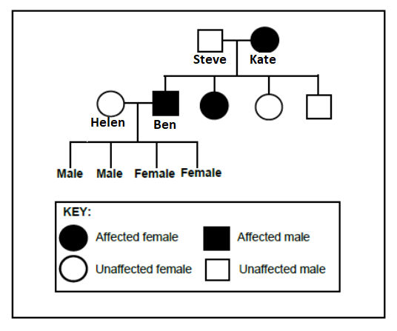

|  |  |  |
| --- | --- | --- |
| 3.1 | Name the type of diagram shown. | (1) |
| 3.2 | How many females are in this family? | (1) |
| 3.3 | How manymales in the F1-generation have Goltz syndrome? | (1) |
| 3.4 | Give Kate's genotype. | (2) |
| 3.5 | Helen and Ben have four children. Give the phenotype of their sons. | (1)  **(6) [30]** |