**LIFE SCIENCES Grade 12 2023**

**Marking Guideline - Practical Task Term 2: Genetics and Heredity**

|  |  |
| --- | --- |
| **Total** |  |
|  | **30** |

**QUESTION 1**

|  |  |  |
| --- | --- | --- |
| 1.1 | 1.1.1 Number of learners ✓ that have free or attached ear lobes  1.1.2 Characteristic✓/type of ear lobe/attached or unattached earlobes | (1)  (1) |
| 1.2 | There are more learners in the school that are tongue rollers than non-rollers✓✓ **OR**  There are more learners in the school that are non-rollers than tongue rollers✓✓ **OR**  The number of learners in the school that are tongue rollers is equal to the number of non-rollers✓ ✓ (any 1 x 2) | (2) |
| 1.3 | ***Allocation of marks for the construction of the table***   |  |  |  | | --- | --- | --- | | **Criterion** | **Elaboration** | **Mark** | | Caption **(C)** | Includes both variables: 'number of learners' and 'different  characteristics' | 1 | | Appropriate column headings **(H)** | Includes names of learners as well as dominant and recessive  phenotypes for each characteristic | 1 | | Data entered **(D)** | Information on the observed phenotypes entered per learner for  each characteristic | 1 | | Percentage of learners  **(P)** | Shown at the end of the table for the different phenotypes for  each characteristic | 1 | | (4) |
| 1.4 | Accept✓ **(If the results obtained are in line with the hypothesis stated by the learner in Question 1.2)**  **OR**  Reject✓ **(If the results obtained contradict the hypothesis stated by the learner in (Question 1.2)** | (1) |
| 1.5 | ***Allocation of marks for the graph***   |  |  |  | | --- | --- | --- | | **CRITERION** | **ELABORATION** | **MARK** | | Same set of axes **(A)** | **Bar Graphs** (6) drawn on the same set of axes | 1 | | Correct caption **(C)** | Includes both variables: 'number of learners' and 'different  characteristics' | 1 | | Correct label and unit for X- and Y-axes **(L)** | X-axis: Correct label (phenotypes of each characteristic)  Y-axis: Correct label (percentage of learners) | 1 | | Scaling **(S)** | Correct scale (equal width and interval of bars) | 1 | | Plotting of Bars **(P)** | 1-5 Bars plotted and drawn correctly  All 6 bars plotted and drawn correctly | 1  2 | | (6)  **(15)** |

**QUESTION 2**

2.1 Incomplete dominance ✓ (1)

2.2 - The pink flower colour is an intermediate phenotype✓/ a blend

of red and white

- indicating that neither of the alleles is dominant✓ (2)

2.3

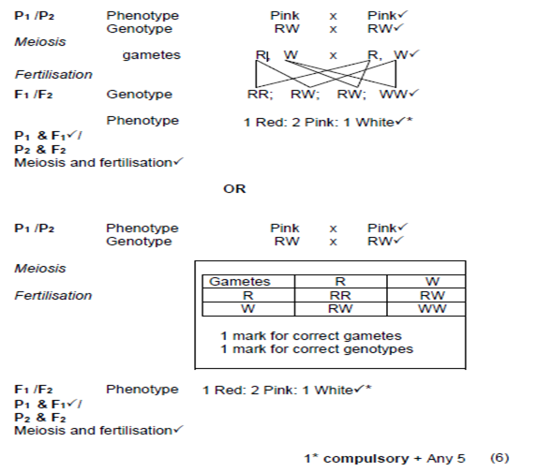

**(9)**

**QUESTION 3**

3.1 Pedigree✓ diagram (1)

3.2 6 ✓ females (1)

3.3 1 ✓ (1)

3.4 X**G** X**g** ✓ ✓ (2)

3.5 Unaffected/without Goltz syndrome (1)

**(6)**

**[30]**