GRADE 12 2022
ASSIGNMENT TERM 3
MARKING GUIDELINES TOTAL: 50

QUESTION 1
1.1 | Million years ago | (1)
1.2 | (a) C /A  (b) A  (c) B | (1)  (1)  (1)
1.3 | Various hypotheses relating to evolution have been tested and verified over  time /has undergone several tests and is supported by evidence | (1)
1.4 | - Biogeography  - Genetics  - Modification by descent /homologous structures  - Fossils  - Cultural (Any 3 x 1)  (Mark first THREE only) | (3)
 |  | (8)
QUESTION 2

2.1 | (a) A  (b) B  (c) A  (d) B | (4)
2.2 | Breeding at different times of the year | (1)
 |  | (5)
QUESTION 3

3.1 | (a) Percentage of attacks. | (1)
 | (b) 24–26% (check final print copy) (accept range) | (1)
 | (c) (78 - 76) – (27 - 25)  = (53 – 49) % | (2)
 | (d) - Sand dunes are lighter /inland fields are darker .  on sand dunes brown fur more visible than white fur to predators/ white  fur on inland fields more visible to predators compared to brown fur  - More brown mice attacked on dunes compared to white mice/  more white mice attacked inland compared to brown mice  - 70% brown mice attacked on coast vs 20% inland / 70% white mice  attacked inland vs 20% on coast | (4)
3.2 | - There is a great deal of variation in the fur colour amongst the offspring.  - Some have white fur and some have brown fur.  - Mice with lighter fur colour had better camouflage against white sand,  - whiter mice had greater chance of surviving/ avoiding predation,  - whilst brown mice will be less suited and more prayed on, die.  - The white mice that survive, reproduce  - and thus, pass on the allele for white fur colour to their offspring.  - The next generation will therefore have a higher proportion of individuals with white fur colour (any 5) | (5)
3.3 | 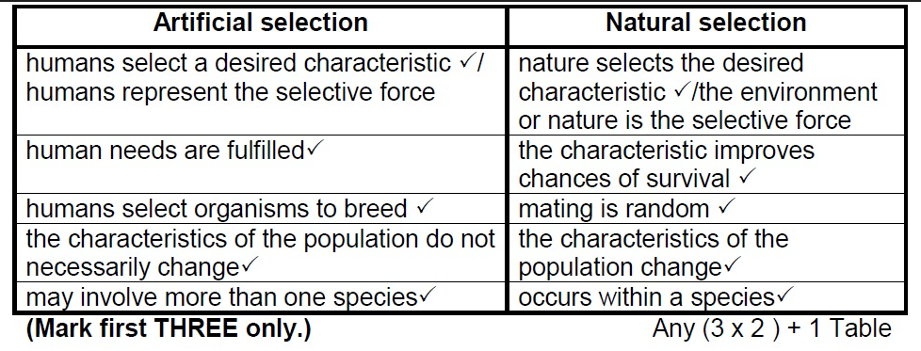 | (7)
 |  | (20)
QUESTION 4
4.1 | Palaeomastodon (Must be underlined; start with a capital letter) | (1)
4.2 | Elephas  Loxodonta | (2)
4.3 | Primelaphus | (1)
4.4 | a) Miocene | (1)
 | b) Pleistocene | (1)
4.5 | 38 – 24  = 14 million years | (3)
 |  | (9)
QUESTION 5
5.1 | Gall size | (1)
5.2 | There is a range of intermediate valuesin gall size | (1)
5.3 | Guideline for the assessing of the graph  CRITERIA ELABORATION MARK  Correct type of graph (T) Line graph drawn 1  Caption of graph (C) Both variables included 1  Axes labels (L) Correct label and units in X- and Y-axis 1  Scale for X- and Y-axis (S) Equal spacing between intervals for each axis 1  Plotting of points (P) 1 to 4 points plotted correctly All 5 points plotted correctly 1 2 | (6)
 |  | (8)
 |  | [50]

Assignment Term 3
Weighting: Practical Skills
Practical Skills
Follow instructions | Handle equipment | Make observations | Draw a diagram | Calculation | Interpret | Design/Plan
Weighting: Cognitive Levels
Question | Cognitive Levels |  |  |  | Levels of difficulty
 | Level A  Knowledge | Level B  Understanding | Level C  Application | Level D  Evaluate, analyse & synthesize | Easy | Moderate | Difficult | Very difficult
1.1 | 1 |  |  |  | 1
1.2 |  |  | 3 |  |  | 3
1.3 | 1 |  |  |  | 1
1.4 | 3 |  |  |  | 3
2.1a-d |  | 4 |  |  |  | 4
2.2 |  | 1 |  |  | 1
3.1a |  |  | 1 |  |  |  | 1
3.1b |  | 1 |  |  | 1
3.1c |  | 2 |  |  |  | 2
3.1d |  |  |  | 4 |  |  | 4
3.2 | 2 |  | 3 |  |  | 5
3.3 | 7 |  |  |  | 7
4.1 |  |  | 1 |  | 1
4.2 |  |  | 2 |  | 2
4.3 |  |  | 1 |  | 1
4.4a |  |  | 1 |  | 1
4.4b |  |  | 1 |  | 1
4.5 |  | 3 |  |  | 1
5.1 |  |  |  | 1 |  |  | 1
5.2 |  |  | 1 |  |  | 1
5.3 | 1 | 2 | 3 |  | 2 | 4
Total | 15 | 13 | 17 | 5 | 25 | 19 | 6 | 0
Percentage | 30 | 26 | 34 | 10 | 50 | 38 | 12 | 0

