**Grade 10 2022 Term 3**

**Practical task: Mitosis, Plant and animal tissues**

**Time: 30 minutes Total: 30**

**INSTRUCTIONS AND INFORMATION**

**Read the following instructions carefully before answering the questions.**

1. This is a formal SBA task and needs to be done under supervised conditions in the classroom.
2. Each learner completes this task on his/her own (under test conditions).
3. Present your answers per the instructions of each question.
4. Draw all diagrams in pencil and labels in blue ink.
5. The diagrams in this task may NOT be drawn to scale.

**QUESTION 1**

**Study the diagrams below and answer the questions that follow:**

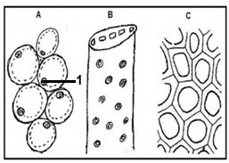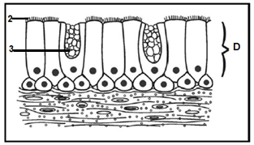

* 1. Provide the LETTER (**A** to **D**) and the NAME of the tissue which:

1. Is found in the trachea and bronchi.
2. Provides mechanical support to a plant.
3. Has thin cell walls.
4. Transports water and minerals in plants. (8)
   1. Provide the correct LABEL for structures numbered 1-3. (3)

1.3 Give one function of the following tissues:

1. **D** (1)
2. **A** (1)

**(13)**

**QUESTION 2**

The diagram below shows the light micrograph of the cell cycle in plant cells. 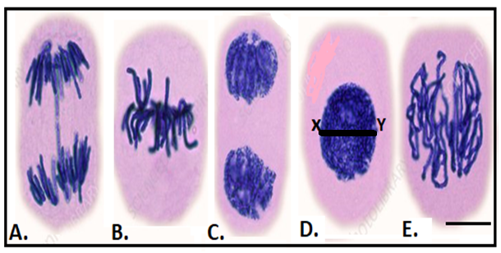

**1 μm**

2.1 Identify the phases of the cell cycle labelled **A** to **E**. Write only the letter and

name. (5)

2.2 Arrange the diagrams in the correct sequence using the letters **A** to **E**. (2)

2.3 State the main difference between mitosis in plant and animal cells. (2)

2.4 If the original cell has 46 chromosomes at the beginning of mitosis, how

many chromosomes will be present in each cell at the end of mitosis? (1)

2.5 How many cells are formed at the end of mitosis from a single cell? (1)

2.6 What is the purpose of mitosis? (2)

2.7. Use the following equation and calculate the width of the structure in diagram **D** (**X** to **Y)**.

Show all your working.

|  |  |
| --- | --- |
| Actual size of object = | Measured length of object (mm) x value of scale (µm) |
| length of scale line (mm) |

(4) **(17)**

**[30]**