Stories to fuel your mind.

The Enlightenment’s Dark Side

How the Enlightenment created modern race thinking, and why we should confront it.
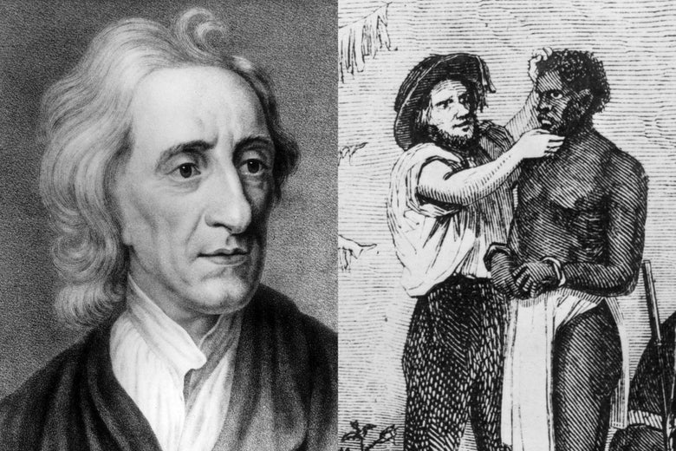
Slate | by Jamelle Bouie

John Locke, and a wood graving of white trader inspecting an African slave during a sale circa 1850. Photo illustration by Slate. Images by ullstein bild/Getty Images, MPI/Getty Images.
The Enlightenment is having a renaissance, of sorts. A handful of centrist and conservative writers have reclaimed the 17^{th-} and 18th-century intellectual movement as a response to nationalism and ethnic prejudice on the right and relativism and “identity politics” on the left. Among them are Jordan Peterson, the Canadian psychologist who sees himself as a bulwark against the forces of “chaos” and “postmodernism”; Steven Pinker, the Harvard cognitive psychologist who argues, in Enlightenment Now, for optimism and human progress against those “who despise the Enlightenment ideals of reason, science, humanism, and progress”; and conservative pundit Jonah Goldberg, who, in Suicide of the West, argues in defense of capitalism and Enlightenment liberalism, twin forces he calls “the Miracle” for creating Western prosperity.
In their telling, the Enlightenment is a straightforward story of progress, with major currents like race and colonialism cast aside, if they are acknowledged at all. Divorced from its cultural and historical context, this “Enlightenment” acts as an ideological talisman, less to do with contesting ideas or understanding history, and more to do with identity. It’s a standard, meant to distinguish its holders for their commitment to “rationalism” and “classical liberalism.”
But even as they venerate the Enlightenment, these writers actually underestimate its influence on the modern world. At its heart, the movement contained a paradox: Ideas of human freedom and individual rights took root in nations that held other human beings in bondage and were then in the process of exterminating native populations. Colonial domination and expropriation marched hand in hand with the spread of “liberty,” and liberalism arose alongside our modern notions of race and racism.
These weren’t incidental developments or the mere remnants of earlier prejudice. Race as we understand it—a biological taxonomy that turns physical difference into relations of domination—is a product of the Enlightenment. Racism as we understand it now, as a socio-political order based on the permanent hierarchy of particular groups, developed as an attempt to resolve the fundamental contradiction between professing liberty and upholding slavery. Those who claim the Enlightenment’s mantle now should grapple with that legacy and what it means for our understanding of the modern world.
To say that “race” and “racism” are products of the Enlightenment is not to say that humans never held slaves or otherwise classified each other prior to the 18th century. Recent scholarship shows how proto- and early forms of modern race thinking (you could call them racialism) existed in medieval Europe, with near-modern forms taking shape in the 15th and 16th centuries. In Spain, for example, we see the turn from anti-Judaism to anti-Semitism, where Jewish ancestry itself was grounds for suspicion, versus Jewish practice. And as historian George Fredrickson notes in Racism: A Short History, “the prejudice and discrimination directed at the Irish on one side of Europe and certain Slavic peoples on the other foreshadowed the dichotomy between civilization and savagery that would characterize imperial expansion beyond the European continent.” One can find nascent forms of all of these ideas in antiquity—indeed, early modern thinkers drew from all of these sources to build our notion of race.
But it took the scientific thought of the Enlightenment to create an enduring racial taxonomy and the “color-coded, white-over-black” ideology with which we are familiar. This project, undertaken by the leading thinkers of the time, involved “the setting aside of the metaphysical and theological scheme of things for a more logical description and classification that ordered humankind in terms of physiological and mental criteria based on observable ‘facts’ and tested evidence,” as historian Ivan Hannaford wrote in Race: The History of an Idea in the West.
Johann Friedrich Blumenbach’s influential 1776 volume On the Natural Varieties of Mankind posited five divisions of humanity, beginning with “Caucasians.” These frameworks evolved into theories of racial difference, developed to square a conceptual circle. If natural rights are universal—if everyone has the capacity to reason—then what is the explanation for enslaved Africans or “savages” in the Americas, who do not seem to act and reason like white Europeans? The answer is biological inferiority, in accordance with those racial classifications.
Immanuel Kant sketched out a more formalized racial hierarchy in his own anthropological work. “In the hot countries the human being matures earlier in all ways but does not reach the perfection of the temperate zones,” Kant wrote. “Humanity exists in its greatest perfection in the white race … The yellow Indians have a smaller amount of Talent. The Negroes are lower and the lowest are a part of the American peoples.” Elsewhere, Kant asserted that “[Whites] contain all the impulses of nature in affects and passions, all talents, all dispositions to culture and civilization and can as readily obey as govern. They are the only ones who always advance to perfection.” This racial theorizing can’t simply be divorced from the moral philosophy for which he’s hailed, since, as the late Emmanuel Eze has noted, it comprised a substantial portion of Kant’s career. Eze writes in “The Color of Reason: The Idea of ‘Race’ in Kant’s Anthropology”:
Kant’s position on the importance of skin color not only as encoding but as proof of this codification of rational superiority or inferiority is evident in a comment he made on the subject of the reasoning capacity of a “black” person. When he evaluated a statement made by an African, Kant dismissed the statement with the comment: “this fellow was quite black from head to foot, a clear proof that what he said was stupid.” It cannot, therefore, be argued that skin color for Kant was merely a physical characteristic. It is, rather, evidence of an unchanging and unchangeable moral quality
Eze’s re-examination in the 1990s kicked off a flood of research and dialogue—some critical, some supportive. Either way, it is fair to say that Kant’s race theorizing matters for how we understand the history of race. On this point, philosopher Robert Bernasconi is blunt: “[Kant] supplied the first scientific definition of race; he promoted this definition when it was challenged, and he saw it adopted by some of the leading students of human varieties at that time.”
John Locke precedes Kant, but his work also shows the influence of early modern racial thinking. In “The Contradictions of Racism: Locke, Slavery, and the Two Treatises,” Bernasconi and Anika Maaza Mann present the pre-eminent liberal philosopher as an architect of the race-based slavery developing in the American colonies during the mid–17th century. At a time when religious conversion could spare an African or Native American from permanent servitude, Locke wrote a provision in The Fundamental Constitutions of Carolina—the governing document for the colony that would become North Carolina and South Carolina—that specified that slaves could be “of what opinion or Religion soever … But yet, no Slave shall hereby be exempted from that civil dominion his Master has over him, but be in all other things in the same State and condition he was in before.” About the same time, when there was still widespread debate over the treatment of enslaved people, Locke changed a clause in that constitution to give slave owners “absolute power and Authority” (versus “absolute Authority”) over their slaves, giving them full rein to treat slaves as they pleased.
It is true that, in his Two Treatises on Government, Locke proclaimed himself an opponent of “slavery.” But this “slavery” refers to the political domination of an absolute monarch. In the second of the treatises, Locke provides a justification for slavery as a result of war, using the same “absolute power” language that grants slave owners the power of life and death over their slaves. While his argument doesn’t fit the hereditary chattel slavery taking shape in the Americans, it was nonetheless used to justify the practice. For Bernasconi and Mann, the Locke of the Two Treatises must be read in dialogue with the Locke of the The Fundamental Constitutions, and can’t be bracketed from his role as a colonial administrator and investor in the slave trade. This Locke, they argue, must be understood as concerned mainly “with the freedom and prosperity of Englishmen, and not troubled if they were gained at the expense of Africans.”
One can make a similar argument with regard to Native Americans. In Liberalism: A Counter-History, Domenico Losurdo notes how “the Second Treatise makes repeated reference to the ‘wild Indian,’ who moved around ‘insolent and injurious in the woods of America’ or the ‘vacant places of America.’ ” For Locke, “God gave the world to men in common; but since he gave it them for their benefit and for the greatest conveniences of life they could get from it, he can’t have meant it always to remain common and uncultivated.” In the context of English settlement, it’s an argument for theft.
It should be said that this view is contested. Recent scholarship challenges this vision of Locke—situating him in a broader conversation that leaves him less tolerant of slavery than he appears. Still, as one of the widely read thinkers of the period, his work remained influential to slaveholders, including the author of the Declaration of Independence, Thomas Jefferson, and the Framers of the Constitution, for whom racial slavery and native expropriation were compatible with natural rights and representative government. Decades later, South Carolina’s John C. Calhoun would appeal to Locke in his defense of individual liberties and attacks on “absolute governments” that turn “the governed” into “the slaves of the rulers.” Calhoun’s cause, of course, was slavery.
For modern-day philosopher Charles Mills, this joint march of liberalism and white supremacy—whether Locke’s social contract or Kant’s moral theory—supports the notion of an implicit “racial contract” undergirding the Enlightenment project. “[T]he Racial Contract establishes a racial polity, a racial state, and a racial juridical system, where the status of whites and nonwhites is clearly demarcated, whether by law or custom. And the purpose of this state … is specifically to maintain and reproduce this racial order, securing the privileges and advantages of the full white citizens and maintaining the subordination of nonwhites.” As European powers spread across the globe, they used racial notions of personhood—pioneered by Enlightenment thinkers—to justify brutality and domination as the march of “civilization.”
This paradox between Enlightenment liberalism and racial domination was well-recognized from the beginning. “You Americans make a great Clamour upon every little imaginary infringement of what you take to be your Liberties; and yet there are no People upon Earth such Enemies to Liberty, such absolute Tyrants, where you have the Opportunity, as you yourselves are,” jeered one English interlocutor to Benjamin Franklin in 1764. Responding to the first American Continental Congress in 1774, Samuel Johnson replied to “no taxation without representation” with, “How is it we hear the loudest yelps for liberty from the drivers of negroes?” Criticizing England’s role in the slave trade in 1776, Josiah Tucker wrote that “We … the boasted Patrons of Liberty, and the professed Advocates for the natural Rights of Mankind, engage deeper in this murderous inhuman Traffic than any Nation whatever.” Writers of African ancestry at the time, like Baron de Vastey of Haiti, made note of the hypocrisy of Enlightenment philosophers. Arguably, the only Enlightenment revolution to do justice to its universal aspirations was the Haitian Revolution, whose authors—like Toussaint L’Ouverture—appealed to those values as they fought slavery and colonialism to establish self-governance.
Today’s popular discourse on the Enlightenment ignores this contradiction and its modern manifestations, seen in the persistence of race hierarchy in the world’s oldest democracy. Some self-proclaimed defenders of Enlightenment ideals have even gone so far as to ridicule the idea of a connection between the Enlightenment and our modern ideas of race and racial hierarchy, as if the scholarship didn’t exist. This isn’t just unfortunate, it’s ironic—a betrayal of the higher principles of the Enlightenment, of the commitment to evidence, observation, reason, and deliberation. It’s also dangerous.
We still live in a world shaped by Enlightenment ideas of race and white supremacy. These notions of inherent inferiority still hold purchase in our society. And political liberalism is still too compatible with both. The path to a truly universal liberalism—one that can actually liberate—demands that we grapple with its ugly heritage. To confront the paradox of the Enlightenment is to take its values seriously; to dismiss it is to prefer hagiography to truth.
Jamelle Bouie is a New York Times opinion columnist. He was formerly Slate’s chief political correspondent.

