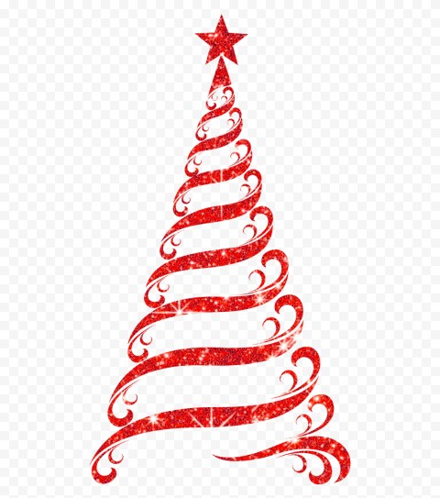
The Boars Head Inn
Christmas Menu 2025
Starters
Cream of Leek and Potato Soup with Crispy Fried Onions and Croutons • • ⸙ • • Wild Mushroom, Spinach and Parmesan Arancini with Dressed Rocket and Tomato Chutney • • ⸙ • • Classic Prawn and Smoked Salmon Cocktail with Lemon • • ⸙ • •
Aromatic Duck in Chilli and Hoi Sin Sauce with Spring Onion and Sesame Seeds
Mains
Roast Crown of Turkey, Sage and Onion Stuffing, Pigs in Blankets, Roast Potatoes, Parsnip Swede Mash, Brussel Sprouts, Carrots and Cauliflower Cheese • • ⸙ • • Roast Sirloin of Beef with Yorkshire Pudding, Roast Potatoes, Parsnip Swede Mash, Sprouts and Cauliflower Cheese • • ⸙ • • Roasted Hake Fillet on Crushed New Potatoes with Buttered Spinach and Crispy Pancetta • • ⸙ • •
Winter Root Vegetable and Lentil Cottage Pie with Cheesy Potato Gratin and Fresh Vegetables
Desserts Chocolate Trifle and Baileys Trifle Vanilla Panna Cotta with Raspberry Sorbet Christmas Pudding with Brandy Sauce Cheese and Biscuits with Grapes with Chutney
The Boars Head Inn
Christmas Booking Form 2025
2 COURSES £33.95 3 COURSES £38.95
Available from 1st to 24th December - Complimentary Coffee and Mince Pie included. (NOT AVALIABLE ON SUNDAYS)
Please Advise us of any Allergies or Requirements (Vegan Options Available from our normal Menu)
£10 Deposit Per Person Required
DATE/ TIME/ NAME/

NAME | STARTER | MAIN | DESSERT | DEPOSIT
1.
2.
3.
4.
5.
6.
7.
8.
9.
10.
11.
12.
13.
14.
15,
16.
17.
18.
19.
20.
21.
22.
23.
24.
25.
26.
27.
28.
29.
30.
 |  |  | TOTAL DEPOSIT PAID

