Worshipful Master: Joseph Felix Marion McDaniel Lodge # 56

Edition: December 2022

**Roosevelt, Franklin D. (Franklin Delano), 1882-1945** 32nd President, 1933 – 1945, made a Mason November 28, 1911, in Holland Lodge No. 8, F. & A.M., New York, New York, the same Lodge in which George Washington, the Nation’s first President, held Honorary membership and remained an active freemason for the rest of his life. Was made a Prophet-at-Sight in Tri-Po-Bed Grotto on October 30, 1931. He was the 44th Governor of New York. Made Honorary Grand Master of the Order of DeMolay on April 13, 1934. America’s longest serving President and in 1935 he presided over Architect Lodge, New York, when his sons Elliot and Franklin Delano Jr were made Master Masons in their own right. Roosevelt was in his 4th Presidential term when he passed away on April 12, 1945.

Roosevelt led the implementation of the New Deal, a series of programs designed to provide relief, recovery, and reform to Americans and the American economy during the Great Depression. He also presided over a realignment that made his New Deal Coalition of labor unions, big city machines, white ethnics, African Americans, and rural white Southerners dominant in national politics until the 1960s and defined modern American liberalism.

During his first hundred days in office, Roosevelt spearheaded unprecedented major legislation and issued a profusion of executive orders. The Emergency Banking Act helped put an end to a run on banks, while the 1933 Banking Act and the Securities Exchange Act of 1934 provided major reforms in the financial sector. To provide relief to unemployed workers, Roosevelt presided over the establishment of several agencies, including the Civilian Conservation Corps, the Public Works Administration, the Federal Emergency Relief Administration and the Agricultural Adjustment Administration to prevent agricultural overproduction. The Second New Deal featured the Works Progress Administration (WPA), the largest work relief agency, and the Social Security Act, a national unemployment insurance program, as well as the Aid to Dependent Children, which provided aid to families headed by single mothers. A third major piece of legislation, the National Labor Relations Act of 1935, guaranteed workers the right of collective bargaining and established the National Labor Relations Board. The result was rapid growth in union membership. After winning re-election in 1936, the second term was a series of disappointments.

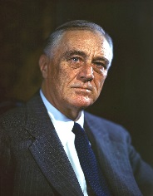

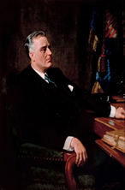

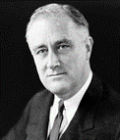

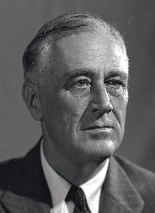

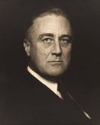

(See more pictures of events about Roosevelt at the end of this Trestle Board.)

Greetings to all brothers! We hope this edition finds you all doing well, and we wish you and yours good health and happiness. This will be the last TB from the current years Officers.

Check out our Web Page at mm56.org. It has posts and new Masonic Education articles on it.

**From Our Worshipful Master:**

Jonathan Livingston Seagull a story

RICHARD BACH

PART THREE

JONATHAN CIRCLED SLOWLY OVER THE FAR CLIFFS, watching. This rough young Fletcher

Gull was very nearly a perfect flight-student. He was strong and light and quick in the air, but far

and away more important, he had a blazing drive to learn to fly.

Here he came this minute, a blurred grey shape roaring out of a dive, flashing one hundred fifty

miles per hour past his instructor. He pulled abruptly into another try at a sixteen- point vertical

slow roll, calling the points out loud. “... eight ... nine ... ten ... see-Jonathan-I’m-running- out-

of-airspeed ... eleven ... I-want-good- sharp-stops-like- yours ... twelve ... but-blast-it-I-just-

can’t-make ... thirteen ... these-last- three-points ... without ... fourtee ... aaakk!”

Fletcher’s whipstall at the top was all the worse for his rage and fury at failing. He fell backward,

tumbled, slammed savagely into an inverted spin, and recovered at last, panting, a hundred feet

below his instructor’s level.

“You’re wasting your time with me, Jonathan! I’m too dumb! I’m too stupid! I try and try, but I’ll

never get it!”

Jonathan Seagull looked down at him and nodded. “You’ll certainly never get it as long as you

make that pullup so hard. Fletcher, you lost forty miles an hour in the entry! You have to be

smooth! Firm but smooth, remember?”

He dropped down to the level of the younger gull. “Let’s try it together now, in formation. And

pay attention to that pullup. It’s a smooth, easy entry.”

By the end of three months Jonathan had six other students, Outcasts all, yet curious about

this strange new idea of flight for the joy of flying. Still, it was easier for them to practice high

performance than it was to understand the reason behind it.

“Each of us is in truth an idea of the Great Gull, an unlimited idea of freedom,” Jonathan would

say in the evenings on the beach, “and precision flying is a step toward expressing our real

nature. Everything that limits us we have to put aside. That’s why all this high-speed practice,

and low speed, and aerobatics ...” ... and his students would be asleep, exhausted from the

day’s flying. They liked the practice, because it was fast and exciting and it fed a hunger for

learning that grew with every lesson. But not one of them, not even Fletcher Lynd Gull, had

come to believe that the flight of ideas could possibly be as real as the flight of wind and feather.

“Your whole body, from wingtip to wingtip,” Jonathan would say, other times, “is nothing more

than your thought itself, in a form you can see. Break the chains of your thought, and you

break the chains of your body, too ...” But no matter how he said it, it sounded like pleasant

fiction, and they needed more to sleep.​

It was only a month later that Jonathan said the time had come to return to the Flock.

“We’re not ready!” said Henry Calvin Gull. “We’re not welcome! We’re Outcast! We can’t force

Ourselves to go where we’re not welcome, can we?”

“We’re free to go where we wish and to be what we are,” Jonathan answered, and he lifted

from the sand and turned east, toward the home grounds of the Flock.

There was brief anguish among his students, for it is the Law of the Flock that an Outcast never

returns, and the Law had not been broken once in ten thousand years.

The Law said stay; Jonathan said go; and by now he was a mile across the water. If they

waited much longer, he would reach a hostile Flock alone.

“Well, we don’t have to obey the law if we’re not a part of the Flock, do we?” Fletcher said,

rather self-consciously. “Besides, if there’s a fight, we’ll be a lot more help there than here.”

And so they flew in from the west that morning, eight of them in a double-diamond formation,

Wingtips almost overlapping. They came across the Flock’s Council Beach at a hundred

thirty-five miles per hour, Jonathan in the lead, Fletcher smoothly at his right wing, Henry Calvin

struggling gamely at his left. Then the whole formation rolled slowly to the right, as one bird ...

level ... to ... inverted ... to ... level, the wind whipping over them all.

The squawks and grackles of everyday life in the Flock were cut off as though the formation

were a giant knife, and eight thousand gull-eyes watched, without a single blink. One by one,

each of the eight birds pulled sharply upward into a full loop and flew all the way around to a

dead-slow stand-up landing on the sand. Then as though this sort of thing happened every day,

Jonathan Seagull began his critique of the flight.

“To begin with,” he said with a wry smile, “you were all a bit late on the join-up ...”

It went like lightning through the Flock. Those birds are Outcast! And they have returned! And that ... that can’t happen! Fletcher’s predictions of battle melted in the Flock’s confusion.

“Well, O.K., they may be Outcast,” said some of the younger gulls, “but where on earth did they

learn to fly like that?”

It took almost an hour for the Word of the Elder to pass through the Flock: Ignore them. The gull

who speaks to an Outcast is himself Outcast. The gull who looks upon an Outcast breaks the

Law of the Flock.

Grey-feathered backs were turned upon Jonathan from that moment onward, but he didn’t

appear to notice. He held his practice sessions directly over the Council Beach and for the first

time began pressing his students to the limit of their ability.

“Martin Gull!” he shouted across the sky. “You say you know low-speed flying. You know

nothing till you prove it! FLY!”

So quiet little Martin William Seagull, startled to be caught under his instructor’s fire, surprised

himself and became a wizard of low speeds. In the lightest breeze he could curve his feathers

to lift himself without a single flap of wing from sand to cloud and down again.

Likewise Charles-Roland Gull flew the Great Mountain Wind to twenty-four thousand feet, came

down blue from the cold thin air, amazed and happy, determined to go still higher tomorrow.

Fletcher Seagull, who loved aerobatics like no one else, conquered his sixteen-point vertical

slow roll and the next day topped it off with a triple cartwheel, his feathers flashing white sunlight

to a beach from which more than one furtive eye watched.

Every hour Jonathan was there at the side of each of his students, demonstrating, suggesting,

pressuring, guiding. He flew with them through night and cloud and storm, for the sport of it,

while the Flock huddled miserably on the ground.

When the flying was done, the students relaxed on the sand, and in time they listened more

closely to Jonathan. He had some crazy ideas that they couldn’t understand, but then he had

some good ones that they could.

Gradually, in the night, another circle formed around the circle of students — a circle of curious

gulls listening in the darkness for hours on end, not wishing to see or be seen of one another,

fading away before daybreak.

It was a month after the Return that the first gull of the Flock crossed the line and asked to learn

how to fly. In his asking, Terrence Lowell Gull became a condemned bird, labelled Outcast; and

the eighth of Jonathan’s students.

The next night from the Flock came Kirk Maynard Gull, wobbling across the sand, dragging his

left wing, to collapse at Jonathan’s feet. “Help me,” he said very quietly, speaking in the way that

the dying speak. “I want to fly more than anything else in the world ...”

“Come along then,” said Jonathan. “Climb with me away from the ground, and we’ll begin.”

“You don’t understand. My wing. I can’t move my wing.” “Maynard Gull, you have the freedom

to be yourself, your true self, here and now, and nothing can stand in your way. It is the Law of

the Great Gull, the Law that Is.”

“Are you saying I can fly?” “I say you are free.”

As simply and as quickly as that, Kirk Maynard Gull spread his wings, effortlessly, and lifted into

the dark night air. The Flock was roused from sleep by his cry, as loud as he could scream it,

from five hundred feet up; “I can fly! Listen! I CAN FLY!”

By sunrise there were nearly a thousand birds standing outside the circle of students, looking

curiously at Maynard. They didn’t care whether they were seen or not, and they listened, trying

to understand Jonathan Seagull.

He spoke of very simple things — that it is right for a gull to fly, that freedom is the very nature of

his being, that whatever stands against that freedom must be set aside, be it ritual or

superstition or limitation in any form.

“Set aside,” came a voice from the multitude, “even if it be the Law of the Flock?” “The only true

law is that which leads to freedom,” Jonathan said. “There is no other.”

“How do you expect us to fly as you fly?” came another voice. “You are special and gifted and

divine, above other birds.”

“Look at Fletcher! Lowell! Charles-Roland! Are they also special and gifted and divine? No more

than you are, no more than I am. The only difference, the very only​ one, is that they have begun

to understand what they really are and have begun to practice it.”

His students, save Fletcher, shifted uneasily. They hadn’t realized that this was what they were

doing.

The crowd grew larger every day, coming to question, to idolize, to scorn.

“They are saying in the Flock that if you are not the Son of the Great Gull Himself,” Fletcher

told Jonathan one morning after Advanced Speed Practice, “then you are a thousand

years ahead of your time.”

Jonathan sighed. The price of being misunderstood, he thought. They call you devil or they

call you god. “What do you think, Fletch? Are we ahead of our time?”

A long silence. “Well, this kind of flying has always been here to be learned by anybody who

wanted to discover it; that’s got nothing to do with time. We’re ahead of the fashion, maybe.

Ahead of the way that most gulls fly.”

“That’s something,” Jonathan said, rolling to glide inverted for a while. “That’s not half as bad as

being ahead of our time.”

It happened just a week later. Fletcher was demonstrating the elements of high-speed flying

to a class of new students. He had just pulled out of his dive from seven thousand feet, a

long grey streak firing a few inches above the beach, when a young bird on its first flight glided

directly into his path, calling for its mother. With a tenth of a second to avoid the youngster,

Fletcher Lynd Seagull snapped hard to the left, at something over two hundred miles per hour,

into a cliff of solid granite.

It was, for him, as though the rock were a giant hard door into another world. A burst of fear and

shock and black as he hit, and then he was adrift in a strange sky, forgetting, remembering,

forgetting; afraid and sad and sorry, terribly sorry.

The voice came to him as it had in the first day that he had met Jonathan Livingston Seagull.

“The trick, Fletcher, is that we are trying to overcome our limitations in order, patiently. We don’t

tackle flying through rock until a little later in the program.”

“Jonathan!”

“Also known as the Son of the Great Gull,” his instructor said dryly.

“What are you doing here? The cliff! Haven’t I ... didn’t I ... die?”

“Oh, Fletch, come on. Think. If you are talking to me now, then obviously you didn’t die, did you?

What you did manage to do was to change your level of consciousness rather abruptly. It’s your

choice now. You can stay here and learn on this level — which is quite a bit higher than the one

you left, by the way — or you can go back and keep working with the Flock. The Elders were

hoping for some kind of disaster, but they’re startled that you obliged them so well.”

“I want to go back to the Flock, of course. I’ve barely begun with the new group!”

“Very well, Fletcher. Remember what we were saying about one’s body being nothing more than

thought itself ...?”

Fletcher shook his head and stretched his wings and opened his eyes at the base of the cliff, in

the center of the whole Flock assembled. There was a great clamor of squawks and screes

from the crowd when first he moved.

“He lives! He that was dead lives! ”

“Touched him with a wingtip! Brought him to life! The Son of the Great Gull!”

“No! He denies it! He’s a devil! DEVIL! Come to break the Flock!”

There were four thousand gulls in the crowd, frightened at what had happened, and the cry

DEVIL! went through them like the wind of an ocean storm. Eyes glazed, beaks sharp, they

closed in to destroy.

“Would you feel better if we left, Fletcher?” asked Jonathan. “I certainly wouldn’t object too

much if we did ...”

Instantly they stood together a half-mile away, and the flashing beaks of the mob closed on

empty air.

“Why is it,” Jonathan puzzled, “that the hardest thing in the world is to convince a bird that he is

free, and that he can prove it for himself if he’d just spend a little time practicing? Why should

that be so hard?”

Fletcher still blinked from the change of scene. “What did you just do? How did we get here?”

“You did say you wanted to be out of the mob, didn’t you?” “Yes! But how did you ...”

“Like everything else, Fletcher. Practice.”

By morning the Flock had forgotten its insanity, but Fletcher had not. “Jonathan, remember

what you said a long time ago, about loving the Flock enough to return to it and help it learn?”

“Yes.”

“I don’t understand how you manage to love a mob of birds that has just tried to kill you.”

“Oh, Fletch, you don’t love that! You don’t love hatred and evil, of course. You have to practice

and see the real gull, the good in every one of them, and to help them see it in them- selves.

That’s what I mean by love. It’s fun, when you get the knack of it.” “I remember a fierce young

bird, for instance, Fletcher Lynd Seagull, his name. Just been made Outcast, ready to fight the

Flock to the death, getting a start on building his own bitter hell out on the Far Cliffs. And here

he is today building his own heaven instead, and leading the whole Flock in that direction.”

Fletcher turned to his instructor, and there was a moment of fright in his eye.

“ Me leading? What do you mean, me leading? You’re the instructor here. You couldn’t leave!”​

“Couldn’t I? Don’t you think that there might be other flocks, other Fletchers, that need an

Instructor more than this one, that’s on its way toward the light?”

“ Me? Jon, I’m just a plain seagull, and you’re ..“...“the only Son of the Great Gull, I suppose?”

Jonathan sighed and looked out to sea. “You don’t need me any longer. You need to keep

finding yourself, a little more each day, that real, unlimited Fletcher Seagull. He’s your instructor.

You need to understand him and to practice him.”

A moment later Jonathan’s body wavered in the air, shimmering, and began to go transparent.

“Don’t let them spread silly rumors about me, or make me a god. O.K., Fletch? I’m a seagull. I like to fly, maybe ...”

“ JONATHAN!”

“Poor Fletch. Don’t believe what your eyes are telling you. All they show is limitation. Look with

your understanding, find out what you already know, and you’ll see the way to fly.”

The shimmering stopped. Jonathan Seagull had vanished into empty air.

After a time, Fletcher Gull dragged himself into the sky and faced a brand-new group of

students, eager for their first lesson.

“To begin with,” he said heavily, “you’ve got to understand that a seagull is an unlimited idea of

freedom, an image of the Great Gull, and your whole body, from wingtip to wingtip, is nothing

more than your thought itself.”

The young gulls looked at him quizzically. Come on, they thought, this doesn’t sound like a rule

for a loop.

Fletcher sighed and started over. “Hm. Ah ... very well,” he said, and eyed them critically. “Let’s

begin with Level Flight.” And saying that, he understood all at once that his friend had quite

honestly been no more divine than Fletcher himself.

No limits, Jonathan? he thought. Well, then, the time’s not distant when I’m going to appear out

of thin air on your beach, and show you a thing or two about flying!

And though he tried to look properly severe for his students, Fletcher Seagull suddenly saw

them all as they really were, just for a moment, and he more than liked, he loved what it was he

saw. No limits, Jonathan? he thought, and he smiled. His race to learn had begun.

*This is a fable about the importance of making the most of our lives, even if our goals run*

*contrary to the norms of our flock, tribe or neighborhood. Through the metaphor of flight,*

*Jonathan’s story shows us that, if we follow our dreams, we too can soar. It is this lesson I hope*

*to leave you all with as my term comes to an end. I wish you all the best in life and may your*

*Masonic path be rich in Knowledge and plentiful in Brotherly Love.*

Fraternally,

Joe Felix, WM

**From the South:**

*Greeting my Brothers! As the holidays quickly approach, and our current year draws to a close, I would hope we all can look back on the year feeling full of growth and accomplishment. True, I am sure all of us did not get to complete every task we laid out for ourselves at the beginning of the year, as life has a way of stepping in and changing our plans for us, but each one of us can reflect on something this past year that we can be proud of. We each had a way to do something good for another Brother, reach out to a friend who just needed a shoulder to support them, support a much needed charity, or just found a way to better our own selves as an individual or as a Brother. My hope and wish for all is that we can continue to carry these virtues, growth, and Brother Love for all mankind into the future year. May you all have a wonderful holiday season and the Supreme Architect watch over and guide you and yours.*

*Fraternally,*

Matt Hedrick, PM, JW

***Upcoming Events December 2022***

***December 5th – Dinner 6pm and meeting at 7pm.***

***December 17th – Installation of Marion McDaniel Lodge 2023 Lodge Officers at 1pm***

***December 13 – Presenting The Star Of Bethlehem by WB Dr. Larry Behars 7 pm (everyone is invited to include family, friends, prospects, OES, OofA, EVERYONE). This is a great presentation for the holiday season.***

**Updates/Reminders:**

**From the Secretary and Treasurer: Brothers, please check your dues card. May we all take care of our annual dues by the end of the year so the Secretary and Treasurer can start their annual reports. There are Grand Lodge, City, County, State and Federal reports to be completed so insuring your dues are paid before the end of the year makes it easier to complete these reports. We thank each one of my Brothers for you dedicated help and support of our lodge.**

**Last chance to purchase tickets on a new Ford Pickup**

**Henry Spomer will have tickets at out December meeting**



*It is getting close to the drawing date so call to get your tickets****. The Lodge has Raffle Tickets for three great prizes in the Jim Click Tucson Millions drawing. The*** *offered prizes are A new 2022 Ford Maverick Lariat Hybrid, two round-trip first-class airline tickets to anywhere in the world or $5,000 cash. Tickets are $25 each or 5 for $100.* ***The lodge gets 50% of the sale for own school charity while the other 50% goes to our Arizona Masonic Foundation for Children charity.*** *Yes 100% goes to our Masonic Charities. Anyone can purchase tickets and the funds raised stays within the Masonic Fraternity. Please contact Henry Spomer to purchase tickets. 1papapie@comcast/net or text @ (520) 661-2021*

Through your financial support the Arizona Masonic Foundation for Children has trained over a hundred (100) more new educators to identify, intervene and help At Risk Students this year. Every day they are working to make our schools and society a safer place to live.

The meal for the Monday December 5th meeting is $10 BBQ chicken, mashed potatoes, green salad and dessert", starting at 6:30 with Lodge opening at 7:30. Please RSVP by December 2nd to Henry Spomer at: [1papapie@comcast.net](mailto:1papapie@comcast.net)

**Helping Hands**: *Brothers, some of us are healthier and in better shape than others and some may need some help. If you are in need of some minor help, please reach out to your brothers, maybe we can give you a hand.*

*If you or you know of one of our Lodge Brothers who has fallen on hard times and needs help with his dues or help in general, please let WM Joe Felix or Secretary Dave Brown know. The lodge and Brothers are there to help you. Please let someone know so we can help.*

*If you would like to participate in a degree, please contact, Josh Sticht at* [*joshsticht@gmail.com*](mailto:joshsticht@gmail.com)*. He will work to schedule practices.*

*Please contact the Worshipful Master to obtain a blank form for Ritual Proficiency that you can fill out. This form will give the Senior Warden information as to who can current and able to provide certain Ritual Work. This will greatly help him when planning degrees and also when other lodges request help.*

**Educationally:**

**EA Tracing Board**

*“THE EDUCATOR” May 8, 2011 By* [Norm](http://www.theeducator.ca/author/Educator/)

**(Continued from last month’s TB)**

**Each month I will add additional Sections**

**Sections 12, 13 & 14 (last sections)**

**Section 12**

In preparing to write this section, I have given much thought, and research, to the particular section of the Tracing Board, which this paper is intended to clarify.

I must admit I have heard the delivery of this section numerous times, however, it has always seemed difficult for me to totally understand.

In presenting my personal understanding I wish to begin by taking an excerpt from the Entered Apprentice Examination of Proficiency where the Brother is asked **“**[**What is Freemasonry**](http://www.theeducator.ca/symbolism/what-is-freemasonry/)?” & he replies “A peculiar system of **MORALITY**, veiled in allegory & illustrated by symbols”

Having peaked your interest, let me now offer the Section itself

*“In all regular, well-formed, constituted Lodges, there is a* ***point within a circle*** *round which the Brethren cannot err. This circle is bounded between North & South by* ***two grand parallel lines****, one representing* ***Moses*** *and the other* ***King Solomon****. On the upper part of this circle rests the* ***Volume of the Sacred Law****, supporting* ***Jacob’s ladder****. The top of which reaches to the Heavens; and were we conversant in that Holy Book, and as adherent to the doctrines therein contained as those parallels were, it would bring us to him who would not deceive us, neither will be suffer deception. In moving round this circle, we must necessarily touch on both of those parallel lines, likewise on the Sacred Volume; and while a Mason keeps himself thus circumscribed, he cannot err”*

**What does all this mean?**

To begin with I believe it is a must that we attempt to understand the symbolism contained within the lecture from an Esoteric (hidden) perspective and lacking reference material dealing with this subject I have found myself searching for my own answers. I emphasize, these are my views only and I encourage all readers to search for their own understanding.

**The Circle & the Point Within the Circle**

From time immemorial the Circle has been seen as a defense against harm & evil and the central point within that circle has been seen to be the most secure and safest place to be located.

**Two Grand Parallel Lines**

The lecture clearly identifies these parallel lines to represent Moses & King Solomon.

It is my opinion that Moses is identified because it was he who God chose to deliver his laws to the Children of Israel and those Ten Commandments continue to represent a standard of morality to be emulated by all, Christian and Non Christian alike.

I am also of the opinion that King Solomon is identified in light of the Biblical accounts of his reputation for Justice & the legendary Wisdom with which he ruled the Israelite Nation plus the regard with which he is held to in all our Masonic ritual & structure.

**Volume of the Sacred Law**

For the purpose of this lecture I believe the author(s) clearly are referring to the Old Testament, however, from a Masonic perspective the VOSL is specific and personal to each and every one of us.

Utilizing the understandings given above, I have concluded that this lecture is an admonition to all Brethren regarding their personal conduct through life, and a guide to their **MORAL BEHAVIOUR.**

**A summation, in my own words, would be something like this:-**

*“ If we were to live our lives within the laws provided by God and recorded in The Ten Commandments; exercise the principles, wisdom and leadership of King Solomon; and govern ourselves according to the teachings of the Volume of the Sacred Law, we could aspire to ascend the three rungs of Jacob’s ladder by the exercise of Faith Hope & Charity to arrive at that ethereal Mansion not made with hands eternal in the Heavens.”*

Should there be any among you who see this differently, or wish to elaborate on this section of the Lecture I would dearly love to have your input for my own edification and sharing with others.

**Section 13**

The section of the Lecture has always touched me personally in that I am a Lewis and the youngest of 4 Sons (no daughters) all of whom became members of the Craft and all of whom emigrated from Ireland in their early 20’s.

As a young man, being initiated into the Craft while not yet 22, I was not aware of the preferment accorded me as the son of a Mason and it was not until much later in life that I became aware of “**The Lewis”** and the Masonic obligations attached to same.

The section referred to reads as follows:-

*“The word Lewis denotes strength, and is here depicted by certain pieces of metal dovetailed into a stone, forming a cramp, and when in combination with some of the mechanical powers, such as a system of pulleys, in enables the operative Mason to raise great weights to certain heights with little encumbrance, and to fix them on their proper bases. Lewis, likewise denotes the son of a Mason; his duty to his parents is to bear the heat and burden of the day, which they, by reason of their age, ought to be exempt from; to assist them in time of need, and thereby render the close of their days happy and comfortable: his privilege for so doing is that of being made a Mason before any other person, however dignified.”*

From an understanding point of view and not being an engineer, or anything close to same, I will merely state that I acknowledge the fact that a “Lewis” is in fact a mechanical apparatus that permits the movement of heavy loads with efficiency and saving of physical effort, and proceed with my attempt to deal with the allegorical and practical aspect of this section.

It is quite simple for each of us **“Lewises or Not”** to look in the mirror and attempt to answer the question “Did we do enough, or are we doing enough, for our parents etc.”

What is not simple is to find our own personal answer.

With that thought in mind, I am deferring any attempt to quantify the extent of this section and suggest that only we, as individuals, can search our hearts & souls in order to find an answer, ever remembering that all too frequently we are our own harshest taskmasters.

**Section 14**

*“ Pendent to the corners of the Lodge are four Tassels, meant to remind us of the four* ***cardinal*** *virtues, namely,* ***Temperance****;*[***Fortitude***](http://www.theeducator.ca/symbolism/fortitude/)***; Prudence & Justice****, the whole of which, tradition informs us, were constantly practiced by a great number of our ancient Brethren. The distinguishing characteristics of a good Freemason are* ***Virtue****,* ***Honour and Mercy****, and may they ever be found in a Freemason’s breast”*

**Clarification**

For the benefit of those Brethren who are now attempting to visualize where these four tassels are in their own Lodge Room, and cannot recall having seen them, I offer this comment.

In my Masonic visiting I have observed that many Lodge rooms do display the Tassels in the manner described in this lecture, however, a good many, including my own Lodge Room, have them displayed in the four corners of our chequered pavement.

(Look for them!!!!!!)

I personally, know of no esoteric reason for this change of placement, and consider it simply the decision of the persons involved in the Lodge Rooms design and possibly cost.

Should someone have additional information on this subject I would be delighted to be made aware of same.

**Explanation**

My research has uncovered quite a lot of material on this subject, however, again, in my opinion, the best, to date, is that contained in “Freemason’s Guide & Compendium” by Bernard E. Jones.

The following is taken from that book and is a partial quote with my own additions shown in red italics.

“We speak in Freemasonry of Cardinal Virtues, Cardinal Points & Cardinal Winds. Briefly, this curious word means important, significant, and carries with it a mental image of matters of great moment all revolving round a center-point acting as a **HINGE** or pivot.(Latin, cardo).

Much ecclesiastical history is wrapped up in this word, which is associated with the red colour of the robe worn by the Roman Catholic cardinal (i.e., worn by a powerful priest occupying a fundamentally important place.)

We go to the doors made and hung by the ancient peoples for the original idea of the meaning of the word. There are two vertical pins, or dowels, projecting from the door, one from the top and one from the bottom, each fitting into a socket, and on these pivots (HINGES) the door swung. The ancients took this hinged door as a figure, or symbol, and supposed that at the top of the Universe was a pivot upon which the heavens revolved, while at the bottom was another pivot, corresponding to that at the bottom of the door.

In course of time, the old Roman writers applied the word “cardinal” to the four points: East, West, North & South, and to the winds blowing from those quarters.”

***The East symbolizes wisdom; West strength; North, darkness and South beauty. We are told that the Cardinal i.e., the most important, virtues in Masonry are prudence; temperance,*** [***fortitude***](http://www.theeducator.ca/symbolism/fortitude/) ***and justice;***

**Prudence** to Direct; **Temperance** to Chasten; [Fortitude](http://www.theeducator.ca/symbolism/fortitude/) to support a brother & **Justice** to be a guide to all his actions

*“Mencius (b. 372 B.C.) taught that men should apply the square and compasses figuratively to their lives, and the level and marking-line besides, if they would walk in the straight and even paths of wisdom, and keep themselves within the bounds of Honour and Virtue”*

On a personal note, while I perceive it to be somewhat difficult to be constantly aware of these principles in this form, I find that by recalling the principles of the Square & Compasses (note the version above) and by wearing my Masonic Ring (with [the compasses](http://www.theeducator.ca/working-tools/the-compasses/) facing me) I am constantly reminded of who I am & what I am.

**Conclusion**

It is hard to realize that it has taken me 13 issues of “**The Educator**” to complete this attempt to provide some explanation to this beautiful Lecture.

I assure you all that, while many hours have been spent both in deliberation and production, it has been a labour of love and I feel privileged to have had the opportunity. Norm

**THE RISE AND FALL OF OPERATIVE MASONS**

November 7, 2022 458 views

*Source: as featured in the United Grand Lodge of England’s educational website.*  
*The UGLE gratefully acknowledges Bro. Eric Gore-Browne as the author of this document.  
Thank you to Bro: Barry Thom of*[*Phoenix Masonic Forum*](http://www.phoenixmasonry.org/)*for sharing.*

Guilds of Operative Masons were present in England and Scotland as far back as the 1400’s and were formed primarily to protect the practice of their craft, provide for their sick, and support their widows and children. In December 1583, King James VI of Scotland appointed one William Schaw as the Master of Works. He was also the General Warden of all Scottish stonemasons’ lodges. Schaw oversaw the erection, repair and maintenance of all government buildings, and through the lodges, ensured that all building work was undertaken by suitably qualified persons.

In December 1598 and 1599, Schaw introduced two statutes to formulate these principles. The Schaw Statutes covered all aspect of the craft and largely hold true today. They enjoined masons to be true to one another and live charitably together as sworn brothers and companions, having taken a binding oath to this effect. There followed directives as to the regulation of the craft, including a provision that the masters of every lodge elect a warden each year to have charge of the lodge and that the choice be approved by the General Warden.

It also made compulsory for each Scottish lodge to appoint a secretary. Under the statutes, an apprentice was bound to his master to serve seven years before being received into the lodge as an Entered Apprentice. Following other seven years, and having completed his apprenticeship, he sought a license granted by the warden, masters, and deacons duly assembled, and following examination by them on his worthiness, his qualifications and his skill, he became a Fellow Craft.

Gradually, ‘Operative’ lodges, dedicated to completing complex building projects, or undertaking specialist activities, allowed ‘non-operatives’ to join their membership. For example, most major long-term projects would have had external superintendents to oversee the quality of the work and they would be given access to their respective lodge. Similarly, there would be others sharing in directing activities, offering technical advice, producing drawings, organizing material and labor and keeping accounts, all requiring access to the lodge.

The acceptance of ‘non-operatives’ would have influenced lodge ceremonies. A brother could not take an oath to keep the trade secrets about which he knew nothing. Neither could he produce a regular apprentice’s masterpiece, as he would not possess the skills. However, from the earliest times, it was not deemed unlawful or irregular for Operative lodges to accept some non-operative men.

The 15th century saw the slow decline of Operative Masonry, and following the Protestant Reformation in England, it almost went out of existence. Most guilds were suppressed by Henry VIII and monasteries dissolved, their funds being confiscated by the Crown. Cathedrals were no longer erected and monasteries and abbeys defaced or partly demolished. Similar bitterness was directed against many other structures throughout the land. Many of the old Operative lodges previously called upon to erect or repair such buildings, found themselves out of work.

For the next hundred or so years, foreign and civil wars left the country exhausted, and the need for men to fill the ranks of both the army and the navy reduced the skilled workforce even further. New cities sprang up with new traditions and at the same time, the shortage of laborers saw foreign workers sourced from the near continent, bringing with them their customs and traditions.

The Act of Union of 1707 united England and Scotland to form Great Britain and slowly, Operative Masonry morphed into Speculative Masonry. 1717 saw the formation of the Premier Grand Lodge of England which, has represented Freemasons working under the English Constitution ever since.

The United Grand Lodge of Scotland followed in 1736, and it could be said that Schaws insistence that each Scottish lodge have a secretary was inspirational. The oldest lodge minutes surviving in England date from the early 18th century, whereas Scottish records are much older. It is from the minutes of Mother Kilwinning Lodge (1642) and Aberdeen Lodge (1670), together with other old documents, that we learn that non- operatives became members of Scottish Lodges and took an active part in lodge affairs.

The Anglo-French wars during the mid to late 1700’s, continued to put a strain on finances further, reducing the workforce available for new large building projects, such that the British government banned skilled masons from emigrating, leaving many artisans without work. In America, George Washington had selected the site for the official residence of the Presidency in 1791, with the cornerstone laid a year later in 1792. James Hoban, who was an Irish Mason, was selected as the architect and overseer of the work.

Washington insisted that the house be built of stone and decorated with ornate carvings. However, there were few expert quarry workers and stonemasons capable of producing intricate masonry and the commissioners turned to Scotland, offering generous wages and covering travel costs. Some twelve unemployed stonemasons defied the British government’s ban and travelled to America in 1794.

By 1795, 99,000 cubic feet of Aquia Creek sandstone had been quarried and transported from Virginia. Although the stone differed from the sandstone worked at home, these craftsmen were able to carve hundreds of individual works of art onto the house, one of the finest being the Scottish Double Rose first cultivated by Royal Botanical Gardens in Edinburgh. On Saturday, November 1, 1800, John Adams became the first president to take residence in the building. The house has been known by a variety of names, such as the ‘President’s Palace’, the ‘President’s House’ and, the ‘Executive Mansion’. It wasn’t until 1901 that President Theodore Roosevelt gave it the name ‘The White House’.

With Operative Lodges of stonemasons having faded into the mists of time, their skill in working with that hard and difficult material is today ever more needed so that our great cathedrals and ancient monuments are maintained as our ancient brethren built them.

Modern technology has made a stonemason’s life a lot easier with automated equipment such as computer- controlled machinery, specialist saws, water and air pressure tools to bring the stone into a rude form but, the maul and chisel as we know them, are still used to shape and polish the stone to be perfect in its parts and honorable to its builder.

**Wisdom**

**A View Point on Freemasonry**   
from an Individual Masons Perspective  
Adapted by V.W. Bro. Norman McEvoy from a paper by  
Francis G. Paul 33* Northern Light, May 1990  
Reproduced from Masonic Bulletin October 1990, Vol. LIII No. 2

The majority of our membership derives its satisfaction by simply belonging. Most Masons do not feel a need to attend Lodge meetings or to be “active” in the life of our fraternity in order to reap the benefits of membership.

It is easy to conclude that this type of passive participation is a serious problem. We lament the fact that so few seem interested enough to attend meetings, and even fewer are ready to take on leadership responsibilities.

At the same time we must never lose sight of the fact that the primary goal of Freemasonry in making Master Masons is to challenge men to achieve moral and ethical excellence in life and start him on his own Personal Spiritual Journey. This is why the Ceremonies of the degrees of Symbolic Masonry are the bedrock of Freemasonry. By the time a man becomes a Master Mason, the vision and the expectations are (or should be) crystal clear!

At that point, he is ushered to where he belongs – on the streets of life. It is there where his Masonry will make a difference. “In the long run,” writes James Fallows, the author of More Like Us, “*a society’s strength depends on the way that ordinary people voluntarily behave.”* This has been the message of Freemasonry down through the centuries. And it’s our message to men today. It is what’s inside a man that determines how he thinks and acts every day of his life, and that’s what our fraternity is all about.

We must never allow ourselves to forget that it is the Masonic message, planted deep within a man that makes him a Mason. Not the attending of meetings; The holding of office ; Not having accolades piled upon him.

We are concerned about how he lives on Main Street, not how many times he attends lodge meetings. The power of Freemasonry rests in the mysterious fact that once a man has received the Light, he can never forget what is expected of him by, most importantly, himself!!

Of course we need to make our meetings more interesting & educational.  
Of course we need to offer opportunities for Masonic service that make sense to our members.  
Of course we need to foster more of a family atmosphere.  
Of course we need to challenge men to shoulder the responsibilities of keeping our fraternity alive and active.  
Nevertheless, it is the Masonic spirit in a man’s heart and life that makes Masonry work.

What does all this mean? Where is it taking us?  
We should be neither surprised not shocked that a majority of our members achieve satisfaction from “simply belonging” to our fraternity. Their quiet pride and immense loyalty send a powerful message –  
Masonry is doing its work in their lives!  
At the same time, our work is cut out and waiting for us: To make it possible for more men to discover the immense and profound mystery that is Freemasonry.

**Comment**  
I clearly recall being made a Mason in 1956, and, due to the fact that I sailed for Canada the following week, and then secured employment that had myself and my growing family transferred every three years, I had little or no opportunity to participate in organized Freemasonry until my final transfer in 1991 & ultimate retirement in 1998.

Did this constant transfer make me less of a Freemason??, absolutely NOT, the lessons I learned & the obligations I had taken were imbedded in me and have remained within me to this day.

Living the Life of a Master Mason does not in any way demand that the Brother to attend Lodge Meetings or make him a better or lesser of a man should he, for whatever reason not attend.  
It seems very obvious to me, that the very taking of my obligation made me a Mason for my Life & Beyond.

How I have lived my life, raised my family, and make me the man that I am has undoubtedly been influenced by my having been made a Brother at the age of 21.

Having said all of that, I can never forget that every well managed body has expenses, without which they cannot operate. We, including myself, must accept a personal responsibility to financially contribute to those bodies on which we depend.

+Thank you Norm for sharing this with me and the world. Henry

**Word Scrambler:**

*December Scrambled Word is:* *ROIPTPNROOS and where is it used in the Ritual?*

*November Scrambled Word is: SVLITUCEAPE – speculative solver by Pat Zech*

*October Scrambled Word is: RRCIMIBSDCCUE – circumscribed solved by Pat Zech*

*September Scrambled Word is:* EENCINME – eminence solved by Pat Zech

***December Masonic History:***

|  |  |
| --- | --- |
| December 4 | On this date in 1807, Most Worshipful Brother Prince Hall, the first African American known to have received the Masonic degrees in America, died. |
| December 5 | On this date in 1730, Benjamin Franklin's *Pennsylvania Gazette* included news about several Lodges of Free-Masons meeting in that "province." Franklin was not yet a Freemason when his newspaper printed this item. |
| December 8 | On this date in 1858, the Grand Lodge of Washington State was formed |
| December 9 | On this date in 1999, the Prince Hall Grand Lodge of D.C. voted to recognize the Grand Lodge of D.C. |
| December 12 | On this date in 1787, the Grand Lodge of North Carolina was organized |
| December 14 | On this date in 1994, the United Grand Lodge of England issued a statement that it found the Prince Hall Grand Lodge of Massachusetts, the source of all Prince Hall Masonry in the United States, to be regular and deserving of recognition. |
| December 15 | On this date in 1779, American Union Lodge, a traveling lodge under the Grand Lodge of Massachusetts, met and proposed that George Washington become the General Grand Master of Masons in the United States. There is no evidence that Washington ever heard about this, and no evidence that he ever held any Masonic position other than Master of a lodge (and no evidence that he attended this lodge while he was Master, or possibly ever).  On this date in 1874, the Grand Lodge of Wyoming was formed |
| December 16 | On this date in 1786, the Grand Lodge of Georgia was organized |
| December 17 | On this date in 1867, the Grand Lodge of Idaho was formed |
| December 18 | On this date in 1786, the Grand Lodge of New Jersey was organized  On this date in 1799, George Washington's funeral was conducted in Masonic fashion, at Mount Vernon, Virginia  On this date in 1843, the Grand Lodge of Wisconsin was formed |
| December 22 | On this date in 1753, the Royal Arch degree was conferred in Fredericksburg Lodge in Virginia. This is the first unquestioned evidence of the conferral of this degree. |
| December 26 | On this date in 1972, Harry S. Truman, former President of the United States, Past Grand Master of Missouri, and a very active Freemason, died. He had requested a Masonic funeral, but instead the government, which handled the details, permitted a short Masonic ceremony during the funeral service. |
| December 27 | On this date in 1783, the Grand Lodge of South Carolina was organized  On this date in 1813, the Grand Lodge of Louisiana was formed  On this date in 1813, Grand Officers and Brethren of the United Grand Lodge of England consummated the union of the Moderns and Ancients into the UGLE |
| December 30 | On this date in 1837, the Grand Lodge of Texas was formed |

|  |  |  |  |  |  |  |  |  |  |  |  |  |  |  |  |  |
| --- | --- | --- | --- | --- | --- | --- | --- | --- | --- | --- | --- | --- | --- | --- | --- | --- |
|  | |  | | BIRTHDAYS | | |  | | |  | | |  | | | |
| Name | |  | | |  | | |  | | | DOB | | | Masonic BD | |
| Nicholas | John | | Leluan | | |  | | | 12/17/1992 | | | 4/30/2012 | | |
| Ronald | Douglas | | Mealka | | |  | | | 12/3/1952 | | | 3/19/1984 | | |
| Phillip | Bradley | | Horton | | |  | | | 12/11/1979 | | | 8/10/1998 | | |
| Charles | Byrd | | Holbert | | | II | | | 12/17/1938 | | | 1/17/1966 | | |
| Michael | John | | Palmer | | |  | | | 12/26/1958 | | | 11/22/1997 | | |
| Merle | Allen | | Hudson | | |  | | | 12/31/1964 | | | 5/15/2006 | | |
| Alfred | Haskel | | Curtis | | | III | | | 12/29/1945 | | | 9/27/2010 | | |
| John | Scott | | Barnes | | |  | | | 12/13/1965 | | | 1/16/2006 | | |

**Officers for 2022**

Worshipful Master--Joseph Felix Senior Warden--Josh Sticht Junior Warden--Matt Hedrick PM

Secretary--David Brown PM Treasurer--Pat Zech PM Chaplain—Henry Spomer PM

Sr. Deacon—Carl Warren Jr. Deacon—Tyler Rivas Tyler—Sam Talvy

Sr. Steward—Thomas Christopherson Jr. Steward—Joe Santisteban PM Marshall--- Stephen Lamb

1 yr. Trustee--Jeff Horton PM 2 yr. Trustee--Jim Wild PM 3 yr. Trustee--Gordon Beatty

The Business Meetings are only about an hour in length. Come join us as we move into the future. Let us all come together and take a small job to make our lodge stronger. See you in Lodge.

Fraternally,

Joseph Felix, WM Matt Hedrick, PM JW

(520) 336-7532 (808) 266-0408

[joseph.felix.m.m@gmail.com](mailto:joseph.felix.m.m@gmail.com) copen73@gmail.com

Josh Sticht, SW Henry Spomer, PM Editor

(520) 977-8607 (520) 661-2021

[joshsticht@gmail.com](mailto:joshsticht@gmail.com) [1papapie@comcast.net](mailto:1papapie@comcast.net)

Roosevelt Continued

Roosevelt sought to enlarge the Supreme Court, but his proposal was defeated in Congress. Roosevelt had little success in passing domestic legislation in his second term, as the bipartisan Conservative Coalition blocked most of his legislative proposals. One success was the Fair Labor Standards Act.

The 1930s were a high point of isolationism in the United States. The key foreign policy initiative of Roosevelt's first term was the Good Neighbor Policy, in which the U.S. took a non-interventionist stance in Latin American affairs. Foreign policy issues came to the fore in the late 1930s, as Nazi Germany, Japan, and Italy took aggressive actions against their neighbors. In response to fears that the United States would be drawn into foreign conflicts, Congress passed the Neutrality Acts, a series of laws that prevented trade with belligerents. After Japan invaded China and Germany invaded Poland, Roosevelt provided aid to China, Great Britain, and France, but the Neutrality Acts prevented the United States from becoming closely involved. After the Fall of France in June 1940, Roosevelt increased aid to the British and began to build up American military power. In the 1940 presidential election, Roosevelt defeated Republican Wendell Willkie, an internationalist who largely refrained from criticizing Roosevelt's foreign policy. He went on to serve a third term and three months of a fourth term.

The third presidential term of Franklin D. Roosevelt began on January 20, 1941, when he was once again inaugurated as the 32nd president of the United States, and the fourth term of his presidency ended with his death on April 12, 1945. Roosevelt won a third term by defeating Republican nominee Wendell Willkie in the 1940 United States presidential election. He remains the only president to serve for more than two terms. Unlike his first two terms, Roosevelt's third and fourth terms were dominated by foreign policy concerns, as the United States became involved in World War II in December 1941.

Roosevelt won congressional approval of the Lend-Lease program, which was designed to aid the United Kingdom in its war against Nazi Germany, while the US remained officially neutral. After Germany began war against the Soviet Union in June 1941, Roosevelt extended Lend-Lease to the Soviet Union as well. In Asia, Roosevelt provided aid to the Republic of China, which was resisting an invasion by the Empire of Japan. In response to the July 1941 Japanese occupation of French Indochina, Roosevelt expanded a trade embargo to cut off oil that Japan urgently needed for its fleet. When Washington refused to end the embargo, on December 7, 1941, Japan launched an attack on the U.S. fleet stationed at Pearl Harbor in Hawaii. Isolationist sentiment in the US immediately collapsed and Congress declared war on Japan. After Germany declared war on the US, Congress declared war on it and Italy. To win the war, the US, Britain and USSR assembled a large coalition of Allied Powers. The U.S. funded much of the war efforts of the other allies, and supplied munitions, food, and oil. In consultation his Army and Navy and British Prime Minister Winston Churchill, Roosevelt decided on a Europe first strategy, which focused on defeating Germany before Japan. In practice, however, in 1942 and 1943 the U.S. focused on fighting Japan.

In late 1942 U.S. began its ground campaign against Germany with an invasion of North Africa. The German and Italian forces surrendered in May 1943, opening the way for the invasions of Sicily and Italy. Meanwhile, the U.S. Navy won a decisive victory over Japan in the Battle of Midway and began a campaign of island hopping in the Pacific. In 1943, the Allies launched an invasion of Italy and continued to pursue the island hopping strategy. The top Allied leaders met at the Tehran Conference in 1943, where they began to discuss post-war plans. Among the concepts discussed was the United Nations, an intergovernmental organization championed by Roosevelt that would replace the League of Nations after the war. In 1944, the U.S. launched a successful invasion of northern France and won a decisive naval victory over Japan in the Battle of Leyte Gulf. By the time of Roosevelt's death in April 1945, the U.S. had occupied portions of Germany and was in the process of capturing Okinawa. Germany and Japan surrendered in May–August 1945 during the administration of Roosevelt's successor Harry S. Truman, who previously served as Roosevelt's Vice President.

Though foreign affairs dominated Roosevelt's third and fourth terms, important developments also took place on the home front. The military buildup spurred economic growth, and unemployment fell precipitously. The United States excelled at war production; in 1944, it produced more military aircraft than the combined output of Germany, Japan, Britain, and the Soviet Union. The United States also established the Manhattan Project to produce the world's first nuclear weapons. As in Roosevelt's second term, the conservative coalition prevented Roosevelt from passing major domestic legislation, though it did increase taxes to help pay for the war. Congress also passed the G.I. Bill, which provided several benefits to World War II veterans. Roosevelt avoided imposing heavy-handed censorship or harsh crackdowns on war-time dissent, but his administration relocated and interned over a hundred thousand Japanese Americans. Roosevelt also prohibited religious and racial discrimination in the defense industry and established the Fair Employment Practice Committee, the first national program designed to prevent employment discrimination. Scholars, historians, and the public typically rank Roosevelt

alongside Abraham Lincoln and George Washington as one of the three greatest U.S.

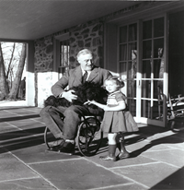 President Roosevelt in his wheelchair on the porch at Top Cottage in Hyde Park, NY with Ruthie Bie and Fala. February 1941. This photograph was taken by his friend, Margaret "Daisy" Suckley. Ruthie Bie (later Bautista), then three years old, was the daughter of the property caretakers.

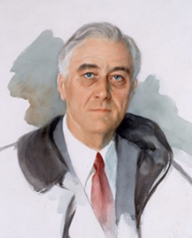 The unfinished painting of FDR as done by Elizabeth Shoumatoff

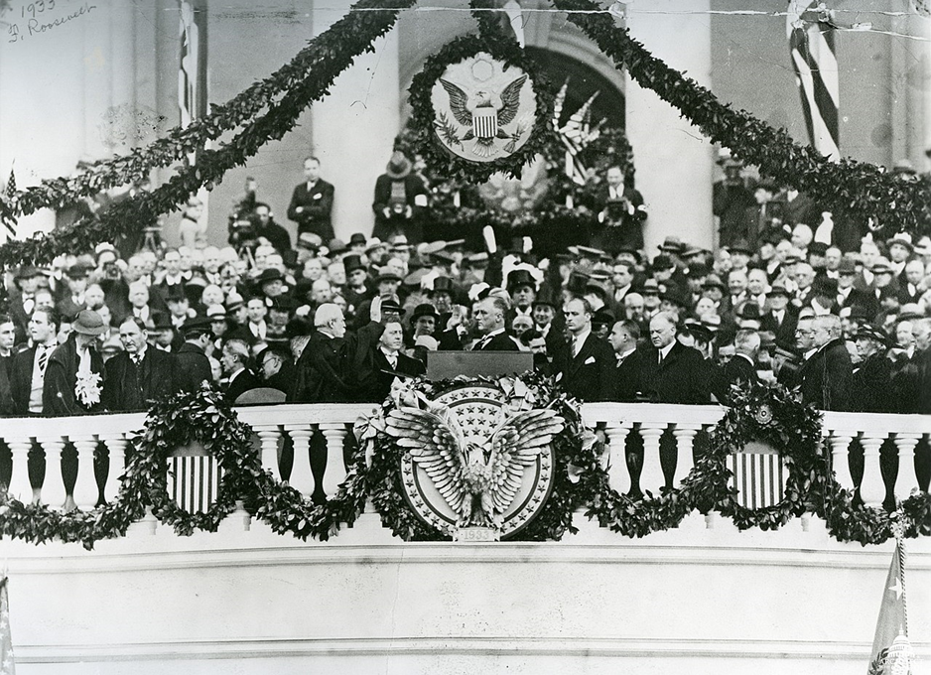

This inauguration ceremony for Franklin D. Roosevelt on March 4, 1933, was the last ceremony to be held in March. All subsequent inaugurals have been held in January. This official Architect of the Capitol photograph is being made available for educational, scholarly, news or personal purposes (not advertising or any other commercial use). When any of these images is used the photographic credit line should read “Architect of the Capitol.” These images may not be used in any way that would imply endorsement by the Architect of the Capitol or the United States Congress of a product, service or point of view.

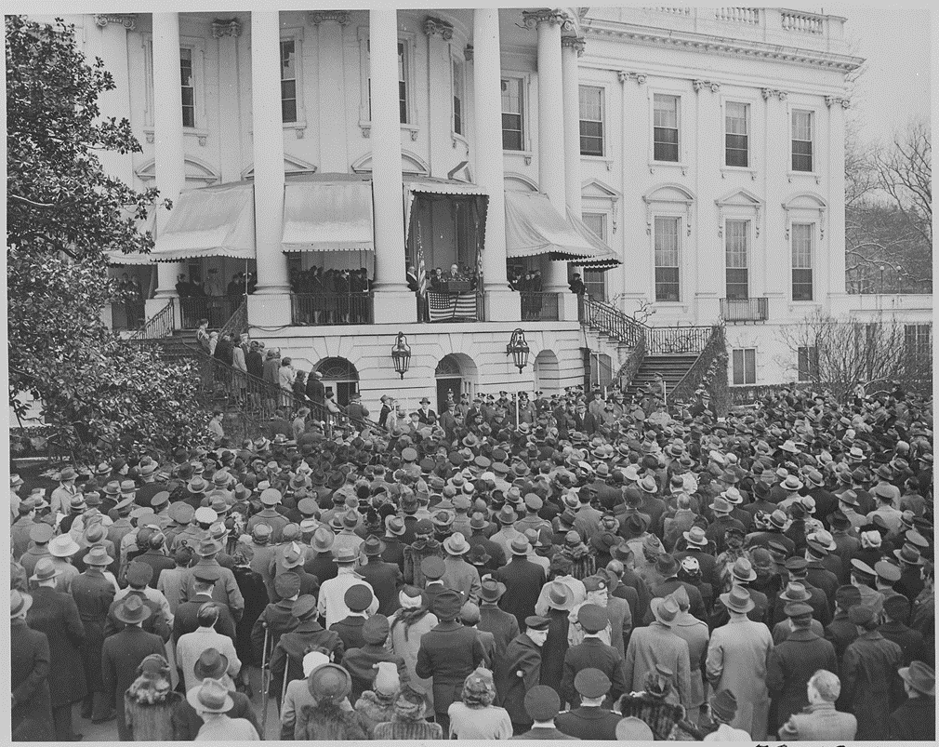

Photograph of President Franklin D. Roosevelt delivering his fourth Inaugural Address.

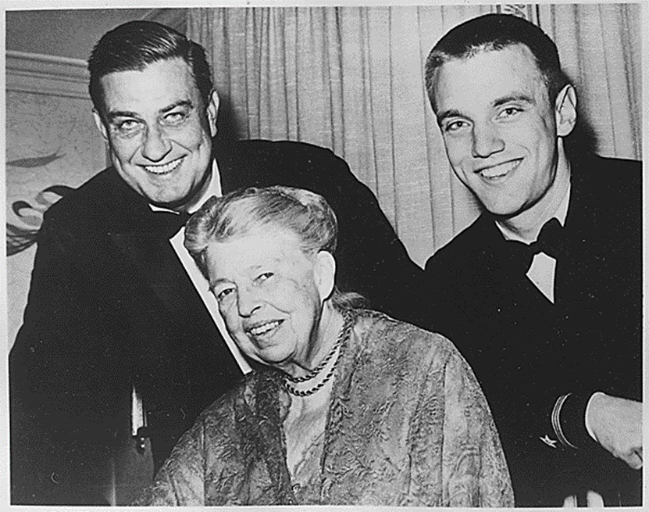 

Eleanor Roosevelt, Franklin D . Presidency of Franklin D.

Roosevelt Jr; and Franklin D. Roosevelt, third and fourth terms.

Roosevelt III, 1962

From Wikipedia, the free encyclopedia presidents.