**Regenerative Symbolism and the Ouroboros in Goethe’s Märchen**

[**AUGUST 3, 2016**](https://skfrench.wordpress.com/2016/08/03/regenerative-symbolism-and-the-ouroboros-in-goethes-marchen/)**BY**[**SIR KNIGHT JEDEDIAH FRENCH**](https://skfrench.wordpress.com/author/sirknightjedediahfrench/)**IN**[**ESOTERICISM**](https://skfrench.wordpress.com/category/esotericism/)**,**[**MYSTERY RELIGIONS**](https://skfrench.wordpress.com/category/mystery-religions/)

[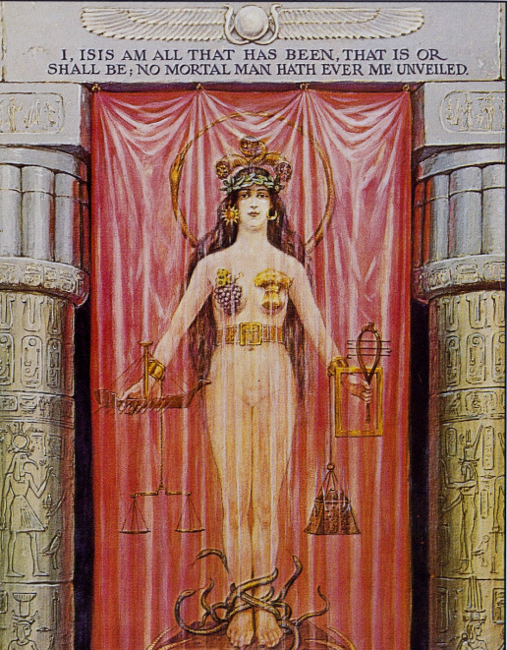](https://skfrench.files.wordpress.com/2016/08/isis.jpg)**Symbolism might best be considered in terms of**revealing and re-veiling. The veil is the protective covering shielding the sacred from the profane, and therefore higher vision can be revealed only to inspired perception. It has always been the task of the initiate to attain this higher vision.

[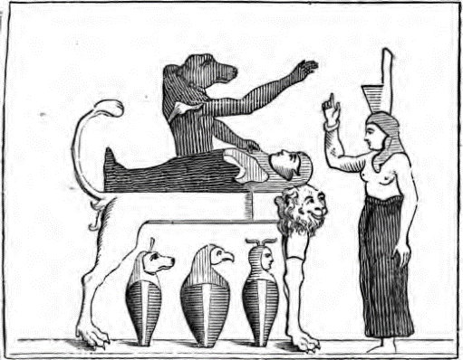](https://skfrench.files.wordpress.com/2016/08/osiris.png)***The God Osiris being raised up from the lion bed (tomb) to dwell as an immortal and to be reborn as the wheat (corn) is reborn each season.***

The veil, i.e. the barrier to the sacred, is often associated with [the goddess Isis](https://en.wikipedia.org/wiki/Veil_of_Isis). [Plutarch](https://en.wikipedia.org/wiki/Plutarch) describes Isis as “a goddess exceptionally wise and a lover of wisdom, to whom, as her name at least seems to indicate, knowledge and understanding are in the highest degree appropriate.” An ancient statue of Athena in Sais was identified with Isis, and according to Plutarch was inscribed “I am all that has been, and is, and shall be, and my robe no mortal has yet uncovered.” [Osiris](https://en.wikipedia.org/wiki/Osiris), on the other hand, is a god of rebirth and resurrection. [Manly P. Hall](https://en.wikipedia.org/wiki/Manly_P._Hall) picked up this theme and expanded on it in his *The Secret Teachings of All Ages*.

[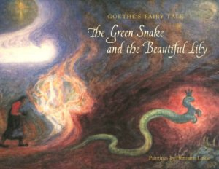](https://skfrench.files.wordpress.com/2016/08/book-cover.jpg)Another symbol associated with the veil is that of the [serpent](https://en.wikipedia.org/wiki/Serpent_(symbolism)), which represents access to the sacred and the re-birth process that accompanies the initiation into the Mysteries. One of the central images in [Goethe](https://en.wikipedia.org/wiki/Johann_Wolfgang_von_Goethe)’s “[The Fairy Tale of the Green Snake and the Beautiful Lily](https://en.wikipedia.org/wiki/The_Green_Snake_and_the_Beautiful_Lily)” is, of course, the snake. A suggestive esoteric scene occurs when the Prince of the fairy tale, the so-called “woeful Youth,” drops dead from touching the fair Lily, in fact dies in her arms, and then the snake creates a “magical circle” around his body by “form[ing] a wide circle round the corpse, and seizing the end of her tail between her teeth,” as in this image below:

[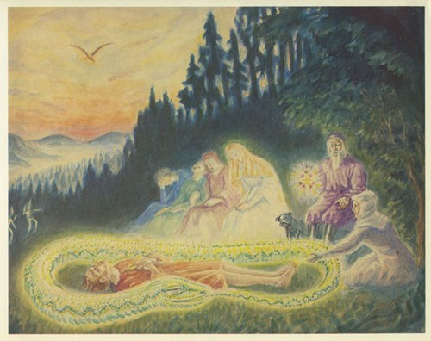](https://skfrench.files.wordpress.com/2016/08/goethe_9_small.jpg)

Indeed, the snake, serpent, or dragon is a powerful symbol that has preoccupied the imagination of mankind since the beginning—particularly the religious imagination—but this image of the snake forming into a circle and biting its own tale is known to sacred history and esoteric literature as the [Ouroboros](https://en.wikipedia.org/wiki/Ouroboros" \t "_blank), a symbol that represents, among other things, the circular nature of life, that all things are begun anew as soon as they end. Thus, when the Prince in Goethe’s fairy tale is resurrected back to life after the snake forms this ancient sign about his corpse, Goethe is indicating to us the illusory nature of death.

The Ouroboros symbol goes back thousands of years and is well known in esoteric circles, particularly secret societies like the Freemasons, of which Goethe himself was a member. So it comes as no surprise to find the snake making this symbol in his *Märchen* (fairy tale)*.*Still, while it is easy to understand how and why this symbol made its way into Goethe’s “Fairy Tale,” why the introduction of such a symbol should restore life to a recently lifeless Prince remains a mystery. [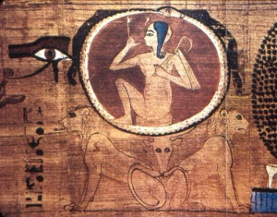](https://skfrench.files.wordpress.com/2016/08/uroborosegipcio.jpg)In order to unravel this, we must first investigate the Ouroboros figure and interpret it further.

The symbol is first thought to have emanated out of Ancient Egypt but was picked up at one time or another by a variety of cults and religions. In [J. E. Cirlot](https://en.wikipedia.org/wiki/Juan_Eduardo_Cirlot)’s *A Dictionary of Symbols*, the Spanish poet writes:

*In the broadest sense, [the Ouroboros] is symbolic of time and of the continuity of life … it represents the dissolution of the body, or the universal serpent which (to quote the Gnostic saying) ‘passes through all things’…. The Ouroboros biting its own tail is symbolic of self-fecundation, or the primitive idea of a self-sufficient Nature—a Nature, that is, which, à la Nietzsche, continually returns, within a cyclic pattern, to its own beginning.*

Cirlot also refers to it as the symbol of “eternity,” of “all cyclic processes,” and of “time in particular.”

[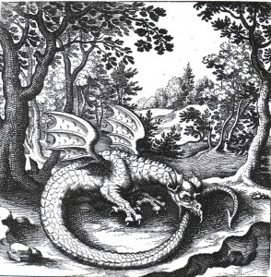](https://skfrench.files.wordpress.com/2016/08/ouroboros_1.jpg)**Engraving by Lucas Jennis, in an alchemical tract titled *De Lapide Philosophic*o.**

Gnostic Christians adopted/modified Ouroboros imagery coming out of Egypt to fit their purposes. The first recorded examples of this symbol appear in 1st c. AD Greek and Roman tablets, but it was later incorporated by the medieval and Renaissance alchemists into their manuscripts to represent allegorical processes.

Even more interesting is that the symbol crops up in East Asia around the same time and even earlier, most noticeably in the Ying and Yang symbol representing life and death, that the two are one, but also in the very first images of the Buddha. While most people are accustomed to thinking about Buddha images as being the familiar rotund meditating or laughing man, the first images of [Siddhārtha Gautama](https://en.wikipedia.org/wiki/Gautama_Buddha" \t "_blank) depicted his footprint with a variety of symbols and instructions covering the foot. Many of these early images also showed a serpent eating its own tail around the entire footprint, as in this figure:

[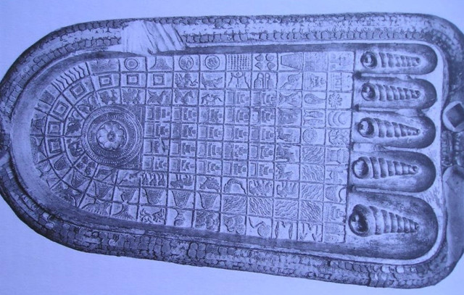](https://skfrench.files.wordpress.com/2016/08/foot1.jpg)***Early footprint of the Buddha.***

From this brief history we can conclude that Goethe’s decision to include the Ouroboros in his “Fairy Tale” was by no means random or unintentional. Indeed, like the rest of the images in the story, its inclusion was to represent something highly symbolic. Also, because it is known that Goethe was a Freemason, it is quite certain that he knew about the esoteric origin as well as the meaning of the Ouroboros symbol, which was why he chose it for the scene where the Prince is brought back to life.

In the mentioned scene, after the fair Lily touches the Prince and he dies, the snake forms the Ouroboros around his body and holds it for some time. Even when there seems to be some distractions or difficulties, the snake does its best to hold the form, as if the utmost depended on it. Goethe writes:

*In this extreme need, the Snake kept looking round on all sides; for she was afraid every moment that the Sun would set, and corruption penetrate the magic circle, and the fair youth immediately moulder away.*

The snake then says, “To sacrifice myself rather than be sacrificed.” Afterward, the fair Lily touches the snake and the Prince at the same time, and the prince is brought back to life. But what does this mean? What is Goethe telling us?

[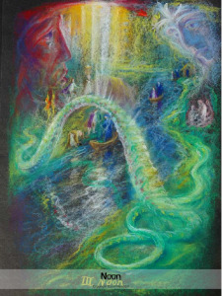](https://skfrench.files.wordpress.com/2016/08/polden_green_snake_7_images-03.jpg)The most important interpretation of the Ouroboros symbol for the Goethe story is the idea that all things begin anew, even as they end. While death is usually thought of as an end to something—well, to life—perhaps that is false, an illusion. On the other hand, it is possible to flip roles and say that life is actually death and that when one dies, they are then fully brought to life. Such an idea is common at least in more exoteric forms in many religions, but particularly Christianity. When the snake bites its own tail, it turns itself into a continuous flow, rather than a literal form. And yet, as an Ouroboros, the snake is neither vertical nor horizontal. It is circular. So in a sense it defies conventional space. But as a circle, the snake is eternal. In other words, immortal.

Thus Goethe, in employing the Ouroboros symbol in his “Fairy Tale” during the significant moment of death and rebirth, might be suggesting that a) the [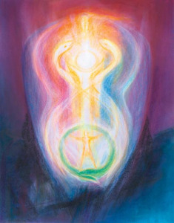](https://skfrench.files.wordpress.com/2016/08/green-snake.jpg)Prince was immortal the whole time and didn’t know it, but the form of the Ouroboros reminded him (and us, too, the readers); and b) that death in life is actually life in death, and vice versa, a tricky combination meant as an allegory of the human soul; namely, that like the snake when it bites its own tail, forms the Ouroboros, and becomes eternal, the human soul is likewise immortal, if only we would realize that death is an illusion, and what’s more, that dying in life is actually life in death, so beautifully portrayed within nature by the process of the snake shedding its skin.